**DBMS ASSIGNMENT: 1**

**Name: Poojan Gandhi**

**Enroll No: AU1940125**

**Faculty: Shefali Naik**

Bank Table (Table 1)

Part 1

1. Increase the size of branch_name field.

* Query: **alter table branch modify branch_name varchar(50);**
* Image:

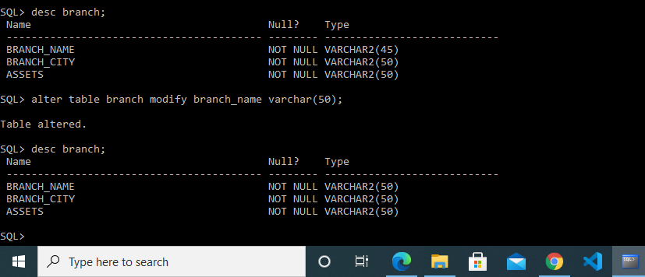

2. Add constraint to check whether balance is more than zero.

* Query: **alter table account add check(balance>0);**
* Image:

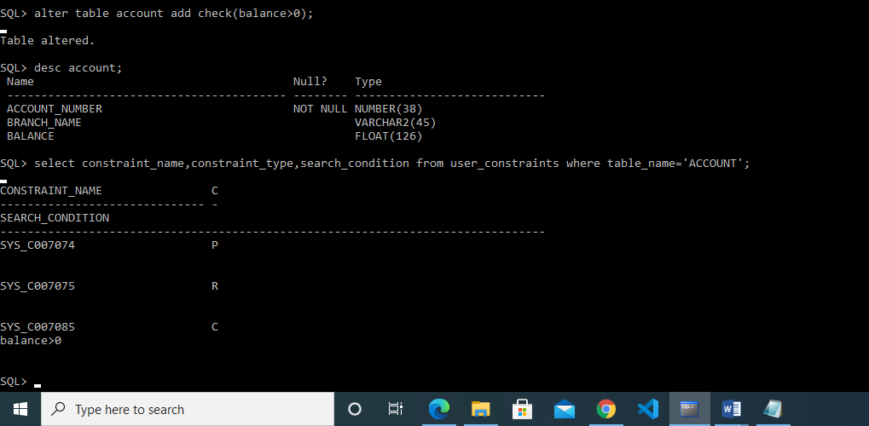

3. Add a column loan_taken_date in loan table.

* Query: **alter table loan add loan_taken_date date;**
* Image:

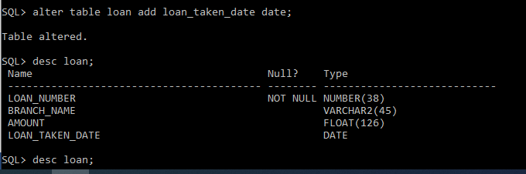

4. Add default constraint on loan_taken_date to insert current date

* Query: **alter table loan modify loan_taken_date default sysdate;**
* Image:

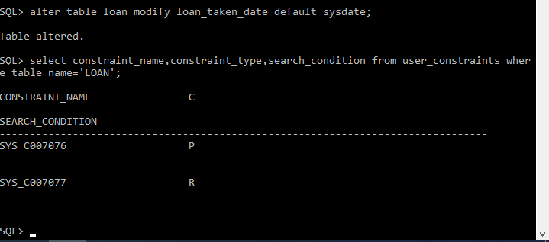

5. Drop foreign key constraint from loan_number field of borrower table

* Query:
  + For getting constraint name of foreign key:

**select constraint_name from user_constraints where table_name = 'BORROWER' and constraint_type = 'R';**

* + For deleting that key by its name:

**alter table borrower drop constraint SYS_C007144;**

* Image:

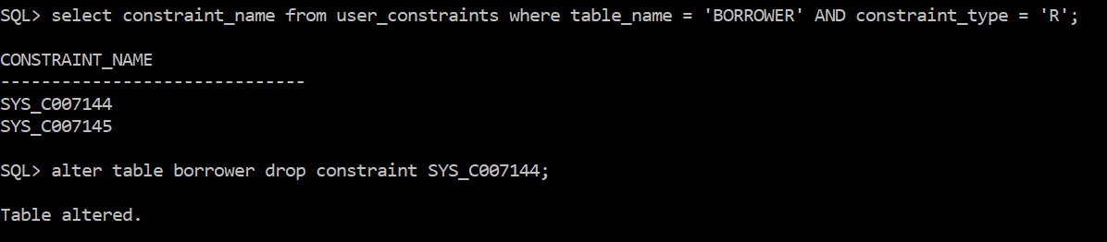

6. Rename column loan_number of borrower table as “loan_id”

* Query: **alter table borrower rename column loan_number to loan_id;**
* Image:

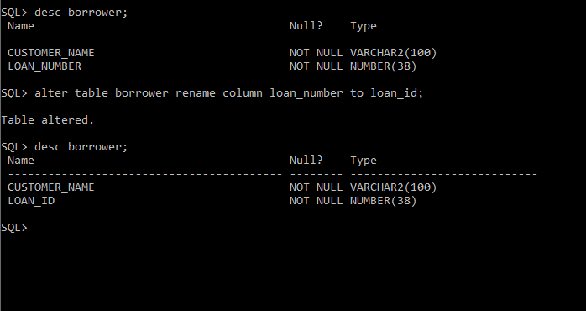

7. Add a field “Aadharid” with unique constraint in customer table

* Query: **alter table customer add Aadharid int unique ;**
* Image:

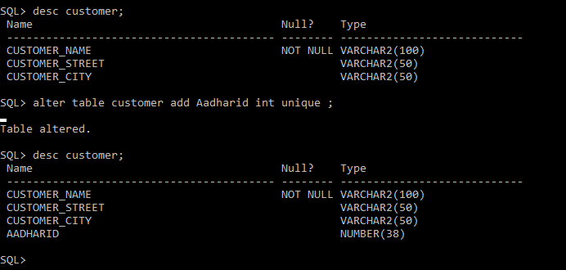

8. Add “Not Null” constraint on loan_number field of borrower table

* Query: **alter table borrower modify loan_id not null;**
* Image:

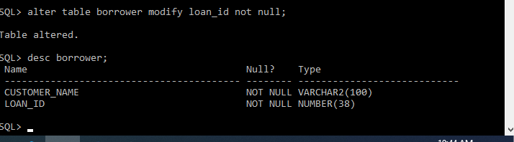

9. Drop primary key constraint from borrower table.

Query: **alter table borrower drop primary key;**

Image:

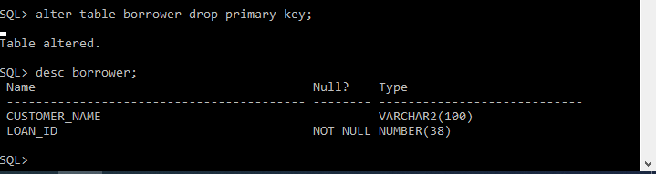

10. Rename table account to bank_account.

Query: **rename account to bank_account;**

Image:

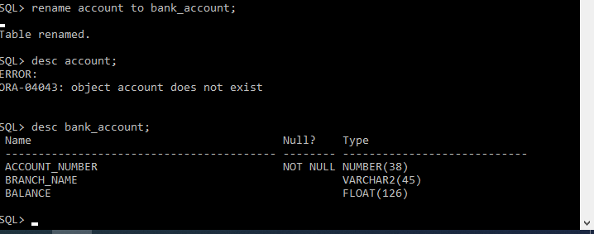

**Part 2**

1. Display names of the customers who have account in the city where they live.

* Query: **select customer.customer_name from customer, depositer, bank_account, branch where (customer.customer_name = depositer.customer_name and depositer.account_number = bank_account.account_number and bank_account.branch_name = branch.branch_name and customer.customer_city = branch.branch_city);**
* Image:

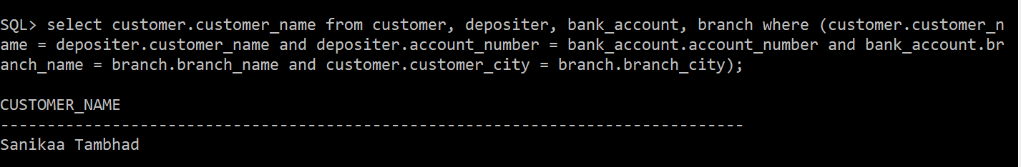

1. Display details of customers who are not borrower.

* Query: **select trim(customer_name) ||' '||trim( customer_street) ||' '|| trim( customer_city) ||' '||aadharid from customer where customer_name not in (select customer_name from borrower);**
* Image:

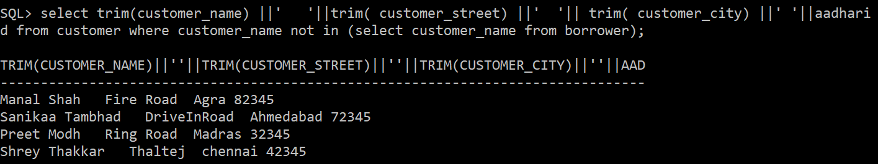

3. Display customer details who have taken loan more than 3 times

* Query: **select trim(customer_name) ||' '||trim( customer_street) ||' '|| trim( customer_city) ||' '||aadharid from customer where customer_name in ( select customer_name from borrower group by customer_name having count(*)>3);**
* Image:

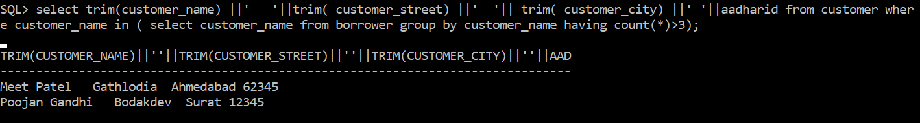

4. Display pairs of customers who live in the same city.

* Query: **select a.customer_name, b.customer_name from customer a, customer b where a.customer_city=b.customer_city and a.customer_name <> b.customer_name;**
* Image: 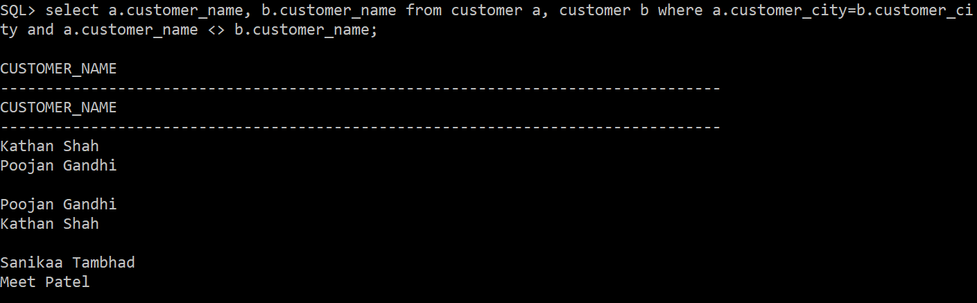

5. Display details of the customers whose name is the longest.

* Query: **select trim(customer_name) ||' '||trim( customer_street) ||' '|| trim( customer_city) ||' '||aadharid from customer where length(customer_name)= (select max(length(customer_name)) from customer);**
* Image:

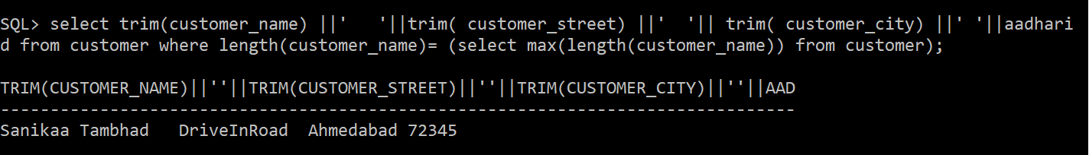

6. Display details of borrowers who have taken loan from 'Ahmedabad' branch

* Query: **select trim(customer_name) ||' '||trim( customer_street) ||' '|| trim( customer_city) ||' '||aadharid from customer where customer_name in (select customer_name from borrower where loan_ID in (select loan_number from loan where branch_name in (select branch_name from branch where branch_city='Ahmedabad')));**
* Image:

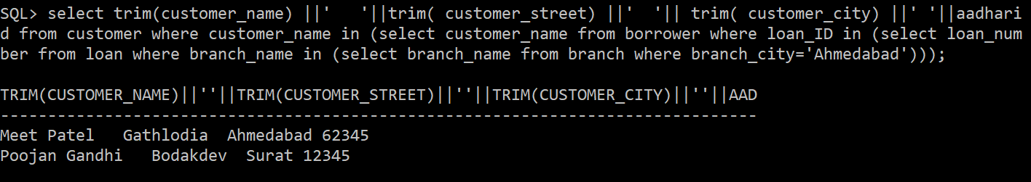

7. Display details of borrowers who have taken **total** loan of more than Rs. 50,00,000.

* Query: **select trim(customer_name) ||' '||trim( customer_street) ||' '|| trim( customer_city) ||' '||aadharid from customer where customer_name in (select customer_name from borrower where loan_ID in (select loan_number from loan where branch_name in (select branch_name from branch where branch_city='Ahmedabad')));**
* Image:

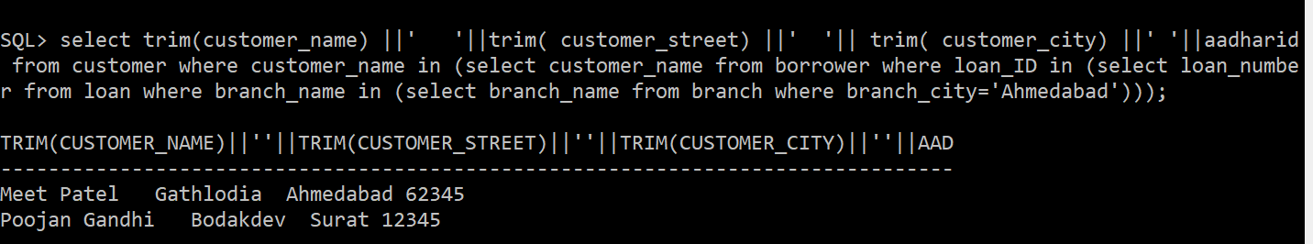

8. Display total assets of all the branches.

* Query: **select sum(assets) from branch ;**
* Image:

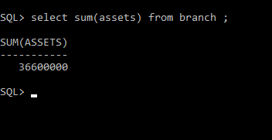

9. Display details of customers who are depositors

* Query: **select trim(customer_name) ||' '||trim( customer_street) ||' '|| trim( customer_city) ||' '||aadharid from customer where customer_name in (select customer_name from depositer);**
* Image:

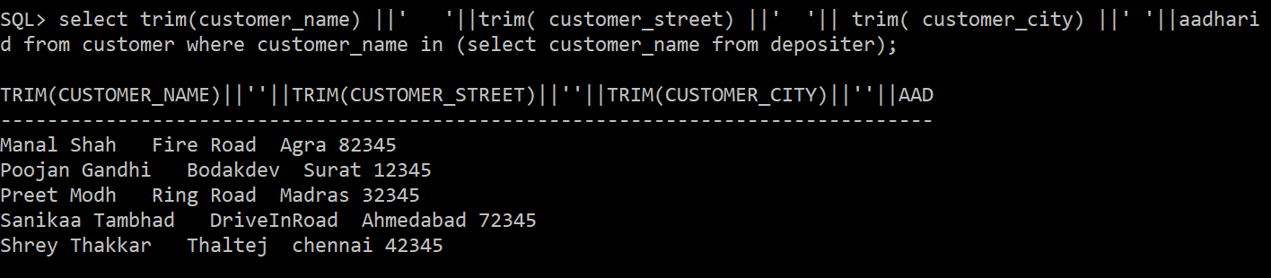

10. Display left outer join of customer and depositor table

* Query: **select customer.customer_name||' '||customer.customer_street||' '||customer.customer_city||' '||depositer.account_number from customer left join depositer on depositer.customer_name = customer.customer_name;**
* Image:

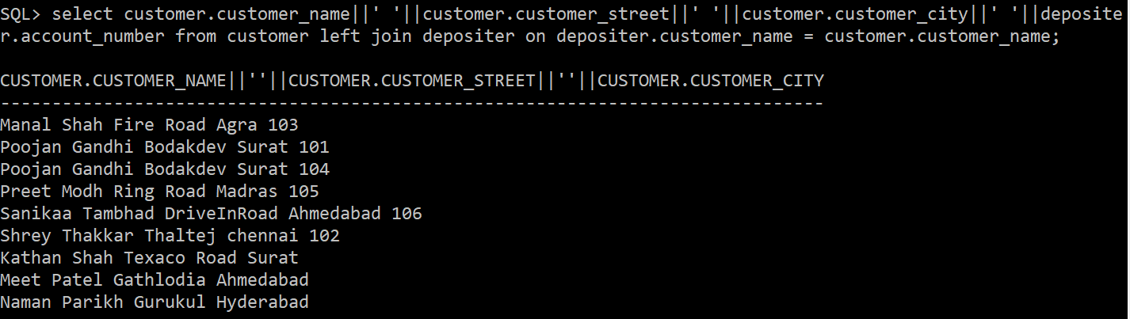

11. Display right outer join of account and depositor table.

* Query: **select bank_account.account_number||' '||depositer.customer_name||' '||bank_account.branch_name||' '||bank_account.balance from bank_account right join depositer on bank_account.account_number = depositer.account_number;**
* Image:

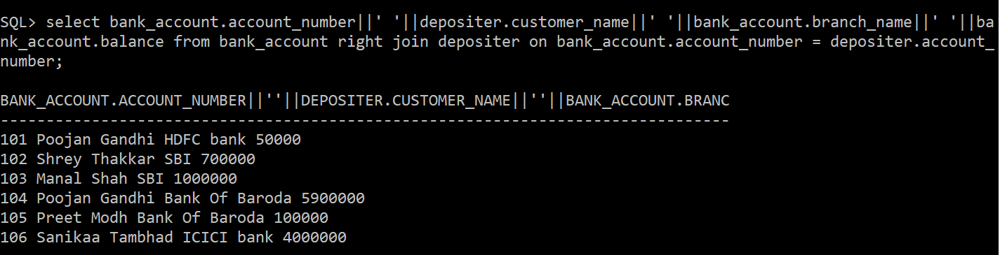

12. Display account number in which balance is minimum.

* Query: **select account_number from bank_account where balance=(select min(balance) from bank_account);**
* Image:

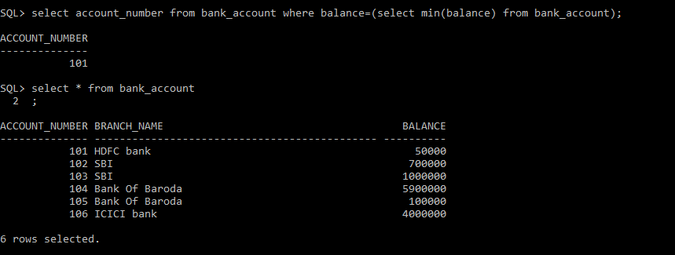

13. Display account number in which balance is second highest

* Query: **select account_number from bank_account where balance=(select max(balance) from bank_account where balance <>(select max(balance) from bank_account));**
* Image:

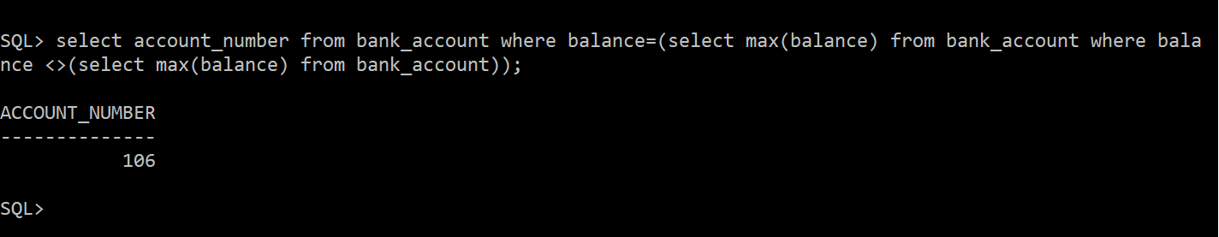

14. Display branch name, branch city, account number, customer name and customer city in ascending order of customer city and descending order of branch city

Query: **select b.branch_name||' '||b.branch_city||' ' ||a.account_number||' ' ||c.customer_name||' '||c.customer_city from branch b, bank_account a, customer c,depositer d where c.customer_name=d.customer_name and d.account_number=a.account_number and a.branch_name=b.branch_name order by c.customer_city,b.branch_city desc;**

**OR**

**select RPAD(b.branch_name, 15) ||' '|| RPAD(b.branch_city, 10) ||' ' || RPAD(a.account_number, 3) ||' ' || RPAD(c.customer_name, 18) ||' '|| RPAD(c.customer_city, 20) from branch b, bank_account a, customer c,depositer d where c.customer_name=d.customer_name and d.account_number=a.account_number and a.branch_name=b.branch_name order by c.customer_city,b.branch_city desc;**

Image: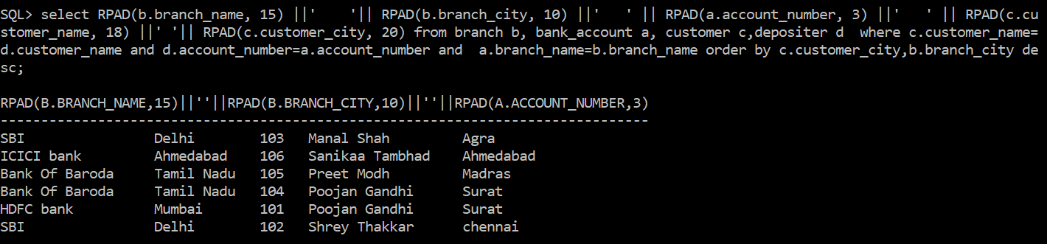

15. Display total no. of customers in each city

* Query: **select count(customer_city), customer_city from customer group by customer_city;**
* Image:

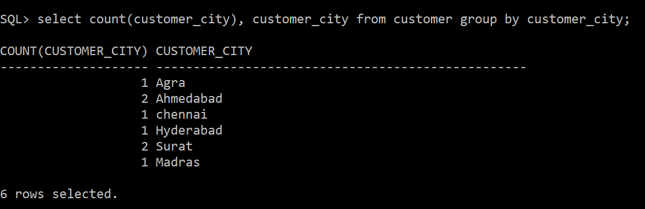

16. Display city wise total assets in descending order of total assets.

* Query: **select branch_city||' '||sum(assets) from branch group by branch_city order by sum (assets) desc ;**
* Image:

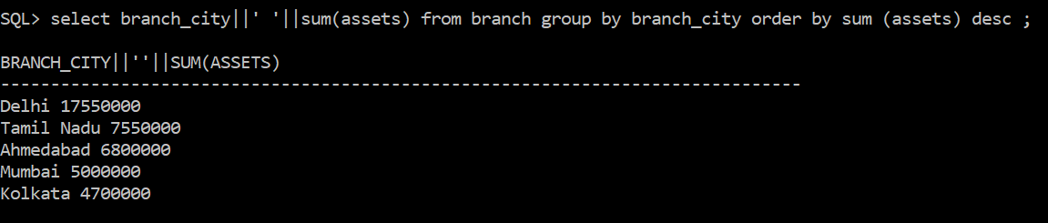

17. Display borrower names with total loan amount taken.

* Query: **select b.customer_name||' '||sum(l.amount) from borrower b , loan l where b.loan_id=l.loan_number group by b.customer_name ;**
* Image:

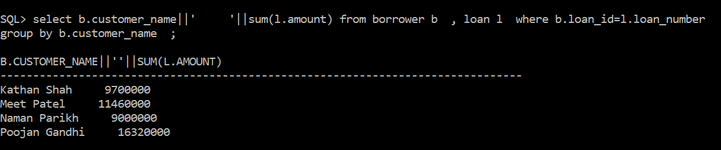

18. Display details of the customers who are depositors as well as borrower.

* Query: **select distinct c.customer_name ||' '|| c.customer_street ||' '|| c. customer_city ||' '||aadharid from customer c,borrower b, depositer d where c.customer_name=d.customer_name or c.customer_name=b.customer_name;**
* Image:

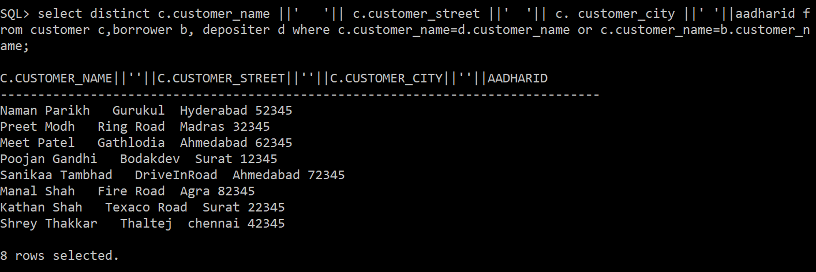

19. Display inner join of customer, borrower, loan and branch.

* Query: **select customer.customer_name||' '||branch.branch_name||' '|| loan.loan_number from branch inner join loan on branch.branch_name= loan.branch_name inner join borrower on loan.loan_number=borrower.loan_id inner join customer on customer.customer_name =borrower.customer_name;**
* Image:

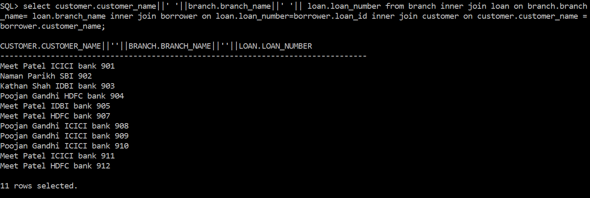

20. Display union of branch and account. (Use “union” operator)

* Query: **select branch_name from branch union select branch_name from bank_account;**
* Image:

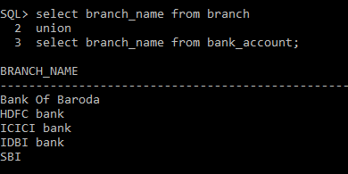

**2ND TABLE**

1. Add constraints:
   * + 1. Credits in course table should be minimum 1.5 and maximum 4.5

* Query:**alter table course add constraint check_credits check (credits>=1.5 and credits<=4.5);**
* Image:

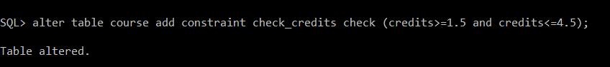

* + - 1. Budget in department table can’t exceed Rs. 10,000.
* Query:**alter table department add constraint budget_max check(budget<=10000);**
* Image:

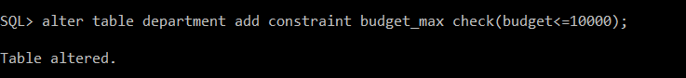

* + - 1. Salary in instructor table should be more than 0.
* Query: **alter table instructor add constraint salary_min check(salary>0);**
* Image:

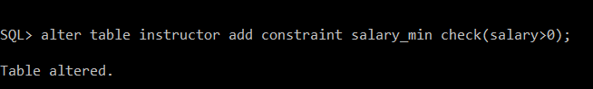

1. Default constraints

i. 1.5 credits in course table.

* + - Query: **alter table course modify credits default 1.5;**
    - Image:

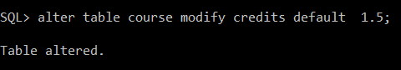

ii. 120 capacity in classroom table.

* + Query: **alter table classroom modify capacity default 120;**
  + Image

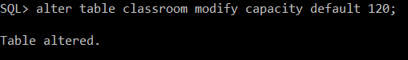

iii. 2019 (Don’t set value directly. Extract year from current date)

* + Query:**alter table section modify year default(extract(year from sysdate));**
  + Image:

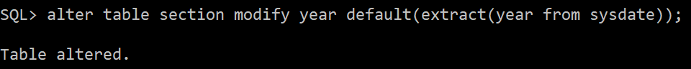

1. Unique constraints:

i. Dept_name in student table.

* + Query: **alter table student modify dept_name unique;**
  + Image:

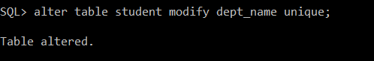

ii. Dept_name in instructor table.

* + Query: **alter table instructor modify dept_name unique;**
  + Image:

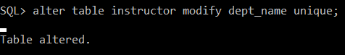

1. NOT NULL

i. Capacity in classroom table.

* + Query: **alter table classroom modify capacity not null;**
  + Image:

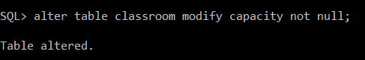

ii. Year in teaches table

* + Query: **alter table teaches modify year not null;**
  + Image:

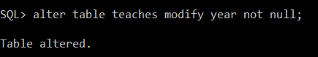

1. Create a new course “CS-001”, titled “Weekly Seminar”, with 2 credits.

* Query: **insert into course values('CS-001','Weekly Seminar','CSE',2);**
* Image:

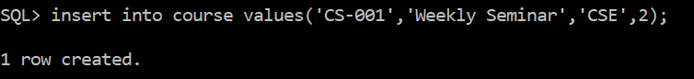

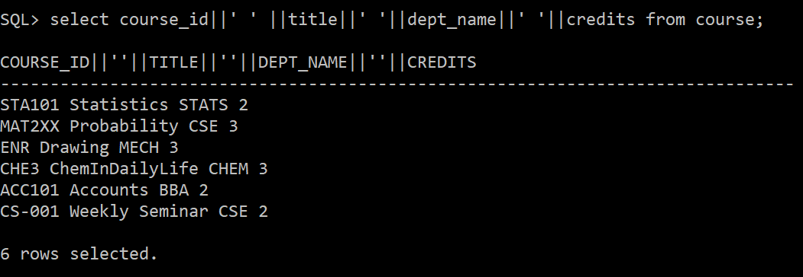

1. Create a section of the course “CS-001” in Autumn 2009, with sec_id of 1
   * Query:**insert into section values('CS-001',1,3,2009,'SEAS',401,1);**
   * Image:

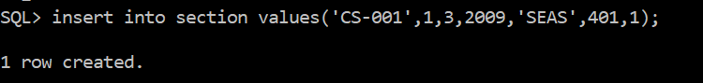

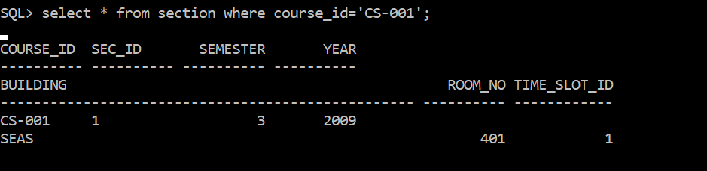

1. Enroll every student in the Comp. Sci. department in section 1.

* Query: **insert into takes (id, course_id, sec_id, semester, year,grade) select id,'CS-001',1,3,2009,'A+' from student where dept_name='CSE';**
* Image:

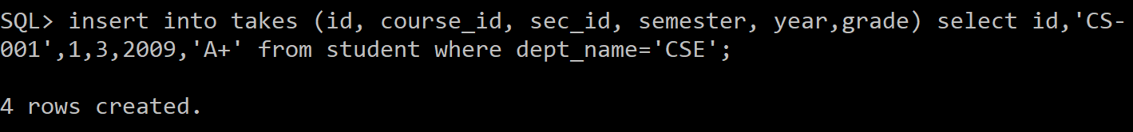

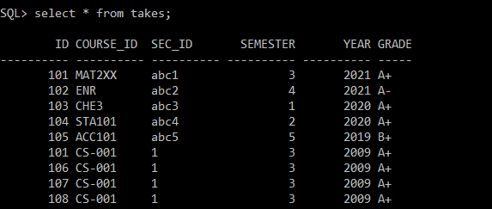

1. Delete enrollment in section 1 where student name is Chiral

* Query: **delete from takes where id in (select id from student where name='Chiral') and sec_id='1';**
* Image:

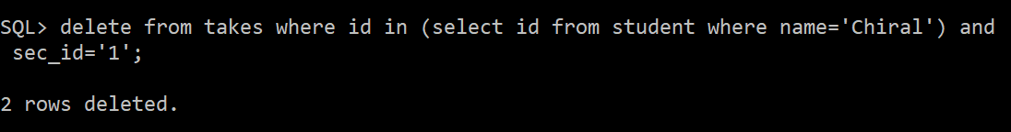

1. Delete all “takes” tuples corresponding to any section of any course with the word “database” as a part of the title, ignore case when matching the word with the title.

* Query: **delete from takes where course_id in (select course_id from course where lower(title) like '%database%');**
* Image:

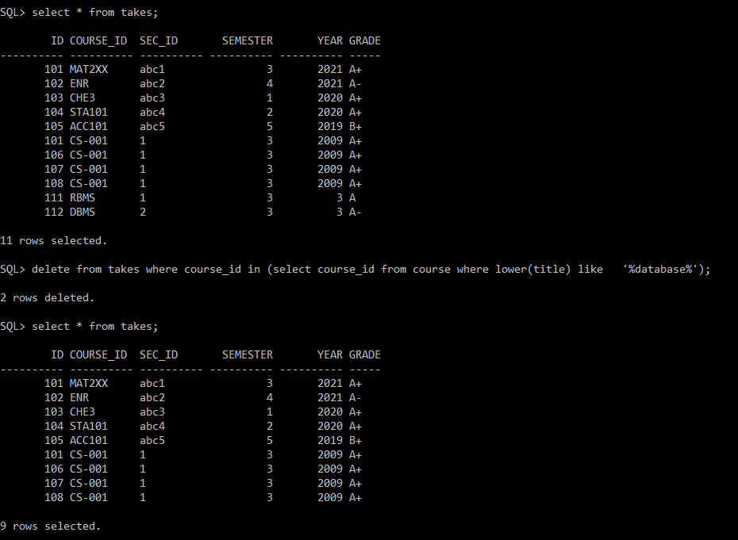

1. Drop “foreign key” constraint from “prereq” table.

Query:

* **select constraint_name from user_constraints where table_name = 'PREREQ' and constraint_type = 'R';**
* **alter table prereq drop constraint SYS_C007100;**

Image:

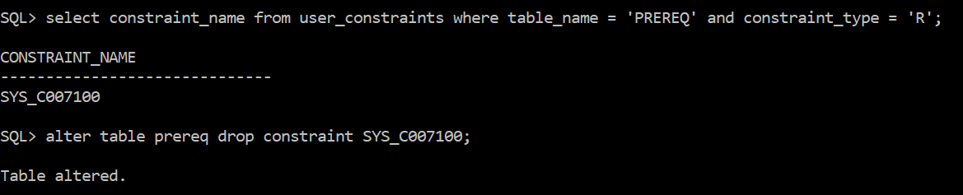

1. Add one field sr_no “prereq” table and make it a primary key.

* Query: **alter table prereq add sr_no int primary key;**
* Image:

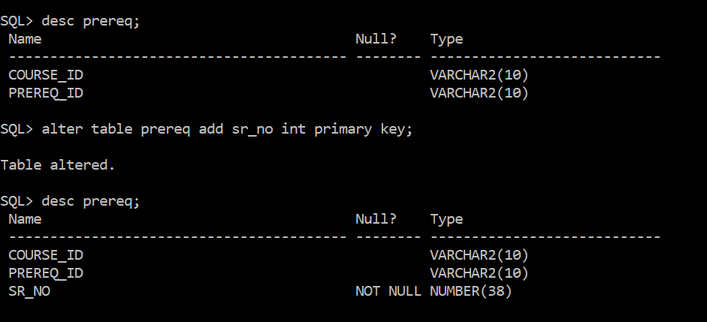

1. Rename “name” field of student table to “std_name”.

* Query: **alter table student rename column name TO std_name;**
* Image:

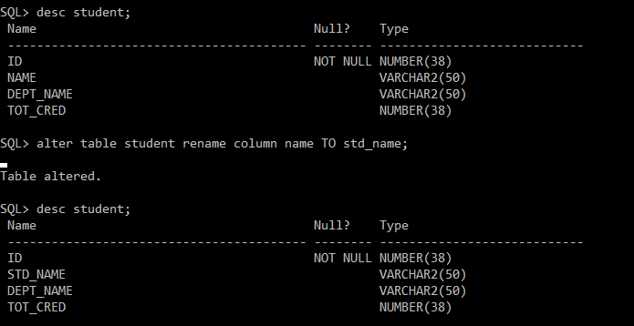

1. Drop unique constraint from “dept_name” field of instructor table.

* Query: **alter table instructor drop unique (dept_name);**
* Image:

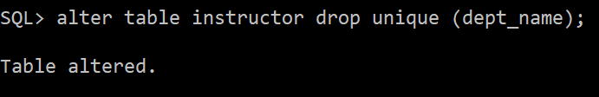

1. Drop not null constraint from “capacity” field of “classroom” table.

* Query: **alter table classroom modify capacity null;**
* Image:

