1. Increase the size of branch_name field.

alter table branch modify branch_name varchar(50);

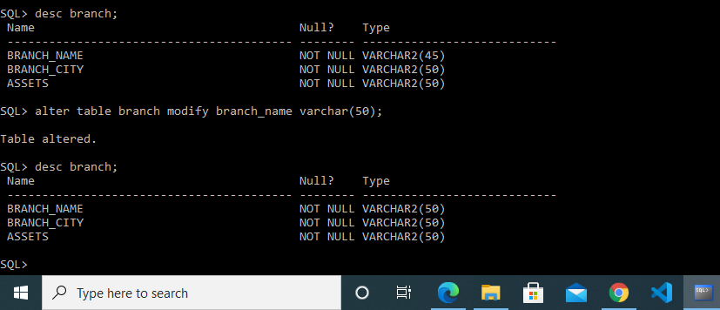

2. Add constraint to check whether balance is more than zero.

alter table account add check(balance>0);

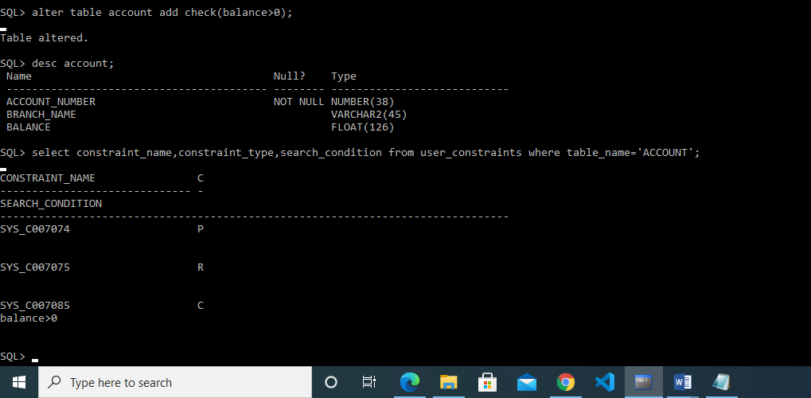

3. Add a column loan_taken_date in loan table.

alter table loan add loan_taken_date date;

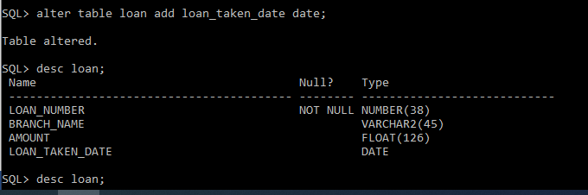

4. Add default constraint on loan_taken_date to insert current date

alter table loan modify loan_taken_date default sysdate;

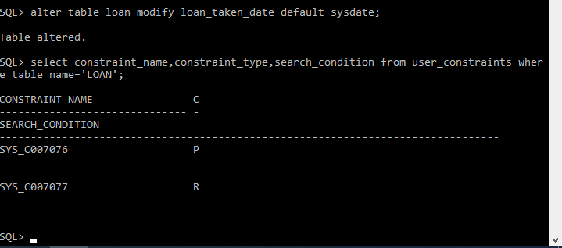

5. Drop foreign key constraint from loan_number field of borrower table

alter table borrower drop foreign key loan_number;

ERROR

6. Rename column loan_number of borrower table as “loan_id”

alter table borrower rename column loan_number to loan_id;

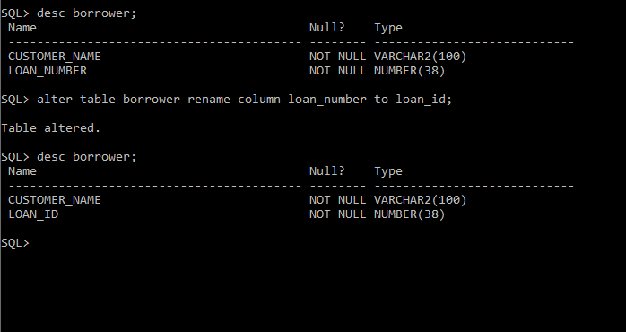

7. Add a field “Aadharid” with unique constraint in customer table

alter table customer add Aadharid int unique ;

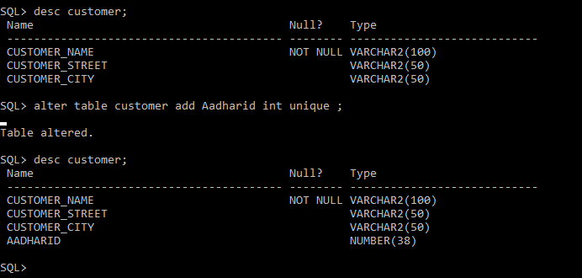

8. Add “Not Null” constraint on loan_number field of borrower table

alter table borrower modify loan_id not null;

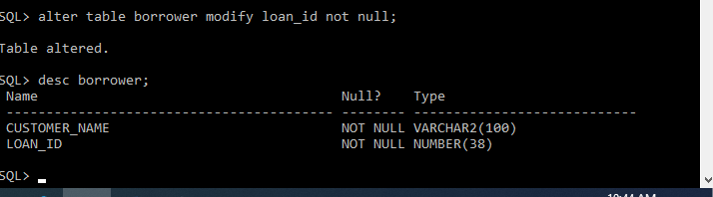

9. Drop primary key constraint from borrower table.

alter table borrower drop primary key;

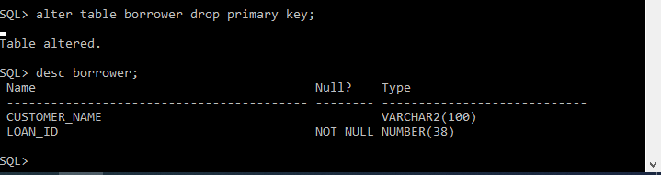

10. Rename table account to bank_account.

rename account to bank_account;

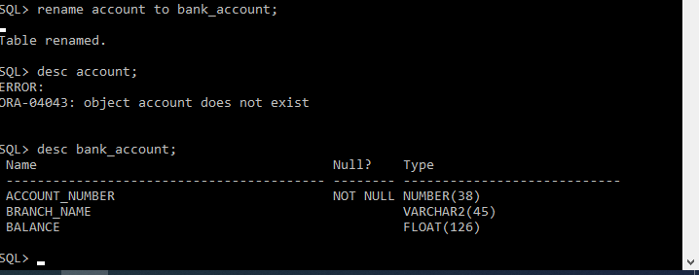

Part 2

1. Display names of the customers who have account in the city where they live.

**select customer_name from customer where customer_city in (select branch_city from branch where branch_name in (select branch_name from bank_account where account_number in (select account_number from depositer where customer_name in (select customer_name from customer))));**

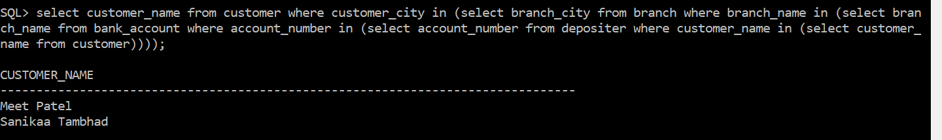

1. Display details of customers who are not borrower.

**select trim(customer_name) ||' '||trim( customer_street) ||' '|| trim( customer_city) ||' '||aadharid from customer where customer_name not in (select customer_name from borrower);**

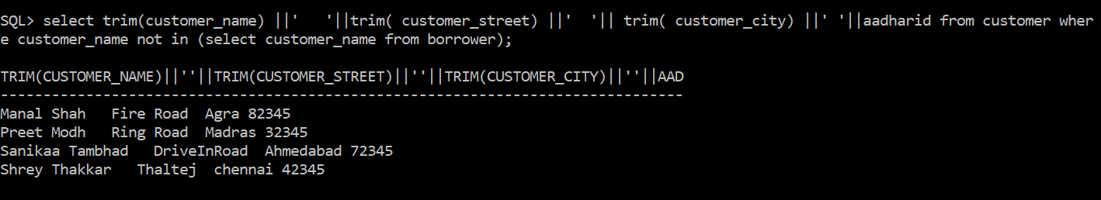

3. Display customer details who have taken loan more than 3 times

**select trim(customer_name) ||' '||trim( customer_street) ||' '|| trim( customer_city) ||' '||aadharid from customer where customer_name in ( select customer_name from borrower group by customer_name having count(*)>3);**

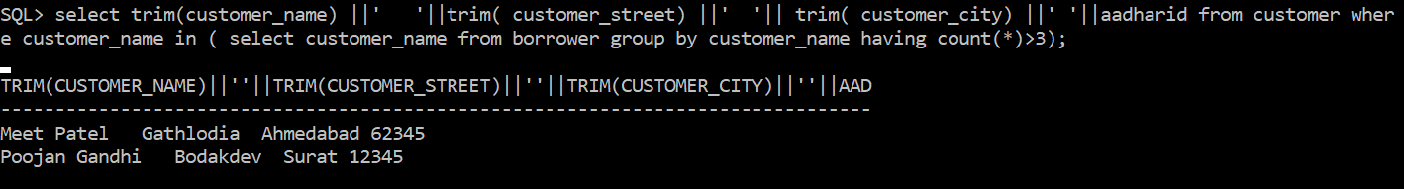

4. Display pairs of customers who live in the same city.

5. Display details of the customers whose name is the longest.

**select trim(customer_name) ||' '||trim( customer_street) ||' '|| trim( customer_city) ||' '||aadharid from customer where length(customer_name)= (select max(length(customer_name)) from customer);**

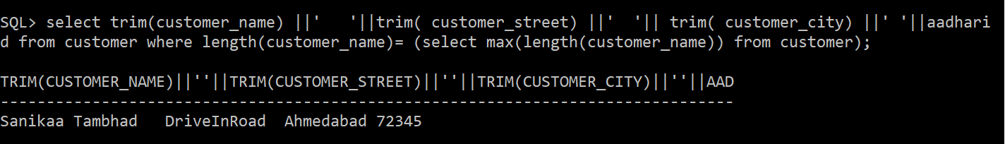

6. Display details of borrowers who have taken loan from 'Ahmedabad' branch

select trim(customer_name) ||' '||trim( customer_street) ||' '|| trim( customer_city) ||' '||aadharid from customer **where customer_name in (select customer_name from borrower where loan_ID in (select loan_number from loan where branch_name in (select branch_name from branch where branch_city='Ahmedabad')));**

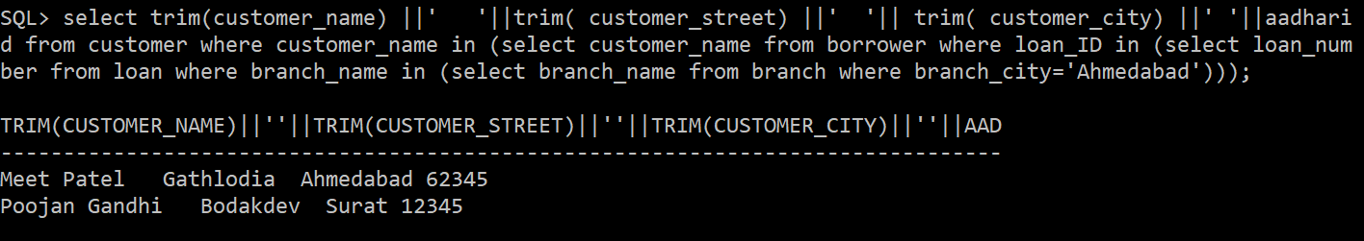

7. Display details of borrowers who have taken **total** loan of more than Rs. 50,00,000.

8. Display total assets of all the branches.

select sum(assets) from branch ;

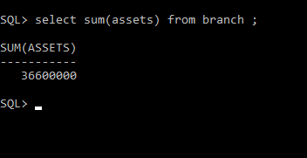

9. Display details of customers who are depositors

select trim(customer_name) ||' '||trim( customer_street) ||' '|| trim( customer_city) ||' '||aadharid from customer where customer_name in (select customer_name from depositer);

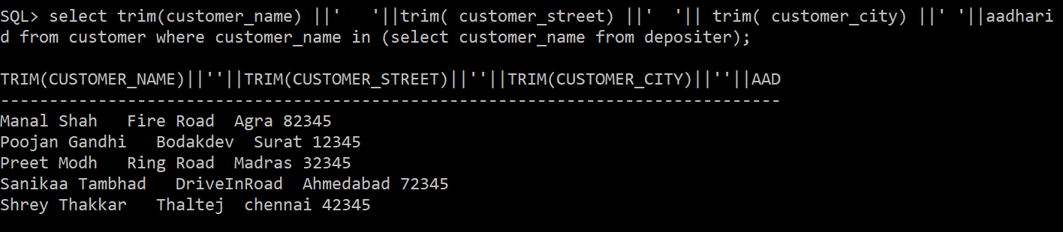

10. Display left outer join of customer and depositor table

12. Display account number in which balance is minimum.

**select account_number from bank_account where balance=(select min(balance) from bank_account);**

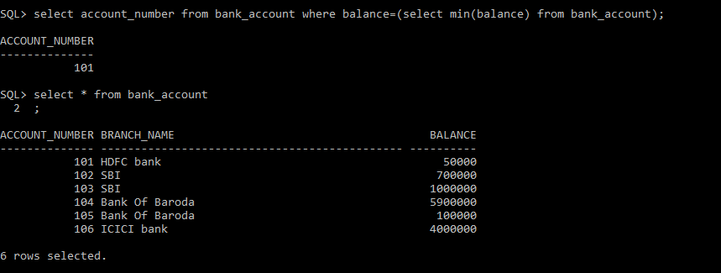

13. Display account number in which balance is second highest

**select account_number from bank_account where balance=(select max(balance) from bank_account where balance <>(select max(balance) from bank_account));**

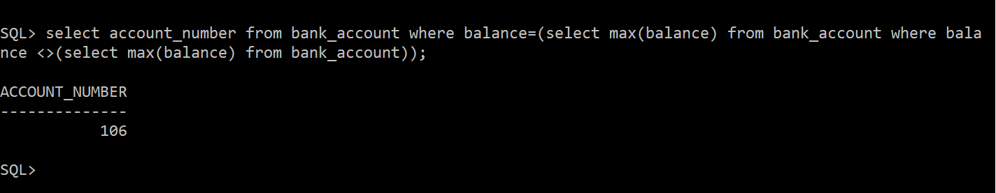

14. Display branch name, branch city, account number, customer name and customer city in ascending order of customer city and descending order of branch city

**select b.branch_name||' '||b.branch_city||' ' ||a.account_number||' ' ||c.customer_name||' '||c.customer_city from branch b, bank_account a, customer c,depositer d where c.customer_name=d.customer_name and d.account_number=a.account_number and a.branch_name=b.branch_name order by c.customer_city,b.branch_city desc;**

**OR**

**select RPAD(b.branch_name, 15) ||' '|| RPAD(b.branch_city, 10) ||' ' || RPAD(a.account_number, 3) ||' ' || RPAD(c.customer_name, 18) ||' '|| RPAD(c.customer_city, 20) from branch b, bank_account a, customer c,depositer d where c.customer_name=d.customer_name and d.account_number=a.account_number and a.branch_name=b.branch_name order by c.customer_city,b.branch_city desc;**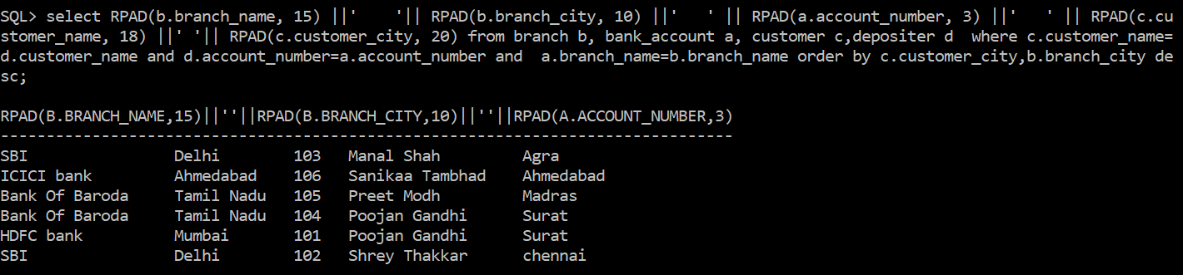

15. Display total no. of customers in each city

**select count( customer_name) from customer group by customer_city;**

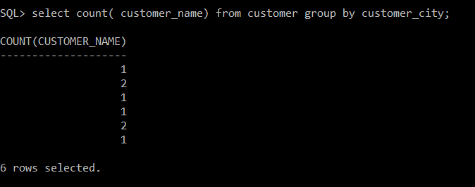

16. Display city wise total assets in descending order of total assets.

**select branch_city||' '||sum(assets) from branch group by branch_city order by sum (assets) desc ;**

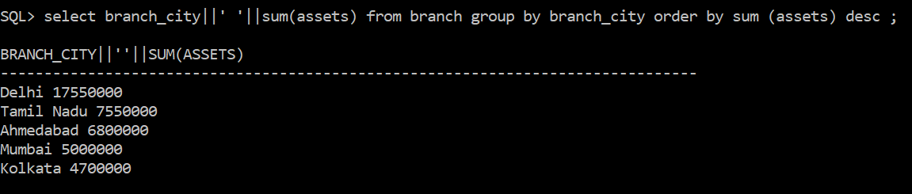

17. Display borrower names with total loan amount taken.

**select b.customer_name||' '||sum(l.amount) from borrower b , loan l where b.loan_id=l.loan_number group by b.customer_name ;**

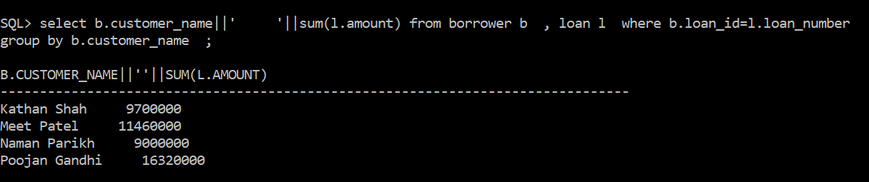

18. Display details of the customers who are depositors as well as borrower.

**select distinct c.customer_name ||' '|| c.customer_street ||' '|| c. customer_city ||' '||aadharid from customer c,borrower b, depositer d where c.customer_name=d.customer_name or c.customer_name=b.customer_name;**

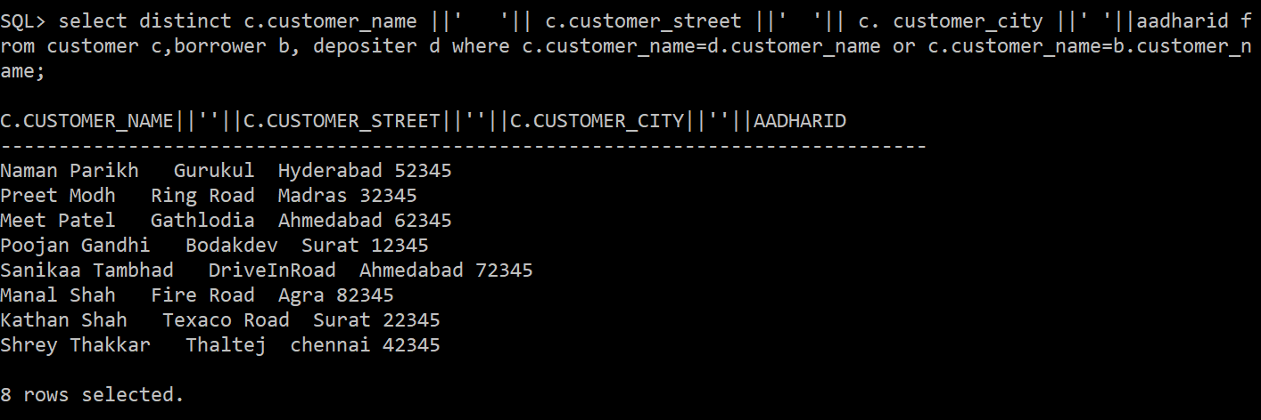

20. Display union of branch and account. (Use “union” operator)

**select branch_name from branch union select branch_name from bank_account;**

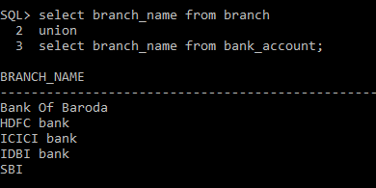

2ND TABLE

1. Add constraints:
   * + 1. Credits in course table should be minimum 1.5 and maximum 4.5

**alter table course add constraint check_credits check (credits>=1.5 and credits<=4.5);**

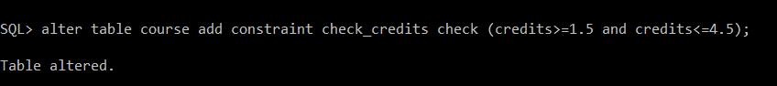

* + - 1. Budget in department table can’t exceed Rs. 10,000.

**alter table department add constraint budget_max check(budget<=10000);**

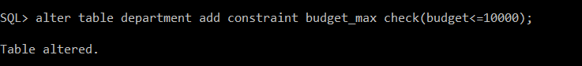

* + - 1. Salary in instructor table should be more than 0.

**alter table instructor add constraint salary_min check(salary>0);**

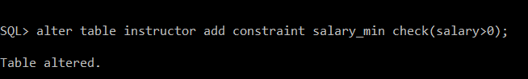

1. Default constraints

i. 1.5 credits in course table.

**alter table course modify credits default 1.5;**

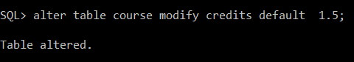

ii. 120 capacity in classroom table.

**alter table classroom modify capacity default 120;**

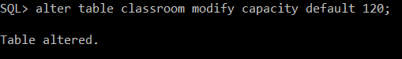

iii. 2019 (Don’t set value directly. Extract year from current date)

1. Unique constraints:

i. Dept_name in student table.

**alter table student modify dept_name unique;**

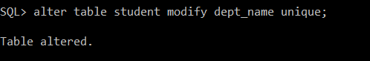

ii. Dept_name in instructor table.

**alter table instructor modify dept_name unique;**

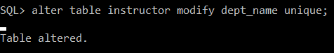

1. NOT NULL

i. Capacity in classroom table.

**alter table classroom modify capacity not null;**

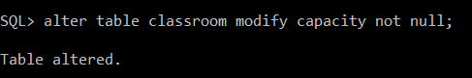

ii. Year in teaches table

**alter table teaches modify year not null;**

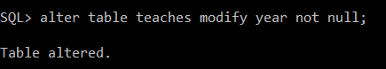

1. Create a new course “CS-001”, titled “Weekly Seminar”, with 2 credits.

**insert into course values('CS-001','Weekly Seminar','CSE',2);**

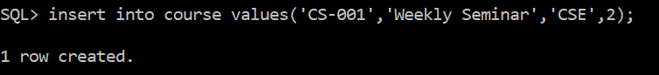

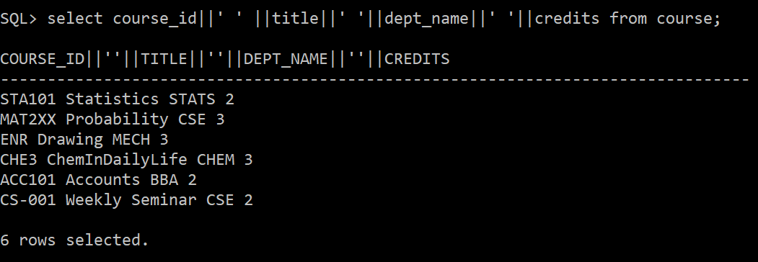

1. Create a section of the course “CS-001” in Autumn 2009, with sec_id of 1

**insert into section values('CS-001',1,3,2009,'SEAS',401,1);**

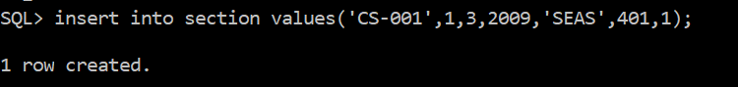

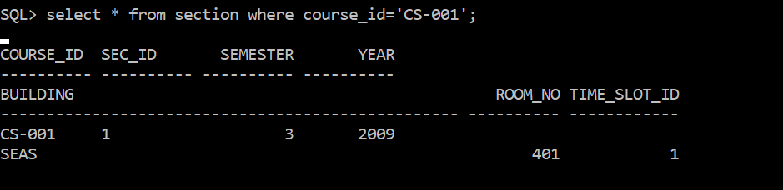

1. Enroll every student in the Comp. Sci. department in section 1.

**insert into takes (id, course_id, sec_id, semester, year,grade) select id,'CS-001',1,3,2009,'A+' from student where dept_name='CSE';**

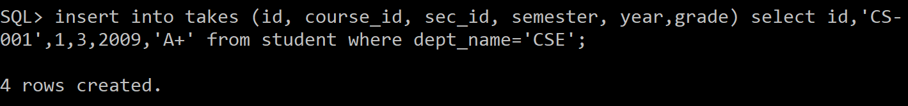

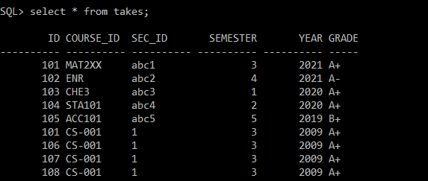

1. Delete enrollment in section 1 where student name is Chiral

**delete from takes where id in (select id from student where name='Chiral') and sec_id='1';**

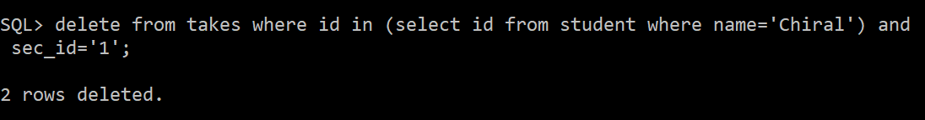

1. Delete all “takes” tuples corresponding to any section of any course with the word “database” as a part of the title, ignore case when matching the word with the title.

**delete from takes where course_id in (select course_id from course where lower(title) like '%database%');**

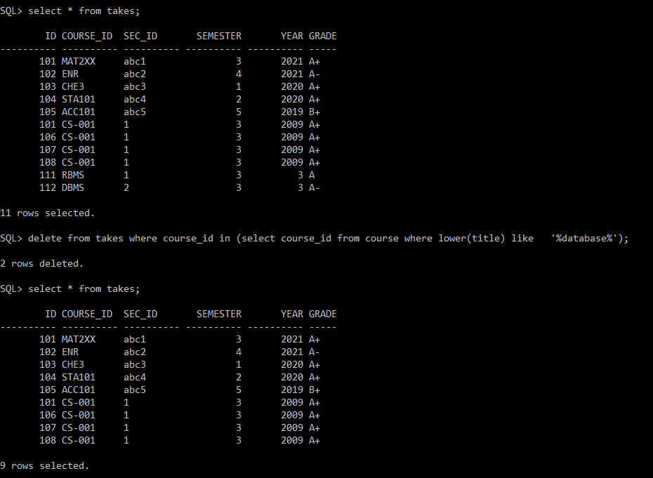

1. Drop “foreign key” constraint from “prereq” table.

* **select constraint_name from user_constraints where table_name = 'PREREQ' and constraint_type = 'R';**
* **alter table prereq drop constraint SYS_C007100;**

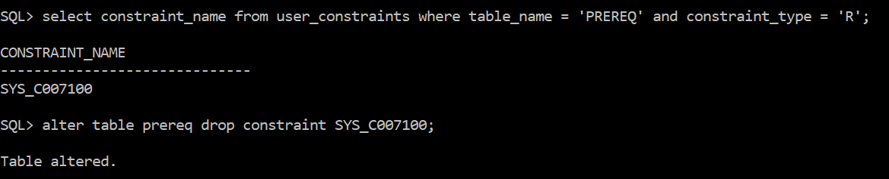

1. Add one field sr_no “prereq” table and make it a primary key.

**alter table prereq add sr_no int primary key;**

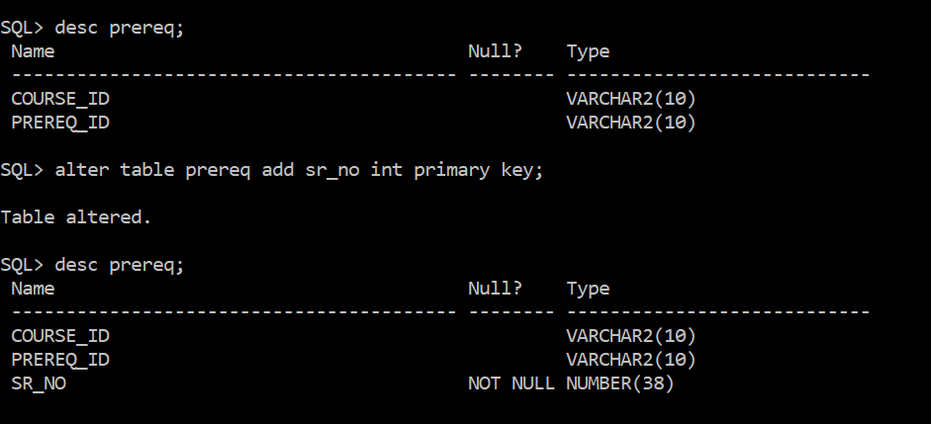

1. Rename “name” field of student table to “std_name”.

**alter table student rename column name TO std_name;**

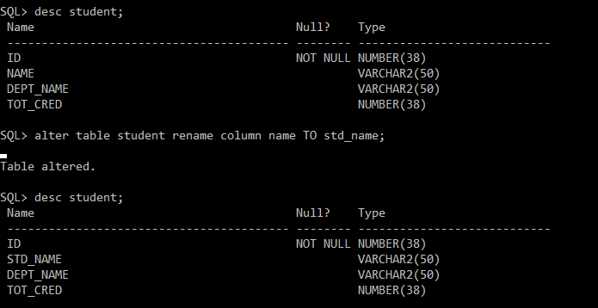

1. Drop unique constraint from “dept_name” field of instructor table.

**alter table instructor drop unique (dept_name);**

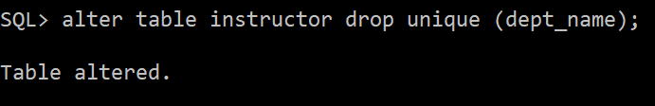

1. Drop not null constraint from “capacity” field of “classroom” table.

**alter table classroom modify capacity null;**

