**WEEK – 2**

**PLSQL_Exercises**

**Exercise 1: Control Structures**

**CODE:**

CREATE TABLE customers (

    customer_id NUMBER PRIMARY KEY,

    name VARCHAR2(100),

    age NUMBER,

    interest_rate NUMBER,

    balance NUMBER,

    is_vip CHAR(1)

);

INSERT INTO customers VALUES (1, 'Pooja', 65, 7.5, 12000, 'N');

INSERT INTO customers VALUES (2, 'Raj', 45, 8.0, 8000, 'N');

INSERT INTO customers VALUES (3, 'Anu', 70, 6.5, 15000, 'N');

SELECT * FROM customers;

**SCENARIO – 1:**

BEGIN

    FOR rec IN (SELECT customer_id FROM customers WHERE age > 60) LOOP

        UPDATE customers

        SET interest_rate = interest_rate - 1

        WHERE customer_id = rec.customer_id;

    END LOOP;

END;

/

SELECT * from CUSTOMERS;

**SCENARIO – 2:**

BEGIN

    FOR rec IN (SELECT customer_id FROM customers WHERE balance > 10000) LOOP

        UPDATE customers

        SET is_vip = 'Y'

        WHERE customer_id = rec.customer_id;

    END LOOP;

END;

/

select * from customers;

**SCENARIO – 3:**

CREATE TABLE loans (

    loan_id NUMBER PRIMARY KEY,

    customer_id NUMBER,

    due_date DATE

);

INSERT INTO loans VALUES (1, 1, SYSDATE + 15);

INSERT INTO loans VALUES (2, 2, SYSDATE + 40);

INSERT INTO loans VALUES (3, 3, SYSDATE + 5);

BEGIN

    FOR rec IN (

        SELECT l.loan_id, c.name, l.due_date

        FROM loans l

        JOIN customers c ON l.customer_id = c.customer_id

        WHERE l.due_date <= SYSDATE + 30

    ) LOOP

        DBMS_OUTPUT.PUT_LINE('Reminder: Loan ID ' || rec.loan_id ||

                             ' for customer ' || rec.name ||

                             ' is due on ' || TO_CHAR(rec.due_date, 'DD-Mon-YYYY'));

    END LOOP;

END;

**OUTPUT:**

**Table:**

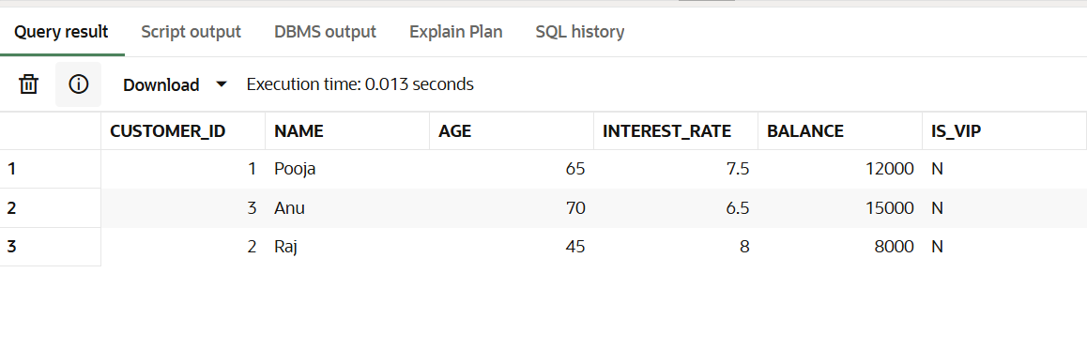

**Scenario – 1:**

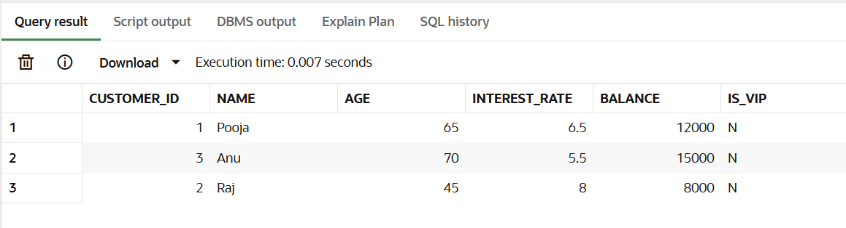

**Scenario – 2:**

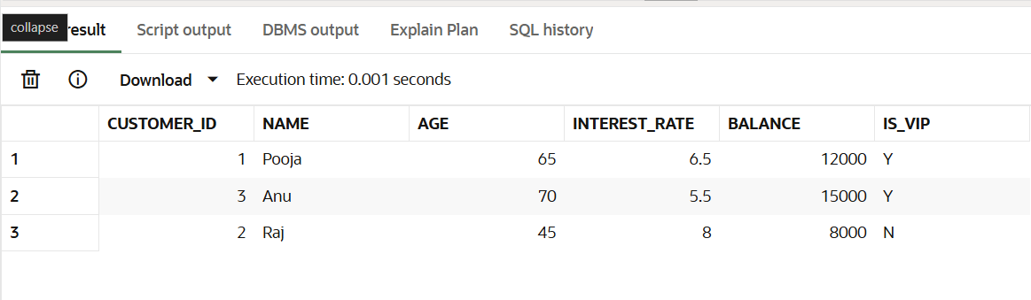

**Scenario – 3:**

