**WEEK – 3**

**MICROSERVICES WITH SPRING BOOT 3 AND SPRING CLOUD**

**CREATING MICROSERVICES FOR ACCOUNT AND LOAN**

**ACCOUNT:**

**AccountController.java:**

package com.cognizant.account;

import org.springframework.web.bind.annotation.*;

*@RestController*

*@RequestMapping*("/accounts")

public class AccountController {

*@GetMapping*("/{number}")

public Account getAccount(*@PathVariable* String number) {

return new Account("00987987973432", "savings", 234343);

}

}

class Account {

private String number;

private String type;

private double balance;

public Account(String number, String type, double balance) {

this.number = number;

this.type = type;

this.balance = balance;

}

public String getNumber() {

return number;

}

public String getType() {

return type;

}

public double getBalance() {

return balance;

}

}

**LOAN:**

**LoanController.java:**

package com.cognizant.account;

import org.springframework.web.bind.annotation.*;

*@RestController*

*@RequestMapping*("/accounts")

public class AccountController {

*@GetMapping*("/{number}")

public Account getAccount(*@PathVariable* String number) {

return new Account("00987987973432", "savings", 234343);

}

}

class Account {

private String number;

private String type;

private double balance;

public Account(String number, String type, double balance) {

this.number = number;

this.type = type;

this.balance = balance;

}

public String getNumber() {

return number;

}

public String getType() {

return type;

}

public double getBalance() {

return balance;

}

}

**OUTPUT:**

**ACCOUNT:**

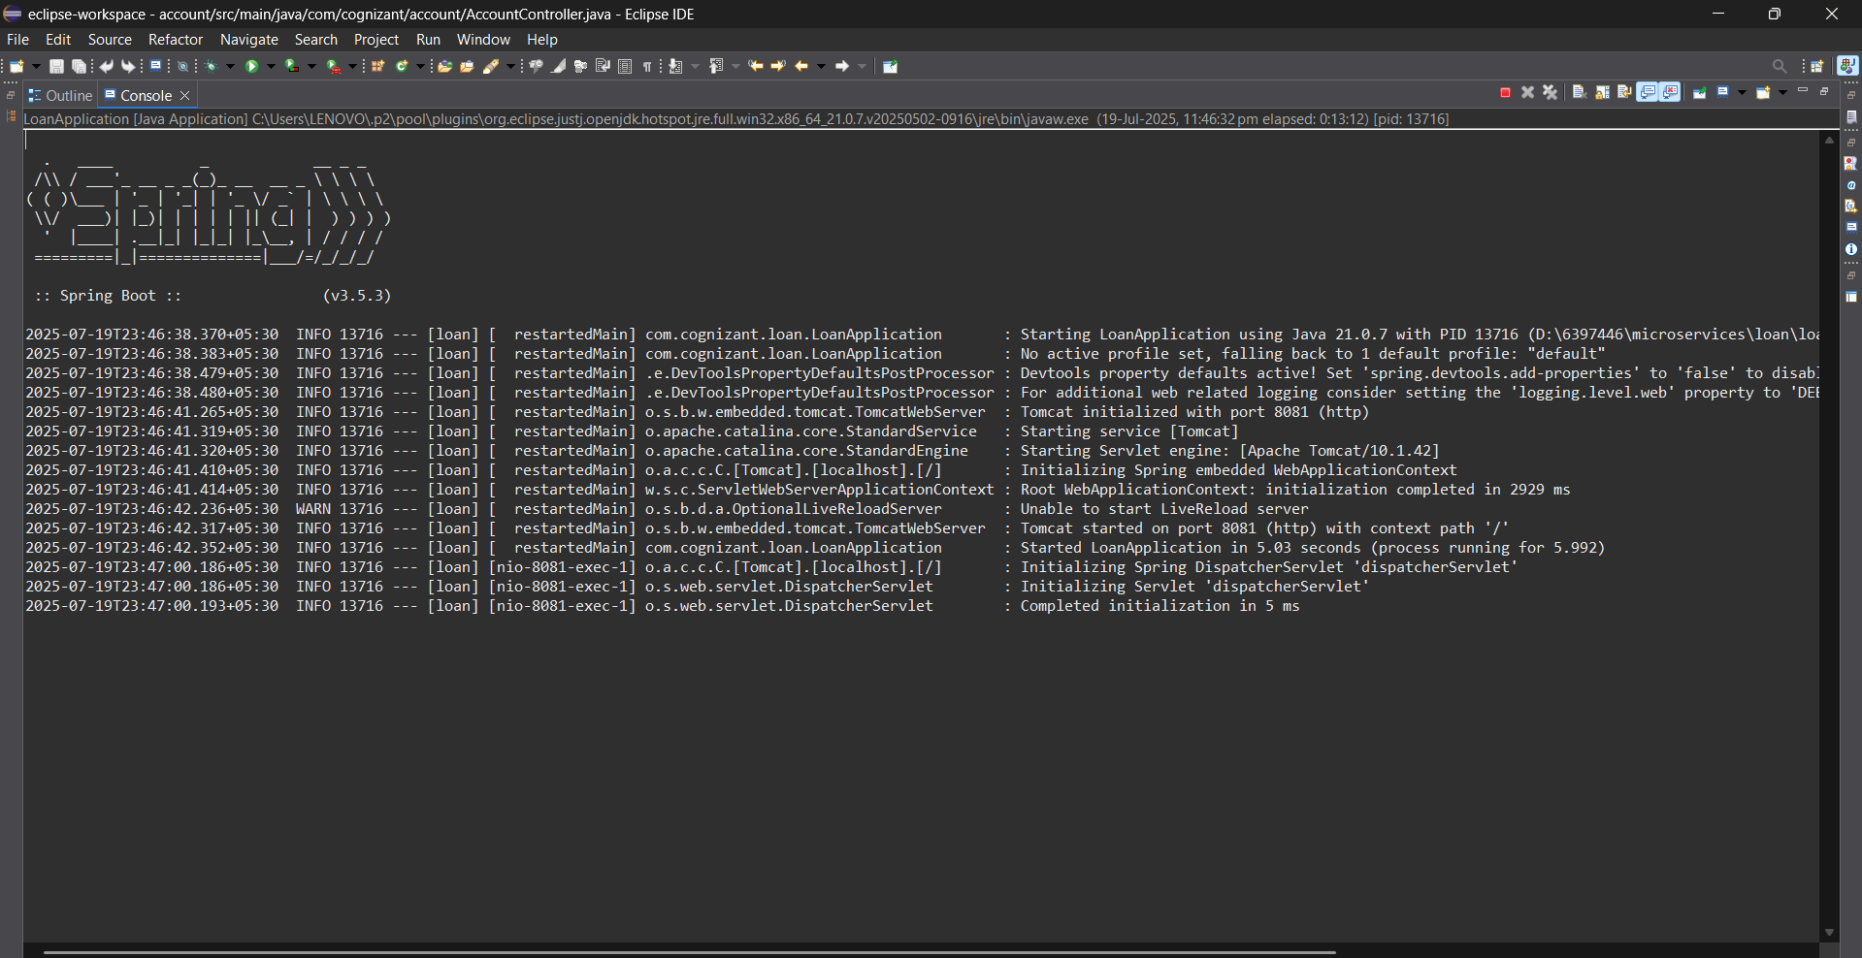

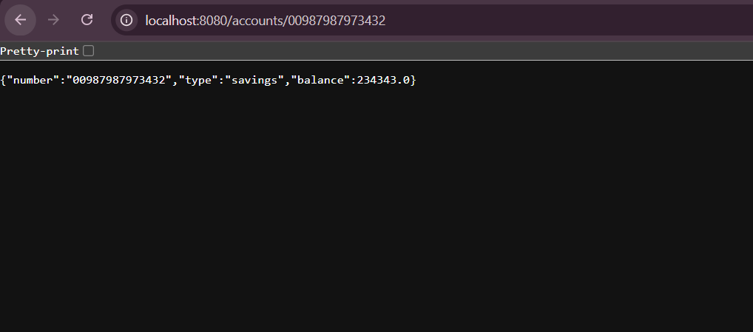

**LOAN:**



