

A Project Report On

**Online Book Store**

**By**

**Pooja Pangarkar**

**Batch:** 2022 – 7400

**Center: Mumbai**

Under the Guidance of,

**Chittaranjan Ghosh.**

**Technical Trainer**

**EduBridge**

(School of coding)

## Introduction:

Java is a **programming language** and a **platform**. Java is a high level, robust, object-oriented and secure programming language.

The primary objective of Java language creation was to make it portable, simple and secure programming language. Object-Oriented Programming is a paradigm that provides many concepts, such as **inheritance**, **data binding**, **polymorphism**, etc. Java is a general-purpose, concurrent, class-based, object-oriented computer programming language that is specifically designed to have as few implementation dependencies as possible. Java can be used to write applications and applets. A Java application is similar to any other high-level language program: It can only be compiled and then run on the same machine. An applet is compiled on one machine, stored on a server in binary, and can be sent to another machine over the Internet to be interpreted by a Java-aware browser. Java comes with a large library of ready-made classes and objects. Java supports object-oriented programming techniques that are based on a hierarchy of classes and well-defined and cooperating objects. Classes: A class is a structure that defines the data and the methods to work on that data. When you write programs in Java, all program data is wrapped in a class, whether it is a class you write or a class you use from the Java API libraries. Classes in the Java API libraries define a set of objects that share a common structure and behavior.

**Features of Java:**

1. Compiled and Interpreted

2. Platform Independent and portable

3. Object-oriented

4. Robust and secure

5. Distributed

6. Familiar, simple and small

7. Multithreaded and Interactive

8. High performance

9. Dynamic and Extensible

**Object In Java:**

An entity that has state and behavior is known as an object.

Object has three characteristics:

* State**:** represents the data (value) of an object.
* Behavior**:** represents the behavior (functionality) of an object such as deposit, withdraw, etc.
* Identity**:** An object identity is typically implemented via a unique ID. The value of the ID is not visible to the external user. However, it is used internally by the JVM to identify each object uniquely.

**Class In Java:**

A class is a group of objects which have common properties. It is a template or blueprint from which objects are created. It is a logical entity. It can't be physical.

A class in Java can contain:

* Fields
* Methods
* Constructors
* Blocks
* Nested class and interface

**Methods In Java:**

In Java, a method is like a function which is used to expose the behavior of an object.

#### Advantages Of Method :

* Code Reusability
* Code Optimization

**Constructor:**

In [Java](https://www.javatpoint.com/java-tutorial), a constructor is a block of codes similar to the method. It is called when an instance of the [class](https://www.javatpoint.com/object-and-class-in-java) is created. At the time of calling constructor, memory for the object is allocated in the memory. It is a special type of method which is used to initialize the object. Every time an object is created using the new() keyword, at least one constructor is called.

**Mini-Project Topic: Online Book Store**

## Introduction:

Book Store Management System is a simple console-based Beginner

level application. It can store and manage the information of books.

it carries all important information about book such as the name, author,

price, description etc. We can view available books and we can also buy

books.

. **Modules:-**

* Book Module
* User Module
* BookStore Module

**Software Requirements:**

**Platform Used:** Eclipse IDE

**Operating System:** Window

**Front end:** Java.

# Screenshots:-

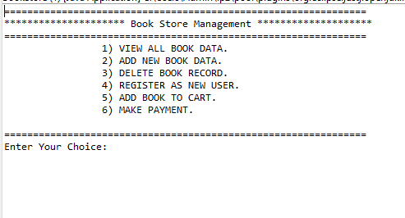

Fig 1: All Function

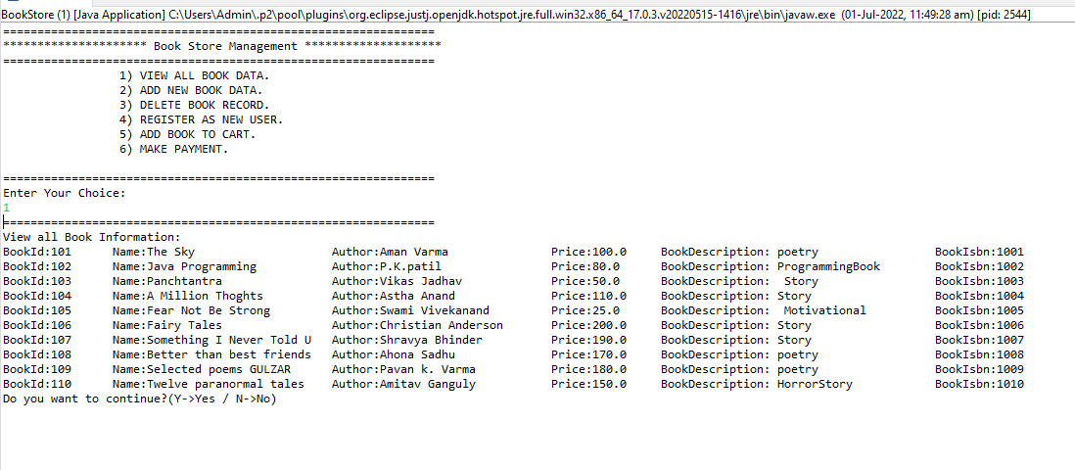

Fig 2: View All Books

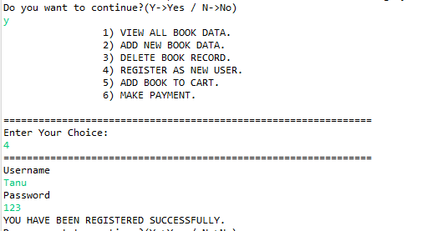

Fig 3: Register Method

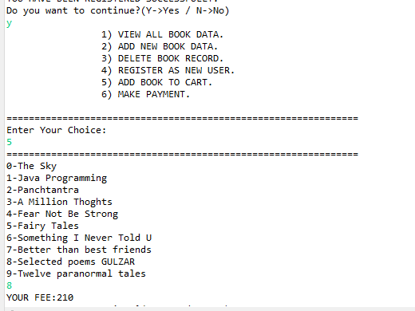

Fig 4: Add To Cart Method

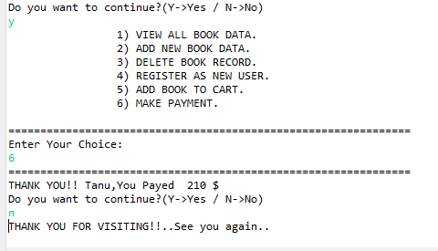

Fig 5: Pay Method

**Thank you…..**