#created table

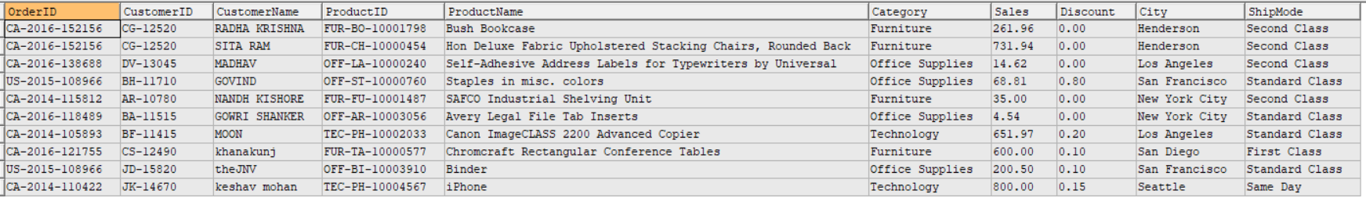

# 1.Top Sales per Customer

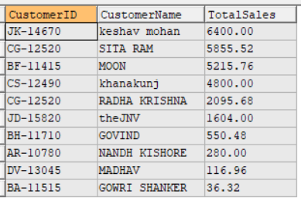

# 2.Average Discount by Product Category

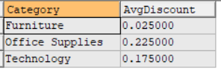

# 3.Top 5 Cities by Total Sales

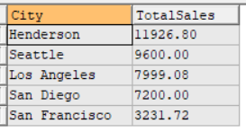

# 4.Product with sales greater than $5000

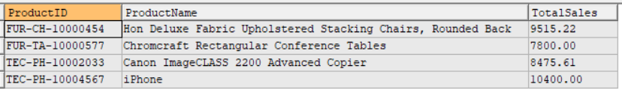

# 5.Number of Orders per Shipping Mode

