Install GIT & make sure it is added into PATH.

Section 0 -Use GIT as local VCS. Steps to follow:

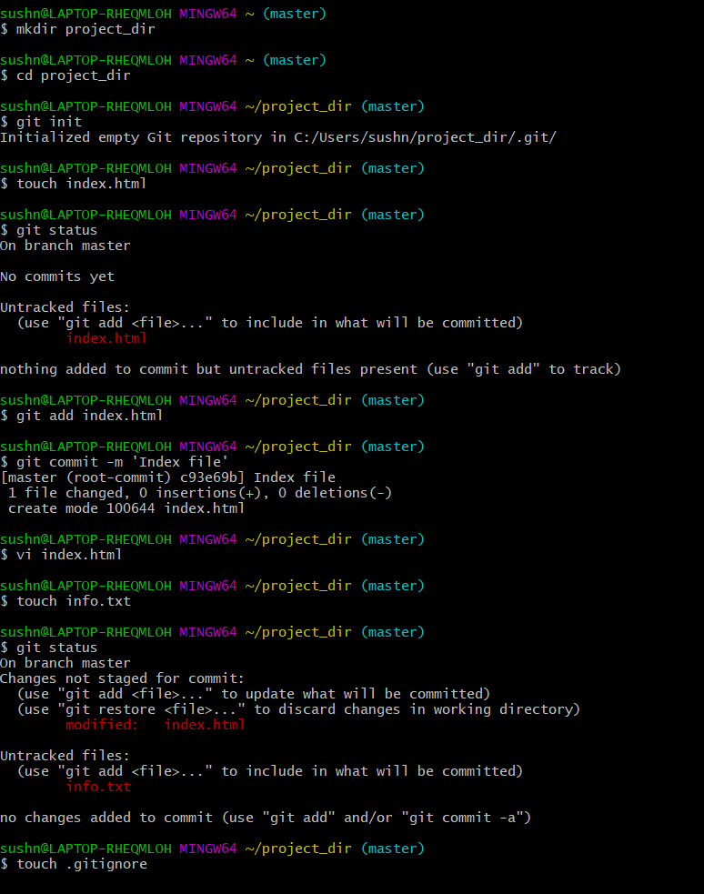

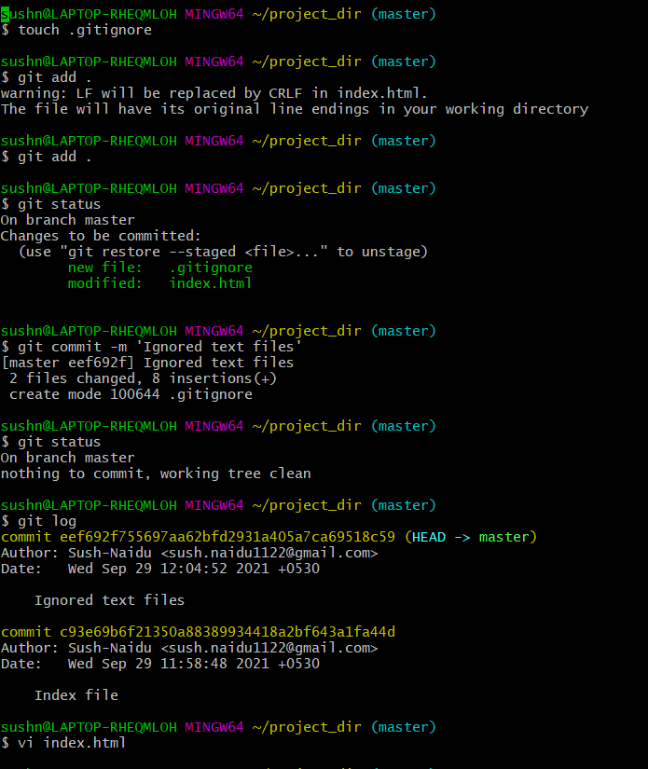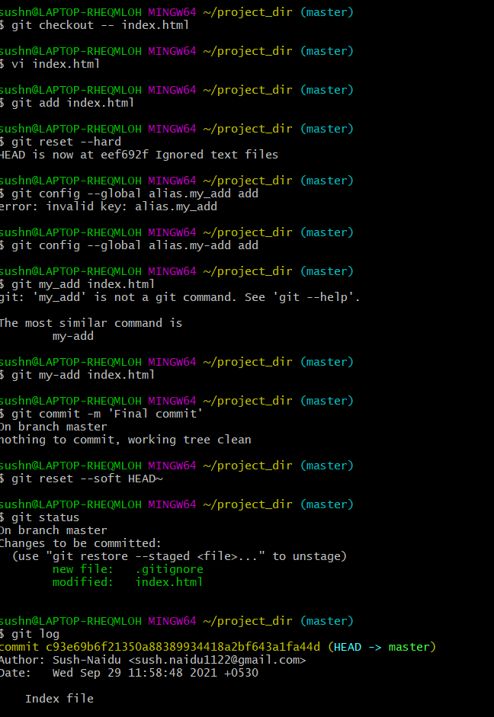

*GIT Branching*

Objective: Commit HTML, CSS & JavaScript assignments into GIT.

SECTION-1 (HTML assignments) – Steps to follow:

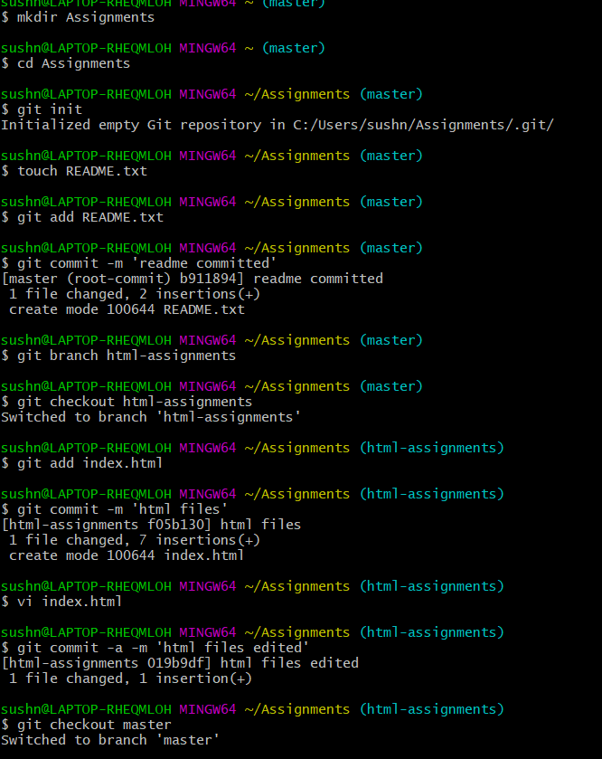

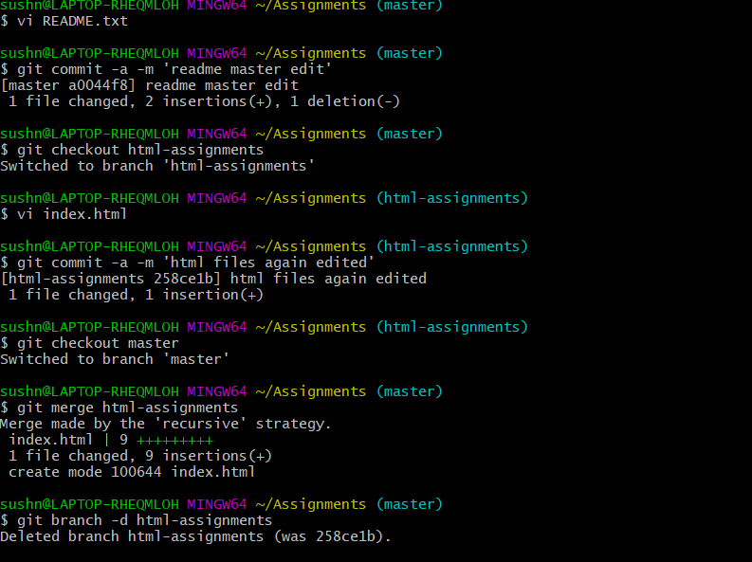

SECTION-2 - (CSS assignments) Steps to follow: 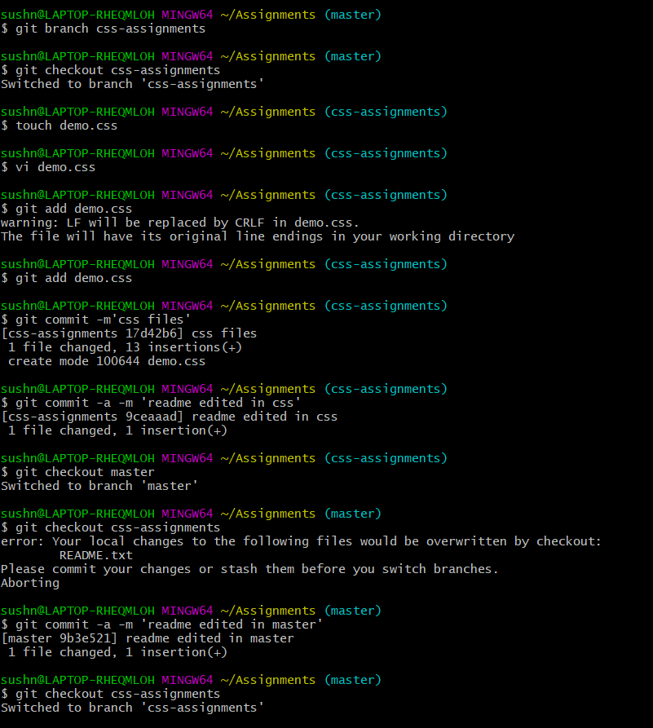

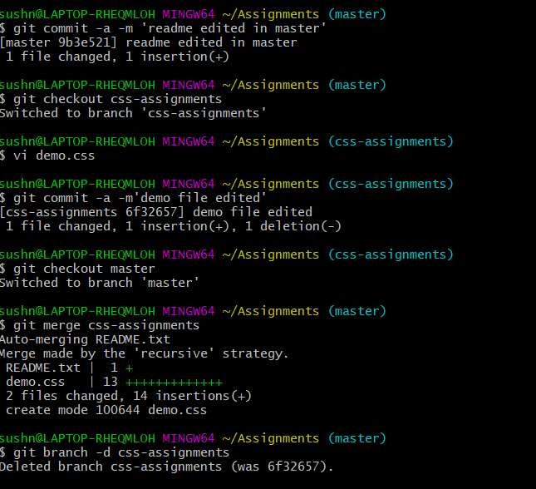

SECTION-3 - (JavaScript assignments) Steps to follow:

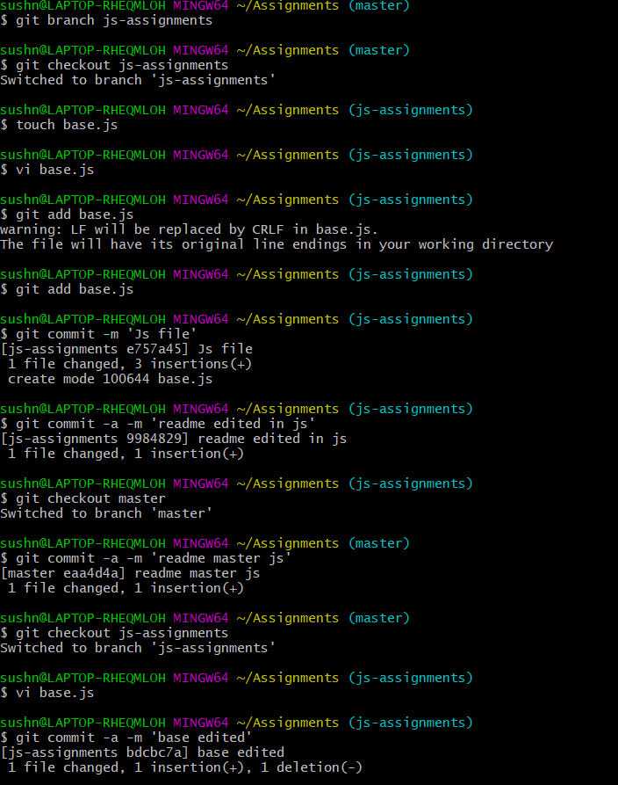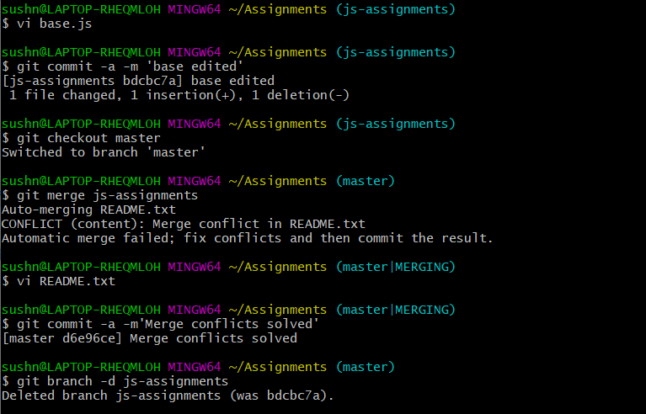

*GIT Remoting*

Objective: Pushing source code into GITHUB & collaborate team members.

SECTION-3 (Pushing assignments to remote repository) - Steps to follow:

