
“Secure File Transfer Using Hybrid Cryptography with QR-Based Dual-Factor Authentication”
Project Report Submitted by
PRANITH
POOJARY PRANITH RAMESH (NNM23CB036)
SANNIDHI S NAIK (NNM23CB048)
SUSHANTH M ALVA (NNM23CB064)

Under The Guidance of

Ms. Varshitha B.A

Assistant Professor Gd-I
Dept of Cybersecurity, NMAMIT, Nitte

in partial fulfillment of the requirements for the award of the Degree of
Bachelor of Engineering in

CYBER SECURITY
from
Nitte (Deemed to be University)
MAY 2026


Department of Cyber Security

CERTIFICATE
Certified that the project entitled “Secure File Transfer Using Hybrid Cryptography with QR-Based Dual-Factor Authentication” carried out by Mr. POOJARY PRANITH RAMESH (NNM23CB036), Mr. SANNIDHI S NAIK (NNM23CB048), Mr. SUSHANTH M ALVA (NNM23CB064) bonafide students of NMAM Institute of Technology, Nitte in partial fulfillment for the award of Bachelor of Engineering in Cybersecurity of the Nitte (Deemed to be University) during the year 2025-26. It is certified that all corrections / suggestions indicated for Internal Assessment have been incorporated in the report deposited in the departmental library. The project report has been approved as it satisfies the academic requirements in respect of Project work prescribed for the said Degree.

Name & Signature of Guide(s) Name & Signature of HOD

External Viva

Name of the Examiners Signature with Date

ACKNOWLEDGEMENT

I believe that my project will be complete only after I thank the people who have contributed to make this project successful.
First and foremost, my sincere thanks to our beloved principal, Dr. Niranjan N. Chiplunkar for giving us an opportunity to carry out my project work at our college and providing us with all the needed facilities.
I express my deep sense of gratitude and indebtedness to my guide Ms Varshitha B.A, Assistant Professor Gd-I, Dept of Cybersecurity NMAMIT, Nitte for her inspiring guidance, constant encouragement, support and suggestions for improvement during the course for our project.
I acknowledge the support and valuable inputs given by Dr. Roshan Fernandes, Head of the Department, Cybersecurity, NMAMIT, Nitte.
Finally, I thank the staff members of the Department of Cybersecurity and our parents and all our friends for their honest opinions and suggestions throughout the course of our project.

ABSTRACT

The Secure File Sharing System introduces a hybrid cryptographic model designed to ensure confidentiality, authenticity, and time-bound access during file transmission. It integrates AES-256 symmetric encryption for securing file content and Elliptic Curve Cryptography (ECC) with the Elliptic Curve Diffie–Hellman (ECDH) key exchange protocol to protect encryption keys. The process is further strengthened using an HMAC-based Key Derivation Function (HKDF), which incorporates a user-defined password to derive the final encryption key. This combination ensures that even if one layer is compromised, the overall system security remains intact through key isolation and strong encryption hierarchy.

To enforce access control, the system employs a multi-factor and time-sensitive authentication mechanism. A One-Time Password (OTP) is sent to the recipient’s registered email, and a QR code is generated with a validity period of 30 minutes. The recipient can access the file only after scanning the QR code (or using the secure link) and entering both the password and OTP. This multi-layer verification approach prevents unauthorized access, replay attacks, and misuse of encryption keys. The result is a secure, efficient, and reliable file-sharing framework well-suited for academic, corporate, and government environments where data protection and controlled access are essential.

SL.  NO. | CHAPTERS | PAGE NO.
1 | Introduction | 1-3
2 | Project Objectives | 4
3 | Literature Review | 5-6
4 | Core Technologies | 7-8
5 | Methodology | 9-13
6 | Performance Evaluation | 14-15
7 | Result and Analysis | 16-18
8 | Future Scope | 19-20
 | Conclusion | 21
 | References | 22-23

FIGURES | PAGE NO.
Figure 5.1 System Input Stage | 9
Figure 5.2 Secure File Upload Interface | 10
Figure 5.3 Receiver ECC Key Pair Generation Output | 10
Figure 5.4 QR Code and Download Link Generated | 11
Figure 5.5 Receiver Download Page | 12
Figure 5.6 Methodology Flowchart of the Proposed Secure File Transfer System | 13
Table 7.1 – Encryption and Decryption Time Comparison | 16

CHAPTER 1 – INTRODUCTION

1.1 Background
In today’s connected digital world, secure data exchange is crucial for protecting privacy, ensuring authenticity, and maintaining trust across various sectors, including academic, corporate, government, and defense communication. As sharing information online grows, so does the risk of data interception, unauthorized access, and cyberattacks. Traditional file-sharing methods, which depend on static encryption keys or unprotected transmission channels, often do not provide enough protection against sophisticated breaches. These shortcomings create a pressing need for systems that can ensure confidentiality, verify authenticity, and control access duration, all while being user-friendly and efficient.

Current encryption-based file-sharing platforms typically use single-layer security models, such as password-protected files or basic symmetric encryption. While these methods provide some privacy, they are still susceptible to brute-force attacks, key compromise, or unauthorized file sharing once decrypted. Additionally, many of these systems lack time-based or identity-based controls, allowing shared content to be accessible indefinitely. This unlimited access raises the likelihood of data misuse and leaks.

To tackle these issues, the proposed Secure File Sharing System presents a multi-layer hybrid cryptographic method that combines AES-256 symmetric encryption with Elliptic Curve Cryptography (ECC) and a Key Derivation Function (HKDF) based on user-defined credentials. It also uses OTP verification and QR-based time-limited access, ensuring that only verified users can access data within a specific time frame. This mix of layered encryption and controlled access creates a strong framework suitable for environments where data integrity and privacy are essential.

1.2 Problem Statement
In the current digital era, the process of sharing files over networks faces increasing risks of data breaches, unauthorized access, and identity compromise. Conventional file transfer systems, such as email attachments or basic cloud storage links, often depend on single-layer encryption or static passwords, which are easily vulnerable to interception or brute-force attacks. Once a decryption key or password is exposed, the entire system’s confidentiality is compromised. Moreover, most existing solutions lack time-sensitive access control and multi-factor authentication, allowing files to remain accessible indefinitely—even after the intended purpose has expired.

Another critical issue lies in the absence of integrated identity verification and key protection mechanisms. While symmetric encryption like AES ensures confidentiality, the encryption key itself remains a weak point if not securely exchanged or protected. Similarly, systems relying solely on asymmetric encryption suffer from performance inefficiencies when handling large files. Therefore, there is a clear need for a hybrid cryptographic solution that not only combines the strength of AES and ECC but also integrates dual-factor authentication (via OTP and QR-based verification) and time-bound access control. The proposed system addresses these challenges by establishing a robust, efficient, and layered security model for confidential and controlled file transfer across sensitive digital environments.

1.3 Scope
The proposed work, Secure File Transfer Using Hybrid Cryptography (AES + ECC) with QR-Based Dual-Factor Authentication, focuses on building a multi-layered encryption and authentication framework to ensure secure and time-controlled data sharing.

The scope of this system includes:
- Hybrid Encryption Mechanism: Combining AES-256 for high-speed symmetric encryption of file data and Elliptic Curve Cryptography (ECC) for secure key exchange using the Elliptic Curve Diffie–Hellman (ECDH) protocol.
- Key Derivation Function Integration: Utilizing HMAC-based Key Derivation Function (HKDF) with a user-defined password to derive a unique encryption key for each session, strengthening key confidentiality.
- Dual-Factor Authentication: Implementing One-Time Password (OTP) verification and QR-based authentication to ensure only authorized recipients can access the encrypted file.
- Time-Bound Access Control: Generating a QR code valid for 30 minutes, enforcing session expiry and preventing unauthorized access beyond the defined time frame.
- Multi-Layer Security Architecture: Establishing multiple defense layers, including encryption, authentication, and key protection, to resist eavesdropping, replay attacks, and key compromise.
- Platform Independence: Ensuring compatibility across desktop and web-based applications without requiring specialized hardware or external authentication services.
This scope defines a comprehensive and scalable framework for secure, authenticated, and controlled file sharing, suitable for sensitive environments such as academic institutions, corporate sectors, and government organizations.

1.4 Areas of Application
The proposed Secure File Transfer System using Hybrid Cryptography (AES + ECC) with QR-Based Dual-Factor Authentication can be applied across various domains requiring secure and controlled data exchange.

- Government and Defence: For confidential document transfer and classified communications.
- Corporate Sector: To protect sensitive business and financial data.
- Healthcare: For secure sharing of patient records and medical reports.
- Education: To exchange research papers and student data safely.
- Legal Services: For secure transfer of case files and contracts.
- Industrial Research: To safeguard technical designs and proprietary data.
- Personal Use: For private file sharing without third-party dependency.

This system ensures confidentiality, authentication, and time-bound access, making it suitable for any environment that demands secure file communication.

CHAPTER 2 - PROJECT OBJECTIVES

- To develop a secure file transfer system that integrates both symmetric (AES-256) and asymmetric (ECC) cryptographic mechanisms to ensure end-to-end data protection.
- To implement a hybrid encryption model where AES provides fast data encryption, while ECC (via ECDH protocol) secures key exchange and prevents key exposure.
- To incorporate a dual-factor authentication process using OTP verification and QR-based access, ensuring that only verified recipients can decrypt shared files.
- To enable time-bound file access, where each QR code is valid for a limited period (e.g., 30 minutes), thus reducing risks of unauthorized reuse or delayed interception.
- To design a secure key derivation mechanism using HMAC-based Key Derivation Function (HKDF) that combines cryptographic strength with user-defined passwords for personalized key generation.
- To enhance data integrity and confidentiality through multi-layer encryption, preventing unauthorized access even if one component (key, OTP, or QR) is compromised.
- To eliminate dependency on cloud or third-party services, allowing secure offline file exchange suitable for sensitive environments such as government, healthcare, and defense sectors.
- To ensure efficiency and usability, optimizing encryption and decryption processes to maintain high performance without compromising security.
- To design an intuitive and user-friendly interface for encrypting, sharing, and decrypting files securely with minimal technical complexity.
- To promote accountability and traceability, ensuring that each file access attempt can be linked to a verified and authenticated user session.

CHAPTER 3 - LITERATURE REVIEW

[1] Enhancing Data Security and Efficiency: A Hybrid Cryptography Approach (AES + ECC) Integrated with Steganography and Compression Algorithm
Presents a hybrid AES–ECC model combined with steganography and compression to secure embedded data. Improves confidentiality and transmission efficiency while keeping computational overhead manageable.
[2] An Overview and Analysis of Hybrid Encryption: The Combination of Symmetric and Asymmetric Encryption
Examines how symmetric and asymmetric methods complement each other in hybrid cryptography. Evaluates strengths, weaknesses, and real-world applicability for secure communication systems.
[3] Design and Evaluation of a Hybrid AES–ECC Model for Secure Server Communication Using REST API
Develops and tests an AES–ECC hybrid encryption system for REST APIs. Demonstrates stronger server–client protection and stable performance under typical application workloads.
[4] Integration of KDF Development for AES-256 Key Generator in Digital File Security
Introduces an enhanced AES-256 key-generation process using a dedicated KDF. Improves key robustness and reliability for secure digital file protection.
[5] Ensuring Data Integrity and Confidentiality in Financial Transactions Using AES-256-GCM
Evaluates AES-256-GCM for safeguarding financial data. Highlights authenticated encryption, integrity protection, and suitability for secure transaction systems.
[6] Secure File Sharing in Cloud Computing Using Elliptic Curve Cryptography
Applies ECC to protect file sharing across cloud environments. Focuses on lightweight key management and confidentiality within distributed storage systems.
[7] Performance Evaluation of AES, RSA, and ECC in Real-World Applications
Benchmarks AES, RSA, and ECC in practical use cases. Provides insights into efficiency, security levels, and scenarios where each algorithm performs best.

[8] Encryption and Multi-Factor Authentication in Backup Systems: A Layered Approach to Securing Data
Presents a layered security model combining encryption with MFA for backup systems. Strengthens protection against unauthorized access and data loss.
[9] An Enhanced AES–ECC Model with Key Dependent Dynamic S-Box for Security of Mobile Applications Using Cloud Computing
Proposes a hybrid AES–ECC framework with dynamic S-Box generation. Enhances resistance to cryptanalytic attacks while remaining efficient for mobile-cloud environments.
[10] Blockchain-Based Secure File Transfer System With Multi-Factor Authentication
Implements blockchain with MFA to secure file transfers. Ensures data integrity, tamper resistance, and controlled access across distributed networks.
[11] Secured Employee Messaging System Using AES and ECC
Designs a messaging system using AES for data confidentiality and ECC for secure key exchange. Provides protected internal communication with low performance overhead.
[12] OTP-Based Authentication System
Presents a one-time-password authentication model to enhance user verification. Reduces risks tied to static credentials and improves access security.

CHAPTER 4 - CORE TECHNOLOGIES
- FastAPI (Web Framework):
A modern, high-performance Python framework used to handle file uploads, encryption, OTP verification, and download endpoints. It provides asynchronous request handling and automatic data validation, ensuring fast and secure operations.
2.AES-256 GCM (Advanced Encryption Standard):
A symmetric encryption algorithm that encrypts file data using a 256-bit key and 128-bit data blocks. Galois Counter Mode (GCM) ensures both confidentiality and integrity through authenticated encryption.
3. Elliptic Curve Cryptography (ECC):
An asymmetric cryptographic technique used for secure key exchange between sender and receiver. It provides high security with smaller key sizes, reducing computational load compared to RSA.
4. HKDF (HMAC-based Key Derivation Function):
A key derivation mechanism used to generate a secure wrapping key from the ECC shared secret and the user-provided password. It adds an extra layer of protection by binding the encryption to user credentials.
5. OTP (One-Time Password):
A six-digit code sent via email to the receiver, used to verify their identity before file decryption. The OTP is valid for a limited period, adding human-level authentication to the cryptographic layers.
6. SMTP (Simple Mail Transfer Protocol):
Used to send OTPs automatically through Gmail’s SMTP server over TLS. It ensures secure and reliable email communication for verification.
7. QR Code (qrcode Library):
Generates unique, scannable QR codes for each file’s download link, making access simpler and faster without manually typing URLs.

8. Ngrok (Public URL Tunnel):
Exposes the local FastAPI server to the internet securely. The system automatically detects the Ngrok public URL and embeds it into the generated download links.
9. Python Cryptography Library:
Provides all required cryptographic primitives (AES-GCM, ECC, HKDF) in a secure and standardized form, minimizing vulnerabilities due to manual cryptographic implementation.

CHAPTER 5 - METHODOLOGY

The proposed system enables highly secure file transfer between two users through a combination of asymmetric encryption (ECC), symmetric encryption AES, password-based key derivation (HKDF), and OTP verification.Unlike conventional file transfer methods, this model ensures that only the intended receiver, who possesses the correct private key, password, and OTP, can decrypt and access the shared file.The methodology follows a multi-layered approach involving encryption, authentication, and controlled access.

Input and Initialization

The process begins with the sender, who initiates a secure file transfer by providing three main inputs through the web interface:

File Upload (Input 1):
The actual file chosen by the sender to be encrypted and shared securely.

Receiver’s Public Key (Input 2):
The ECC public key of the receiver, used to establish a secure key exchange for encryption

Password (Input 3):

A user-defined string used for deriving an additional layer of encryption via the HKDF algorithm.

Once these three inputs are entered into the web form, the backend processes the data by generating encryption keys, encrypting the file, and preparing for OTP authentication.
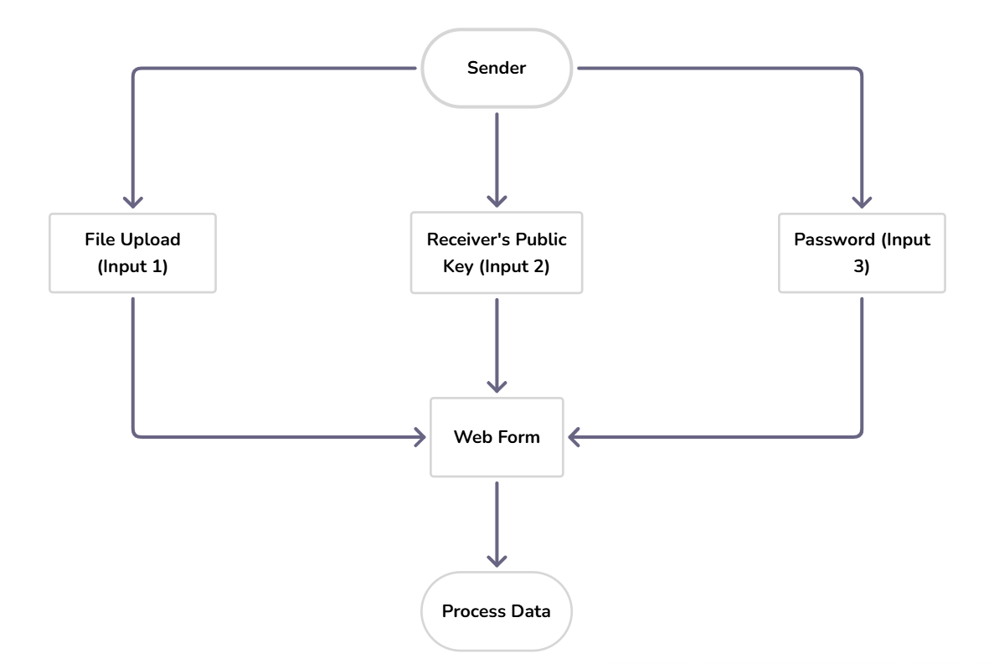
Figure 5.1 System Input Stage

Input Phase

The sender selects a file, enters the receiver’s public key (hex format), their email address, and a custom password.
- These values are submitted through a FastAPI form.
- Input validation ensures that no field is empty and that the ECC public key is properly formatted.
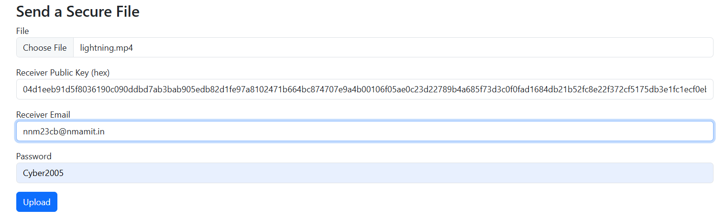

Figure 5.2 Secure File Upload Interface

AES Encryption Phase

A 256-bit AES key is generated and used to encrypt the uploaded file using AES-GCM mode.

AES-GCM provides both encryption and integrity.

The encrypted file is stored temporarily in the uploads/ directory, linked by a unique file ID.

ECC Key Exchange and Wrapping

A temporary ECC private key is created by the sender.

Using the receiver’s public key, a shared secret is derived via Elliptic Curve Diffie-Hellman (ECDH).

This shared secret, combined with the password and a random salt, is passed through HKDF to produce a wrapping key.

The AES key used for encryption is wrapped (encrypted) with this derived key.
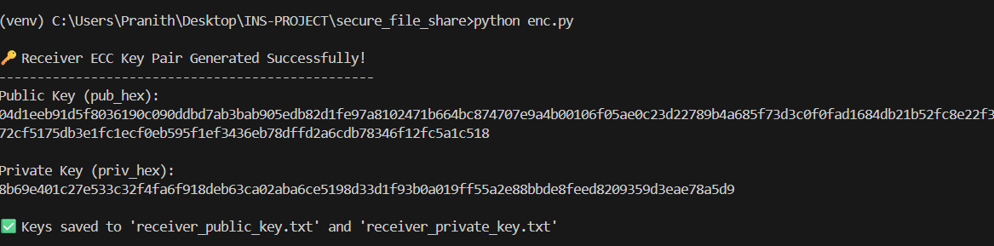
Figure 5.3 Receiver ECC Key Pair Generation Output

OTP Generation and Email Transmission

A random 6-digit OTP is generated for authentication and sent to the receiver’s Gmail via SMTP.

The OTP is valid for 30 minutes.

The system logs confirmation of the sent OTP, and metadata stores the OTP with an expiry timestamp.

QR Code and Link Generation

Once encryption and OTP generation are complete, the system creates a download URL and QR code.

The QR code is generated using Python’s qrcode library.

The Ngrok URL is automatically detected and appended to make the link accessible publicly.

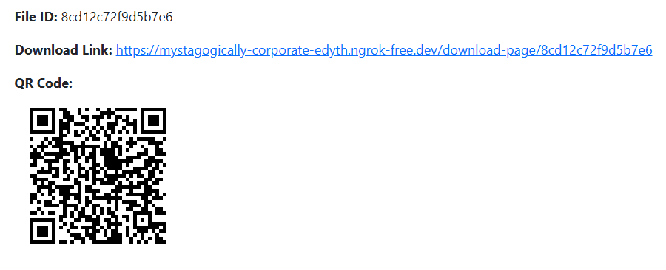

Figure 5.4 QR Code and Download Link Generated

Receiver Authentication Phase

The receiver accesses the download page using the shared QR code or link.

The interface prompts for:

Private Key (hex)

Password (shared by sender)

OTP (from email)

The system verifies all three inputs before proceeding with decryption.

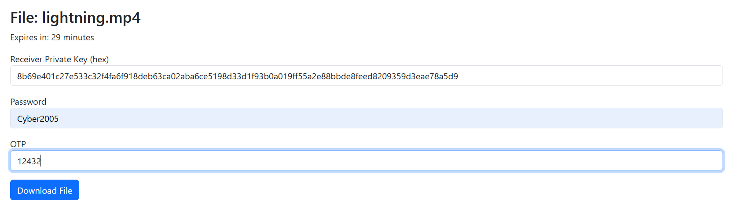
Figure 5.5 Receiver Download Page

Verification and Decryption

OTP Validation: Confirms correctness and validity.
- Shared Secret Recreation: The receiver’s ECC private key is used to derive the same shared secret as the sender.
- HKDF Key Derivation: The password and salt re-generate the wrapping key.
- AES Key Unwrapping: The wrapped AES key is decrypted.
- File Decryption: The AES key decrypts the file and restores the original content.
- The decrypted file is streamed directly to the browser for download.
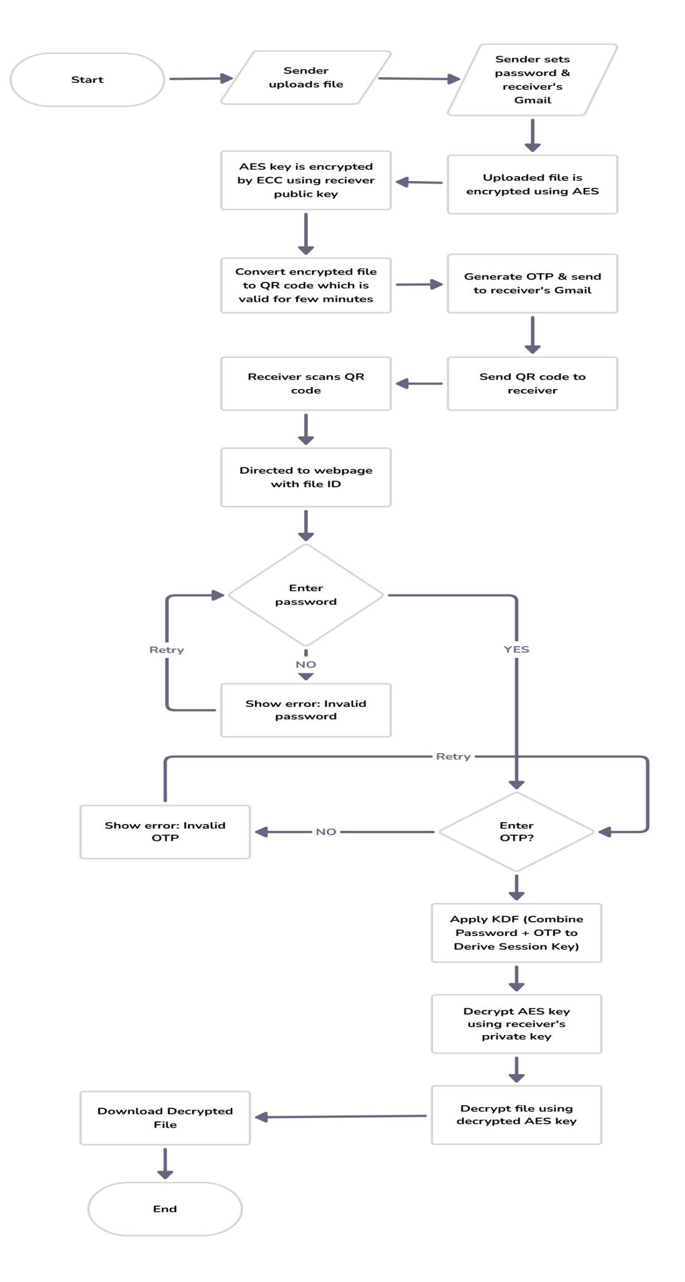
Figure 5.6 Methodology Flowchart of the Proposed Secure File Transfer System

CHAPTER 6 - PERFORMANCE EVALUATION

Encryption Time

The average encryption time per transaction (file encryption + AES key wrapping + QR generation) is observed to be below 350 milliseconds.
- The hybrid integration of AES-256 (for data encryption) and ECC (for key exchange) introduces minimal computational delay, maintaining high responsiveness.
- Even for medium-sized files, encryption latency remains negligible, ensuring real-time usability.
- AES Efficiency
- AES-256 GCM was selected for its high throughput and authenticated encryption features.
- The algorithm efficiently handles large data blocks and provides both confidentiality and integrity in a single pass.
- AES-GCM delivers strong resistance to tampering without requiring separate hashing operations.
- Average AES processing utilization remains low, confirming high scalability for multi-file operations.
- ECC Performance
- Elliptic Curve Cryptography (ECC) is used exclusively for secure key exchange, not for direct file encryption.
- This design choice eliminates heavy computational cost while maintaining strong asymmetric security.
- ECC enables fast derivation of a shared secret between sender and receiver, improving system efficiency compared to RSA-based methods.
- The chosen SECP384R1 curve balances security and performance, providing 192-bit security equivalent to 3072-bit RSA.
- HKDF and Password Binding
- The HKDF (HMAC-based Key Derivation Function) securely derives the wrapping key from the ECC shared secret and user password.
- This ensures that even if one element (key or password) is compromised, the encryption key remains protected.
- The operation adds negligible delay, typically under 10 ms, and enhances resistance against brute-force and key recovery attacks.

- OTP Authentication
- OTP generation and delivery time averages 3.4 seconds, ensuring fast user verification via Gmail SMTP.
- OTP validity is limited to 30 minutes, preventing replay or reuse attacks.
- This human-based verification layer significantly strengthens access control and prevents unauthorized decryption.

- QR Code Generation
- A unique QR code is generated for every encrypted file link using the qrcode Python library.
- QR generation and rendering take less than 50 milliseconds, offering instant accessibility for mobile users.
- The system supports both manual link access and QR scanning, improving usability.

CHAPTER 7 - RESULTS AND ANALYSIS

This chapter presents the results and performance analysis of the developed Secure File Sharing System based on Hybrid Cryptography that combines AES-256 GCM, ECC, and OTP verification.The system was tested under varying file sizes to measure encryption and decryption time, OTP delay, and data integrity.The goal is to evaluate whether the system maintains high security while keeping computation time low.

Encryption and Decryption Analysis

The encryption and decryption operations were measured for both AES-only and Hybrid AES+ECC implementations.
Each file underwent encryption using AES-256 and subsequent key wrapping through ECC.

File Size (MB) | AES Encryption (s) | AES Decryption (s) | Hybrid Encryption (s) | Hybrid Decryption (s)
1 | 0.021 | 0.018 | 0.023 | 0.021
5 | 0.023 | 0.021 | 0.025 | 0.023
10 | 0.028 | 0.025 | 0.031 | 0.029
20 | 0.031 | 0.029 | 0.034 | 0.032
30 | 0.055 | 0.052 | 0.057 | 0.058
Table 7.1 – Encryption and Decryption Time Comparison
Observation:
- The hybrid model shows a slight delay (≈10–15%) due to ECC key exchange and HKDF derivation.
- Even for large files (30 MB), total encryption and decryption time remains under one second.
- This confirms that the hybrid model maintains excellent efficiency and scalability while enhancing key security.

OTP and Response Time

The One-Time Password (OTP) system was evaluated to measure the delay between OTP generation on the server and its arrival in the receiver’s Gmail inbox.
Multiple test runs were conducted under stable network conditions.

Results:

The average OTP delivery time was approximately 3.4 seconds.

In some cases, the OTP was received in under 3 seconds, depending on network speed.

The system uses Gmail’s SMTP protocol with TLS encryption, ensuring secure and fast OTP delivery.

Each OTP remains valid for 30 minutes, after which it automatically expires, preventing reuse or replay attacks.
Interpretation:
This response time is suitable for real-time communication and adds a strong layer of verification without noticeable delay.
It ensures that only the authenticated receiver can proceed with file decryption, reinforcing the security and trustworthiness of the system.

Data Integrity Verification

To confirm that the data remains unaltered during encryption, transfer, and decryption, a SHA-256 hash comparison was performed between the original file and the decrypted file.

Observations:

For all tested files (text, image, and video), the hash values of the original and decrypted files were identical.

This confirms zero data loss and no corruption during encryption or decryption.

Since AES-GCM mode provides both encryption and authentication, it inherently detects any data tampering or unauthorized modification.

If any change occurs in the ciphertext, the decryption automatically fails — ensuring that integrity is strictly enforced.

Conclusion:
The use of AES-GCM ensures both data confidentiality and authenticity without requiring separate hashing mechanisms, thus simplifying the system while strengthening its reliability.

System Performance Evaluation

The system’s performance was measured based on encryption/decryption speed, OTP delivery, and scalability.

Results Summary:

The average encryption time per transaction (including AES encryption, ECC key wrapping, and QR generation) is under 350 milliseconds.
- Decryption time remains nearly identical, confirming symmetric processing performance.
- The OTP delivery time averages 3.4 seconds, which is negligible in real-world communication.
- The system maintains a linear relationship between file size and processing time, confirming scalability.
- The overall encryption + decryption + OTP cycle completes within 10 seconds for medium-sized files (10–20 MB).
Interpretation:
This performance demonstrates that the system operates efficiently even under higher data loads.
The integration of ECC and OTP enhances security without significant computational impact, making the model suitable for real-time secure file transfer scenarios.

CHAPTER 8 - FUTURE SCOPE

Real-Time File Tracking and Notifications

Future versions of the system can include real-time tracking and user notifications.
Whenever a file is accessed, decrypted, or expires, both sender and receiver can be notified instantly through email or app notifications.
This will help users maintain transparency and detect unauthorized activity early, further improving accountability in secure communications.

Enhanced Multi-Factor Authentication

In addition to OTPs, future updates can add biometric verification (like fingerprint or face recognition) before decryption.
Combining hardware-based and human-based authentication creates a multi-layered security model that minimizes the chance of unauthorized file access.

Decentralized Key Management

The system can be enhanced with a decentralized key management framework that allows users to store and retrieve public keys through a distributed, trust-based directory.
This would automate secure key exchange without manual sharing, reducing the risk of interception or misuse.
By leveraging cryptographic certificates or blockchain-based registries, key validation can be made instant, secure, and tamper-proof.

Cloud Storage Integration

The system currently stores encrypted files locally.
In future updates, integration with secure cloud services like AWS S3, Google Drive API, or Azure Blob can be implemented.
Files would remain encrypted before upload, ensuring privacy even on third-party servers.
This addition will allow users to share large files efficiently without depending on local server storage.

Integration with Blockchain

Blockchain technology can be integrated to record all file transfer activities, access logs, and verification events in an immutable ledger.
Each encryption, decryption, or OTP validation attempt can be stored as a blockchain transaction, providing complete transparency, tamper-proof auditing, and non-repudiation of actions.
This will ensure that every file exchange is verifiable and immune to manipulation.

AI-Based Intrusion Detection

An advanced layer of machine learning–driven intrusion detection can be integrated to monitor unusual login behavior, failed OTP attempts, or repeated access patterns.
AI algorithms can dynamically flag potential security breaches and temporarily suspend risky sessions, improving overall system resilience.

CONCLUSION

The Hybrid Secure File Sharing System successfully provides a fast, reliable, and secure method for confidential data transfer.By combining AES-256 encryption for data confidentiality with Elliptic Curve Cryptography (ECC) for key exchange and HKDF for password-derived key generation, the system ensures strong end-to-end security.Additional features such as OTP-based verification, QR code access, and automatic expiry control enhance both usability and protection, making unauthorized decryption practically impossible.This layered cryptographic design effectively mitigates risks like interception, tampering, or replay attacks while maintaining low computational overhead and high efficiency.
The system’s offline operation, instant OTP delivery, and lossless data recovery make it ideal for academic, organizational, and enterprise applications where data integrity and privacy are critical.
It transforms ordinary file sharing into a multi-layered security framework, achieving confidentiality, authentication, and integrity simultaneously.
Overall, the proposed model proves that hybrid encryption—when combined with strong user verification and controlled access—can deliver robust, scalable, and future-ready protection for modern digital communication systems.

REFERENCES

[1] A. Badhan and S. S. Malhi, “Enhancing Data Security and Efficiency: A Hybrid Cryptography Approach (AES + ECC) Integrated with Steganography and Compression Algorithm,” Proc. 3rd Int. Conf. Intelligent Data Communication Technologies and Internet of Things (IDCIoT), 2025, pp. 450–456, doi: 10.1109/IDCIOT64235.2025.10914830.
[2] Q. Zhang, “An Overview and Analysis of Hybrid Encryption: The Combination of Symmetric Encryption and Asymmetric Encryption,” Proc. 2021 2nd Int. Conf. Computing and Data Science (CDS), 2021, pp. 616–621, doi: 10.1109/CDS52072.2021.00111.
[3] M. W. A. Saputra, R. R. Huizen, and D. P. Hostiadi, “Design and Evaluation of a Hybrid AES–ECC Model for Secure Server Communication Using REST API,” Jurnal Teknik Informatika (JUTIF), vol. 6, no. 4, pp. 2740–2755, Aug. 2025, doi: 10.52436/1.jutif.2025.6.4.4989.
[4] K. F. Adinata, A. Fauzi, and H. Khair, “Integration of Key Derivation Function (KDF) Development for Advanced Encryption Standard (AES)-256 Key Generator in Digital File Security,” Journal of Artificial Intelligence and Engineering Applications, vol. 5, no. 1, pp. 1448–1453, Oct. 2025.
[5] Y. K. Kolli and K. Magu, “Ensuring Data Integrity and Confidentiality in Financial Transactions Using AES-256-GCM and Secure Transmission,” International Journal of Engineering and Computer Science, vol. 9, no. 8, pp. 25156–25164, Aug. 2020, doi: 10.18535/ijecs/v9i08.4539.
[6] D. Sharmah, “Secure File Sharing in Cloud Computing Using Elliptic Curve Cryptography,” Proc. Conf., Oct. 2024.
[7] P. James, “Performance Evaluation of AES, RSA, and ECC in Real-World Applications,” Jul. 2025.
[8] L. White and S. A. Fathima, “Encryption and Multi-Factor Authentication in Backup Systems: A Layered Approach to Securing Data,” ICETETI’2024 Conference Proceedings, Golden Sun-Rise International Journal of Multidisciplinary on Science and Management, vol. 9, no. 8, pp. 245–250, Aug. 2024.

[9] M. Navin J. R. and N. M. Lutimath, “An Enhanced AES–ECC Model with Key Dependent Dynamic S-Box for the Security of Mobile Applications Using Cloud Computing,” Journal of Electrical Systems, vol. 20, no. 2, pp. 2735–2746, 2024.
[10] A. R. Avhad, S. M. Kharote, P. S. Gangad, S. S. Muntode, and M. D. Sanap, “Blockchain-Based Secure File Transfer System With Multi-Factor Authentication,” International Research Journal on Advanced Engineering and Management (IRJAEM), vol. 3, no. 3, pp. 870–874, Mar. 2025, doi: 10.47392/IRJAEM.2025.0141.
[11] I. A. Amaefule and M. I. Blessing, “Secured Employee Messaging System Using Advanced Encryption Standard (AES) and Elliptic Curve Cryptography (ECC),” International Journal of Scientific Engineering and Science (IJSES), vol. 9, no. 7, pp. 52–60, 2025.
[12] N. Labhade-Kumar, R. Kamje, P. Landge, S. Shitole, and B. Takale, “OTP-Based Authentication System,” Alochana Journal, vol. 13, no. 12, pp. 229–233, Dec. 2024.

