**What is NGINX?**

It is free, open-source software that can be used as a web server, reverse proxy, load balancer and HTTP cache.

Based on asynchronous event-driven

Lightweight and high performance

Partially for windows and mostly for Linux

**Websites that use Nginx:**

Netflix, Hulu, Pinterest, CloudFlare, Airbnb, WordPress.com, GitHub, SoundCloud, Zynga, Eventbrite, Zappos, Media Temple, Heroku, RightScale, Engine Yard, StackPath, CDN77

**Diff btw windows and unix version:**

-there is no availability of:

* :XSLT filter
* :image filter
* :Geo IP module
* :Perl language

-less scalable

-low performance

**Latest version** : 1.23.3

**WHY?**



Also provides dynamic configuration : update the backend without disturbing the clients using the systems.

**es NGINX work ?**

**How do**

It means that similar threads are managed under one worker process, and each worker process contains smaller units called worker connections. This whole unit is then responsible for handling concurrent requests. Worker connections deliver the requests to a worker process, which will also send it to the master process. Finally, the master process provides the result of those requests. That may sound simple, but one worker connection can take care of up to 1024 similar requests.

Full Working link:[nginx at higher levels-working]

<https://www.nginx.com/blog/inside-nginx-how-we-designed-for-performance-scale/>

**ps -ef --forest | grep nginx**

**To display all the currently running process**

**Master , worker , cache loader and cache manager!**

**Conclusion**

NGINX is a popular open-source web server that also acts as an email proxy, reverse proxy, and load balancer. The software’s structure is asynchronous and event-driven; which enables the processing of many requests at the same time. NGINX is highly scalable as well, meaning that its service grows along with its clients’ traffic. NGINX and Apache are indeed two of the most popular web servers in the market.

___________________________________________________________________________

**Proxy**

Similar to attendance proxies.

Forward : hides the clients details

Reverse: hides the server details

Works as a gateway between the users and the internet.

Provides caching

Filtering requests and blocking websites in co-orperate companies

Types:

Transparent Proxy, Hostile Proxy, Anonymous Proxy, SSL Proxy Server, HTTP Proxy.

___________________________________________________________________________

**Configuration**

**Commands :**

Ngnix - v : version

-t : test conf file

-T : display current configurations

-s reload - pushes it the existing instance . basically creates new worker nodes

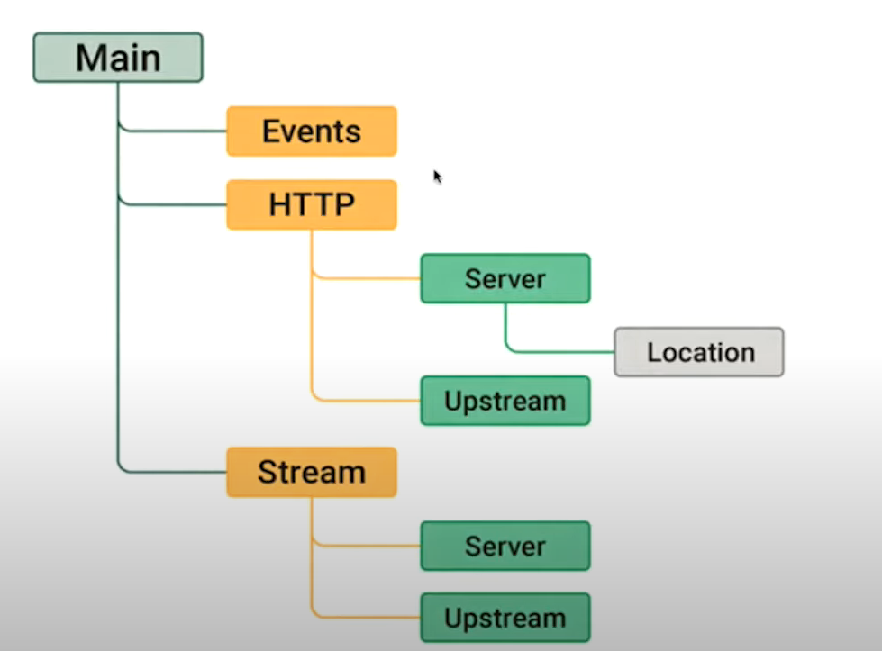

* sudo service nginx restart - to restart the nginx with 4 worker nodes and 1 master process
* ps -ef | grep nginx - to display the working process of nginx
* Configure - build the file
* Nginx -s [reload][quit][stop][reopen]

For getting the list of all running nginx processes, the ps utility may be used, for example, in the following way:

ps -ax | grep nginx

[Fastcgi_pass](https://nginx.org/en/docs/http/ngx_http_fastcgi_module.html#fastcgi_pass) instead of proxy_pass