Exp 15Create a Cloning of a VM and Test it by loading the Previous Version/Cloned VM using vmware workstation.
Aim
Create a clone of a VM and verify the cloned VM runs independently of the source.
Procedure
- Power off the source VM → Manage → Clone (or Snapshot Manager → right-click snapshot → Clone).
- Choose Clone from current state or from a specific snapshot.
- Pick Linked clone (faster, shares base disk) or Full clone (independent).
- Name the cloned VM and choose storage location → Finish.
- Open/Power on the cloned VM; if network conflicts occur, ensure new MAC is assigned.
- Verify independence: change wallpaper/hostname or create a file in the clone and confirm the source VM is unaffected.
Output
Figure 1 Virtual Machine with 1 CPU, 2 GB RAM, and 15 GB storage
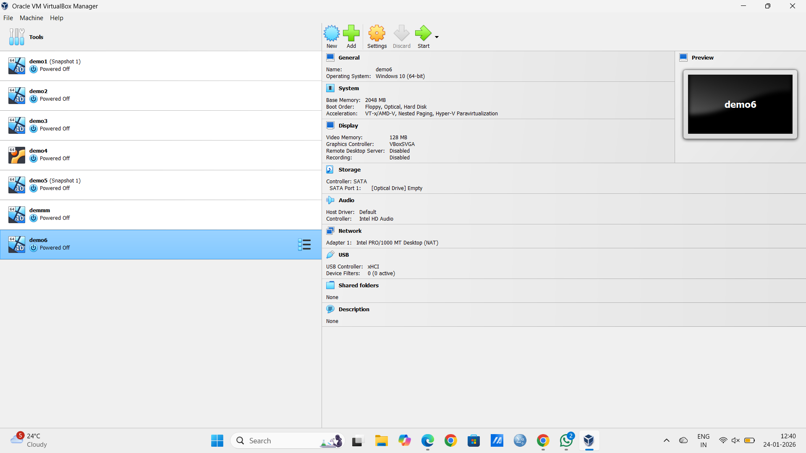

Result
A separate, bootable clone runs successfully; operations in the clone do not impact the source VM.

