6. Simulation of Handoff Scenario in a Mobile Network
Aim:
To simulate a handoff scenario in a mobile network using Figma and visualize the process.
Procedure:
- Open Figma and create a new design file.
- Create a frame representing the mobile network.
- Add two or more cellular coverage areas.
- Place a base station in each coverage area.
- Add a mobile station inside the first cell.
- Show the mobile station moving towards the second cell.
- Represent signal strength measurement using arrows.
- Show the connection transferring from the serving cell to the target cell.
- Use prototype interactions to demonstrate the handoff process.
Link: https://www.figma.com/design/H6kScDvacEqUFZUWtNX2xA/4th-ques?node-id=2025-248&t=uwscihbvkYsKSiaF-0
Output: 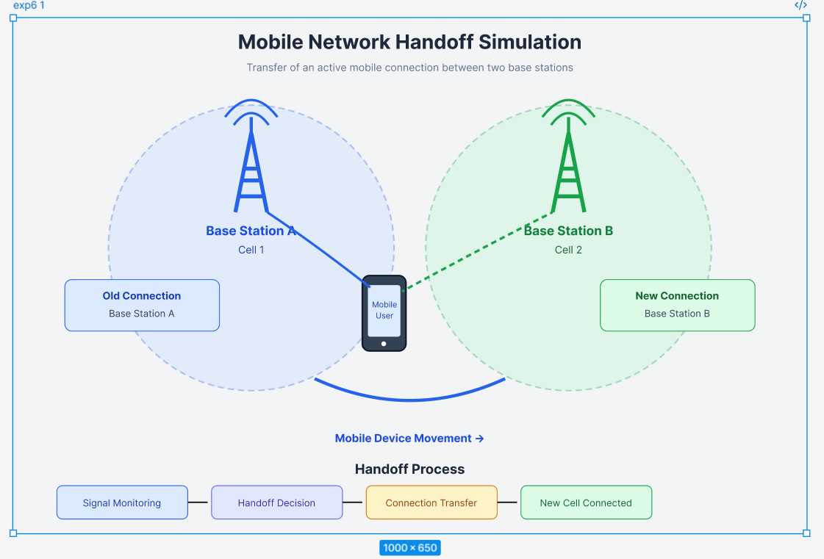
Result:A mobile network handoff scenario was successfully simulated and visualized using Figma.

