**Time Series Analysis For Bitcoin Price Prediction Using Prophet**

**Abstract**

This study focuses on time series analysis for predicting Bitcoin prices using various methodologies, including Recurrent Neural Networks (RNN), Long Short-Term Memory networks (LSTM), Auto Regressive Integrated Moving Average (ARIMA), and Facebook's Prophet. We utilize a dataset consisting of timestamps and closing prices to train and evaluate the performance of these models. The objective is to identify the most effective forecasting technique for Bitcoin price movements, addressing the inherent volatility of cryptocurrency markets. By leveraging historical price data, we aim to enhance prediction accuracy, contributing to more informed trading decisions. Our findings will provide valuable insights into the applicability of different predictive models in the context of cryptocurrency, ultimately aiming to assist investors in navigating the complexities of Bitcoin trading. The results underscore the strengths and weaknesses of each method, paving the way for future research in financial time series analysis.

Keywords: RNN, LSTM, ARIMA and Prophet, Kaggle dataset.

**Statement about the Problem**

The cryptocurrency market, particularly Bitcoin, is characterized by high volatility, making accurate price prediction a significant challenge for investors. Traditional forecasting methods often struggle to adapt to the dynamic nature of these markets. This study aims to explore the effectiveness of various time series analysis techniques, including RNN, LSTM, ARIMA, and Facebook's Prophet, to predict Bitcoin prices. By employing a dataset of historical timestamps and closing prices, we seek to determine which methodology yields the most accurate forecasts, ultimately providing insights that can aid investors in making informed trading decisions amidst market fluctuations.

**Why the Particular Topic is Chosen**

This study addresses the increasing interest in cryptocurrency investments, particularly Bitcoin, which is characterized by significant price volatility. Understanding the factors influencing Bitcoin price movements is crucial for investors seeking to make informed decisions. By investigating various forecasting methodologies, including RNN, LSTM, ARIMA, and Prophet, the research aims to identify the most effective techniques for predicting Bitcoin prices. The findings will provide insights into the applicability of these models in financial markets, ultimately aiding investors in navigating the complexities of cryptocurrency trading. This exploration contributes to the broader field of financial time series analysis, emphasizing the importance of accurate prediction strategies.

**Objective of the Project**

The primary objective of this project is to conduct a comprehensive time series analysis for predicting Bitcoin prices by comparing various forecasting methodologies, including RNN, LSTM, ARIMA, and Facebook's Prophet. We aim to utilize historical closing price data to develop and evaluate these models, with a focus on enhancing prediction accuracy amidst the inherent volatility of the cryptocurrency market. By identifying the most effective predictive technique, this study seeks to provide insights that will assist investors in making informed trading decisions, thereby contributing to a deeper understanding of financial time series analysis in the context of cryptocurrency.

**Scope**

This study explores the application of time series analysis techniques for predicting Bitcoin prices, focusing on RNN, LSTM, ARIMA, and Prophet models. By utilizing a comprehensive dataset of timestamps and closing prices, we aim to evaluate each model's performance in forecasting Bitcoin price movements amidst market volatility. The research will examine the strengths and weaknesses of these methodologies, offering insights into their effectiveness in cryptocurrency trading. Additionally, the findings will serve as a foundation for future studies in financial time series analysis, enabling investors to make data-driven decisions in an increasingly complex trading environment.

**Existing System**

The existing system for Bitcoin forecasting primarily relies on traditional time series analysis models such as ARIMA and PROPHET, implemented using the R analytics platform. ARIMA focuses on capturing linear trends and seasonality in historical Bitcoin price data, while PROPHET is adept at handling non-linear trends and holidays or special events. Both methods are evaluated on the same dataset from May 2016 to March 2018, with pre-processing techniques like timestamp conversion and feature selection applied. The system is designed to improve accuracy by incorporating additional variables derived from correlations between cryptocurrencies and real currencies.

**Disadvantages of Existing Systems:**

1. **ARIMA:** Struggles to model non-linear patterns, limiting its forecasting accuracy for volatile Bitcoin data.
2. **PROPHET:** Handling of special events may not capture unforeseen market shocks in cryptocurrency prices.
3. **Data Sensitivity:** Both ARIMA and PROPHET models are sensitive to noisy and incomplete data, impacting forecast reliability.
4. **R Analytics Platform:** Has a steep learning curve, which can hinder accessibility for users unfamiliar with it.
5. **Lack of Machine Learning:** Limited incorporation of advanced machine learning techniques may restrict improvements in forecast precision.

**Proposed System**

This study proposes a comprehensive system for predicting Bitcoin prices through time series analysis. By implementing various forecasting models—RNN, LSTM, ARIMA, and Facebook's Prophet—we will analyse historical price data to assess each model's effectiveness. The system will utilize a Kaggle dataset containing timestamps and closing prices, allowing us to train and evaluate the performance of the different methodologies. Our approach aims to enhance prediction accuracy amidst Bitcoin's volatility, offering insights into the strengths and limitations of each technique. Ultimately, the system seeks to aid investors in making informed trading decisions within the cryptocurrency market.

**Advantages of Proposed System**

**Comprehensive model comparison:** The system evaluates the strengths of RNN, LSTM, ARIMA, and Prophet for Bitcoin forecasting.

**Enhanced prediction accuracy:** By leveraging multiple models, it improves the precision of Bitcoin price predictions.

**Data-driven insights:** Historical price data analysis provides valuable insights for understanding Bitcoin's volatility.

**Investor decision support:** The system educates investors on model-driven forecasts to improve trading strategies.

**Educational focus:** The project offers students and researchers a deeper understanding of time series forecasting techniques.

**BLOCK DIAGRAM:**

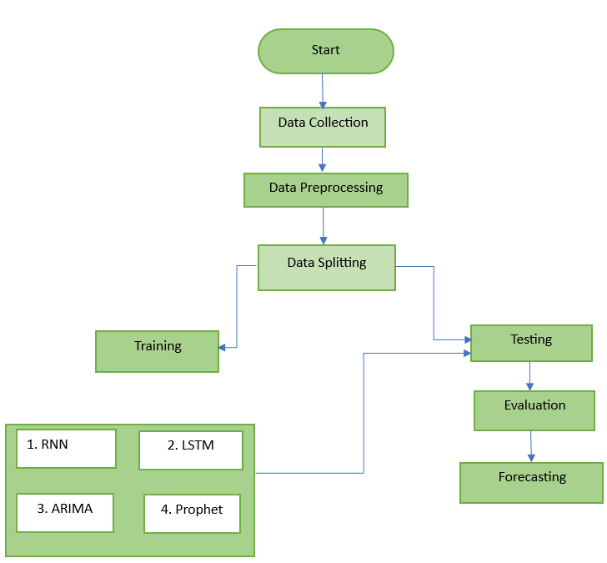

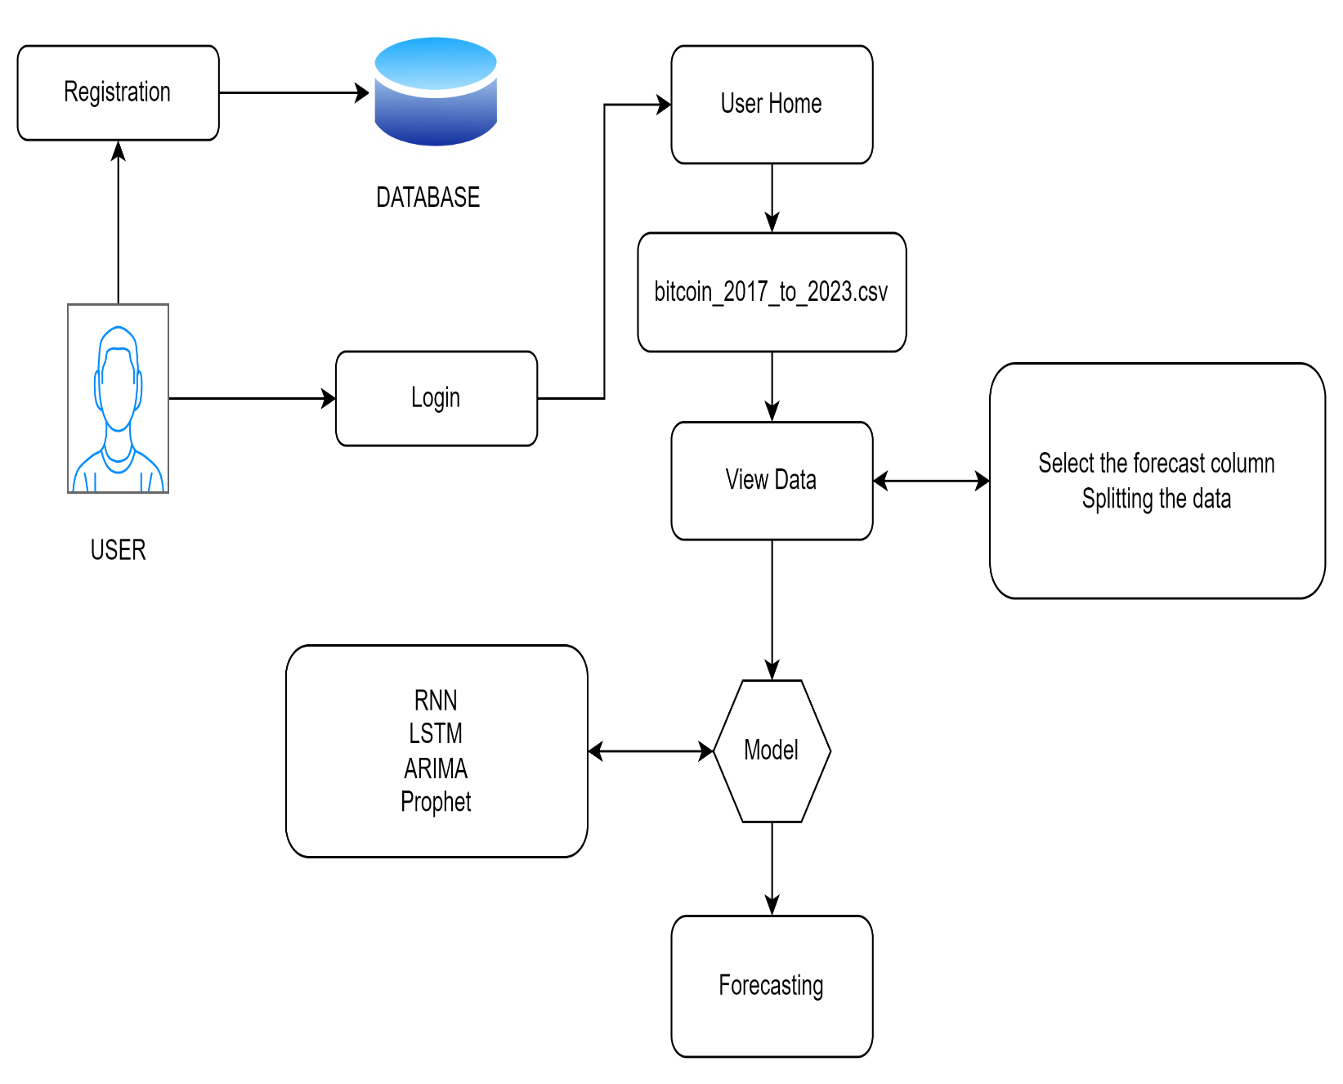

**SOFTWARE AND HARDWARE REQUIREMENTS:**

**Hardware:**

Operating system : Windows 7 or 7+

RAM : 8 GB

Hard disc or SSD : More than 500 GB

Processor : Intel 3rd generation or high or Ryzen with 8 GB Ram

**Software:**

Software’s : Python 3.10 or high version

IDE : Visual Studio Code.

Framework : Flask