Exp No: 11 | Routing at Network Layer - Static Routing and RIP

AIM:
To simulate static routing and the RIP dynamic routing protocol configuration using Cisco Packet Tracer.
ALGORITHM / PROCEDURE:

(a) Static routing
- Place 3 routers (2911 with HWIC-2T serial card) and 2 PCs. Connect PC0 to R1 and PC1 to R3 with a crossover cable, and connect the routers using serial DCE cables (R1-R2 and R2-R3).
- Assign IP addresses to all the router interfaces and the PCs as shown in the address table. Set the default gateways (192.168.1.1 and 192.168.2.1).
- On the DCE side of each serial link give _{clock rate 64000} and use _{no shutdown} on all interfaces.
- Ping from PC0 to PC1. It fails because the routers do not know the remote networks.
- On each router add a static route for every network that is not directly connected: _{ip route}
<network> <mask> <next-hop>
- Verify with _{show ip route} and ping PC0 to PC1 again. Use _{tracert} to see the path.

(b) RIP (Routing Information Protocol)
- Remove the static routes using _{no ip route ...} (or build the same topology again).
- On every router enter RIP configuration mode with _{router rip} and _{version 2}.
- Advertise the directly connected networks using the _{network <address>} command and disable auto summary using no auto-summary.
- Wait for about 30 seconds (RIP update timer). Check the learnt routes with _{show ip route} and _{show} ip protocols.
- Ping PC0 to PC1 and trace the path.

Device | Interface | IP address | Subnet mask
R1 | Gig0/0 | 192.168.1.1 | 255.255.255.0
R1 | Se0/0/0 (DCE) | 10.0.0.1 | 255.255.255.252
R2 | Se0/0/0 | 10.0.0.2 | 255.255.255.252
R2 | Se0/0/1 (DCE) | 10.0.0.5 | 255.255.255.252
R3 | Se0/0/1 | 10.0.0.6 | 255.255.255.252
R3 | Gig0/0 | 192.168.2.1 | 255.255.255.0
PC0 | NIC | 192.168.1.2 | 255.255.255.0
PC1 | NIC | 192.168.2.2 | 255.255.255.0

Commands used

Static routing | RIP
R1(config)#ip route 192.168.2.0 255.255.255.0  10.0.0.2 | R1(config)#router rip
R1(config)#ip route 10.0.0.4 255.255.255.252  10.0.0.2 | R1(config-router)#version | 2
R2(config)#ip route 192.168.1.0 255.255.255.0  10.0.0.1 | R1(config-router)#network | 192.168.1.0
R2(config)#ip route 192.168.2.0 255.255.255.0  10.0.0.6 | R1(config-router)#network | 10.0.0.0
R3(config)#ip route 192.168.1.0 255.255.255.0  10.0.0.5 | R1(config-router)#no auto-summary
R3(config)#ip route 10.0.0.0 255.255.255.252  10.0.0.5 | (similar for R2: 10.0.0.0 and R3:  192.168.2.0)
DIAGRAM:


R

R

R

R1

Gig0/0
192.168.1.1

Se0/0/0
10.0.0.1

R2

Se0/0/0

10.0.0.2

Se0/0/1

10.0.0.5

R3

Se0/0/1
10.0.0.6

Gig0/0
192.168.2.1

PC

PC

PC0

192.168.1.2

PC1

192.168.2.2

Fig 1: Three routers connected by serial links (dotted lines are serial links)
OUTPUT:

Part (a) - Static routing

Cisco Packet Tracer
-

static_routing.pkt


R1

Gig0/0
192.168.1.1

Se0/0/0
10.0.0.1

R2

Se0/0/0
10.0.0.2

Se0/0/1
10.0.0.5

R3

Se0/0/1
10.0.0.6

Gig0/0
192.168.2.1

PC0

192.168.1.2

PC1

192.168.2.2

Packet Tracer view (red lightning lines are serial links)



C:
\
>
ping

192.168.2.2

Pinging

192.168.2.2

with

32

bytes

of

data:

Reply from 192.168.1.1:
Destination host unreachable
.
Reply from 192.168.1.1:
Destination host unreachable
.
Reply from 192.168.1.1:
Destination host unreachable
.
Reply from 192.168.1.1:
Destination host unreachable
.

Ping

statistics

for

192.168.2.2:

Packets:

Sent

=

4
,

Received

=

0
,

Lost

=

4

(100
%

loss),

PC0
-

Command Prompt (before static
routes)

R1 - CLI
R1#show ip route
Codes: L - local, C - connected, S - static, R - RIP, M - mobile, B - BGP
Gateway of last resort is not set
10.0.0.0/30 is subnetted, 2 subnets
C 10.0.0.0 is directly connected, Serial0/0/0
S 10.0.0.4 [1/0] via 10.0.0.2
C 192.168.1.0/24 is directly connected, GigabitEthernet0/0
S 192.168.2.0/24 [1/0] via 10.0.0.2

PC0
-

Command Prompt (after static
routes)

C:\>ping 192.168.2.2
Pinging 192.168.2.2 with 32 bytes of data:
Request timed out.
Reply from 192.168.2.2: bytes=32 time=3ms TTL=125
Reply from 192.168.2.2: bytes=32 time=2ms TTL=125
Reply from 192.168.2.2: bytes=32 time=2ms TTL=125

Ping statistics for 192.168.2.2:
Packets: Sent = 4, Received = 3, Lost = 1 (25% loss),

C:\>tracert 192.168.2.2


Tracing route to 192.168.2.2 over a maximum of 30 hops:
- 0 ms 0 ms 0 ms 192.168.1.1
- 1 ms 1 ms 0 ms 10.0.0.2
- 2 ms 1 ms 2 ms 10.0.0.6
- 2 ms 2 ms 1 ms 192.168.2.2
Trace complete.

Part (b) - RIP

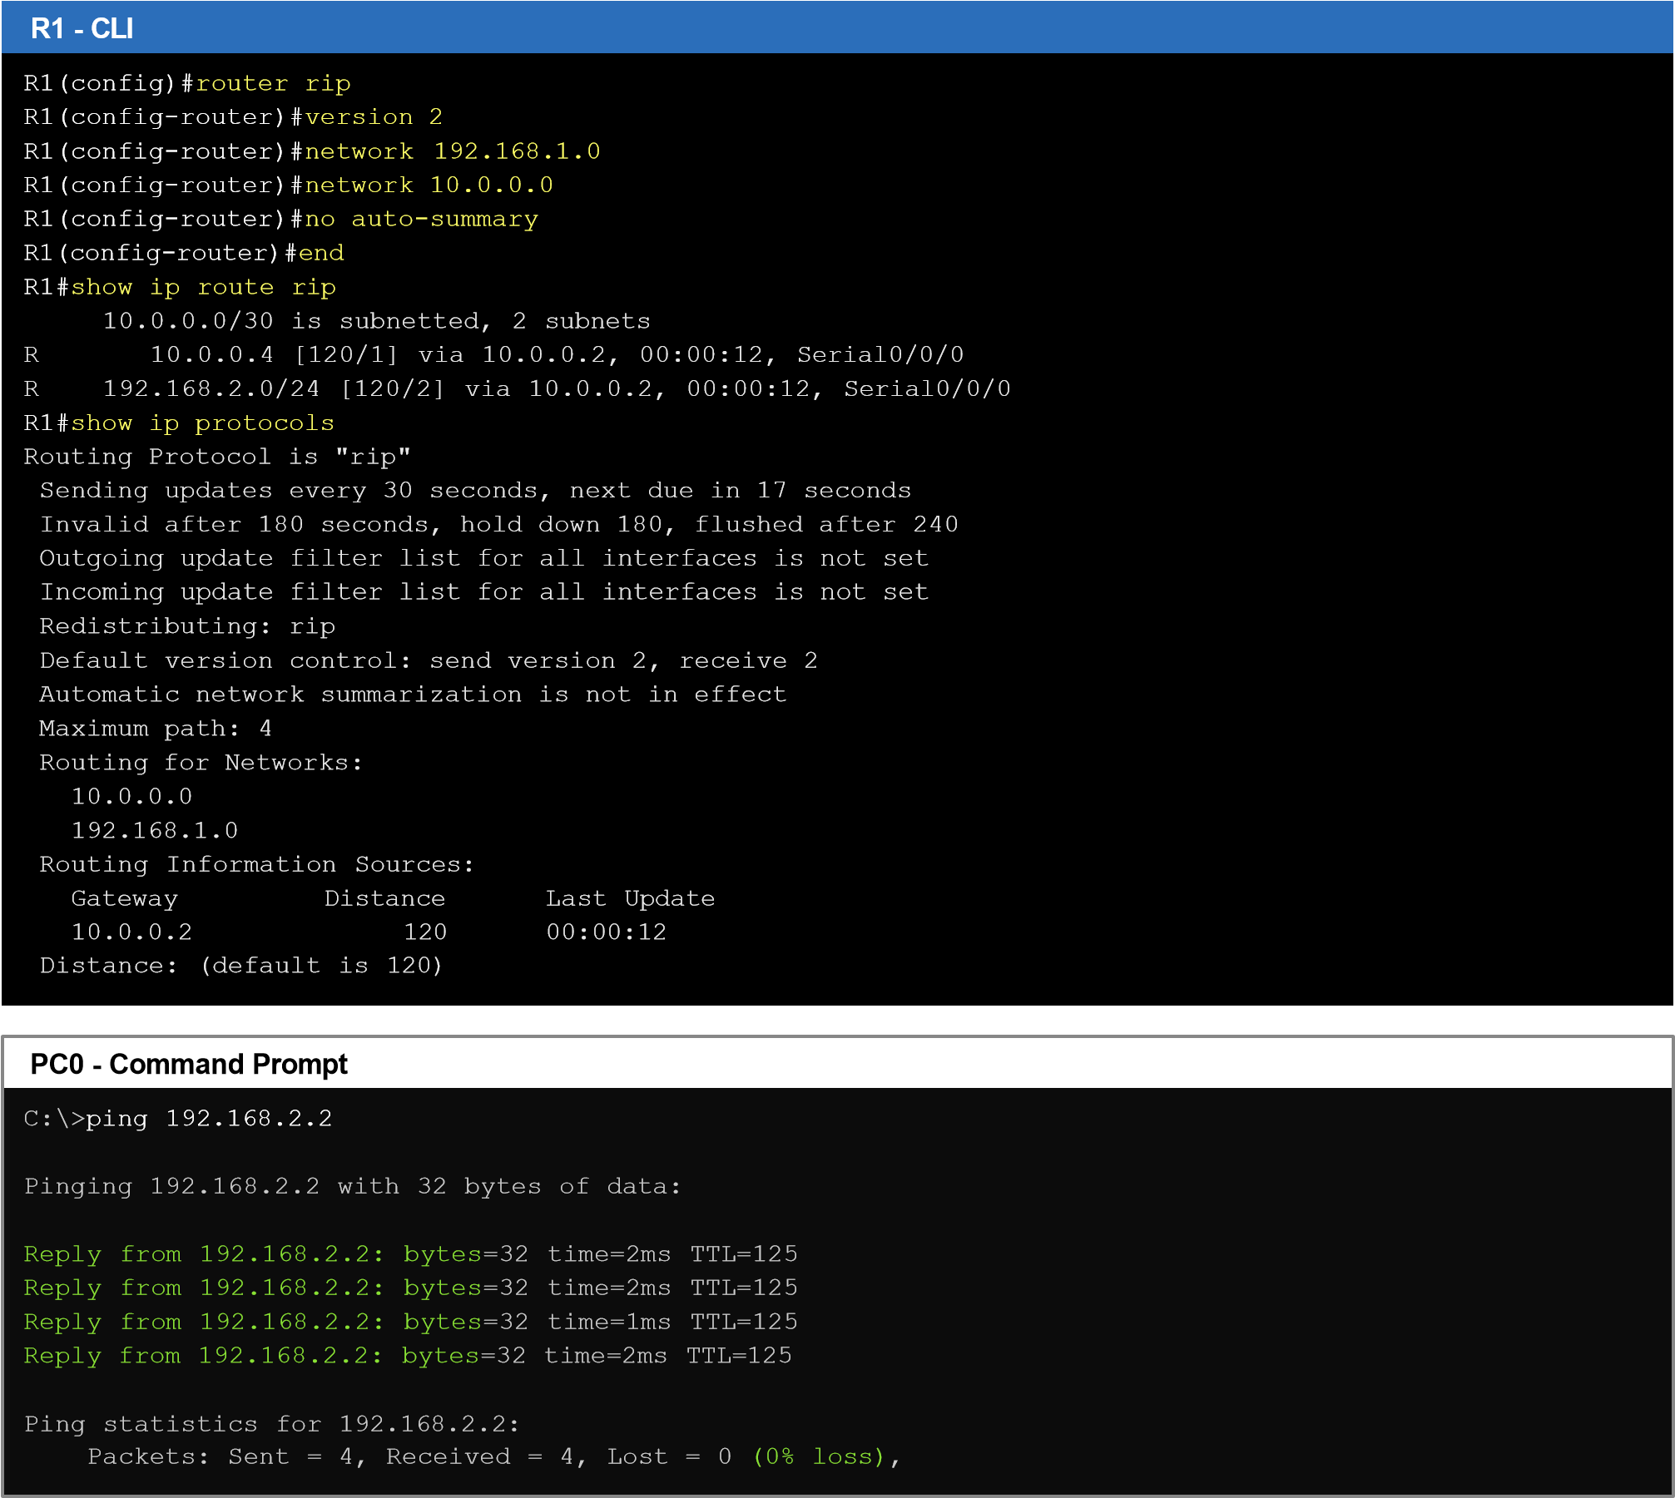

Fire | Last Status | Source | Destination | Type | Color | Time(sec) | Periodic | Num
 | Successful | PC0 | R1 | ICMP |  | 0.000 | N | 0
 | Successful | R1 | R2 | ICMP |  | 0.001 | N | 1
 | Successful | R2 | R3 | ICMP |  | 0.002 | N | 2
 | Successful | R3 | PC1 | ICMP |  | 0.003 | N | 3
 | Successful | R1 | R2 | RIP |  | 30.000 | N | 4
 | Successful | R2 | R3 | RIP |  | 30.001 | N | 5

Point | Static routing | RIP
Route entry | Typed manually by the admin (S) | Learnt automatically from neighbours (R)
Administrative distance | 1 | 120
Updates | None | Every 30 seconds
Link failure | Admin has to change the route | Finds another path automatically
Metric | Not used | Hop count (max 15)
Best for | Small and stable networks | Small to medium networks
RESULT:
Thus static routing and RIP were configured and simulated in Cisco Packet Tracer. Ping between the two remote networks failed without routes and became successful after configuring the static routes and also after configuring RIP.

