Exp No: 15 | Analyse various types of servers using Webalizer tool

AIM:
To analyse the log files of various types of servers (web, proxy and FTP servers) using the Webalizer web server log analysis tool and to study the usage statistics generated by it.
ALGORITHM / PROCEDURE:
- Install Webalizer in Linux using sudo apt install webalizer _{apache2}.
- Locate the log files of the servers to be analysed (Apache, Nginx, IIS, FTP, Squid) as given in the table below.
- Edit the configuration file /etc/webalizer/webalizer.conf and set _{LogFile}, _{LogType},
OutputDir and HostName.
- Run Webalizer for each server. The option _{-n} gives the host name for the report, _{-o} gives the output folder and _{-F} gives the log type (clf, w3c, ftp, squid).
- Open the generated _{usage_YYYYMM.html} file in a web browser
(http://localhost/webalizer/apache/) to see the report.
- Study the monthly summary, the daily graph, the top URLs, the top clients, the user agents and the HTTP response codes.
- Compare the results of the different servers and note down the inference. Servers and their log formats

Server type | Log file | Log format | Webalizer option
Apache web server | /var/log/apache2/access.log | Common Log Format (CLF) | -F clf
Nginx web server | /var/log/nginx/access.log | CLF compatible (combined) | -F clf
IIS web server | C:\inetpub\logs\LogFiles\W3SVC1\u_ ex261008.log | W3C extended | -F w3c
FTP server (vsftpd) | /var/log/xferlog | wu-ftpd xferlog | -F ftp
Squid proxy server | /var/log/squid/access.log | Squid native | -F squid

webalizer.conf (important lines)
LogFile /var/log/apache2/access.log
LogType clf
OutputDir /var/www/html/webalizer/apache
HostName apache-server
PageType htm*
PageType php
PageType cgi
HideSite localhost

Sample log records
Apache (CLF):
192.168.1.25 - - [08/Oct/2026:10:41:07 +0530] "GET /index.html HTTP/1.1" 200 4521
192.168.1.12 - - [08/Oct/2026:10:41:09 +0530] "GET /css/style.css HTTP/1.1" 304 - 10.0.2.2 - - [08/Oct/2026:10:42:15 +0530] "GET /missing.html HTTP/1.1" 404 492 IIS (W3C):
#Fields: date time s-ip cs-method cs-uri-stem sc-status sc-bytes
2026-10-08 05:12:44 192.168.1.30 GET /default.aspx 200 6120

DIAGRAM:
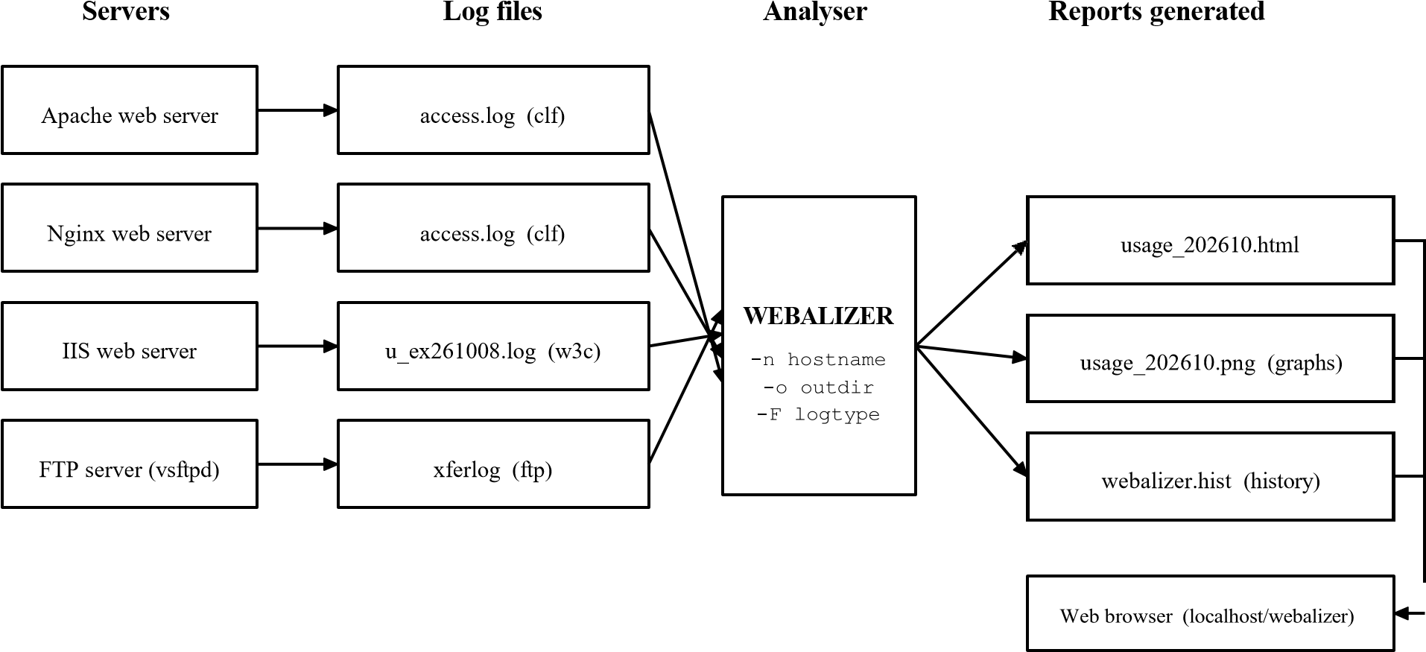
Fig 1: Log analysis of different servers using Webalizer
OUTPUT:

UuUSsEeRr @UuUSsEeRr -VirtualBox: ~
^{UuUSsEeRr} @UusSseEerRr -VirtualBox:~$ sudo webalizer -n apache-server -o /var/www/html/webalizer/apache -F clf /va r/log/apache2/access.log
Webalizer V2.23-08 (Linux 5.15.0-91-generic) English
Using logfile /var/log/apache2/access.log (clf)
Creating output in /var/www/html/webalizer/apache Hostname for reports is 'apache-server'
History file not found...
Generating report for October 2026
Generating summary report Saving history information... 1243 records in 0 seconds ^{uUsSseEerRr} UuUSsEeRr -VirtualBox:~$ sudo webalizer -n nginx-server -o /var/www/html/webalizer/nginx -F clf /var/ @ log/nginx/access.log
Using logfile /var/log/nginx/access.log (clf)
Creating output in /var/www/html/webalizer/nginx
Generating report for October 2026
Generating summary report Saving history information...
856 records in 0 seconds
^{UuSsEeRr} UuSsEeRr -VirtualBox:~$ sudo webalizer -n iis-server -o /var/www/html/webalizer/iis -F w3c u_ex26100
@
8. log
Using logfile u_ex261008.log (w3c)
Creating output in /var/www/html/webalizer/iis
Generating report for October 2026
Generating summary report
Saving history information...
522 records in 0 seconds
^{UuUSsEeRr} @UuUSsEeRr -VirtualBox:~$ sudo webalizer -n ftp-server -o /var/www/html/webalizer/ftp -F ftp /var/log/ xferlog
Using logfile /var/log/xferlog (ftp)
Generating report for October 2026
64 records in 0 seconds

Report of the Apache web server

Monthly Statistics for October 2026
Total Hits | 1243
Total Files | 1131
Total Pages | 402
Total Visits | 138
Total KBytes | 18642
Total Unique Sites | 57
Avg / Max Hits per Day | 155 / 276
Avg / Max Files per Day | 141 / 252
Avg / Max Pages per Day | 50 / 93
Avg / Max Visits per Day | 17 / 23
Avg / Max KBytes per Day | 2330 / 3342

Top URLs by hits

# | Hits | % | URL
1 | 214 | 17.2% | /index.html
2 | 188 | 15.1% | /css/style.css
3 | 163 | 13.1% | /images/logo.png
4 | 97 | 7.8% | /login.php
5 | 76 | 6.1% | /about.html
6 | 52 | 4.2% | /contact.html
7 | 41 | 3.3% | /favicon.ico

Top clients

# | Hits | % | Client (site)
1 | 311 | 25.0% | 192.168.1.25
2 | 204 | 16.4% | 192.168.1.12
3 | 142 | 11.4% | 10.0.2.2
4 | 96 | 7.7% | 192.168.1.30

Hits by response code

HTTP response code | Hits | %
200 - OK | 1019 | 82.0%
304 - Not Modified | 112 | 9.0%
404 - Not Found | 74 | 6.0%
301 - Moved Permanently | 21 | 1.7%
403 - Forbidden | 9 | 0.7%
500 - Internal Server Error | 8 | 0.6%
Comparison of the servers

Server | Records | Total hits | Visits | KBytes | Most requested URL
Apache | 1243 | 1243 | 138 | 18642 | /index.html
Nginx | 856 | 856 | 97 | 12408 | /api/status
IIS | 522 | 522 | 61 | 7915 | /default.aspx
FTP (vsftpd) | 64 | 64 | 9 | 41230 | /pub/notes.pdf

Inference
- The Apache server is the busiest server and its highest load was on 08-Oct-2026 (276 hits).
- About 82% of the requests were successful (200) and 6% gave 404 errors, which means some links on the site are broken.
- The home page _{/index.html} is the most visited page. Image and CSS files form most of the hits, whereas only 402 hits are actual pages.
- The same tool can analyse all the servers because only the log type option (_{-F}) changes.

RESULT:
Thus the log files of various types of servers (Apache, Nginx, IIS, FTP) were analysed using the Webalizer tool and the usage statistics such as hits, visits, top URLs, clients and response codes were studied.

