Exp No: 1 | Study of various Network commands used in Linux and Windows

AIM:
To study and practise the various network commands used in Linux and Windows operating systems.
ALGORITHM / PROCEDURE:
- Open the Terminal in Linux and the Command Prompt (_{cmd}) in Windows.
- Use _{hostname} to see the name of the computer.
- Use _{ifconfig} (Linux) and _{ipconfig} (Windows) to see the IP address, subnet mask and MAC address.
- Use _{ping} to check whether the remote system is reachable. Note the packet loss and the time taken.
- Use _{traceroute} (Linux) and _{tracert} (Windows) to see the path taken by the packets.
- Use _{nslookup} and _{dig} to find the IP address of a domain name.
- Use _{netstat} to see the active connections and open ports.
- Use _{arp -a} to see the IP address to MAC address table.
- Use _{route} (Linux) and _{route print} (Windows) to see the routing table.
- Note down the output of each command.

Commands used:

Purpose | Linux | Windows
Host name | hostname | hostname
IP configuration | ifconfig / ip addr | ipconfig /all
Check connectivity | ping -c 4 google.com | ping google.com
Trace the route | traceroute google.com | tracert google.com
DNS lookup | nslookup / dig | nslookup
Active connections | netstat -tuln | netstat -an
ARP table | arp -a | arp -a
Routing table | route -n | route print
MAC address | ip link | getmac
DIAGRAM:
Fig 1: Network commands and the layers they work in

Application Layer nslookup, dig, telnet
Transport Layer netstat, ss
Network Layer
ping, traceroute / tracert, ifconfig / ipconfig, route
Data Link Layer arp, getmac

Fig 2: Working of ping command



1
. ICMP Echo
Request

2
. ICMP Echo
Reply

Destination
(
Server
)

Source
(
PC
)

OUTPUT:
Linux:

UuUSsEeRr

@
UuUsSeErR

-
VirtualBox:

~


-
VirtualBox

UuUSsEeRr

@
UusSseEerRr

-
VirtualBox:

~

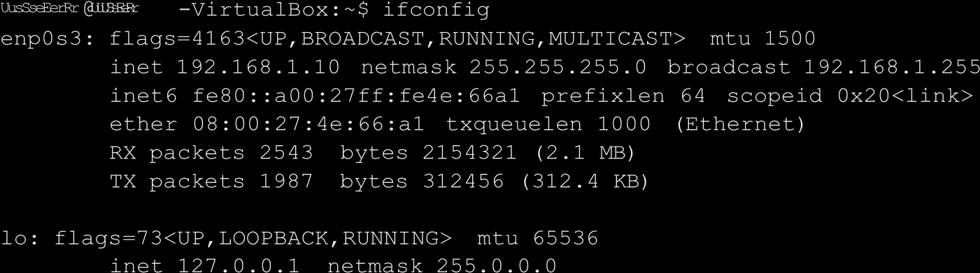

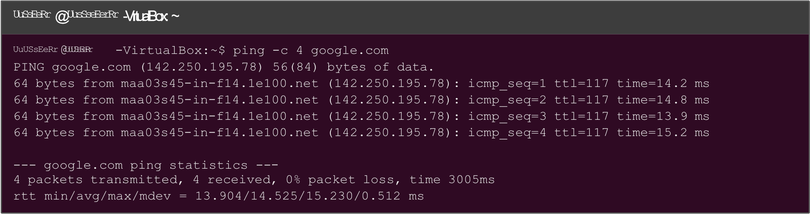

UuUSsEeRr

@
UuSsEeRr

-
VirtualBox:

~

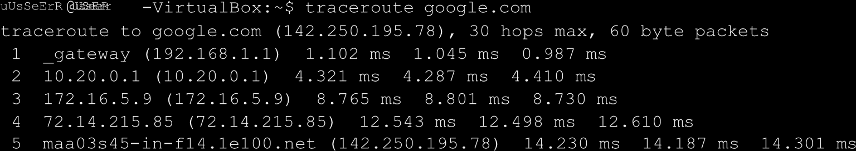

uUsSeErR

@
UusSseEerRr

-
VirtualBox:

~



UuUsSeErR

@
UuUsSeErR

-
VirtualBox:

~

UuUSsEeRr @uUsSseEerRr -VirtualBox: ~
UuSsEeRr @UuUsSeErR -VirtualBox:~$ netstat -tuln
Active Internet connections (only servers)
Proto Recv-Q Send-Q Local Address |  |  | Foreign Address |  | State
tcp | 0 | 0 0.0.0.0:22 | 0.0.0.0:* |  | LISTEN
tcp | 0 | 0 127.0.0.1:631 | 0.0.0.0:* |  | LISTEN
tcp6 | 0 | 0 :::80 | :::* |  | LISTEN
udp | 0 | 0 0.0.0.0:68 | 0.0.0.0:*

UuUSsEeRr

@
UuUSsEeRr

-
VirtualBox:

~

UusSseEerRr @UusSseEerRr -VirtualBox: ~
uUsSeErR @UuUsSeErR -VirtualBox:~$ rou  Kernel IP routing table  Destination Gateway |  | te -n  Genmask | Flags Metric Ref | Use Iface
0.0.0.0 | 192.168.1.1 | 0.0.0.0 | UG 100 0 | 0 enp0s3
192.168.1.0 | 0.0.0.0 | 255.255.255.0 | U 100 0 | 0 enp0s3
Windows:

Command
Prompt


C:
\
Users
\
UuUSsEeRr

Command Prompt
C:\Users\^{UuUsSeErR} >ipconfig /all
Windows IP Configuration
Host Name . . . . . . . . . . . . : DESKTOP-^{uUsSeErR} Primary Dns Suffix . . . . . . . :
Node Type . . . . . . . . . . . . : Hybrid IP Routing Enabled. . . . . . . . : No
Ethernet adapter Ethernet:
Physical Address. . . . . . . . . : 00-1A-2B-3C-4D-5E
DHCP Enabled. . . . . . . . . . . : Yes
IPv4 Address. . . . . . . . . . . : 192.168.1.25(Preferred)
Subnet Mask . . . . . . . . . . . : 255.255.255.0
Default Gateway . . . . . . . . . : 192.168.1.1
DHCP Server . . . . . . . . . . . : 192.168.1.1
DNS Servers . . . . . . . . . . . : 8.8.8.8
Command
Prompt

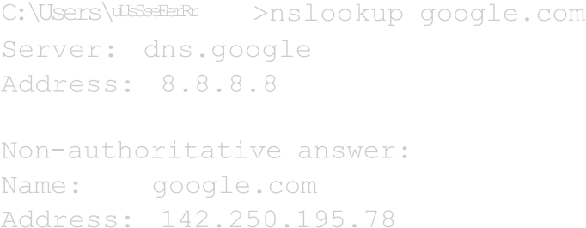

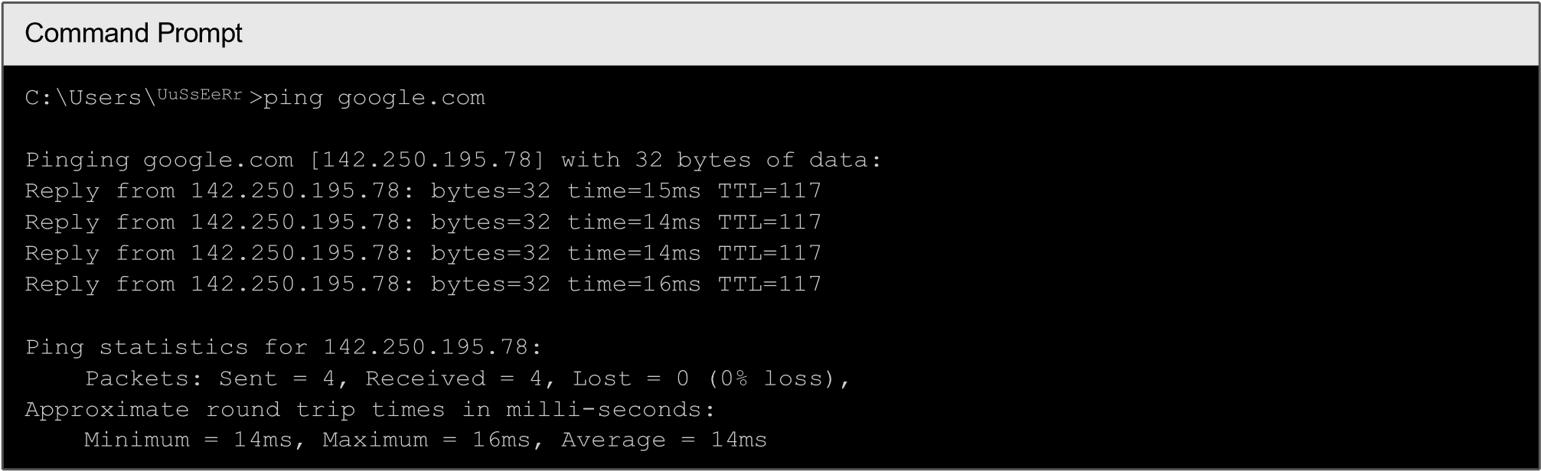

Command
Prompt

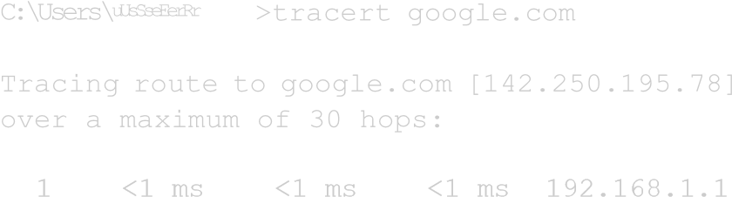
- 4 ms 4 ms 4 ms 10.20.0.1
- 9 ms 8 ms 9 ms 172.16.5.9
- 13 ms 12 ms 12 ms 72.14.215.85
- 14 ms 14 ms 15 ms 142.250.195.78

Command Prompt
C:\Users\^{UuUsSeErR} >netstat -an

Active Connections
Proto Local Address |  | Foreign Address |  | State
TCP | 0.0.0.0:135 | 0.0.0.0:0 |  | LISTENING
TCP | 0.0.0.0:445 | 0.0.0.0:0 |  | LISTENING
TCP | 192.168.1.25:50234 | 142.250.195.78:443 |  | ESTABLISHED
UDP | 0.0.0.0:5353 | *:*

Command Prompt
C:\Users\UuUSsEeRr >arp -a  Interface: 192.168.1.25 --- 0x8  Internet Address Physical Address |  | Type
192.168.1.1 c4-e9-84-2a-5b-10 |  | dynamic
192.168.1.255 ff-ff-ff-ff-ff-ff |  | static

Command Prompt
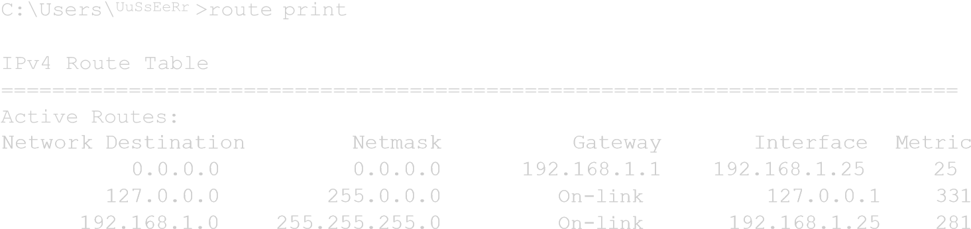

Command
Prompt

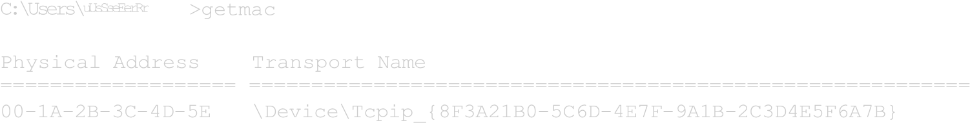

RESULT:
Thus the various network commands used in Linux and Windows were studied and executed successfully.

