Exp No: 2 | Study of Network cables - straight-through and crossover cable

AIM:
To study the different types of network cables and to make a straight-through cable and a cross-wired (crossover) cable using a crimping tool.
APPARATUS REQUIRED:
- Cat5e / Cat6 UTP cable (about 1 metre for each cable)
- RJ45 connectors (4 numbers)
- Crimping tool with built-in cutter and stripper
- LAN cable tester (main unit and remote unit)
ALGORITHM / PROCEDURE:

Part A - Study of network cables
- Observe the sample twisted pair, coaxial and fibre optic cables available in the lab.
- Note the outer jacket marking (for example Cat5e, 24 AWG) and the number of pairs.
- Write down the use, speed and maximum length of each cable type in the table given below.

Part B - Making the cables
- Cut the UTP cable to the required length (about 1 m) using the cutter.
- Remove about 2.5 cm of the outer jacket from both ends with the stripper. Take care not to cut the inner wires.
- Untwist the four pairs and straighten the eight wires with fingers.
- For the straight-through cable: arrange the wires in _{T568B} order on both ends.
- For the crossover cable: arrange _{T568B} order on one end and _{T568A} order on the other end.
- Cut the wire tips even so that about 1.3 cm of the wires is left outside the jacket.
- Hold the RJ45 connector with the clip facing down, push the wires inside till they touch the end of the connector. The jacket should also go inside a little.
- Put the connector in the crimping tool and press firmly so that the pins cut into the wires.
- Repeat steps 2 to 8 for the other end of the cable.
- Insert both ends into the LAN tester and check the LED sequence. Types of network cables

Cable | Connector | Max. length | Speed | Used for
Twisted pair (UTP / STP) | RJ45 | 100 m | 10 Mbps to 10 Gbps | LAN, connecting PCs to switch
Coaxial (RG-6, RG-59) | BNC / F-type | 185 m to 500 m | 10 Mbps (old  Ethernet) | Cable TV, CCTV, old LANs
Fibre optic (single / multi mode) | SC / LC / ST | 2 km (multi) up to  40 km+ (single) | 1 Gbps to 100 Gbps | Backbone, long distance links

UTP category | Max. speed | Bandwidth
Cat5 | 100 Mbps | 100 MHz
UTP category | Max. speed | Bandwidth
Cat5e | 1 Gbps | 100 MHz
Cat6 | 1 Gbps (10 Gbps up to 55 m) | 250 MHz
Cat6a | 10 Gbps | 500 MHz

Pin | 1 | 2 | 3 | 4 | 5 | 6 | 7 | 8
T568A | W/G | G | W/O | B | W/B | O | W/Br | Br
T568B | W/O | O | W/G | B | W/B | G | W/Br | Br
W = white stripe, G = green, O = orange, B = blue, Br = brown

Cable | Wiring | Used to connect
Straight-through | T568B to T568B | PC to Switch, PC to Hub, Router to Switch (unlike devices)
Crossover | T568B to T568A | PC to PC, Switch to Switch, Hub to Hub, PC to Router (like devices)
DIAGRAM:
RJ45 - End A RJ45 R- JE4n5d-BEnd A RJ45 - End B

1

2

3

4

5

6

7

8

1

2

3

4

5

6

7

8

1

2

3

4

5

6

7

8

4

5

7

8

6

3

2

1

Fig 1: Straight-through cable (pin 1 to 1, 2 to 2 ...) Fig 2: Crossover cable (1 to 3, 2 to 6, 3 to 1, 6 to 2)

OUTPUT:

Colour order of the wires at both ends
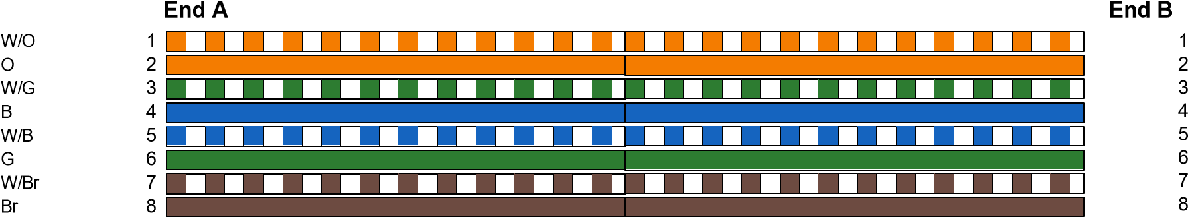
W/O
O
W/G
B
W/B
G
W/Br
Br

Cable 1: Straight-through cable (T568B - T568B)

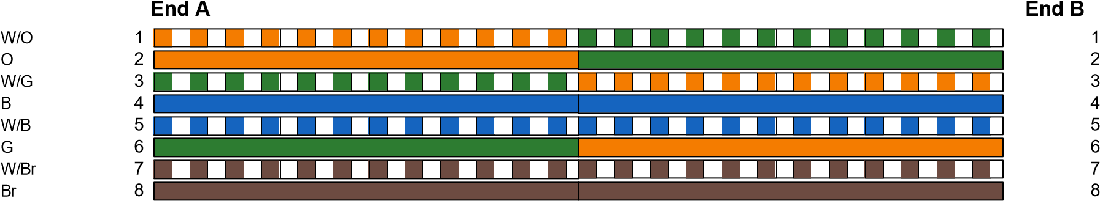
W/G
G
W/O
B
W/B
O
W/Br
Br

Cable 2: Crossover cable (T568B - T568A)

LAN cable tester result
MAIN |   1 |  | 2 | LAN TESTER - Cable 1 (Straight)
 |  |  |  |   3  4  5  6 | 7 | 8
REMOTE |   1 |  | 2 |   3  4  5  6 | 7 | 8
LEDs glow in the order 1-2-3-4-5-6-7-8 : cable is OK


LAN TESTER
-

Cable 2
)
Crossover
(

MAIN

1

2

3

4

5

6

7

8

REMOTE

3

6

1

4

5

2

7

8

LEDs glow in the order 3-6-1-4-5-2-7-8 : crossover cable is OK

Cable | Main unit LED | Remote unit LED | Status
Straight-through | 1 2 3 4 5 6 7 8 | 1 2 3 4 5 6 7 8 | Working
Crossover | 1 2 3 4 5 6 7 8 | 3 6 1 4 5 2 7 8 | Working

RESULT:
Thus the different types of network cables were studied. A straight-through cable and a crossover cable were made using the crimping tool and both were tested successfully with the LAN tester.

