Exp No: 5 | Experiments on Packet capture tool: Wireshark

AIM:
To understand the features of Wireshark as a packet capture tool and to understand the encapsulation of information at the various layers of a protocol stack.
ALGORITHM / PROCEDURE:
- Install and open Wireshark. The home screen lists all the network interfaces with a small activity graph.
- Double click the active interface (Ethernet / Wi-Fi) to start the capture.
- Generate some traffic: open a website in the browser, run ping google.comand nslookup example.com in the Command Prompt.
- Stop the capture using the red square button.
- Apply display filters in the filter bar, for example icmp, dns, tcp.port == 80, ip.addr == 192.168.1.25.
- Select one packet and expand its layers in the Packet Details pane. Study the Frame, Ethernet II, Internet Protocol, TCP / ICMP headers.
- Select any header field and see the corresponding bytes highlighted in the Packet Bytes pane.
- Use Analyze > Follow > TCP Stream to follow the full TCP conversation and note the three-way handshake (SYN, SYN-ACK, ACK).
- Save the capture using File > Save As (.pcapng).
Features of Wireshark
- Captures live packets from Ethernet, Wi-Fi, loopback and other interfaces and also reads saved .pcap files.
- Capture filters (before capture) and display filters (after capture).
- Colouring rules to identify the protocols easily (TCP, UDP, ICMP, ARP, HTTP ...).
- Shows all the protocol headers layer by layer with the raw bytes.
- Statistics tools like Conversations, Protocol Hierarchy and I/O Graph.

Layer | Protocol example | PDU name | Header added
Application | HTTP, DNS | Data / Message | Application header
Transport | TCP, UDP | Segment / Datagram | Port numbers, sequence no. (TCP 20 B, UDP 8 B)
Network | IP, ICMP | Packet | Source and destination IP address (20 B)
Data link | Ethernet | Frame | Source and destination MAC (14 B) + FCS (4 B)
Physical | UTP, Wi-Fi | Bits | None - only signals
DIAGRAM:

DATA

TCP/ICMP header +
DATA

IP header | TCP header |
DATA

Eth header | IP | TCP | DATA |
FCS

Application
layer

Data

Transport
layer

Segment

Network
layer

Packet

Data link
layer

Frame

0 1 0 1 1 0 0 1 0 1 1 ...

Physical layer Bits

Fig 1: Encapsulation of data as it moves down the protocol stack
OUTPUT:

Capturing from Ethernet - Wireshark
No. | Time | Source | Destination | Protocol | Len | Info
1 | 0.000000 | 192.168.1.25 | 192.168.1.1 | DNS | 70 | Standard query 0x3a1c A example.com
2 | 0.012431 | 192.168.1.1 | 192.168.1.25 | DNS | 86 | Standard query response 0x3a1c A example.com A 93.184.21
3 | 0.013102 | 192.168.1.25 | 93.184.216.34 | TCP | 66 | 51322 > 80 [SYN] Seq=0 Win=64240 Len=0 MSS=1460
4 | 0.041875 | 93.184.216.34 | 192.168.1.25 | TCP | 66 | 80 > 51322 [SYN, ACK] Seq=0 Ack=1 Win=65535 Len=0
5 | 0.041932 | 192.168.1.25 | 93.184.216.34 | TCP | 54 | 51322 > 80 [ACK] Seq=1 Ack=1 Win=131328 Len=0
6 | 0.042210 | 192.168.1.25 | 93.184.216.34 | HTTP | 142 | GET / HTTP/1.1
7 | 0.071655 | 93.184.216.34 | 192.168.1.25 | TCP | 54 | 80 > 51322 [ACK] Seq=1 Ack=89 Win=65535 Len=0
8 | 0.093340 | 93.184.216.34 | 192.168.1.25 | HTTP | 1294 | HTTP/1.1 200 OK (text/html)
9 | 1.402118 | 192.168.1.25 | 142.250.195.78 | ICMP | 74 | Echo (ping) request id=0x0001, seq=21/5376, ttl=128
10 | 1.416875 | 142.250.195.78 | 192.168.1.25 | ICMP | 74 | Echo (ping) reply id=0x0001, seq=21/5376, ttl=117
11 | 2.118004 | c4:e9:84:2a:5b:10 | Broadcast | ARP | 60 | Who has 192.168.1.25? Tell 192.168.1.1

6.34

Packet List pane - captured packets (colours show the protocol)

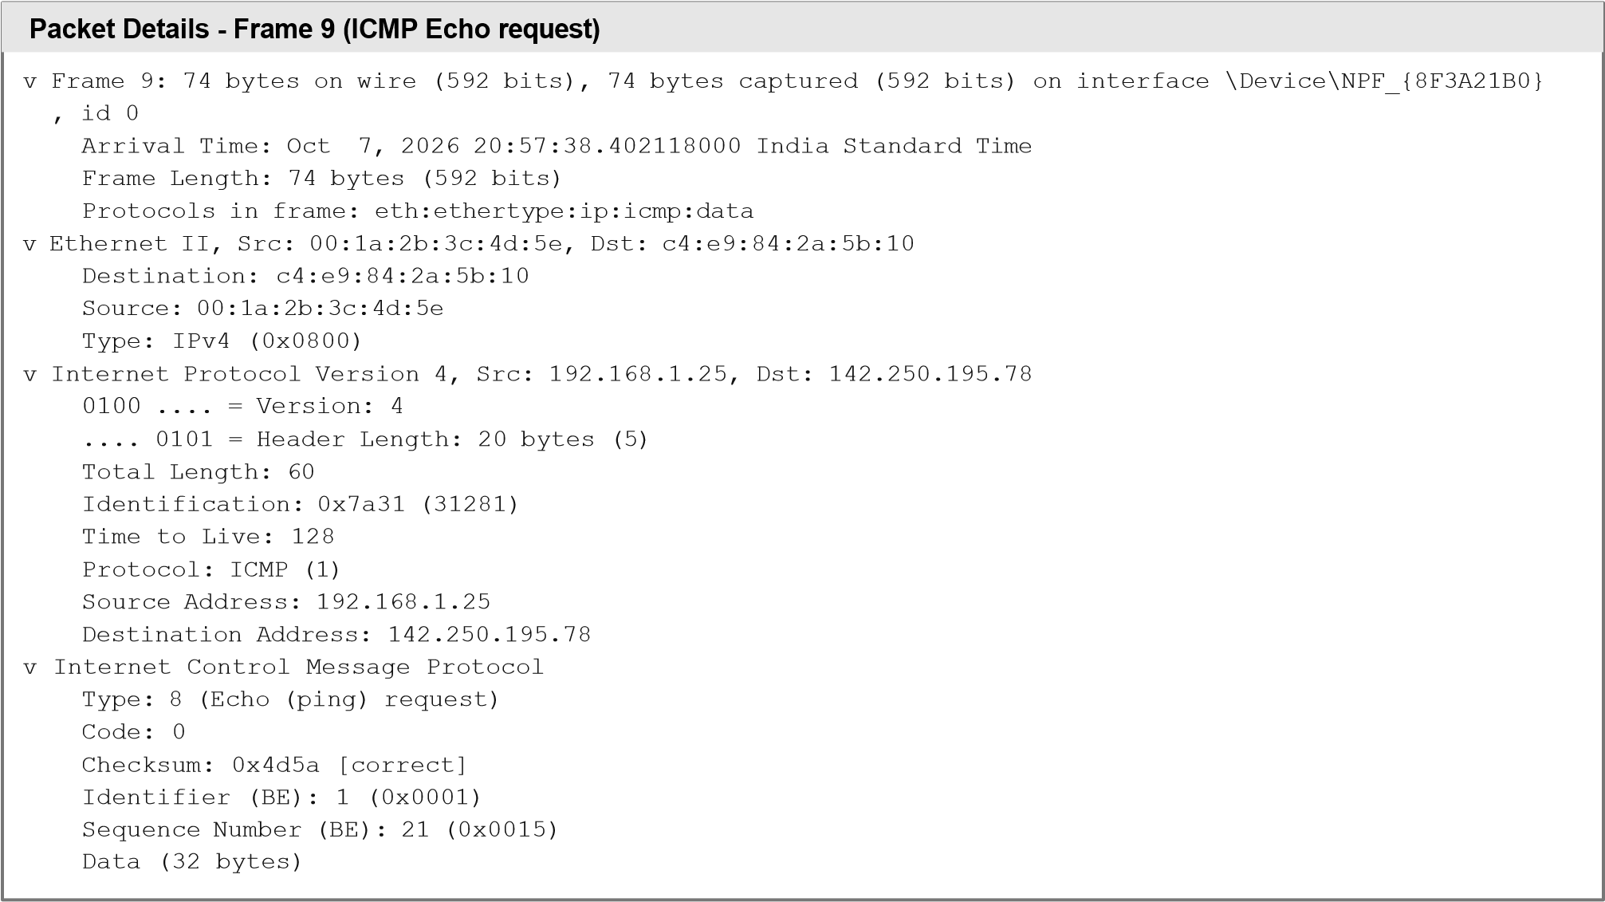
Packet Bytes - Frame 9
0000 | c4 | e9 | 84 | 2a | 5b | 10 | 00 | 1a | 2b | 3c 4d 5e 08 | 00 | 45 | 00 | ...*[...+<M^..E.
0010 | 00 | 3c | 7a | 31 | 00 | 00 | 80 | 01 | 00 | 00 c0 a8 01 | 19 | 8e | fa | .<z1............
0020 | c3 | 4e | 08 | 00 | 4d | 5a | 00 | 01 | 00 | 15 61 62 63 | 64 | 65 | 66 | .N..MZ. .......... abcdef
0030 | 67 | 68 | 69 | 6a | 6b | 6c | 6d | 6e | 6f | 70 71 72 73 | 74 | 75 | 76 | ghijklmnopqrstuv
0040 | 77 | 61 | 62 | 63 | 64 | 65 | 66 | 67 | 68 | 69 |  |  |  | wabcdefghi

Layer | Bytes in the frame | Observed value
Ethernet II | 00 - 13 (14 bytes) | c4:e9:84:2a:5b:10 <- 00:1a:2b:3c:4d:5e, type 0x0800
IPv4 | 14 - 33 (20 bytes) | 192.168.1.25 -> 142.250.195.78, TTL 128, protocol 1 (ICMP)
ICMP | 34 - 41 (8 bytes) | Type 8, Code 0, id 1, seq 21
Data | 42 - 73 (32 bytes) | abcdefghijklmnopqrstuvwabcdefghi

RESULT:
Thus the features of Wireshark were studied. Packets were captured and the encapsulation of data at the Data link (Ethernet), Network (IP), Transport (TCP) and ICMP layers was observed in the packet details.

