Exp No: 7 | Flow Control at Data Link Layer using Sliding Window Protocol

AIM:
To write a program that implements flow control at the data link layer using the Sliding Window Protocol (Go-Back-N) and to simulate the flow of frames from one node to another.
ALGORITHM / PROCEDURE:
- Read the total number of frames and the window size N. The sender may send up to N frames without waiting for an acknowledgement.
- Keep two pointers at the sender: _{base} (oldest unacknowledged frame) and _{nxt} (next frame to send).
- While _{nxt < base + N}, send frame number nxt and increase nxt.
- The receiver accepts frames in order. For each correct frame it sends an acknowledgement ACK (frame number + 1).
- When the sender receives an ACK, the window slides forward by one position (base = base + 1).
- If a frame is lost the receiver discards the later frames, the sender times out and sends again from the lost frame (Go-Back-N).
- Repeat until all the frames are acknowledged and display the sequence of events.

Fig 1: Sender window over the frame sequence

Frames F4 to F7 wait outside the window


F7

F6

F5

F4

F3

F2

F1

F0

Sender window (size = 4)

Fig 2: Frame and ACK exchange between sender and receiver


Frame
0

Frame
1

Frame
2

Frame
3

ACK 1, 2,
3

Frame 3 lost
-
>
timeout
-
>
resend from Frame
3

SENDER

RECEIVER

PROGRAM:

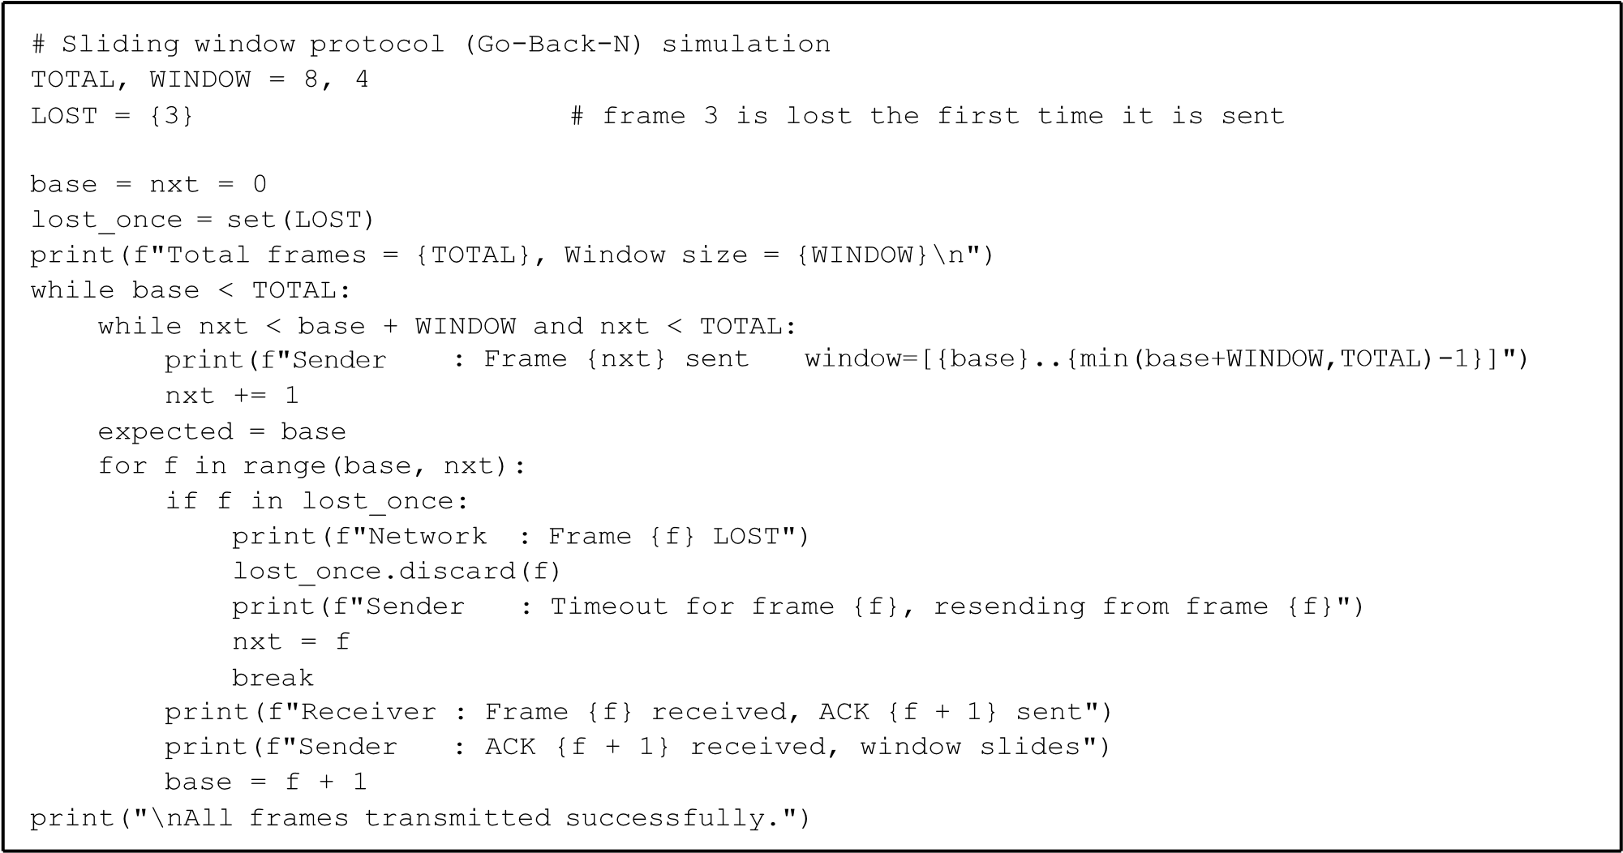
OUTPUT:

UuUsSeErR

@
UuUsSeErR

Terminal
-

Sliding window
simulation

-
VirtualBox
:
~$

python3

exp7.py

Total

frames

=

8
,

Window

size

=

4

Sender

:
Frame 0 sent

window=[0..3]
Sender

:
Frame 1 sent

window=[0..3]
Sender

Frame 2 sent
:

window=[0..3]
Sender

:
Frame 3 sent

window=[0..3]
Receiver : Frame 0 received, ACK 1 sent
Sender

:
ACK 1 received, window slides
Receiver : Frame 1 received, ACK 2 sent
Sender

:
ACK 2 received, window slides
Receiver : Frame 2 received, ACK 3 sent
Sender

ACK 3 received, window slides
:
Network

:
Frame 3 L
OST

Sender

Timeout for frame 3, resending from frame 3
:
Sender

Frame 3 sent
:

window=[3..6]

Sender

Frame 4 sent
:

window=[3..6]
Sender

:
Frame 5 sent

window=[3..6]
Sender

Frame 6 sent
:

window=[3..6]
Receiver : Frame 3 received, ACK 4 sent
Sender

:
ACK 4
received, window slides
Receiver : Frame 4 received, ACK 5 sent
Sender

:
ACK 5 received, window slides
Receiver : Frame 5 received, ACK 6 sent
Sender

:
ACK 6 received, window slides
Receiver : Frame 6 received, ACK 7 sent
Sender

:
ACK 7 received, window slides
Sender

:
Frame 7 sent

window=[7..7]
Receiver : Frame 7 received, ACK 8 sent
Sender

:
ACK 8 received, window slides

All

frames

transmitted

successfully.

RESULT:
Thus the sliding window protocol was implemented and the transmission of 8 frames from the sender to the receiver was simulated successfully. The lost frame 3 was retransmitted after the timeout and all frames were delivered in order.

