Exp No: 8 | NMAP to Discover Live Hosts using Nmap Scans (ARP, ICMP, TCP/UDP) on the TryHackMe Platform

AIM:
To use the Nmap tool on the TryHackMe platform to discover live hosts in a network using ARP, ICMP, TCP and UDP ping scans.
ALGORITHM / PROCEDURE:
- Log in to the TryHackMe website, open the Nmap Live Host Discovery room and click Start AttackBox. Click Start Machine to deploy the target.
- Open the terminal in the AttackBox and note the IP address of the AttackBox using ip a.
- ARP scan: run nmap -PR -sn 10.10.5.0/24. ARP works only for hosts on the same subnet.
- ICMP scan: run nmap -PE -sn 10.10.5.0/24to send ICMP echo requests (ping).
Send probe |  | Reply? |  | Mark host  UP / DOWN |  | Print scan report
- TCP scan: run nmap -PS22,80,443 -sn( SYN ping) and nmap -PA80 -sn( ACK ping).
- UDP scan: run nmap -PU53,161 -snto send empty UDP packets to the given ports.
- Note the hosts reported as "up" and compare the results of the four scan types.

Fig 1: Host discovery probes sent from the AttackBox

Attacker  TryHackMe  AttackBox  10.10.5.10 | ARP request (-PR) | Target network  10.10.5.0/24  .1 Gateway  .17 Target  .23 Other host
Attacker  TryHackMe  AttackBox  10.10.5.10 | ICMP echo request (-PE)
Attacker  TryHackMe  AttackBox  10.10.5.10 | TCP SYN / ACK (-PS, -PA)
Attacker  TryHackMe  AttackBox  10.10.5.10 | UDP probe (-PU)

Fig 2: Working of a host discovery scan

Commands used:

Scan type | Option | Command
ARP ping | -PR | nmap -PR -sn 10.10.5.0/24
ICMP echo ping | -PE | nmap -PE -sn 10.10.5.0/24
TCP SYN ping | -PS | nmap -PS22,80,443 -sn 10.10.5.0/24
TCP ACK ping | -PA | nmap -PA80 -sn 10.10.5.0/24
UDP ping | -PU | nmap -PU53,161 -sn 10.10.5.0/24
List scan (no probes) | -sL | nmap -sL 10.10.5.0/24
OUTPUT:

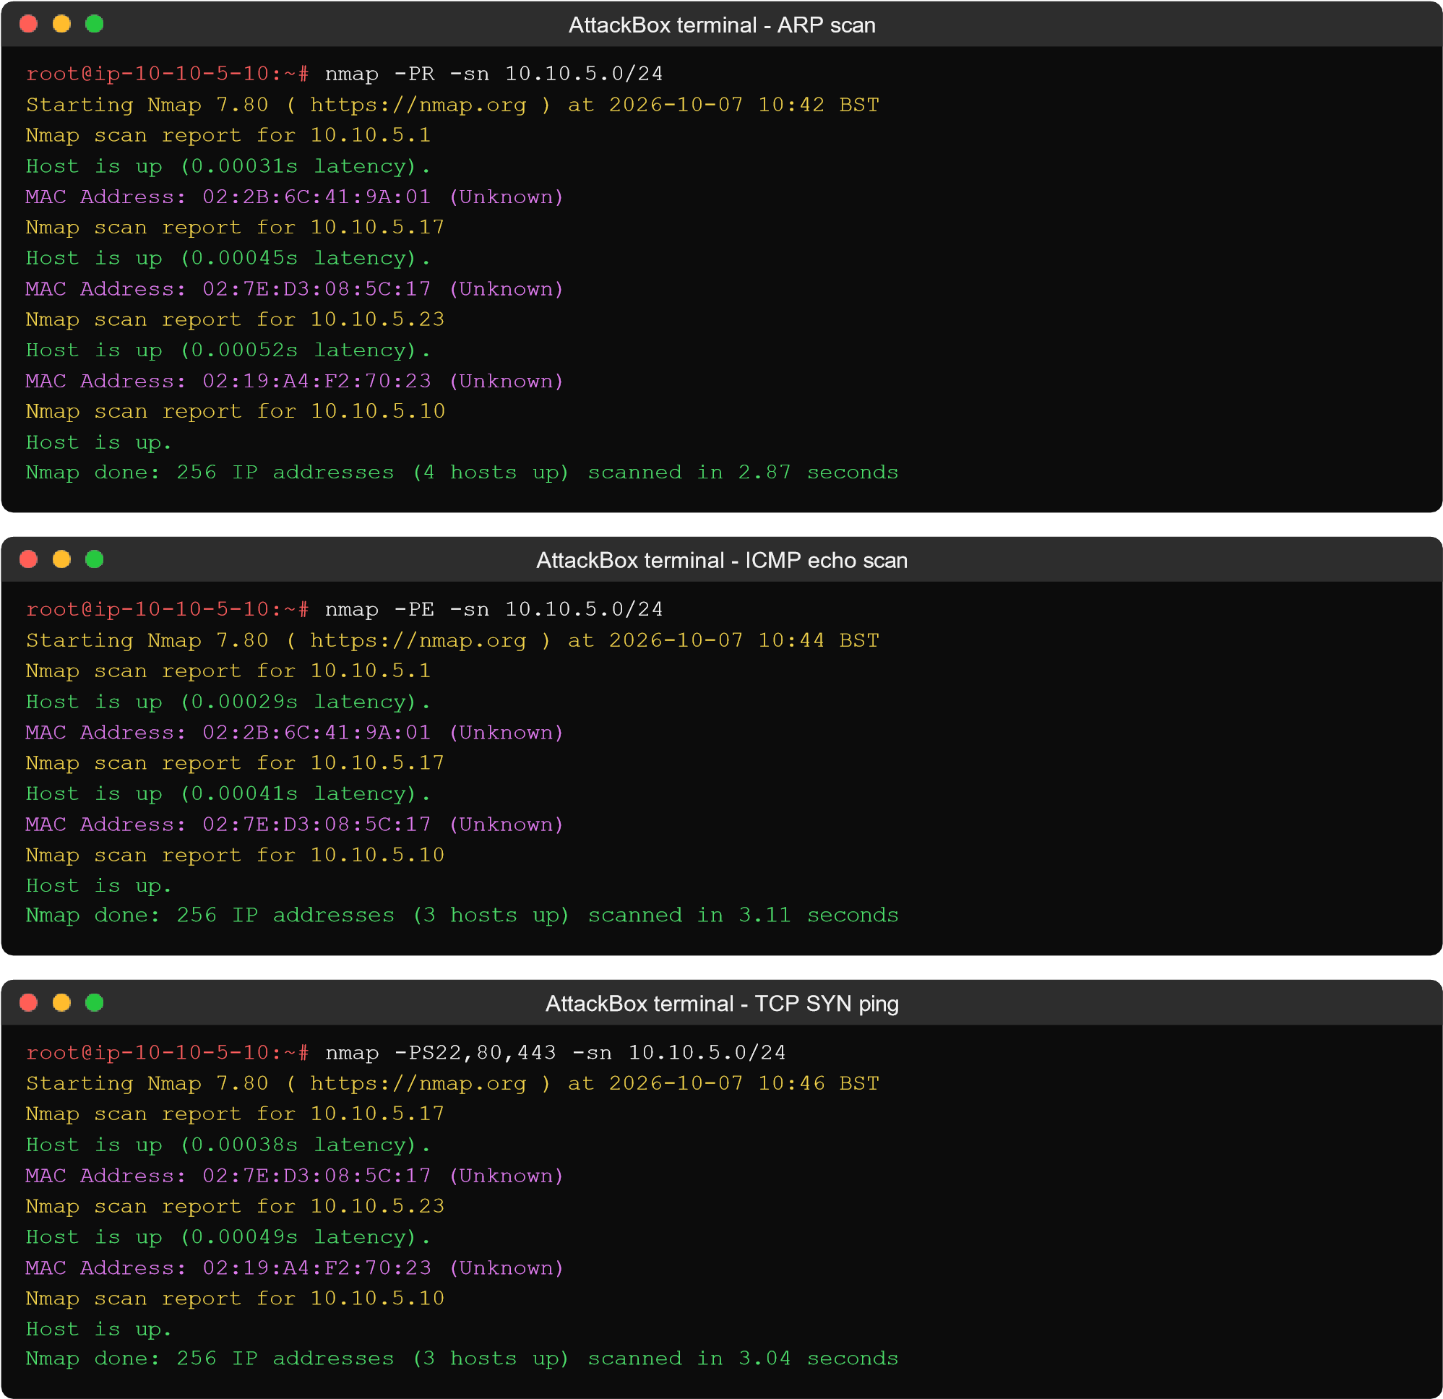


AttackBox terminal
-

UDP
ping

root@ip
-
10
-
10
-
5
-
10:
~#

nmap

-
PU53,161

-
sn

10.10.5.0/24

Starting Nmap 7.80 (
https://nmap.or
g

)
at
2026
-
10
-
07
10:49
BST
Nmap scan report for 10.10.5.17

Host

is

up

(0.00044
s

latency).

MAC Address: 02:7E:D3:08:5C:17 (Unknown)
Nmap scan report for 10.10.5.10

Host

is

up.

Nmap

done:

256

IP

addresses

(2

hosts

up)

scanned

in

3.15

seconds

AttackBox terminal
-

TCP ACK
ping

root@ip
-
10
-
10
-
5
-
~#
10:

nmap

-
PA80

-
sn

10.10.5.0/24

Starting Nmap 7.80 (
g
https://nmap.or

2026
)
at
-
10
-
10:47 BST
07
Nmap scan report for 10.10.5.17

Host

is

up

(0.00036
s

latency).

MAC Address: 02:7E:D3:08:5C:17 (Unknown)
Nmap scan report for 10.10.5.10

Host

is

up.

Nmap

do
ne:

256

IP

addresses

(2

hosts

up)

scanned

in

3.02

seconds

RESULT:
Thus the live hosts in the network were discovered using Nmap with ARP, ICMP, TCP and UDP scans on the TryHackMe platform. The ARP scan found the most hosts (4) because it works at the data link layer and cannot be blocked by a firewall on the same subnet, while the ICMP, TCP and UDP scans depended on how the target responded to each probe.

