**INTEGRATING WEB APP USING FLASK**

In this phase, we build the chatbot and integrate it into the web app using Flask.

**Step 1:** ( USER INTERFACE (UI) )

Creating the HTML template (**index.html**) to create a better user interface. We can use CSS for styling and JavaScript to handle user interactions.

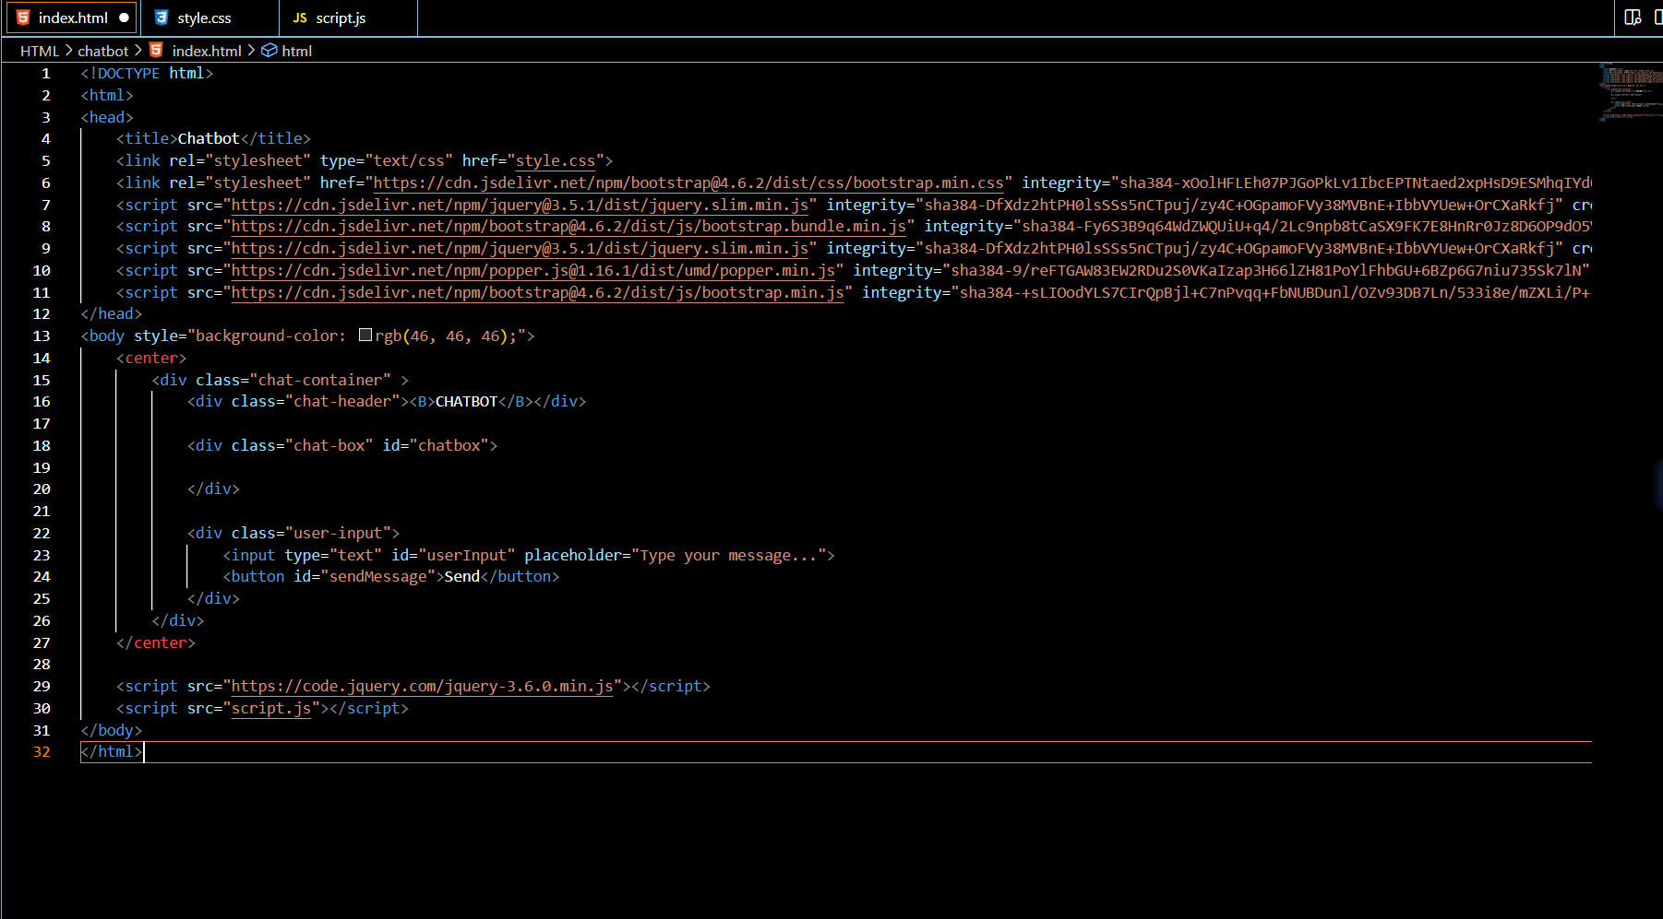

UI:

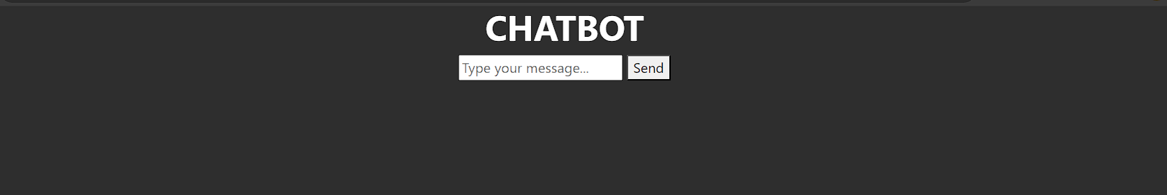

**Step 2 :** (STYLING)

Create an “EXAMPLE NAME” directory in our project directory and place all HTML, CSS, and JavaScript files there.

Then we can customize the styling of our chatbot interface in these files.

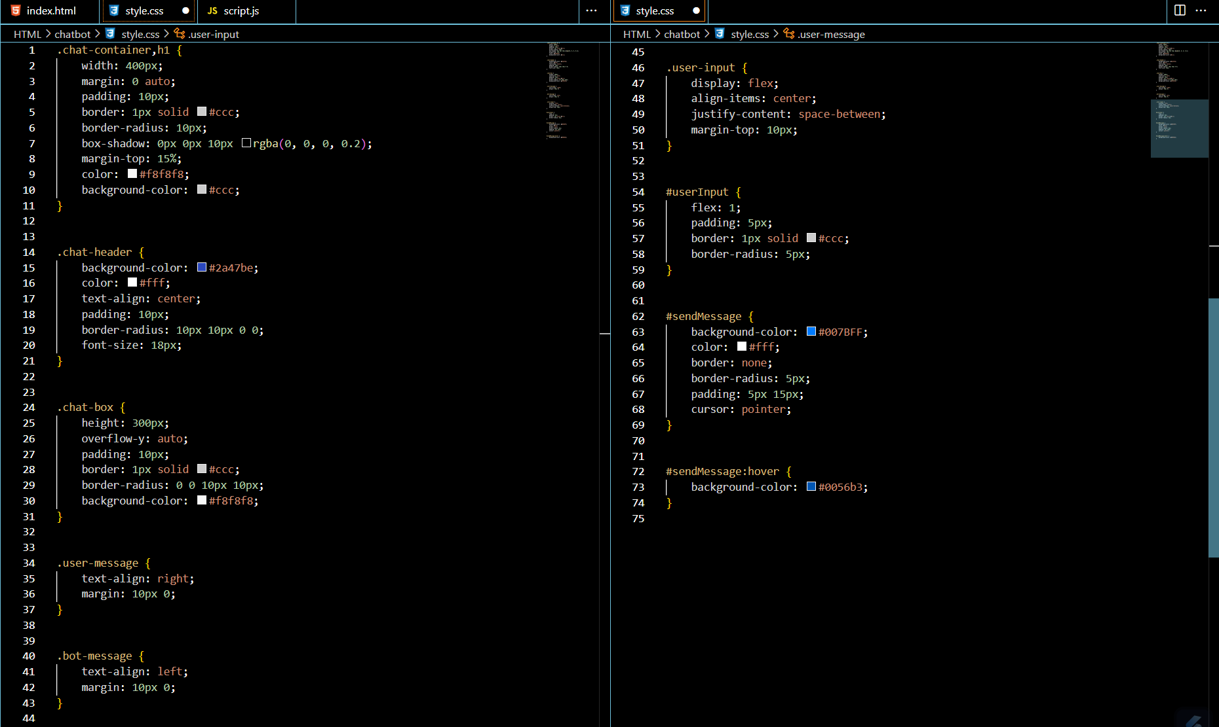

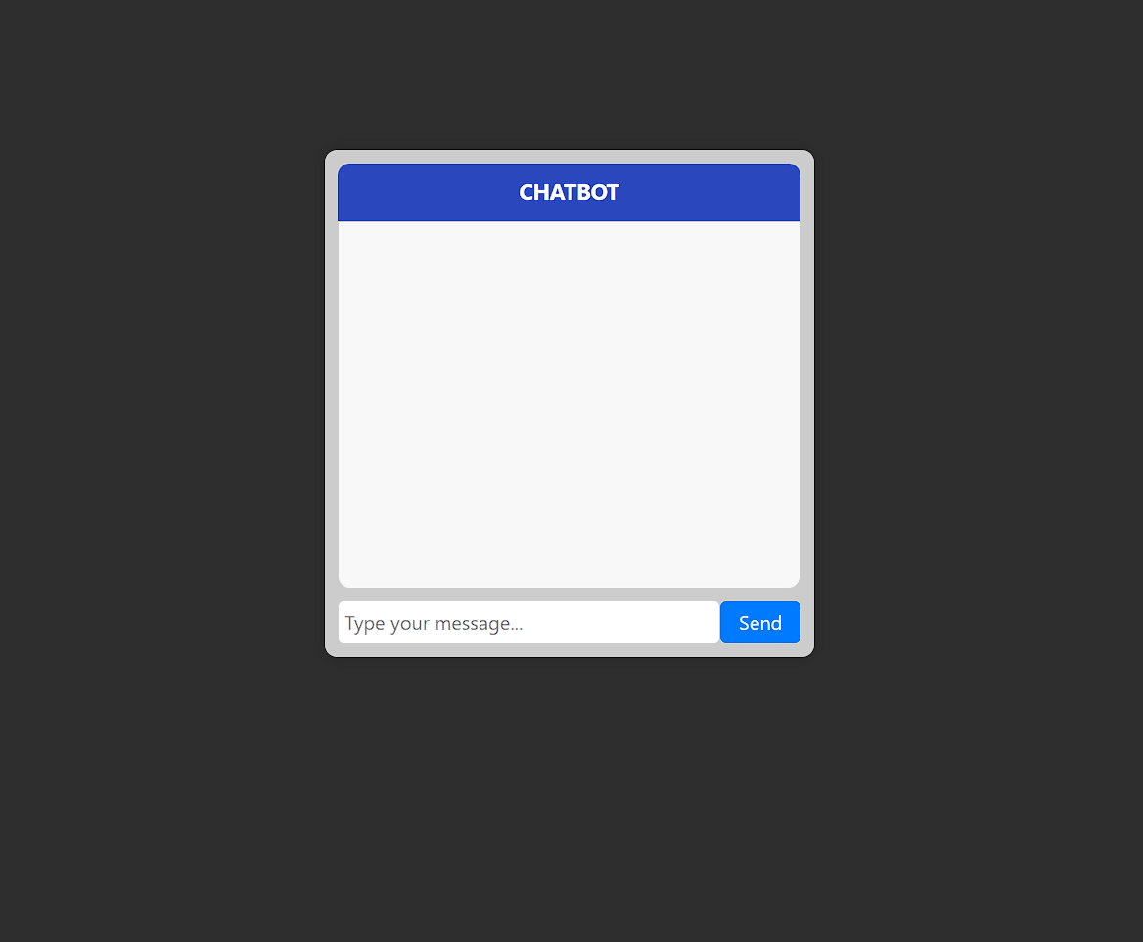

**Step 3:** (CHAT INTEGRATION)

Adding the JavaScript code in our ‘**script.js’** to handle chat interactions. This code will send user messages to the server and display responses.

