

SIMATS ENGINEERING

Saveetha Institute of Medical and Technical Sciences
Chennai – 602105

SMART WATER CONSUMPTION MONITORING AND
LEAK DETECTION MANAGEMENT SYSTEM

A CAPSTONE PROJECT REPORT

A Capstone Project Report submitted in partial fulfilment of the requirements
for the course and award of the degree of

BACHELOR OF TECHNOLOGY
IN
COMPUTER SCIENCE AND ENGINEERING

Submitted by
M. Poojith Ganesh – 192311290
Under the Supervision of
Madhan

SIMATS ENGINEERING
Saveetha Institute of Medical and Technical Sciences
Chennai – 602105

SEPTEMBER 2026

BONAFIDE CERTIFICATE

This is to certify that the Capstone Project entitled “Intelligent Water Usage Monitoring and Leakage Alert Management System” has been carried out by M. Poojith Ganesh (192311290) , K. Krishna Charan (192311316), Ch Teja Srinivas(192311280) and A.Adarsh(192365002) under the supervision of Madhan and is submitted in partial fulfilment of the requirements for the current semester of the B.Tech. Computer Science and Engineering programme at SIMATS Engineering, Saveetha Institute of Medical and Technical Sciences, Chennai.
The project applies Object-Oriented Analysis and Design principles to model water-consumption monitoring, abnormal-flow analysis, leakage detection, alert management, reporting and data storage. The report presents the analysis and proposed design using UML-based artefacts and a layered software architecture.

Role | Name / Designation | Signature
Project Supervisor | Madhan
Course / Faculty | CSA1101 – Object Oriented Analysis and Design
Student | K. Krishna Charan – 192311316
Student | K. Krishna Charan – 192311316

Place:
Date:

DECLARATION
We, M. Poojith Ganesh (192311290) and K. Krishna Charan (192311316), Ch Teja Srinivas (192311280) and A. Adarsh(192365002), students of the Computer Science and Engineering programme at SIMATS Engineering, hereby declare that the Capstone Project Work entitled “Intelligent Water Usage Monitoring and Leakage Alert Management System” is the result of our academic work.
The report has been prepared using the supplied project presentation as the primary project source and by developing the corresponding OOAD documentation in a capstone-report structure. The UML diagrams, system architecture, requirements tables and database model included in this report represent the proposed design of the system based on the project scope described in the source presentation.
All books, standards and other sources used for the report have been acknowledged in the References section. No claim of measured field performance is made where implementation or experimental evidence is not available in the supplied material.

Place:
Date:
Signature of Students with Names

INDIVIDUAL CONTRIBUTION STATEMENT
Student | Analysis & Design | Implementation / Modelling | Testing & Documentation | Contribution
M. Poojith Ganesh  192311290 | Requirement analysis, use-case modelling | Water-consumption monitoring design, UML modelling | Review of system behaviour and records | 25%
K. Krishna Charan  192311316 | Problem analysis, architecture and class identification | Leak detection, alert-management and database design | Integration, testing plan and final documentation | 25%
Ch Teja Srinivas 192311280 | Activity & requirement analysis | Component & deployment modelling | Test cases & documentation | 25%
A. Adarsh  192365002 | Non-functional & system analysis | Sequence & reporting design | Results & final review | 25%
TOTAL |  |  |  | 100%

The responsibilities are divided around the two principal functional areas identified in the project presentation: water-consumption monitoring and leak detection/alert management. Both students contribute to the OOAD analysis, UML design, validation and final report preparation.

Academic Deliverables
- Requirements and problem definition.
- Object-oriented analysis and identification of actors, use cases, classes and interactions.
- System architecture and layered design.
- Use Case, Class, Sequence, Activity, Component and Deployment diagrams.
- Logical database model for users, consumption records, leakage information, alerts and logs.
- Testing strategy, limitations, future scope and final technical documentation.

ABSTRACT
The Intelligent Water Usage Monitoring and Leakage Alert Management System is an object-oriented design for observing water-flow behaviour, maintaining usage history and assisting users in responding to suspected leakage. The proposed solution combines sensor-oriented data acquisition with application services that interpret flow information and present useful status information through a centralized interface.
The system is developed from an Object-Oriented Analysis and Design perspective so that requirements can be traced to actors, use cases, domain classes, interactions and deployment elements. A three-tier arrangement is used to separate presentation functions, operational services and persistent storage. This separation helps the proposed application accommodate future changes such as additional sensing points, alternative notification channels and analytical services.
The solution is organized around two complementary capabilities: water-usage observation and leakage-event management. Usage observation focuses on receiving readings, validating them and maintaining historical records. Leakage management examines the readings for abnormal patterns, creates an event when a configurable condition is reached, records the event and prepares an appropriate notification.
The report presents an implementation-oriented design rather than claiming completed field performance. It provides requirements, UML models, database structures, verification scenarios, risks and future enhancements. Possible extensions include connected meters, mobile access, cloud synchronization, predictive analytics and multi-zone monitoring.
The system is analysed using Object-Oriented Analysis and Design (OOAD) principles. UML artefacts—including Use Case, Class, Sequence, Activity, Component and Deployment diagrams—are used to represent functional requirements, static structure, interactions, process flow and deployment structure. The proposed architecture is organized into a User Interface Layer, Business Logic Layer and Database Layer. Water-flow sensor data is processed by the business logic, consumption records are maintained in the database, and abnormal patterns are passed to a leak-detection engine that can create alerts and notifications.
The design is divided into two principal functional areas: Water Consumption Monitoring and Leak Detection and Alert Management. The first area tracks usage and maintains consumption records; the second analyses flow behaviour, identifies possible leak conditions, manages notifications and maintains leakage history. The system also provides a foundation for report generation, user management and configurable system settings.
The proposed design emphasizes modularity, maintainability, scalability and timely decision-making. Future extensions can include IoT-enabled sensors, mobile applications, smart meters, machine-learning-based prediction and advanced analytics. The report therefore provides a structured OOAD foundation for developing a smart water-management application that can help reduce water wastage and improve resource management.
Keywords: Object-Oriented Analysis and Design, Smart Water Management, Water Consumption, Leak Detection, UML, IoT, Database, Alert Management.

TABLE OF CONTENTS
Sl. No. | Title | Page No.
1 | CHAPTER 1: INTRODUCTION AND ENGINEERING PROBLEM | 10
1.1 | Background | 10
1.2 | Need for the Project | 10
1.3 | Problem Statement | 11
1.4 | Aim and Objectives | 11
1.5 | Scope | 11
1.6 | Expected Engineering Outcome | 12
2 | CHAPTER 2: LITERATURE REVIEW AND EXISTING SOLUTIONS | 12
2.1 | Review Method | 13
2.2 | Review of Existing Work | 13
2.3 | Comparative Analysis | 13
2.4 | Research / Engineering Gap | 14
2.5 | Proposed Contribution | 14
3 | CHAPTER 3: SYSTEM ANALYSIS AND OOAD DESIGN | 15
3.1 | Requirements Analysis | 15
3.2 | Functional and Non-Functional Requirements | 15
3.3 | Constraints and Design Principles | 16
3.4 | Design Specifications | 16
3.5 | System Architecture | 17
3.6 | Use Case Model | 18
3.7 | Class Model | 19
3.8 | Interaction Model – Sequence | 20
3.9 | Activity Model | 21
3.10 | Component and Deployment Models | 22
3.11 | Database Design | 24
3.12 | Design Alternatives and Trade-Offs | 25
3.13 | Sustainability, Ethics, Safety, Risk & Security | 25
4 | CHAPTER 4: IMPLEMENTATION, TESTING & RESULTS | 26
4.1 | Development Approach and Resources | 26
4.2 | Implementation Flow | 26
4.3 | Testing and Verification | 27
4.4 | Results and Discussion | 27
4.5 | Challenges and Limitations | 28
4.6 | Project Management | 29
5 | CHAPTER 5: CONCLUSION, FUTURE WORK AND REFLECTION | 30
5.1 | Conclusion | 30
5.2 | Future Scope | 30
5.3 | Professional Learning & Reflection | 30
 | REFERENCES | 32
 | APPENDICES | 33

LIST OF FIGURES
Figure No. | Figure Name | Page No.
Figure 1.1 | Expected system workflow | 11
Figure 3.1 | System Architecture | 16
Figure 3.2 | Use Case Diagram | 17
Figure 3.3 | Class Diagram | 18
Figure 3.4 | Sequence Diagram | 19
Figure 3.5 | Activity Diagram | 20
Figure 3.6 | Component Diagram | 21
Figure 3.7 | Deployment Diagram | 21
Figure 3.8 | Logical Database Model | 22

LIST OF TABLES
Table No. | Table Name | Page No.
Table 2.1 | Literature Review / Background | 12
Table 2.2 | Comparative Analysis of Existing Approaches | 13
Table 3.1 | Stakeholder and User Requirements | 14
Table 3.2 | Functional and Non-Functional Requirements | 14
Table 3.3 | Constraints and Design Principles | 15
Table 3.4 | Design Specifications | 15
Table 3.5 | Design Alternatives Evaluation | 23
Table 3.6 | Sustainability, Ethics, Safety and Security | 23
Table 3.7 | Project Risk Register | 23
Table 4.1 | Development Resources Used | 24
Table 4.2 | Test Plan and Verification | 26
Table 4.3 | System Testing Scenarios | 27

LIST OF ABBREVIATIONS / SYMBOLS

Abbreviation | Description
OOAD | Object-Oriented Analysis and Design
UML | Unified Modeling Language
UI | User Interface
DBMS | Database Management System
IoT | Internet of Things
API | Application Programming Interface
SQL | Structured Query Language
CRUD | Create, Read, Update, Delete
SMS | Short Message Service
HTTPS | Hypertext Transfer Protocol Secure
PK | Primary Key
FK | Foreign Key

CHAPTER 1
INTRODUCTION AND ENGINEERING PROBLEM

1.1 BACKGROUND
Water distribution systems require visibility into both the quantity of water being consumed and the conditions under which that consumption occurs. A conventional meter can provide a useful measurement, but a reading viewed only at intervals may hide short-duration or continuous abnormal flow.
This project proposes an intelligent software model in which flow information is treated as a stream of observations that can be stored, analysed and converted into user-visible events. Instead of treating measurement, analysis and notification as isolated activities, the design connects them through a coherent object-oriented workflow.
From the OOAD viewpoint, the problem is decomposed into identifiable responsibilities. Users need understandable consumption information, operators need operational records and administrators need configuration and management facilities. Sensor data therefore becomes an input to a set of collaborating objects rather than an isolated hardware value.
The supplied project presentation proposes a Intelligent Water Usage Monitoring and Leakage Alert Management System using OOAD principles. The system is intended to collect water-flow information, monitor consumption, analyse abnormal usage patterns, detect possible leakage and provide alerts. The design is organized around a user interface, business logic and database layer, enabling separation of concerns and easier maintenance.
From an OOAD perspective, the problem is modelled through actors, use cases, domain classes, object interactions, activities, components and deployment nodes. This allows the proposed software to be examined before implementation and provides a common representation for developers, evaluators and stakeholders.

1.1.1 Project Context
- Real-time or near-real-time flow information can provide better visibility than periodic manual readings.
- Abnormal or continuous flow can be treated as an indication requiring further inspection.
- A centralized record of consumption and leakage events supports analysis and reporting.
- Alert management provides a mechanism for communicating possible leakage conditions to users or administrators.
- A modular OOAD design supports later integration with smart meters, IoT devices and analytics.

1.2 NEED FOR THE PROJECT
- The proposed system is motivated by the need for quicker visibility of water usage and abnormal flow. Manual inspection may be unable to reveal when an unusual condition begins, while unstructured historical readings make it difficult to compare present behaviour with earlier observations.
- A centralized application can reduce this gap by retaining timestamped observations, presenting current status, applying configurable detection logic and maintaining a traceable alert history. Such a design also creates a common information source for users and administrators.
- Leakages can remain undetected when inspection depends on manual observation.
- Excessive consumption is difficult to analyse without organized historical records.
- Timely alerts can reduce the delay between abnormal flow and corrective action.
- Centralized management can improve visibility of users, consumption, leakage and alert history.

1.3 PROBLEM STATEMENT
The engineering problem is to design a maintainable software system that can accept water-flow observations, transform them into meaningful consumption records, evaluate unusual flow behaviour and communicate suspected leakage events. The design must also preserve historical information and provide controlled access to users and administrators.
The challenge is not simply to detect a high flow value. The system must keep acquisition, validation, analysis, persistence and notification sufficiently separated so that each responsibility can be tested and improved independently.

1.4 AIM AND OBJECTIVES
Aim: To design an object-oriented water-management application that converts flow observations into organized consumption information and traceable leakage alerts.
Objectives:
• Identify stakeholders, actors and system responsibilities.
• Define functional and quality requirements for monitoring and alert handling.
• Develop a modular architecture with clear separation of presentation, services and storage.
• Model domain objects and their relationships using UML.
• Describe the interaction sequence from sensor input to user notification.
• Provide configurable leakage-event handling and historical record management.
• Define a relational data model that supports reporting and auditing.
• Establish verification scenarios, risks and future implementation directions.
- Analyse system requirements and identify actors and major use cases.
- Design a layered, modular architecture for monitoring and management.
- Model water-consumption data and abnormal-flow analysis using object-oriented classes.
- Represent system interactions through sequence and activity models.
- Provide leakage-alert and notification management.
- Design a logical database structure for consumption, leakage, alerts and logs.
- Evaluate design alternatives, risks, limitations and future extensions.

1.5 SCOPE
The design covers sensor-data intake, validation, water-usage recording, abnormal-flow evaluation, leakage-event management, alert handling, user administration, reporting and persistent storage. It can be extended to multiple sensing locations and additional notification channels.
The present capstone design does not claim guaranteed physical leak localization, commercial-scale deployment or a trained machine-learning predictor. Those capabilities are treated as possible future extensions and would require implementation data and field validation.

1.6 EXPECTED ENGINEERING OUTCOME
The expected engineering outcome is a traceable OOAD design in which raw flow observations are converted into validated records, evaluated by monitoring and leakage services, and exposed through dashboards and alert mechanisms. The resulting structure should make it possible to replace or extend individual subsystems without redesigning the complete application.
The workflow begins with data acquisition and ends with either a normal usage update or a leakage event and notification. Persistent records provide the historical basis for reporting, auditing and later analytical improvements.
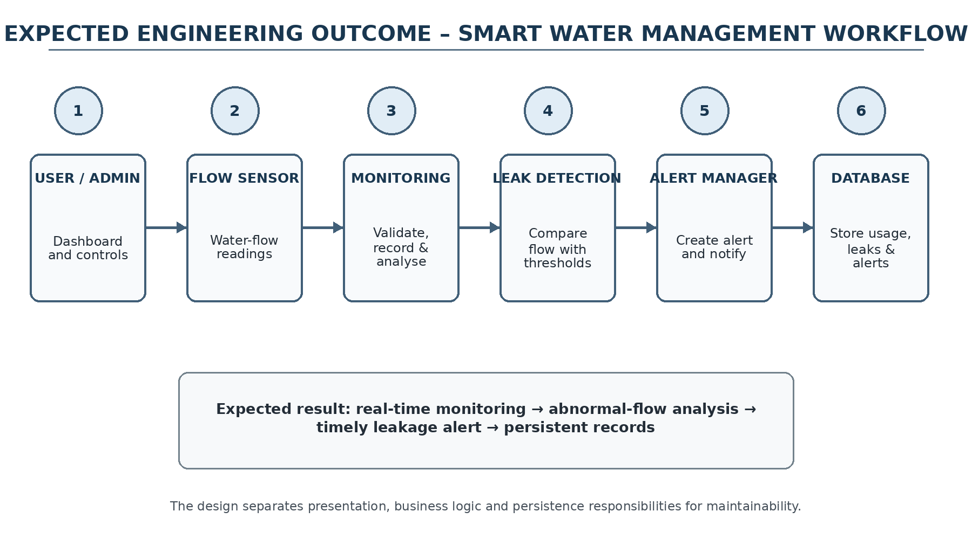
Figure 1.1 – Expected Engineering Outcome / Monitoring Workflow
The workflow is consistent with the source presentation: users interact through a dashboard and related interfaces; sensor readings enter the business-logic layer; consumption analysis and leak detection operate on the readings; alerts are managed and records are maintained in the database. The architecture also leaves a clear path for mobile notifications, email/SMS and cloud backup as extensions.

CHAPTER 2
LITERATURE REVIEW AND EXISTING SOLUTIONS

2.1 REVIEW METHOD
The review examines four solution directions relevant to the proposed application: conventional meter-based observation, IoT-enabled monitoring, sensor-assisted leakage analysis and centralized water-management platforms. The comparison focuses on visibility, responsiveness, data dependence and suitability for an OOAD implementation.
The purpose of the review is not to reproduce individual implementations but to identify design characteristics that should be retained or improved in the proposed system.

2.2 REVIEW OF EXISTING WORK
S.No | Study / Approach | Methodology Used | Drawbacks
1 | Smart Water Management: A Review of IoT-Based Technologies | IoT sensors and smart monitoring techniques for collecting and managing water data. | Limited focus on integrated leakage management.
2 | IoT-Based Smart Water Monitoring System | Flow sensors, microcontrollers and IoT communication for real-time monitoring. | Depends on connectivity and sensor accuracy.
3 | Water Leakage Detection Using Smart Sensors | Flow-pattern analysis and sensor readings to identify possible leakage. | Irregular normal usage may cause false detection.
4 | Real-Time Water Consumption Monitoring Using IoT | Smart meters and IoT platforms for continuous monitoring. | Requires calibration, maintenance and reliable communication.

2.3 COMPARATIVE ANALYSIS
Existing Approach | Advantages | Limitations | Relevance
Traditional meter + manual monitoring | Simple and familiar | Periodic readings; delayed leakage awareness | Baseline approach to improve
IoT-based smart monitoring | Real-time visibility and remote access | Connectivity and integration complexity | Future-compatible architecture
Sensor-based leakage detection | Can analyse flow behaviour | False alerts for irregular usage | Core detection concept
Proposed OOAD system | Modular, maintainable, traceable design | Implementation quality depends on sensor/data reliability | Selected capstone approach

2.4 RESEARCH / ENGINEERING GAP
A practical gap remains between collecting water data and turning that data into a maintainable software workflow. A system can have sensors and a dashboard yet still lack clear responsibility boundaries, event traceability and controlled handling of uncertain leakage conditions.
This project addresses that design gap by modelling acquisition, consumption records, detection, alerts, reporting and administration as coordinated but separable responsibilities.
- Monitoring and leakage management should be treated as coordinated functions.
- Consumption and alert history should be retained for analysis.
- Abnormal usage should be handled as a detection problem with configurable decision logic.
- The architecture should support future IoT and analytics integration without redesigning the entire system.

2.5 PROPOSED CONTRIBUTION
The contribution of this capstone is an implementation-oriented OOAD package for intelligent water monitoring. It connects stakeholder requirements with UML models, a layered architecture, relational data structures, verification scenarios and a risk-aware implementation plan. The design is intended to provide a clear starting point for a prototype and later IoT integration.

CHAPTER 3
SYSTEM ANALYSIS AND OOAD DESIGN

3.1 REQUIREMENTS ANALYSIS
Requirements were organized by the information and actions needed by each stakeholder. Users require current and historical usage information and understandable leakage notifications. Operators require access to operational records and system status. Administrators require control over users, thresholds, reports and configuration.
The resulting requirements are deliberately traceable: each major stakeholder need maps to one or more system functions, and each function can be represented through an OOAD artefact or verification scenario.
Stakeholder | Requirement
User | View current and historical water-consumption information.
User | Receive or view alerts for possible leakage conditions.
Administrator | Manage users and system settings.
Administrator | Review consumption and leakage records and generate reports.
System / Sensor | Provide water-flow readings to the monitoring subsystem.
Maintenance / Operator | Access organized records and system logs for inspection.

3.2 FUNCTIONAL AND NON-FUNCTIONAL REQUIREMENTS
Type | Requirement | Acceptance / Design Target
Functional | Collect flow data | Sensor readings are accepted by the monitoring service.
Functional | Record consumption | Readings are stored with time/context information.
Functional | Analyse usage | Usage patterns are processed for abnormal conditions.
Functional | Detect leakage | Possible abnormal flow creates a leakage event.
Functional | Manage alerts | Alert state, message and delivery channel are maintained.
Non-functional | Maintainability | Services and classes are modular and testable.
Non-functional | Reliability | Invalid or missing readings are handled without corrupting records.
Non-functional | Security | User access and stored records are protected through authentication and controlled access.

3.3 CONSTRAINTS AND DESIGN PRINCIPLES
Constraint / Principle | Application in the Project
OOAD modularity | Separate responsibilities into domain classes and services.
Separation of concerns | Keep presentation, business logic and database responsibilities distinct.
Data integrity | Validate sensor readings and database operations before storing or displaying data.
Scalability | Allow additional sensors, users, notification channels and analytics to be integrated.
Availability | Design the monitoring workflow so temporary communication problems do not silently corrupt records.
Usability | Provide understandable dashboards, status information and alerts.
Security | Use authentication, authorization, input validation and controlled database access.

3.4 DESIGN SPECIFICATIONS
Parameter | Target / Requirement | Priority
Flow sensing | Accept water-flow readings from the sensor interface | High
Consumption monitoring | Maintain current and historical usage information | High
Leak detection | Analyse abnormal/continuous flow behaviour | High
Alert management | Create, store and communicate leakage alerts | High
User management | Support user/admin access and settings | Medium
Reporting | Generate organized consumption/leakage summaries | Medium
Database | Store users, readings, leakage events, alerts and logs | High
Extensibility | Support future IoT, mobile and analytics integration | Medium

3.5 SYSTEM ARCHITECTURE
The architecture is organized into Presentation, Business Service and Persistence layers. The presentation layer contains dashboards, administrative screens and status views. Business services perform validation, consumption processing, leakage analysis, alert handling and reporting. The persistence layer maintains user, usage, leakage, alert and system-log information.
This arrangement limits direct dependencies between the interface and storage implementation. It also permits a sensor interface or notification mechanism to be changed with less impact on the rest of the application.
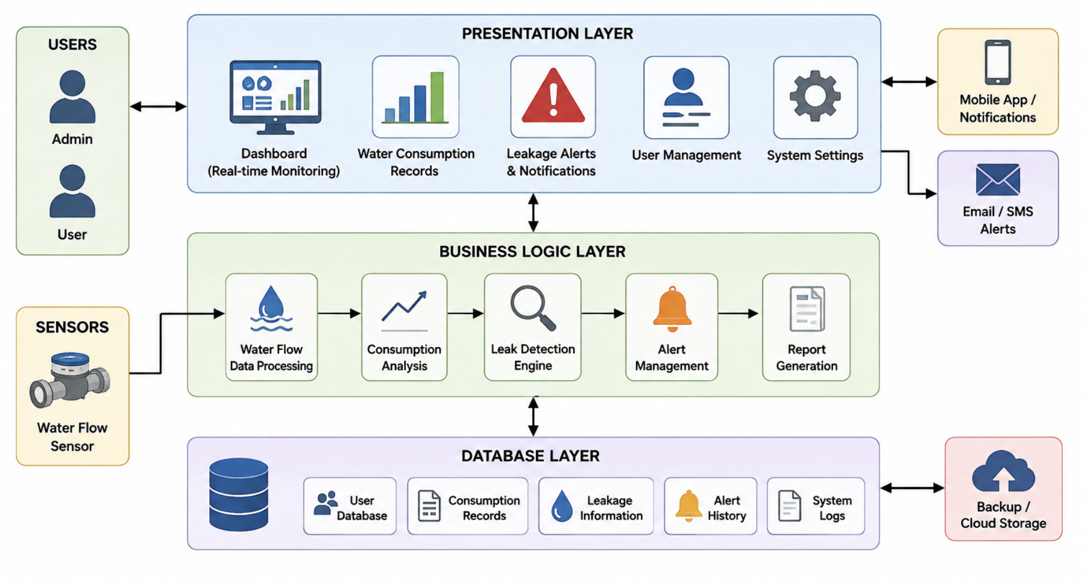
Figure 3.1 – System Architecture of the Smart Water Management System

3.6 USE CASE MODEL
The use case model identifies User, System Operator and Administrator as the principal human actors. The sensor or gateway is treated as an external source of flow observations. User-facing functions include viewing consumption and receiving leakage information, while operational and administrative functions include managing records, configuring thresholds, generating reports and monitoring system status.
The model clarifies the system boundary and ensures that internal processing is not incorrectly represented as a human responsibility.
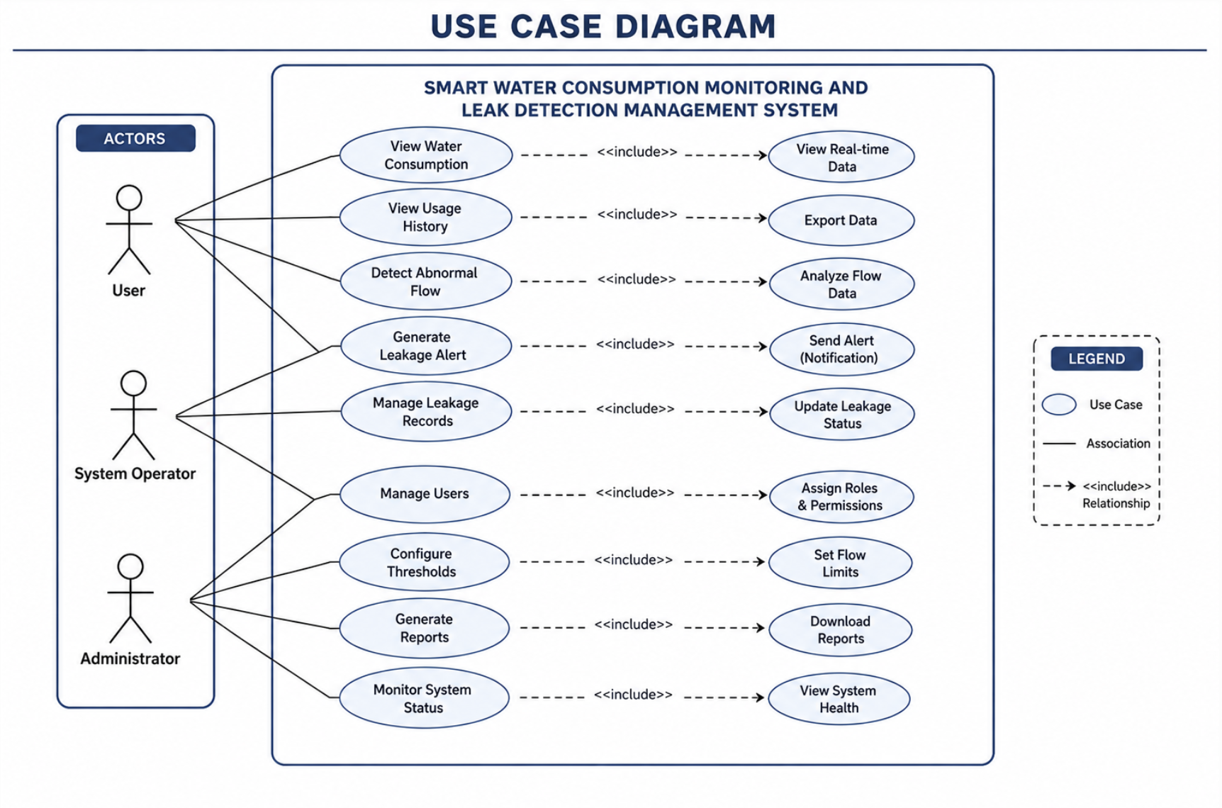
Figure 3.2 – Use Case Diagram
Key use cases include Login/Authenticate, View Dashboard, Monitor Water Consumption, View Consumption Records, Detect Abnormal Flow/Leakage, Receive/Manage Alerts, Generate Reports, Configure Thresholds & Settings, Manage Users and Send Flow Data.

3.7 CLASS MODEL
The class model divides responsibilities among domain entities and services. User-related classes manage identity and access, WaterFlowSensor represents acquisition, ConsumptionRecord represents observations, LeakDetectionEngine evaluates patterns, Alert represents a leakage notification event and supporting services manage reporting and persistence.
The objective is low coupling with clear ownership of data and behaviour. This makes individual services easier to test and permits future replacement of the sensor, notification or storage mechanism.
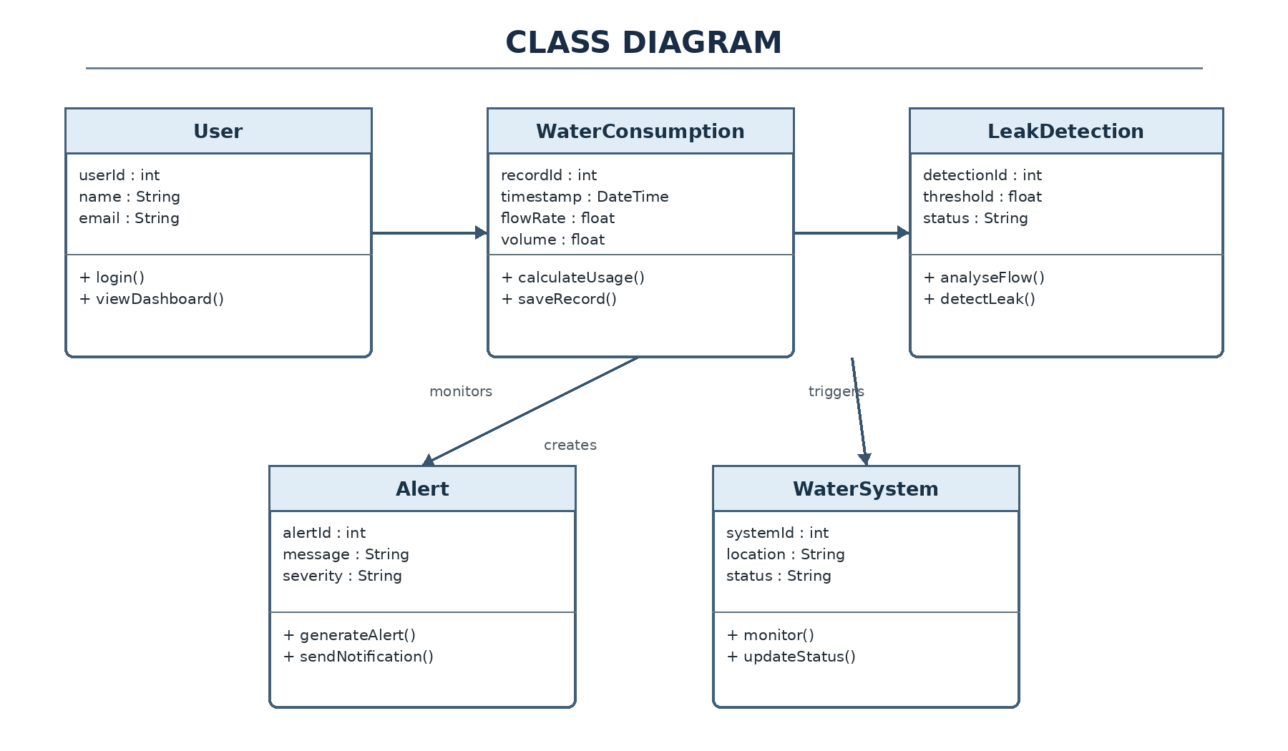
Figure 3.3 – Class Diagram
The proposed classes follow single-responsibility-oriented decomposition. This reduces coupling and makes it possible to test monitoring, detection, alerting and reporting services independently.

3.8 INTERACTION MODEL – SEQUENCE
The interaction begins with a flow reading arriving from the sensing interface. The monitoring service validates the input and creates a consumption record. The detection service then evaluates the relevant observation or history. When an abnormal condition is identified, the system creates a leakage event and alert, stores the event and invokes the configured notification mechanism.
The sequence model demonstrates that persistence, decision-making and communication are coordinated business operations rather than direct UI actions.
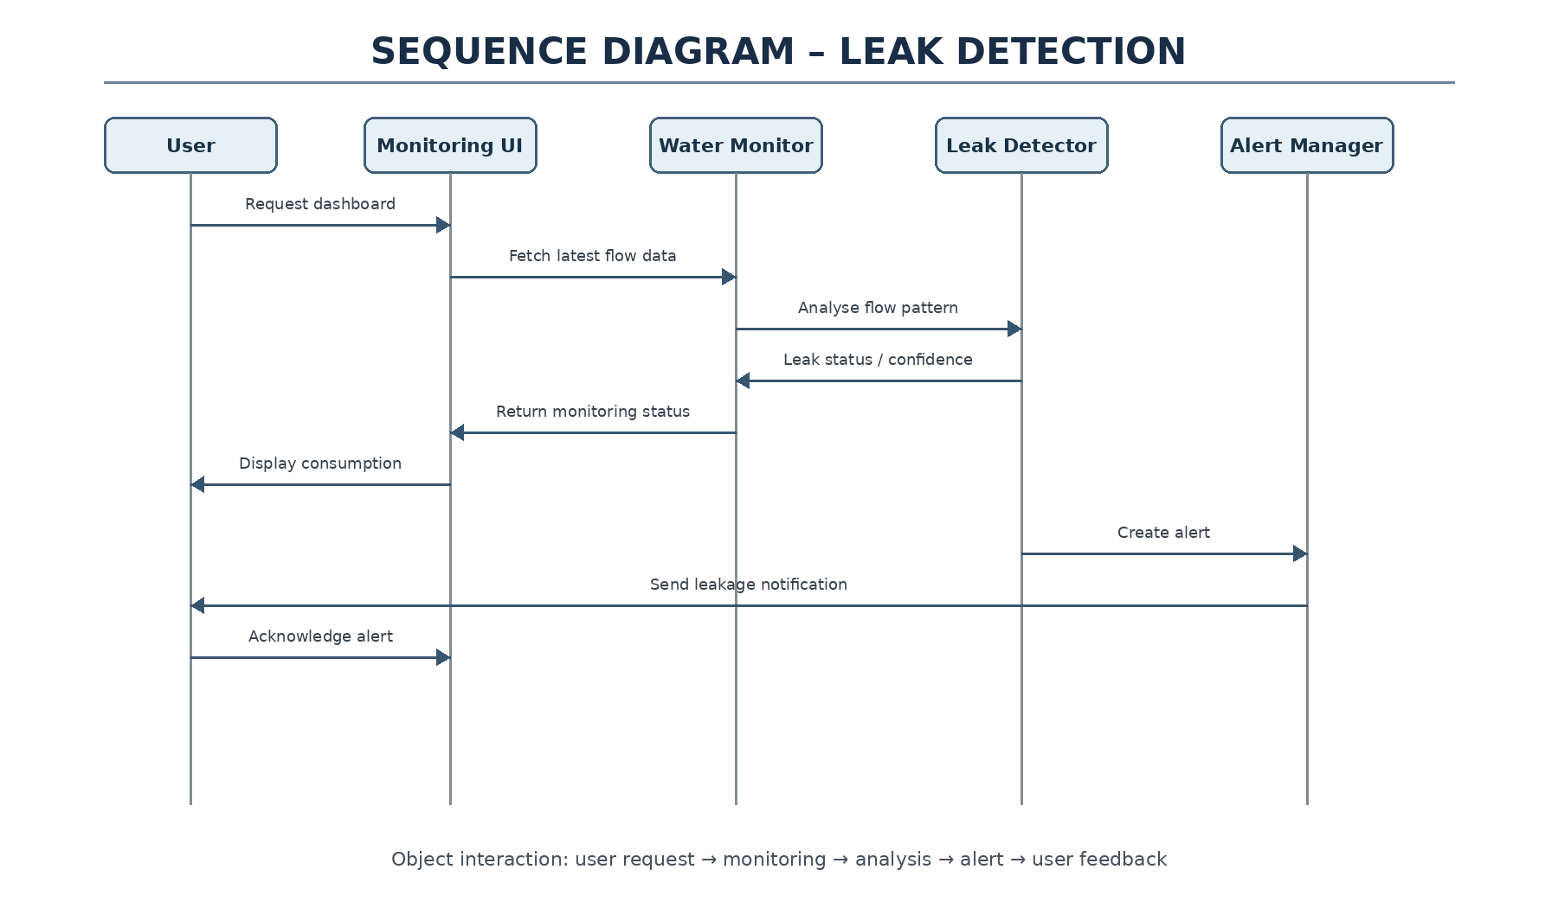
Figure 3.4 – Sequence Diagram for Monitoring and Leak Alert Generation
The sequence emphasizes that data persistence and alert creation are part of the business workflow rather than isolated user-interface functions.

3.9 ACTIVITY MODEL
The activity model represents the repeated monitoring cycle. A reading is received and validated, then stored and analysed. A decision determines whether the observed behaviour is within the configured operating range. Normal flow results in an updated consumption view; abnormal flow initiates leakage-event and notification processing. The cycle then continues.
This representation is useful for verification because each activity can be associated with inputs, processing rules and expected outcomes.
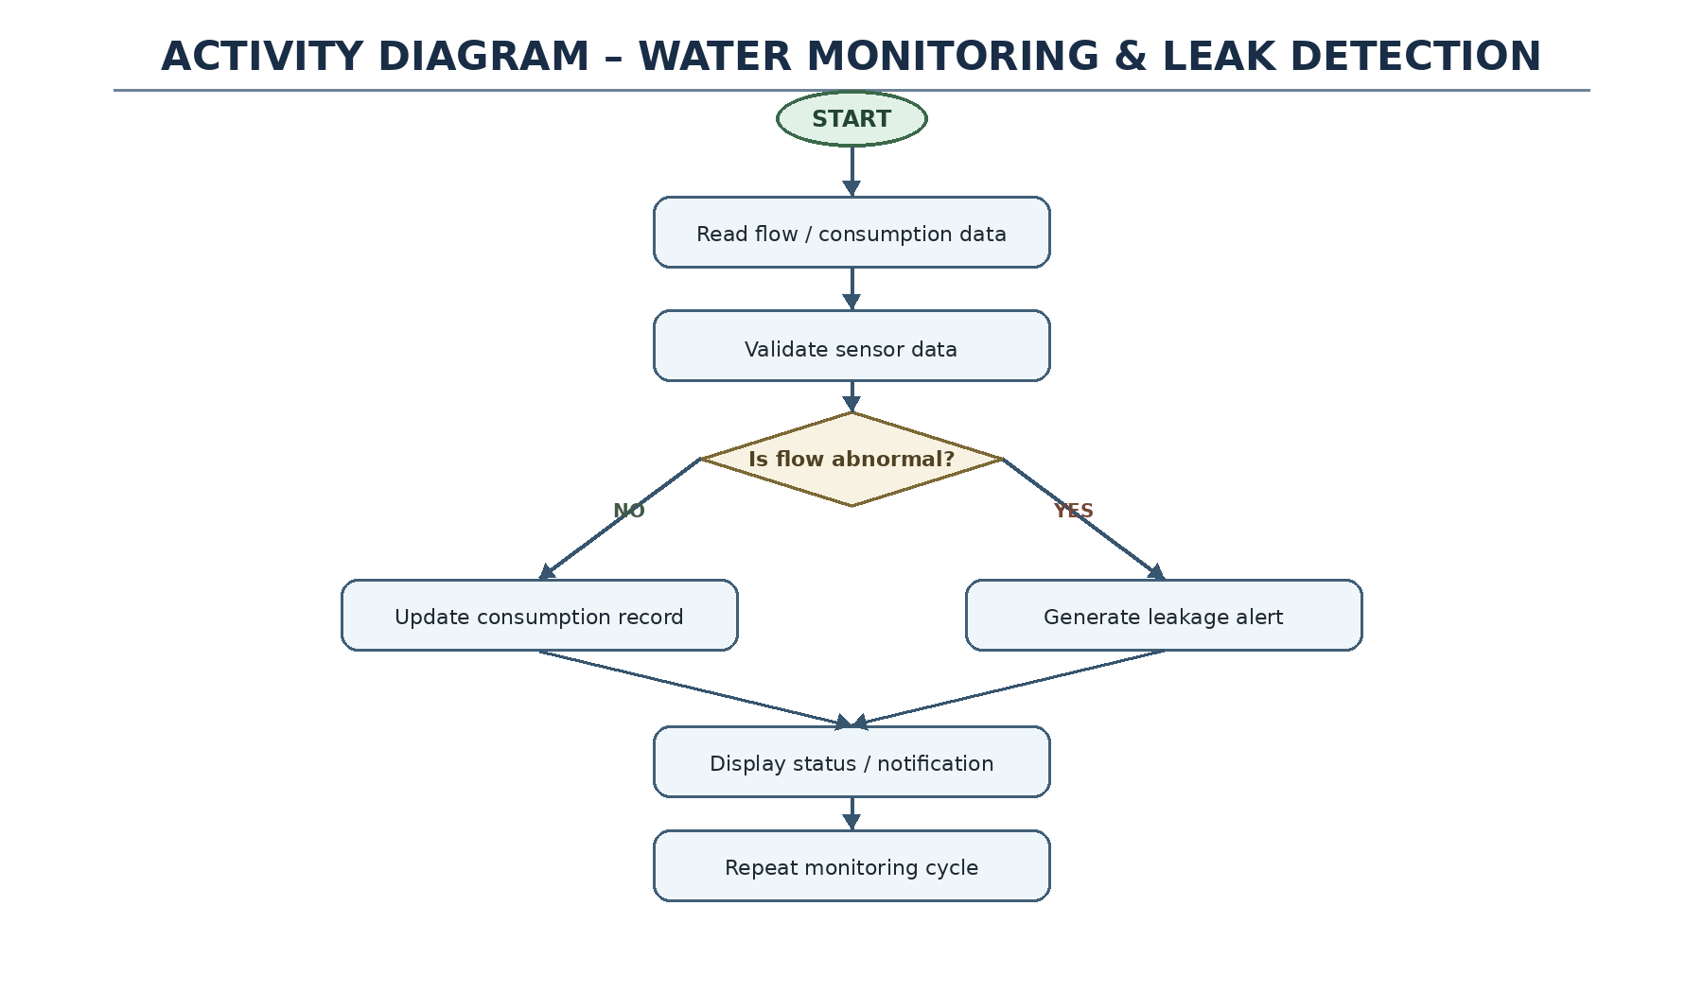
Figure 3.5 – Activity Diagram for Water Monitoring and Leak Detection
This model supports structured testing because each activity can be associated with an observable input, processing step and expected outcome.

3.10 COMPONENT AND DEPLOYMENT MODELS

3.10.1 Component Model
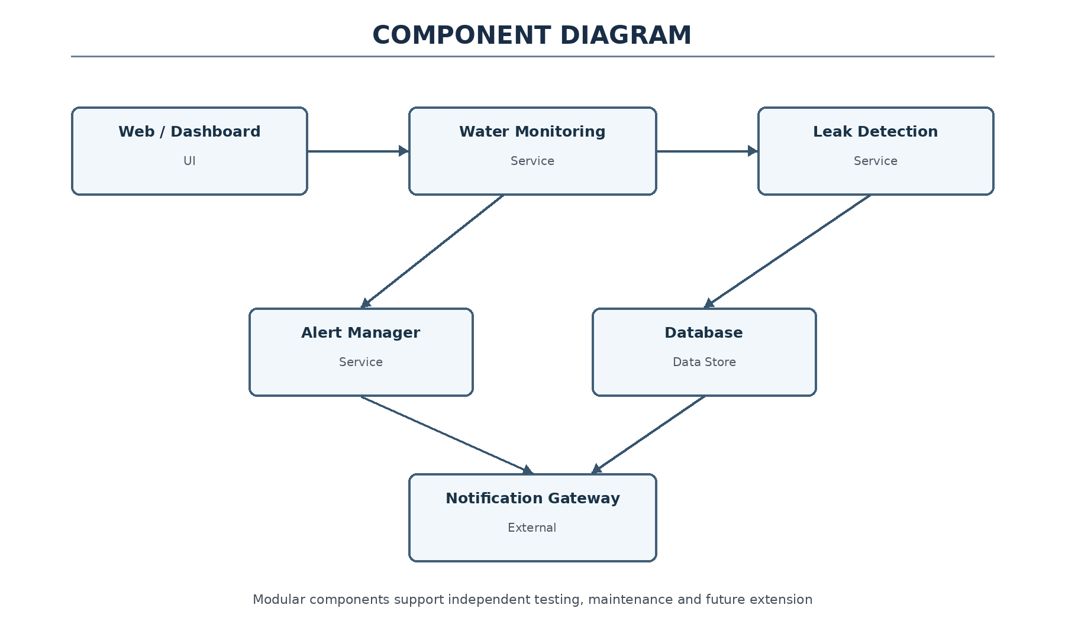
Figure 3.6 – Component Diagram

3.10.2 Deployment Model
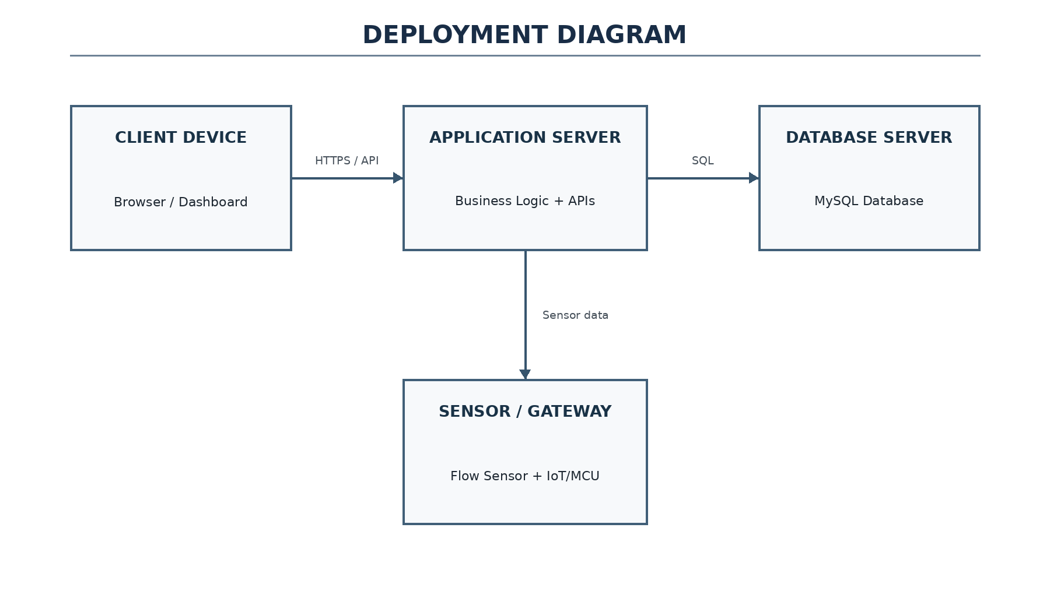
Figure 3.7 – Deployment Diagram
The component model separates monitoring, leak detection, alert management, reporting and persistence. The deployment model places the client interface, sensor gateway, application server, database and external notification services on appropriate logical nodes. The exact technology choices can be finalized during implementation.

3.11 DATABASE DESIGN
The logical database design stores users, consumption observations, leakage events, alerts and system status. Primary and foreign keys provide traceability between a usage observation and any leakage or alert event derived from it.
A relational model is appropriate for the proposed capstone because it supports historical queries, reporting, integrity constraints and audit-oriented records. Additional indexes can be introduced during implementation when query patterns are known.
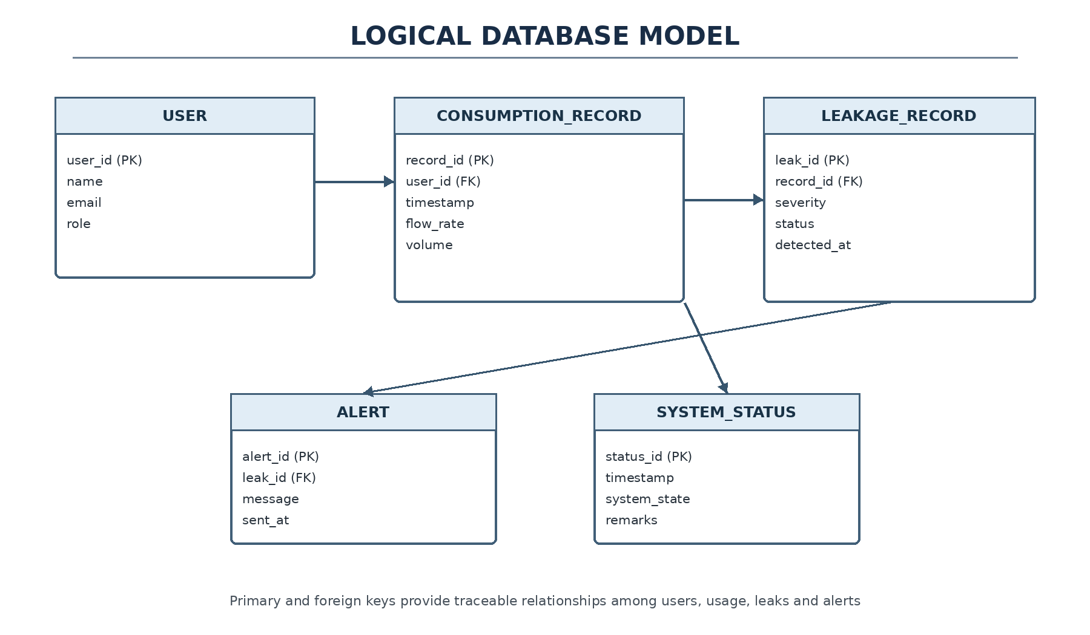
Figure 3.8 – Proposed Logical Database Model
Entity | Important Attributes | Purpose
User | user_id, name, email, role | Authentication and user management.
ConsumptionRecord | record_id, user_id, timestamp, flow_value, period_total | Stores water usage observations.
Leakage | leakage_id, record_id, severity, detected_at, status | Stores suspected/confirmed leakage events.
Alert | alert_id, leakage_id, channel, sent_at, status | Tracks alert delivery and state.
SystemLog | log_id, user_id, timestamp, action | Supports audit and troubleshooting.

3.12 DESIGN ALTERNATIVES AND TRADE-OFFS
Decision | Alternative | Benefit of Selected Design | Trade-Off
Architecture | Monolithic design | Layered design improves maintainability and separation of concerns. | More components to coordinate.
Monitoring | Manual/periodic entry | Automated flow readings improve timeliness. | Requires sensor integration.
Leak detection | Fixed manual inspection | Automated analysis can flag abnormal patterns earlier. | May produce false alerts.
Notifications | Dashboard only | Multiple channels improve responsiveness. | External services add dependency.
Storage | Single flat record | Relational entities improve traceability. | Database design is more involved.

3.13 SUSTAINABILITY, ETHICS, SAFETY, RISK & SECURITY
Domain | Consideration | Design Response
Sustainability | Reduce water wastage through earlier awareness. | Monitoring and alerts support conservation.
Ethics | Avoid misleading leakage claims. | Present suspected leakage as an alert requiring validation.
Safety | Incorrect sensor values may trigger unnecessary actions. | Validate readings and use controlled thresholds.
Security | User and consumption records are sensitive operational data. | Authentication, authorization and secure storage are required.
Reliability | Irregular flow may resemble leakage. | Use configurable logic and maintain alert history.

Project Risk Register
Risk | Probability | Impact | Mitigation
False leakage detection | Medium | Medium | Use thresholds/pattern rules and validation.
Missing/incorrect sensor data | Medium | High | Validate readings and record sensor status.
Database inconsistency | Low–Medium | High | Use transactions, constraints and backups.
Notification failure | Medium | Medium | Retain alert in the system and retry delivery.
Integration delay | Medium | Medium | Develop and test subsystems independently.

CHAPTER 4
IMPLEMENTATION, TESTING & RESULTS

4.1 DEVELOPMENT APPROACH AND RESOURCES
A staged development process is recommended: requirements, domain modelling, architecture, data design, interface construction, service implementation, integration, verification and documentation. UML tools support analysis and design, while web technologies can provide the dashboard and Java/Python or comparable technologies can implement service logic.
Version control should be used throughout development so that the three student contributors can work on separate logical areas and integrate reviewed changes.
Resource / Tool | Purpose | Stage
StarUML / Umbrello | UML modelling and visualization | Analysis & design
HTML, CSS, JavaScript | User interface implementation | Presentation layer
Java / Python / Web technologies | Application logic implementation options | Business logic
MySQL | Persistent storage of system records | Database
Git / GitHub | Version control and collaboration | Development
Flow sensor interface | Water-flow data source | Input

4.1.1 Module Decomposition
- Water Consumption Monitoring: collects readings, analyses usage and maintains consumption records.
- Leak Detection and Alert Management: identifies abnormal flow, creates alerts, manages notification state and maintains leakage history.
- Supporting services: authentication, user management, reporting, persistence and system logging.

4.2 IMPLEMENTATION FLOW
Implementation begins by authenticating the requesting user and loading permitted functions. The sensing interface then supplies a reading, which is validated and normalized before being stored. Monitoring services update the consumption history, while the detection service evaluates abnormal conditions. A suspected leakage produces a persistent event and alert, followed by notification and dashboard updates.
The workflow is intentionally modular so that acquisition, detection, persistence and communication can evolve independently.
1. Authenticate the user and load the appropriate dashboard permissions.
2. Receive a water-flow reading from the sensor interface.
3. Validate and normalize the incoming reading.
4. Create and store a consumption record.
5. Pass the relevant reading/history to the consumption-analysis and leak-detection services.
6. If abnormal flow is detected, create a leakage event and alert.
7. Persist alert state and send the configured notification.
8. Update dashboard, records and reports.
9. Record significant operations in the system log.
10. Repeat monitoring while the system is active.

4.2.1 Processing Logic
The core processing separates data acquisition from decision logic. This enables the sensor interface to be replaced or expanded without changing the leak-detection algorithm. Similarly, the alert service can support dashboard alerts, mobile notifications, email or SMS without changing the consumption-recording class.

4.3 TESTING AND VERIFICATION
The verification plan covers valid readings, repeated observations, abnormal flow, leakage-event creation, dashboard retrieval, historical queries, invalid input, reporting, service interaction and repeated monitoring cycles. These are design-level verification scenarios because the supplied material does not provide measured execution logs.
Before final deployment, each scenario should be executed against the implemented prototype and recorded with actual input, output, pass/fail status and evidence.
Test ID | Test Action | Expected Result | Verification Type
T01 | Submit a valid flow reading | Reading is accepted and stored | Functional / black-box
T02 | Submit repeated readings | Consumption record sequence is maintained | Functional
T03 | Trigger abnormal/continuous flow condition | Leak detection identifies a possible leak | Use-case
T04 | Generate a leakage event | Alert is created and logged | Functional
T05 | Open dashboard | Current status and records are displayed | UI / use-case
T06 | Retrieve historical records | Correct records are returned | Database / functional
T07 | Use invalid or missing sensor data | Input is rejected/handled without corrupting data | Error handling
T08 | Generate a report | Consumption/leakage summary is produced | Functional
T09 | Verify class interaction | Services exchange expected objects/data | White-box
T10 | Run repeated monitoring cycles | System remains stable during test interval | Performance / reliability

Acceptance Principles
- Each functional requirement should have at least one corresponding test.
- Sensor and user inputs should be validated before persistence or decision-making.
- Alert generation should be traceable to the underlying consumption record.
- The system should preserve records even when notification delivery fails.
- Results should be recorded using actual implementation evidence before final deployment claims are made.

4.4 RESULTS AND DISCUSSION
The intended result is a coherent monitoring workflow that turns sensor observations into historical consumption records and actionable leakage events. From an engineering perspective, the most important result of the OOAD stage is traceability: stakeholders can be connected to use cases, use cases to classes and interactions, and interactions to stored records.
Performance values should only be reported after prototype execution. In particular, detection accuracy depends on sensor quality, usage patterns and the chosen decision logic, so the design avoids unsupported numerical claims.
Area | Expected / Intended Result | Engineering Interpretation
Consumption monitoring | Water-flow readings are captured and represented as records. | Provides a continuous data basis for usage analysis.
Leak detection | Abnormal flow is identified as a possible leakage condition. | Transforms raw readings into actionable events.
Alert management | Leakage alerts are created, stored and communicated. | Reduces delay in responding to suspected leaks.
OOAD architecture | Responsibilities are separated into classes/layers. | Improves maintainability and extensibility.
Database | Users, consumption, leakage and alert data are retained. | Supports history, reporting and auditing.
Reporting | Organized summaries can be generated. | Supports decision-making and conservation analysis.

Engineering Discussion
A central design issue is false detection: normal irregular consumption may appear similar to leakage. Therefore, the leak-detection engine should not be treated as an infallible classifier. Thresholds, time windows, user context and historical behaviour can be used to reduce false alerts in a future implementation.
Another important issue is data quality. Missing or noisy sensor readings can directly affect both consumption totals and leakage decisions. Validation, logging and calibration therefore form part of the functional reliability of the software, not merely an implementation detail.

4.5 CHALLENGES AND LIMITATIONS
- Important limitations include sensor calibration, noisy or missing readings, legitimate irregular consumption, communication interruptions, database consistency and notification-service availability. A simple threshold may also be insufficient for complex environments where flow varies by time of day or occupancy.
- These limitations do not invalidate the design; instead, they define the areas that require prototype measurements, field data and iterative refinement.
- Irregular normal usage can produce false leakage alerts.
- The system depends on timely sensor data and suitable communication between components.
- Database records must remain consistent as readings and alerts are created continuously.
- External notification services can fail or become unavailable.
- Advanced analytics and IoT integration increase software and deployment complexity.
- The supplied project presentation does not provide measured field-performance data; therefore numerical performance claims are intentionally avoided.

4.6 PROJECT MANAGEMENT
Phase | Major Activities | Deliverable
1. Requirement Analysis | Problem definition, objectives, scope | Requirement specification
2. Literature Review | Background and engineering gap | Review summary
3. OOAD Analysis | Actors, use cases, classes and interactions | Analysis models
4. System Design | Architecture, database and UML diagrams | Design package
5. Module Development | Monitoring and leak-management services | Software modules
6. Integration | Connect UI, business logic and database | Integrated system
7. Testing | Functional, use-case and reliability tests | Test records
8. Documentation | Results, limitations, conclusion and references | Final capstone report

Version / Change Management
Git/GitHub can be used to maintain design files, source code and documentation revisions. Each module can be developed in a separate branch or logical work package and integrated after review and testing.

CHAPTER 5
CONCLUSION, FUTURE WORK AND REFLECTION

5.1 CONCLUSION
The Intelligent Water Usage Monitoring and Leakage Alert Management System provides an OOAD-based structure for a practical water-management problem. The design connects flow acquisition, usage recording, abnormal-behaviour analysis, leakage-event management, reporting and persistence.
The main value of the approach is architectural clarity. By separating presentation, services and storage and by modelling the domain explicitly, the proposed system provides a maintainable basis for prototype implementation. Its effectiveness as a real-world monitoring solution must subsequently be established through actual implementation and measured testing.
The use of object-oriented analysis provides a clear mapping from stakeholder requirements to actors, use cases, classes and interactions. The layered architecture separates presentation, business logic and persistence responsibilities, which improves maintainability and provides a practical foundation for future implementation.
The project addresses a meaningful engineering problem: water wastage can be reduced when abnormal usage is detected earlier and presented to users in an understandable form. The design should be interpreted as a capstone software architecture and OOAD model; actual field performance must be established through implementation and measured testing.

5.2 FUTURE SCOPE
- Future development can introduce networked smart meters, multiple sensing zones, mobile access, cloud synchronization, richer trend analytics and machine-learning-assisted anomaly detection. Notification escalation can be added when an event remains unresolved.
- Further work should also examine adaptive thresholds, sensor calibration strategies, offline buffering, stronger audit controls and deployment across multiple buildings or facilities.
- Develop a mobile application for remote monitoring and instant leakage alerts.
- Add machine-learning models for consumption forecasting and improved leak-pattern detection.
- Integrate smart water meters for automated and higher-resolution data collection.
- Add advanced analytics and dashboards for daily, weekly and monthly usage trends.
- Support multiple buildings, zones and sensor groups through scalable deployment.
- Add automated notification escalation when an alert remains unresolved.
- Introduce stronger authentication, audit trails and secure API communication for production deployment.

5.3 PROFESSIONAL LEARNING & REFLECTION
- The project provides practical experience in translating a real-world requirement into an object-oriented software structure. Important learning areas include stakeholder analysis, UML modelling, service decomposition, relational design, verification planning, risk analysis and technical documentation.
- The three-member workflow also highlights the importance of consistent naming, version control, review checkpoints and traceability when several contributors work on interconnected design artefacts.
- Application of Object-Oriented Analysis and Design to a practical monitoring problem.
- Use of UML to represent system behaviour, structure, interaction and deployment.
- Understanding of layered architecture and separation of responsibilities.
- Design of domain classes and relationships around real-world entities.
- Logical database modelling for operational and historical data.
- Importance of validation, error handling and traceability in monitoring systems.

Engineering & Professional Skills Developed
- Requirement analysis and problem decomposition.
- System architecture and UML modelling.
- Database and component-level design.
- Testing strategy and acceptance criteria definition.
- Risk identification and trade-off analysis.
- Technical documentation and presentation.

Individual Reflection – M. Poojith Ganesh
The main learning outcome was understanding how a real-world water-management problem can be decomposed into actors, use cases and domain objects. Developing the monitoring-oriented part of the design highlighted the importance of clean data models, traceability and user-focused presentation of consumption information.

Individual Reflection – K. Krishna Charan
The main learning outcome was understanding how abnormal-flow analysis can be connected to alert management without tightly coupling the system components. Designing the leak-detection, database and integration aspects emphasized modularity, error handling, security and the need to distinguish suspected leakage from confirmed physical leakage.

Individual Reflection – Ch Teja Srinivas
I contributed to activity modelling, component and deployment design, and system workflow analysis. This project helped me understand how OOAD concepts can be applied to convert system requirements into structured UML models. I also improved my skills in teamwork, testing, and technical documentation.

Individual Reflection – A. ADARSH
I contributed to requirement analysis, sequence modelling, reporting design, and testing documentation. Through this project, I gained a better understanding of object-oriented system design and UML diagrams. I also developed my ability to analyse requirements, coordinate with team members, and prepare technical documentation.

REFERENCES
[1] I. Sommerville, Software Engineering, Pearson Education.
[2] G. Booch, J. Rumbaugh, and I. Jacobson, The Unified Modeling Language User Guide, Addison-Wesley.
[3] C. Larman, Applying UML and Patterns: An Introduction to Object-Oriented Analysis and Design, Pearson Education.
[4] Object Management Group (OMG), Unified Modeling Language (UML) Specification.
[5] A. K. Sharma and R. K. Gupta, “Smart Water Management and Leakage Detection Using IoT,” International Journal of Engineering Research and Technology.
[6] Espressif Systems, ESP32 Documentation, for IoT-based monitoring and sensor integration.
[7] OOAD Project Presentation, “Intelligent Water Usage Monitoring and Leakage Alert Management System,” CSA1101 – Object Oriented Analysis and Design, supplied project material, 2026.
Note: The literature-review entries and project-specific system description are reproduced/structured from the supplied OOAD project presentation. The presentation itself lists the six principal UML diagram types and the proposed technology stack used as the basis for this report.

APPENDICES

Appendix A – UML Deliverables Summary
Artefact | Purpose | Primary Elements
Use Case Diagram | Capture user/system functionality | Admin, User, Sensor, monitoring, detection, alerts, reports
Class Diagram | Represent static object structure | User, Admin, Sensor, Record, Detection Engine, Alert, Notification, Report, Database
Sequence Diagram | Show object interactions over time | Sensor → Monitoring → Database → Detection → Alert → User
Activity Diagram | Represent process workflow | Read → Store → Analyse → Decision → Alert/Update → Repeat
Component Diagram | Show software modules | UI, monitoring, leak detection, alert, reporting, database
Deployment Diagram | Show runtime nodes | Client, sensor gateway, application server, database, notification service

Appendix B – Proposed Logical Data Fields
Entity | Field | Type / Meaning
User | user_id | Primary identifier
User | role | User / Admin authorization role
ConsumptionRecord | timestamp | Time of observation
ConsumptionRecord | flow_value | Measured flow value from sensor
ConsumptionRecord | period_total | Aggregated usage for a period
Leakage | severity | Classification of suspected event
Leakage | status | Open / resolved state
Alert | channel | Dashboard / push / email / SMS
Alert | status | Delivery / acknowledgement state
SystemLog | action | Recorded system operation

Appendix C – End-to-End Processing Logic
START → Authenticate User / Initialize Monitoring → Receive Flow Reading → Validate Reading → Store Consumption Record → Analyse Usage Pattern → Abnormal Flow? → YES: Create Leakage Event → Create Alert → Send Notification → Log Event → Update Dashboard → Continue Monitoring → NO: Update Dashboard / Records → Continue Monitoring.

Appendix D – Implementation Evidence to Add Before Final Submission

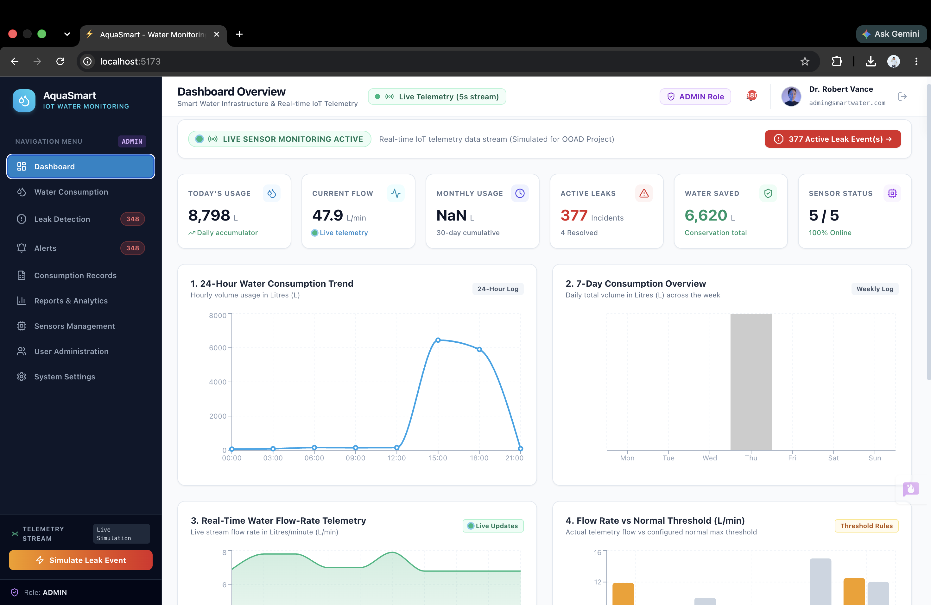
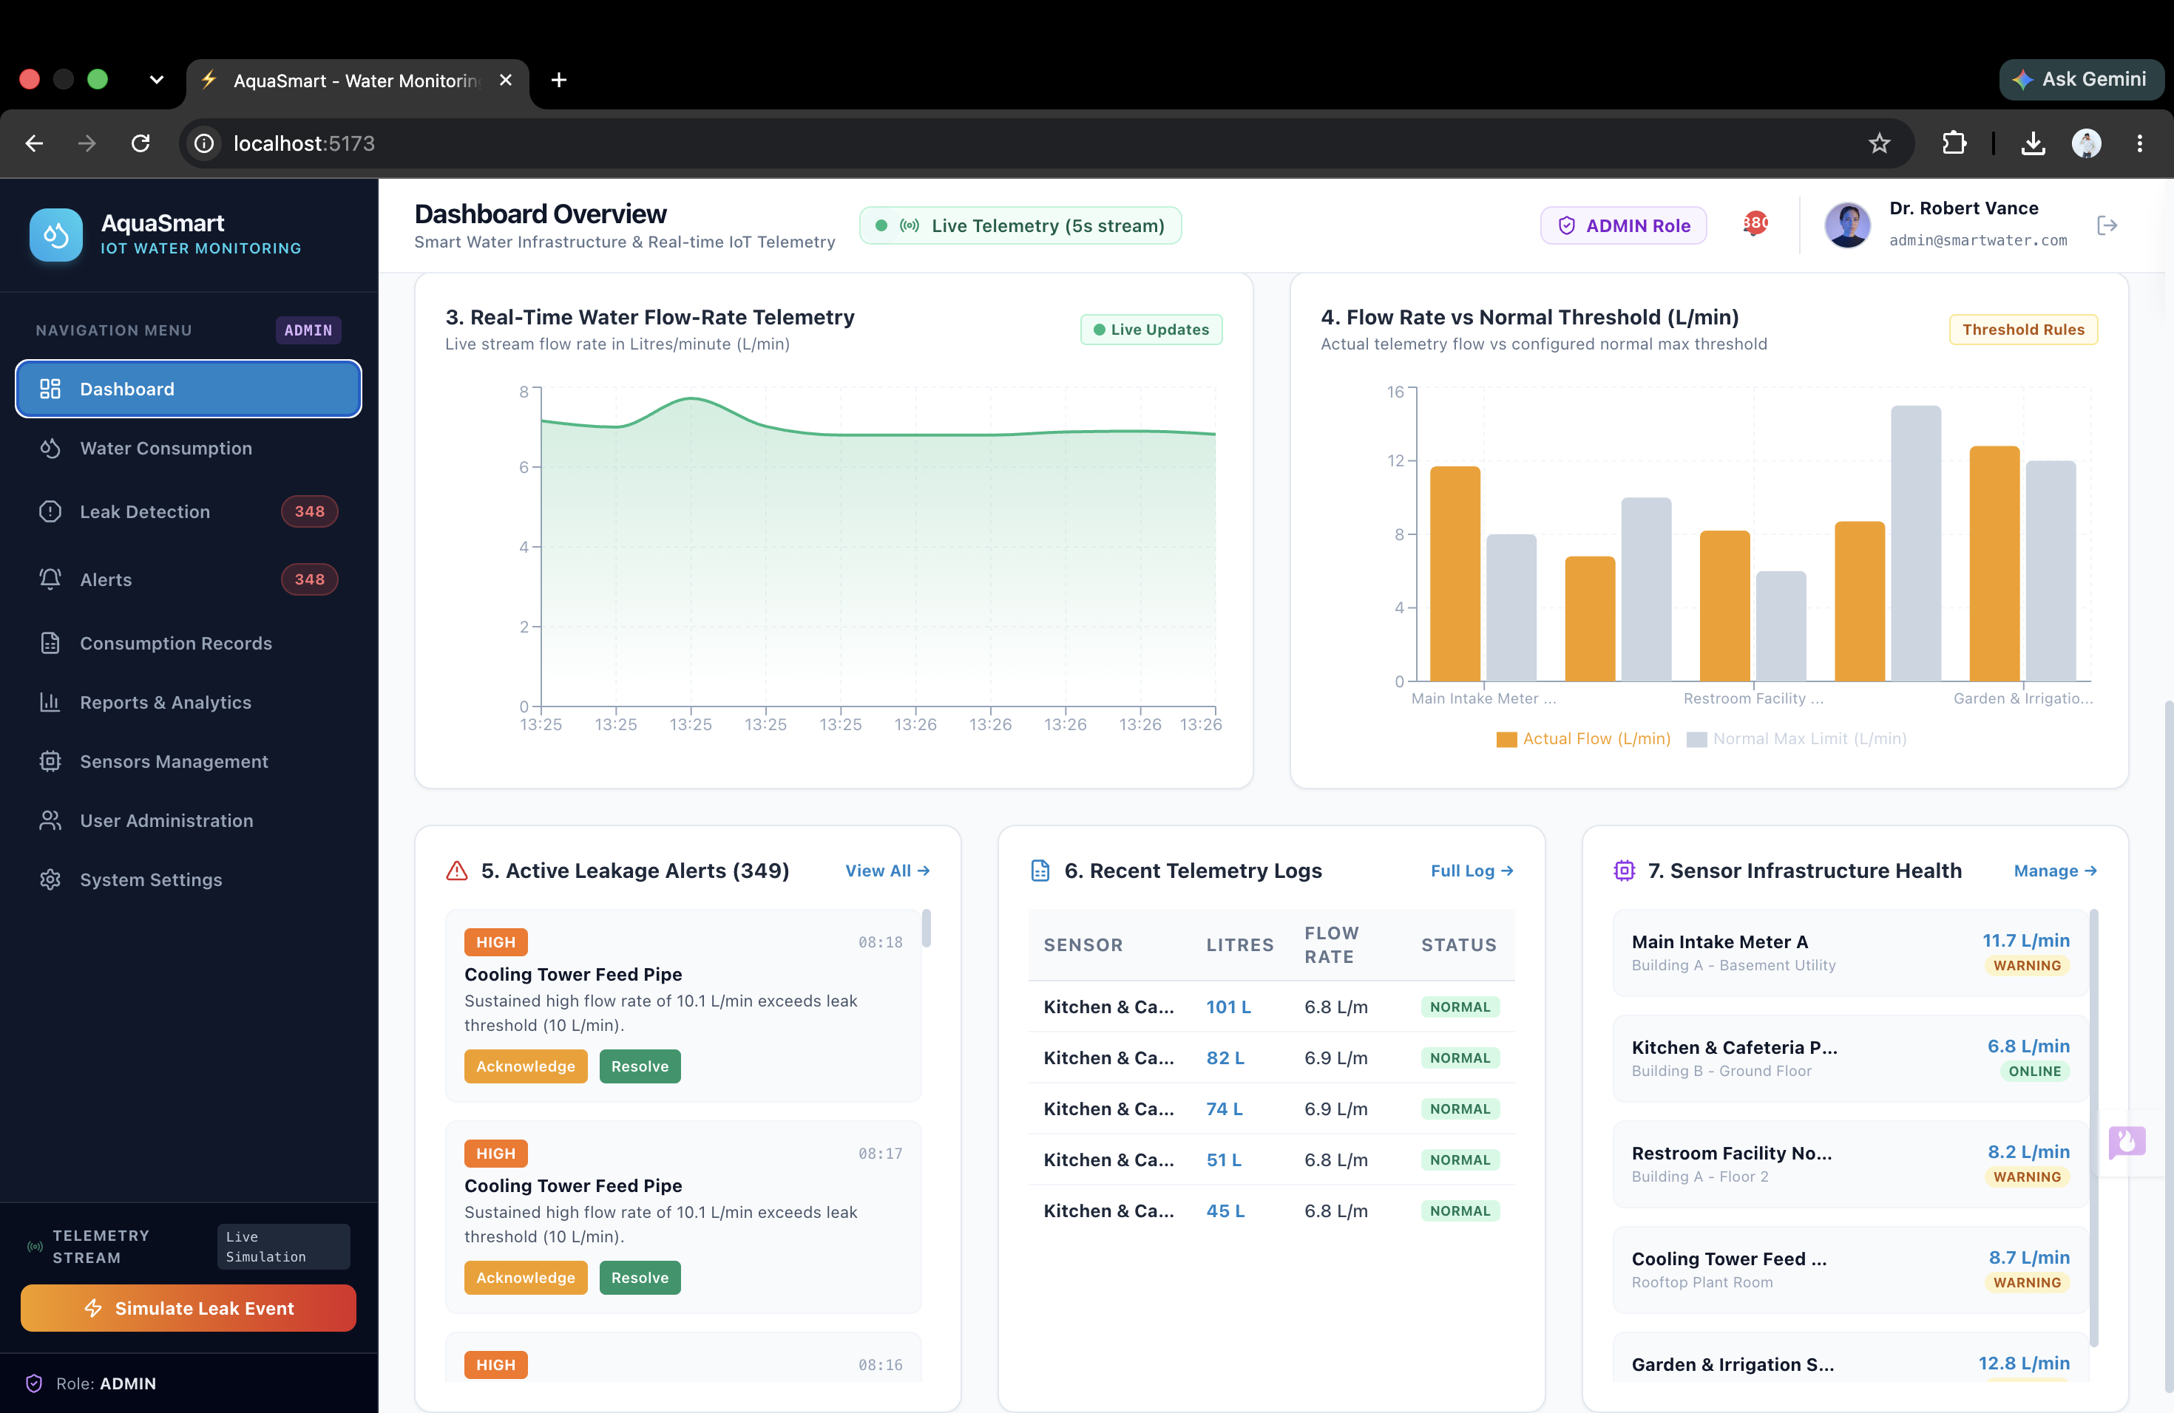
Dashboard

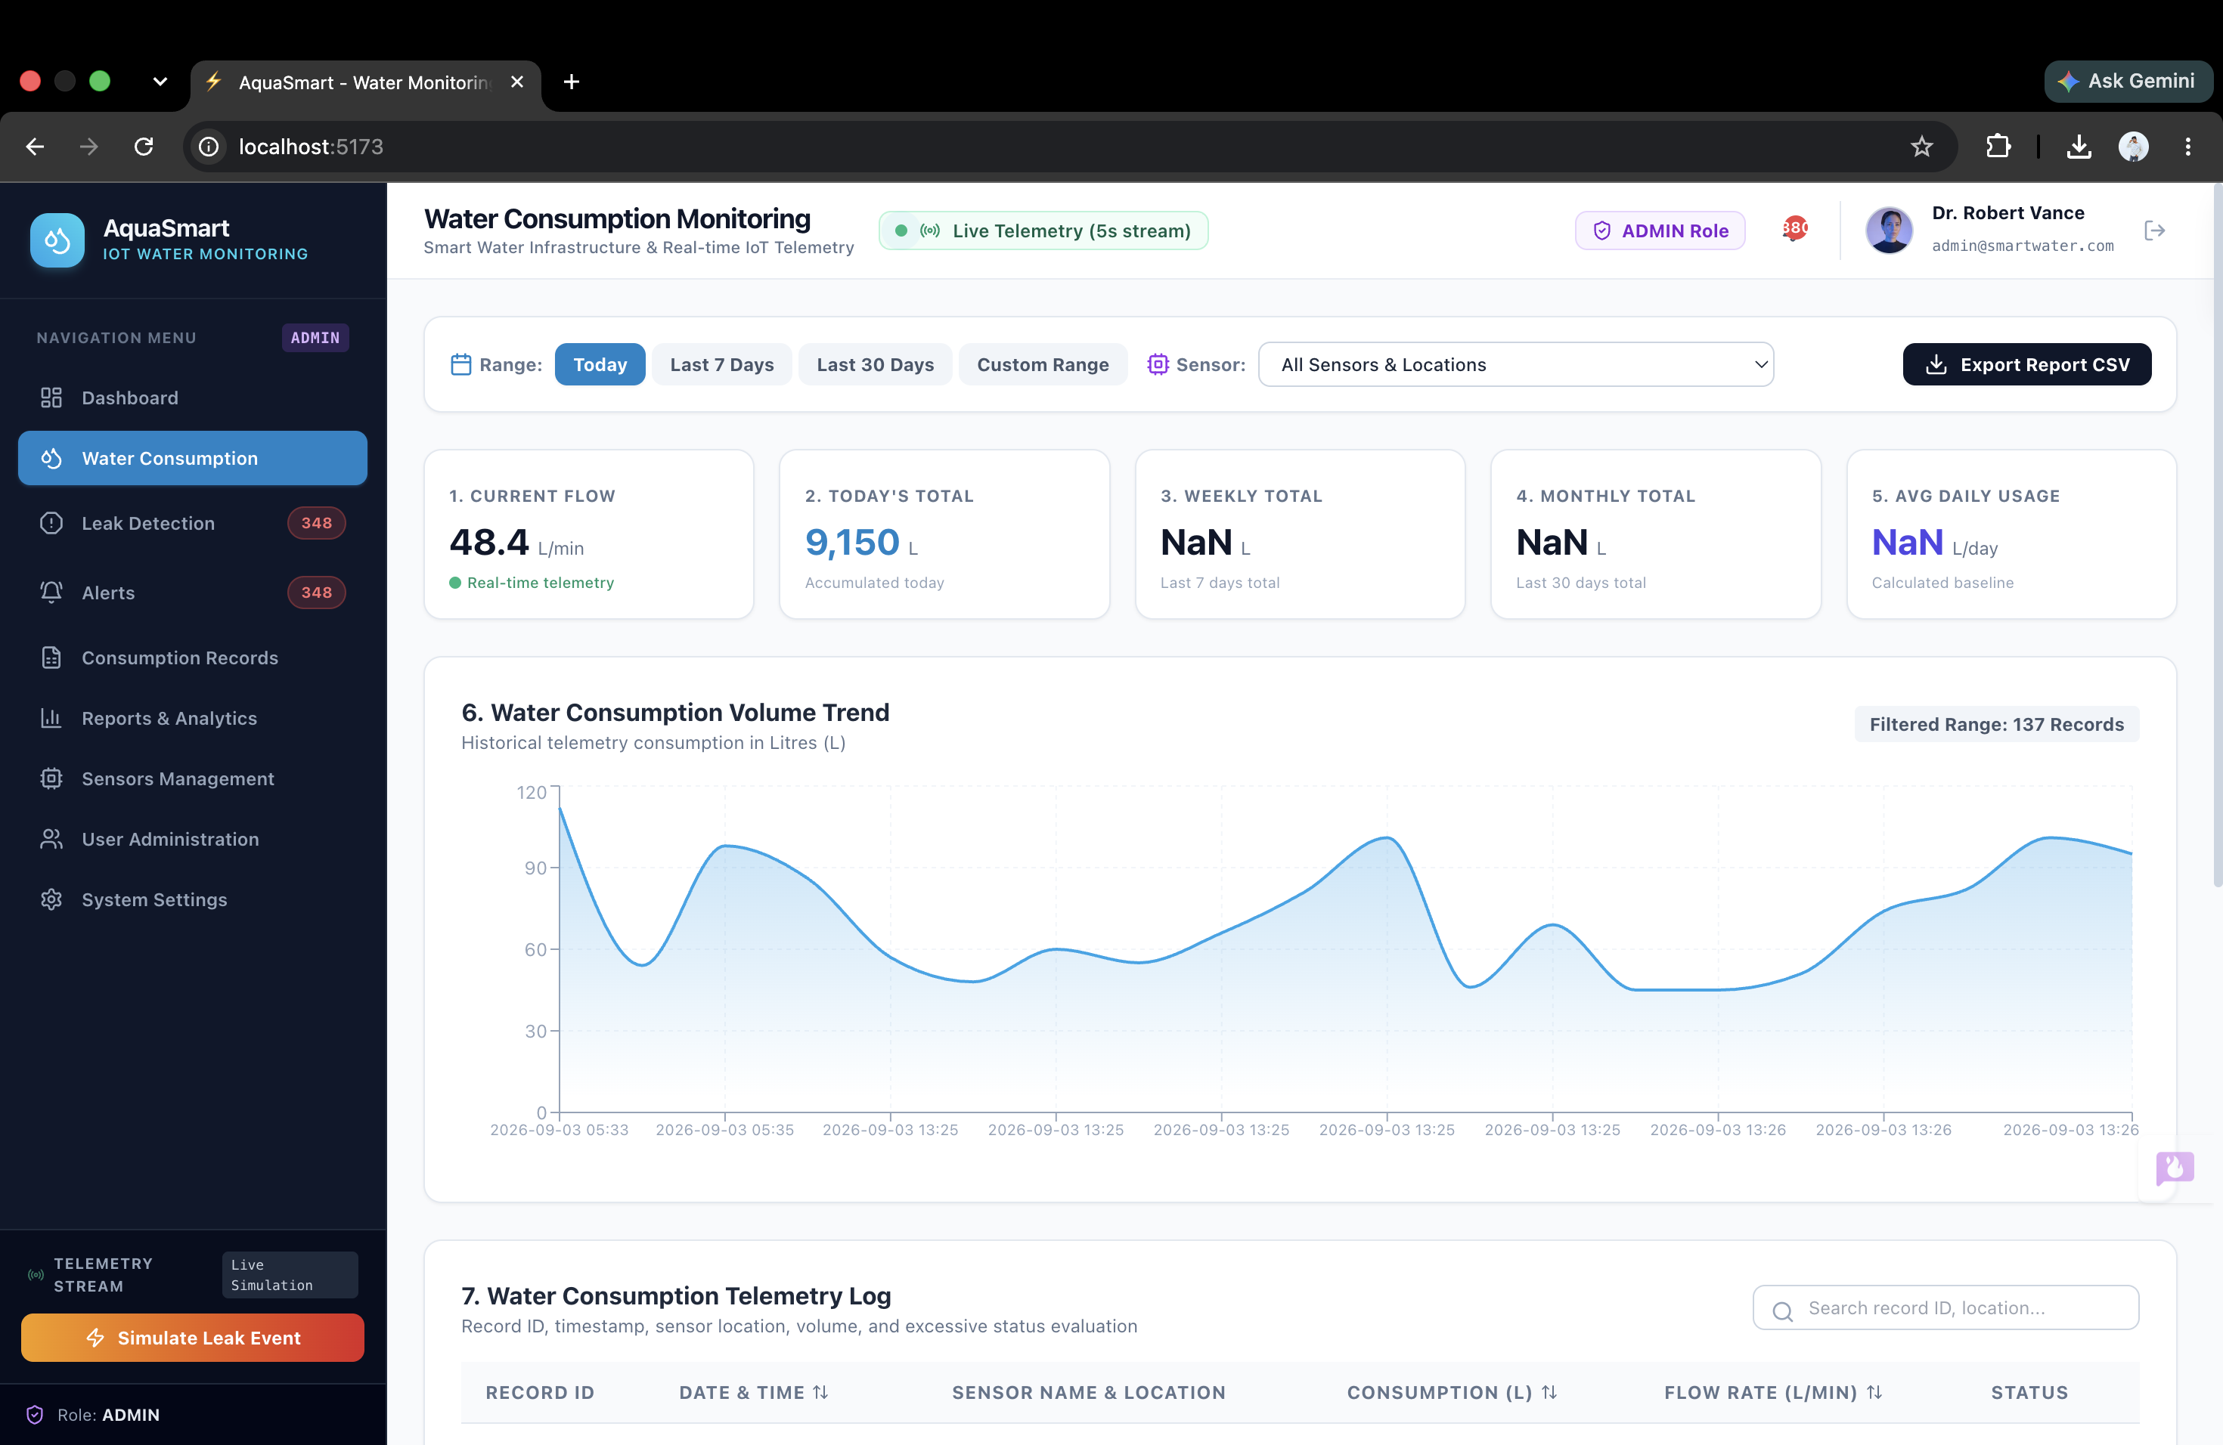
Water Consumption

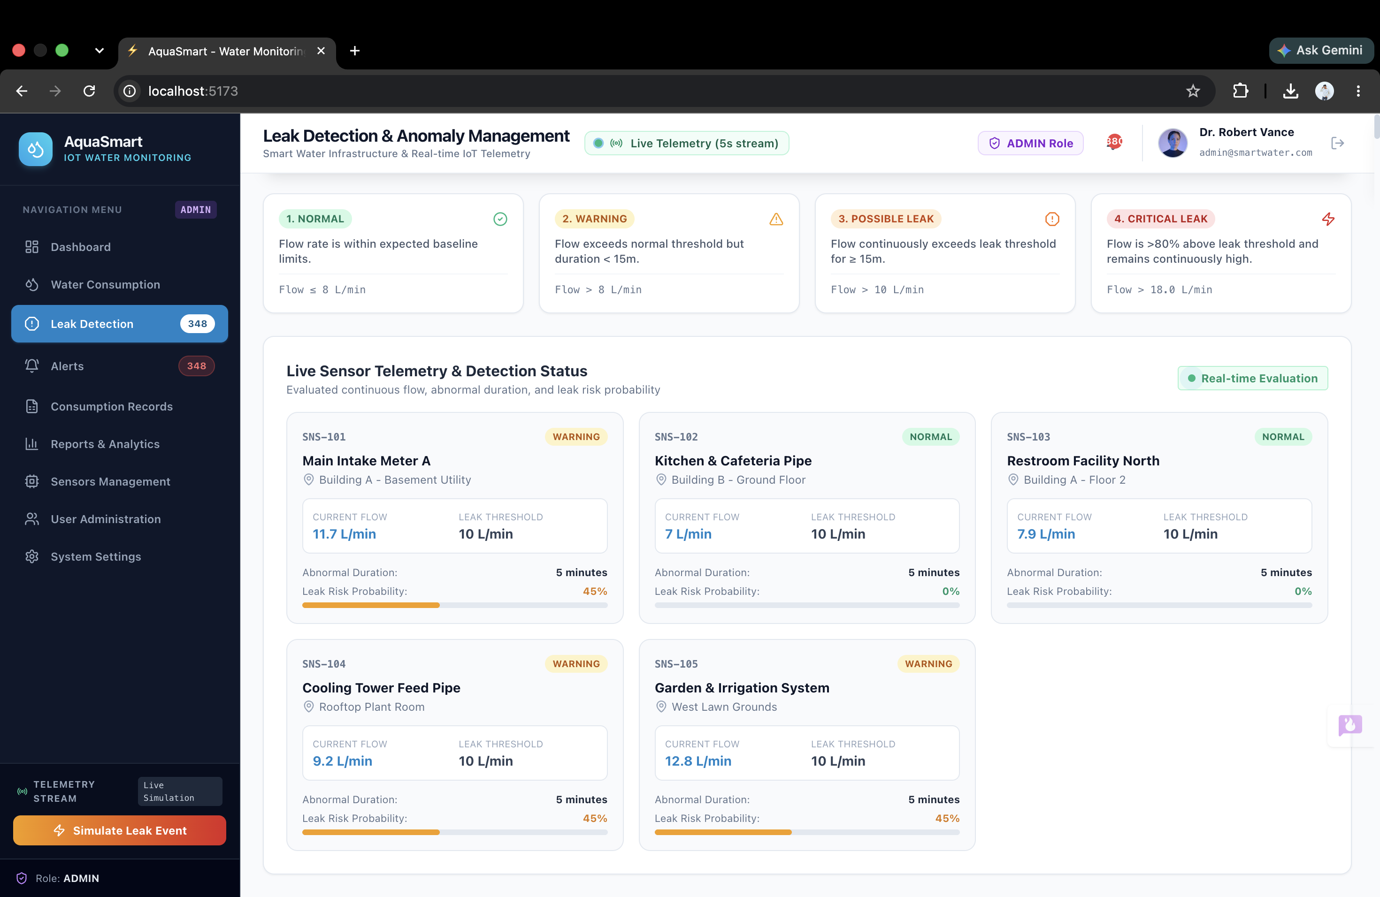
Leak Detection

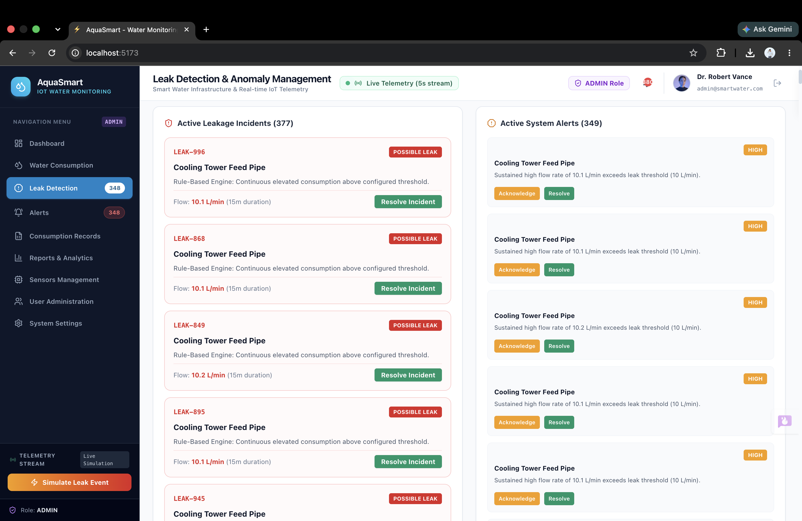
Active Leakage and System Alerts

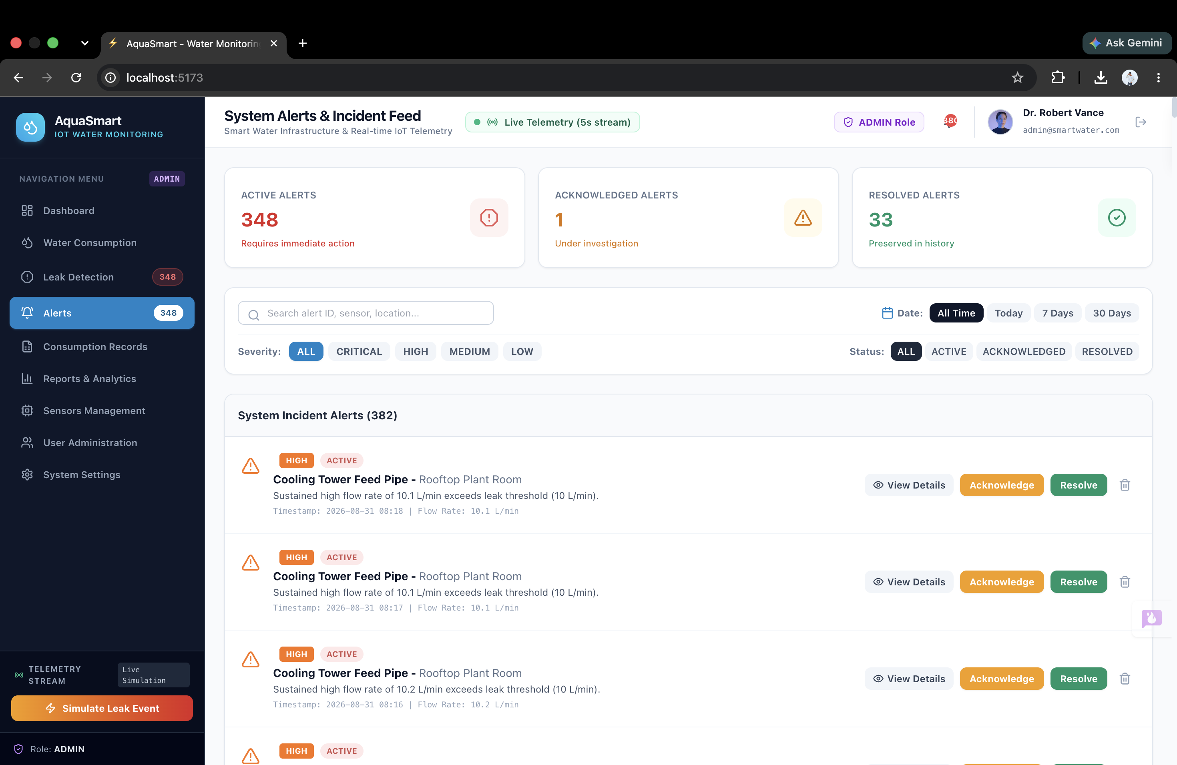

System Incident Alerts

