**find Assignment**

Mandatory:

1. Search and display all *.c and *.h files in all subdirectories starting from current directory

A : give the command as find .*c for c files find .*h for header files

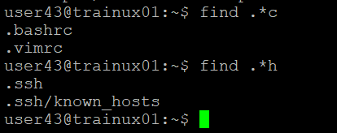

1. Search and display all directories in all subdirectories starting from current directory

A : find . -type d

1. Search and display all files with permissions only rw with user and execute permission for others

A : find -type f -perm /u+rw

