**Keywords, Identifier, Literals, Operators and Expression Assignment**

**Mandatory:**

**1**. Choose all valid identifiers

a. int int

b. int _numvalue

c. float price_money

d. char name1234567890123456789012345678901234567890

e. char name value

f. char $name

A: Valid Identifiers are :

float price_money

char $name

char name 1234567890123456789012345678901234567890

. int _numvalue

**2**. What is the meaning of the following keywords, show the usage

a. auto : the auto keyword is used to allocate the memory without intialising

b. extern : Extern keyword helps in to say that the file or intialisation is in another file so it takes the value from that file

c. volatile : this keyword is used to update the value one value cant be constant and the size wont be fixed we intimately says that the values is temporary

d. sizeof : to get the size of data type

e. const : cant change the value

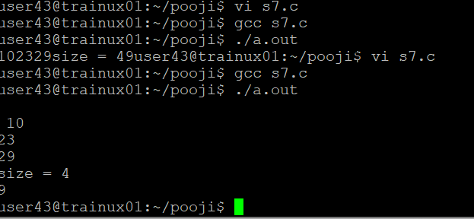

3. Explain the difference between the following variables.

a. char *ptr = “ABC”;

b. char arr[]=”ABC”;

Can you manipulate the contents of ptr? Why?

Can you manipulate the contents of arr? Why?

Which one of the above is a string literal?

1. No, we cant manipulate the contents of ptr because it is sring literal they are stored as read only not for editable
2. Yes,we can manipulate in arr because they are not string literals and the it contains the copy of the data
3. Ptr is the string literals

4. Predict the output of the following code .

void main()

{

//set a and b both equal to 5.

int a=5, b=5;

//Print them and decrementing each time.

//Use postfix mode for a and prefix mode for b.

printf("\n%d %d",a--,--b);

printf("\n%d %d",b++,--b);

}

A: output :

5,4

4,4

5.Refer the code snippet. It fails with error. Fix it.

#include<stdio.h>

int main()

{

int i,k;

const int num;

/* for(i = 0;i < 9;i++)

{

k = k + 1;

} */

num = num + k; /* Compiler gives the error here */

printf("final value of k:%d\n",k);

printf("value of num:%d\n",num);

return 0;

}

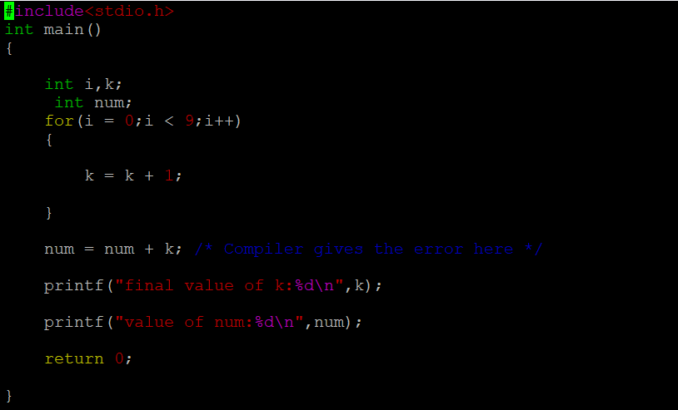

6.Consider the following code snippet. Evaluate the value of f1, f2 and f3.

int main()

{

int i = 10;

int j = 3;

float f1 = i / j;

float f2 = (float ) i / j;

float f3 = (float ) (i / j);

}

