Valgrind Assignment

1. Login into the Linux server with your login Ids

2. Create a new directory called mem_errors in your home directory <home>

mkdir mem_errors : make the directory by mkdir mem_errors

3. Go inside the directory you have created in (2) /<home>/mem_errors

cd mem_errors : change to directory

4. Copy the following files from the path as mentioned by the trainer:

a. sample1.c

b. sample2.c

c. sample3.c

d. sample4.c

e. sample5.c

5. Take a look at the example programs and observe if you can find any errors.

6. Compile the files

gcc –o sample1 –g sample1.c

gcc –o sample2 –g sample2.c

gcc –o sample3 –g sample3.c

gcc –o sample4 –g sample4.c

gcc –o sample5 –g sample5.c

7. Execute the file sample1

valgrind –-leak-check=yes sample1

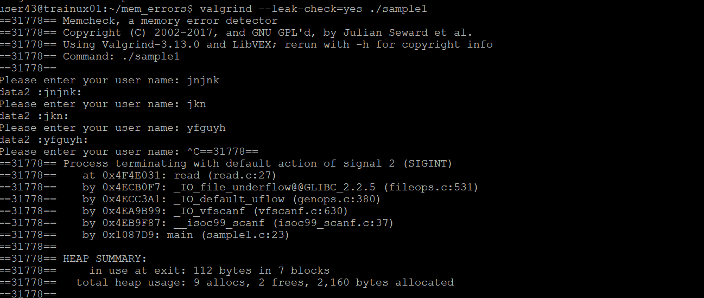

8. Execute the file sample2

valgrind –-leak-check=yes ./sample2

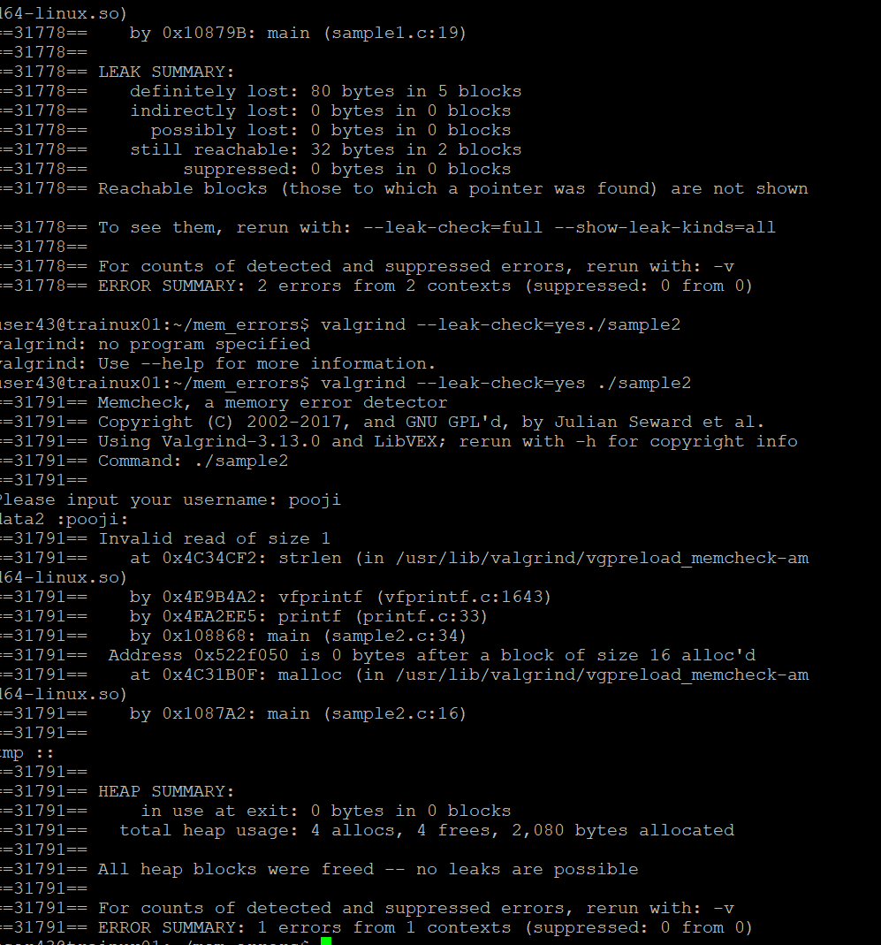

9. Execute the file sample3

Valgrind –-leak-check=yes ./sample3

After quitting the program Valgrind displays a list of memory errors in the program. Analyze these errors.

10. Execute the file sample4

Valgrind –-leak-check=yes ./sample4

After quitting the program Valgrind displays a list of memory errors in the program. Analyze these errors.

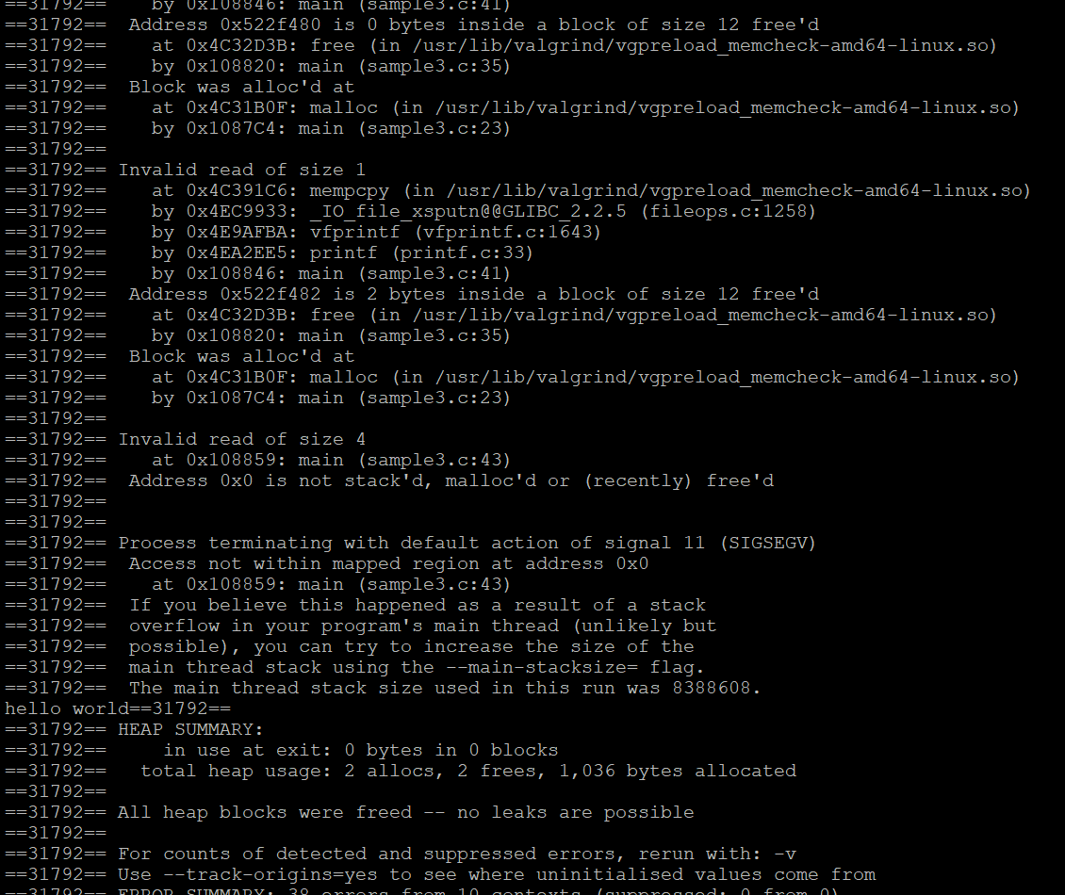

11. Execute the file sample4

Valgrind –-leak-check=yes ./sample5

After quitting the program Valgrind displays a list of memory errors in the program. Analyze these errors.

12. Compile and execute the program in queue_linked_list_memory_leak

valgrind –leak-check=yes ./queue_llist

After quitting the program Valgrind displays a list of memory errors in the program. Analyze these errors.