**Enumerated Datatypes and Typedefs assignments**

**Mandatory**

1. WAP to define an enum to store designations in an organization. List of possible values are

{E2F=1, E2, E3, E4, E5}

Prompt and read a designation from the user. Then display his designation string such as

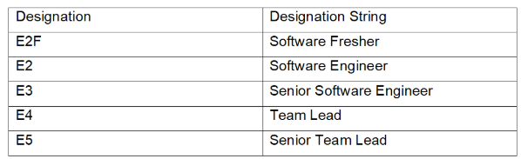

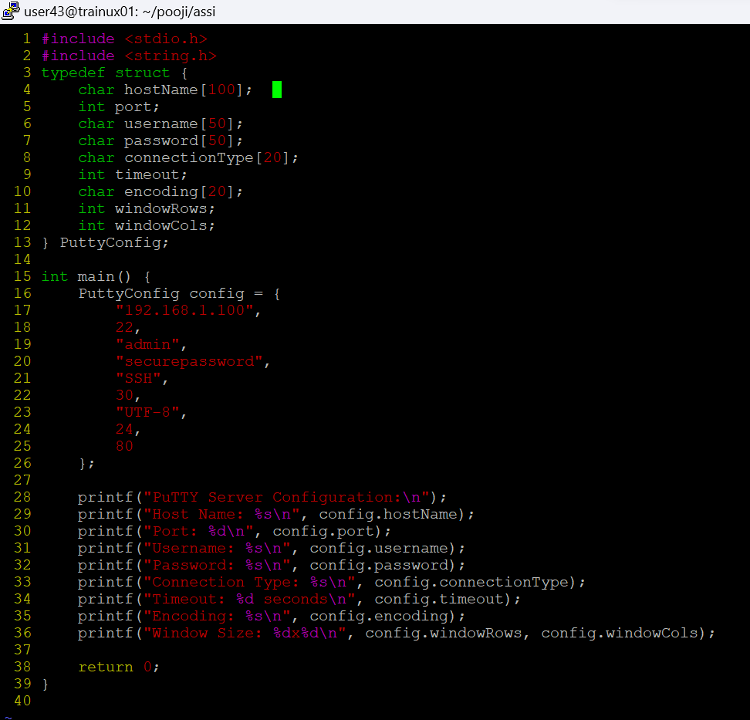

2. Define a typedef structure to keep the configuration of putty server. Identify and place all the required members. Create a structure variable and initialize it with user defined values and finally display the content**s.**



