**Variable Argument Handling Assignment**

1.

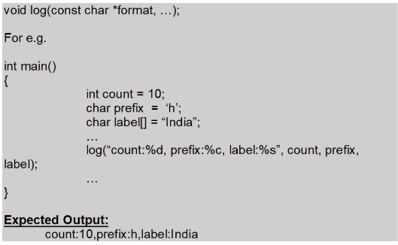

3. Refer the code “find_max.c”. Add a function below to accept variable number of strings and to return the string with maximum length to the caller. In case of strings with same length, return the first string in the input sequence

max_len_string(<variable number of arguments>)

Eg. Code below shoud output “hello”

char *ptr = max_len_string(“hi”, “hello”, “How”, “ Are”, “END”);

printf(“%s”, ptr);



