**STRINGS**

in strings we must give null character becoz it takes the empty space also as ascii sowe should include the null value like we should give extra one character if there are 6 – we should 7

string declaration

name[6] = {‘h’, ‘a’,’s’, ‘I’ ,’n’ ,’\0’} ;

char name[6] = “hello” ;

char greet[] = “hello world”;

char[21] = {“hi sai”} --- here we have given the 21 characters space its takes only 20 and 1 for null characters

char[][20] --- 20 is for capacity of each character like {“hinu”,”muno”,”krishna”}

errors may occur while creating strings or displaying strings

… segmentation error… / core dump…/(theses errors are occur due to the illigel entry of other characters or scope or memory )(it occurs when we looping like for) (but if we use printf of string directly we cant get that type of error)

**String operations**

…………………………………………………………………………………

1. **Strcpy (**char*dest, constant char*src) --- the null is not copied but after copy the string and copy creates null
2. Strncpy ( char * dest, constant char*src, size_t n)

Retutn Type …… it may give destination address tooooo

**Strcat() : destination should be greater than the source (des>src)**

**Strcmp() : “it will check character by an dcompare the ascii value” (if it is un comparable it will be break)**

**Retutn type is integer…… (= 0,<0,>0)**

Ex : str1 str2

Bhima bhina ------- here it returns(<0) becoz the m is < n so ascii values are less in this the return values takes place)

***Memset and mencpy -,strstr,strch,strtok,strsep,strlen(excluding the null char),strerror(that carries error)🡪are use splint prj (strtok is very veryyyyy important how to toknise and assign)***

**Strstr : to find the 1st occuramce in that string or find the occurrence(if str not found it return nuill)**

**Strrch :**

**Strtok:\*\*\*\*\*\*\*\*\*\*\*\*\*\*\*\*\*\*\*\*\*\*\*\*\*\*\*\*\*\*\*\*\*\*\*\*\*\*\*\*\*\*\*\*\*\*\*\*\*\*\*\*\*\*\*\*\*\***

**Pointer can hold the another addresss but actual values it has it sow n address it relocate it so we mostly use pointers**

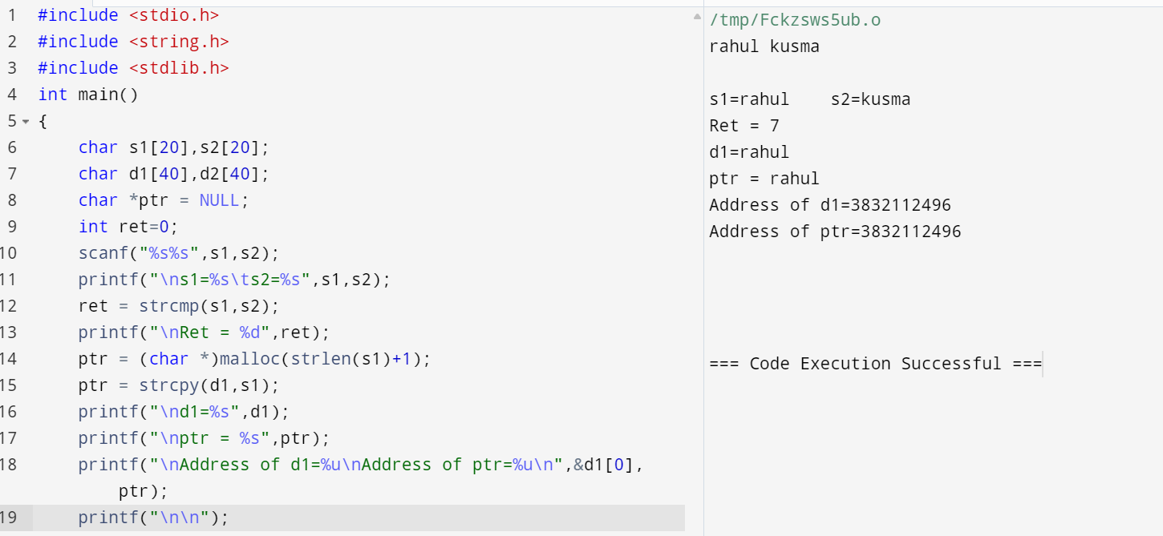

**Strtok :**

