**grep Assignment**

Mandatory:

1. Use any .c file. Using grep command extract and display
2. all lines beginning with #include with line numbers

A: grep -n “#include” main.c



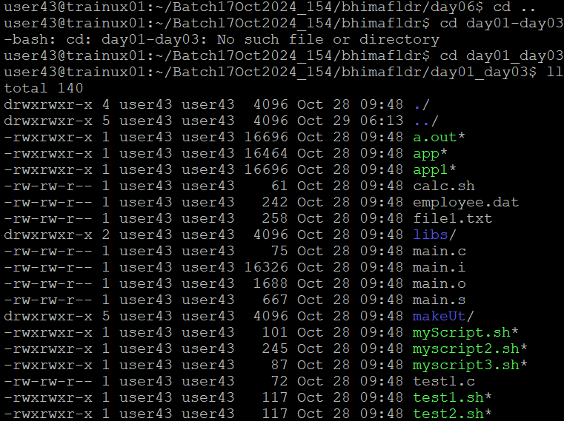

1. display all lines which do not begin with #include

A: grep -vi “include” main.c

c. display the line number of main()

A: grep -n “main.c()” main.c



d. extract all lines containing characters of opening and closing parathesis {(,))

A: grep -n [“{“,”(“,”)”,”}”] main.c

1. Perform the above operations on a set of *.c files

A: grep -n “#include” *.c

grep -vi “#include” *.c

grep -n “main()” *.c

grep [“{“,”(“,”)”,”}”] *.c



