**Gcov**

1. Login into the Linux server with your login Ids : login in linux

2. Create a new directory called code_cov in your home directory <home>

mkdir code_cov : created directory file by using command mkdir code_cov

3. Go inside the directory you have created in (2) /<home>/code_cov

cd code_cov : use the command cd code_cov

4. Copy the following files from the path as mentioned by the trainer:

a. sample.c

b. link.c

c. link.h

copied the files by using vi editor vi sample.c and paste the code

vi link.c and paste the code

vi link.h and paste the code

5. Take a look at the example programs sample.c and link.c

**Compilation**

6. Compile the files sample.c and sample1.c and put the output in the executable file called output

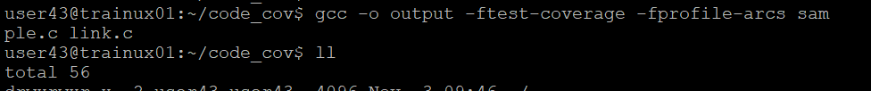

**Execution**

7. Execute the file output

8. Now run gcov for each source file one by one

gcov link.c

9. Run output again, this time with command line arguments:

./output a a b b

10. Now run gcov for sample.c again

What do you observe?

