**To Supply Leftover Food To Poor**

**Category: Salesforce**

**Skills Required: Salesforce Developer**

1. Project Overview

1.1 Project Objectives and Goals

Objective:

This project aims to develop a Salesforce-based application designed to manage and streamline the distribution of leftover food to underserved communities. The primary goal is to enhance the efficiency of food drop-offs, coordinate tasks, manage volunteers, and generate insightful reports.

2. Detailed Description of Implemented Features

2.1 Custom Objects

**1. Drop-Off Point:**

**Purpose:**

The Drop-Off Point object captures essential details about locations where food is dropped off. This helps in tracking and managing food distribution points effectively.

**Fields:**

* Drop-Off Point Name: A text field representing the name of the drop-off point.
* Location Details: A text field for additional details about the drop-off point location.
* Distance: A number field that the distance from the drop-off point to the delivery area.
* Venue: A lookup relationship field linking to the Venue object to provide a connection between drop-off points and venues.

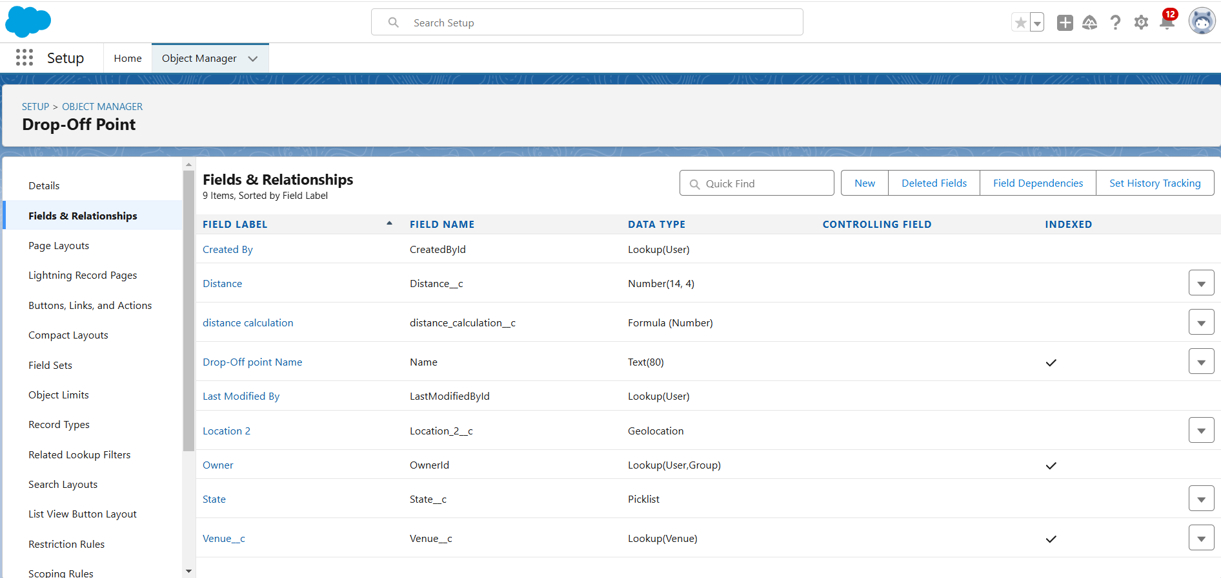**Task :**

**Purpose :**

The task object is used to manage and track various tasks related to food distribution, including assigning tasks to volunteers and recording task details.

**Fields :**

* Task name : A text field representing the name of the task.
* Date : A date field indicating when the task is scheduled or completed.
* Rating : A numeric field used to rate the task performance.
* Drop-off point : A lookup relationship field liking to the drop-off point object to associate tasks with specific drop-off points.
* Sponsored By : A lookup relationship field liking to the drop-off point object to indicate the sponsor of the task.

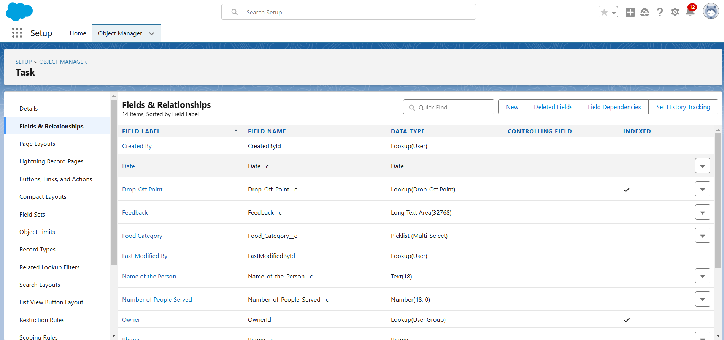

**Volunteer :**

**Purpose :**

The volunteer object tracks of individuals who are involved in the food distribution process, including their contact information and assigned tasks.

**Fields :**

* Volunteer name : A text field for the name of the volunteer.
* Contact email : An email field for the volunteer’s contact email.
* Contact phone : A phone field for the volunteer’s contact number.
* Assigned tasks : A related list showing tasks assigned to the volunteer.

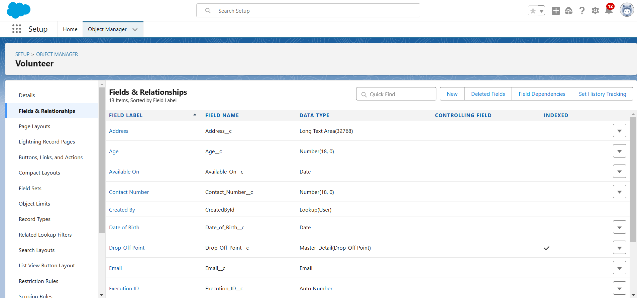

**Execution Detail :**

**Purpose :**

The execution detail object captures detailed information about food distribution activities,including which volunteers and tasks are associated with each distribution.

**Fields :**

* Execution detail name : A text field for naming the execution detail record.
* Volunteer : A master-detail relationship field linking to the volunteer object to associate

execution details with a specific volunteer.

* Task : A master-detail relationship field linking to the task object to associate execution details with a specific task.
* Details : A text field for additional information about the execution.

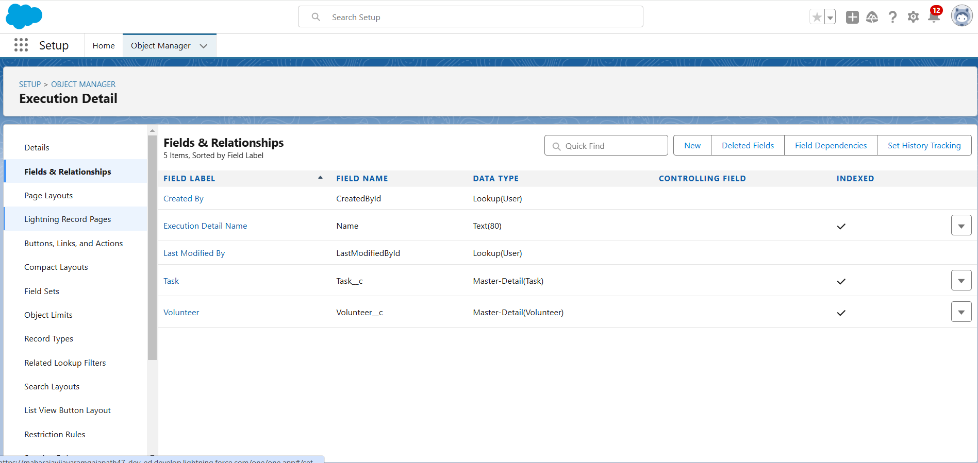

2.2 Object Relationships

Master-Detail Relationships:

àExecution detail to volunteer : Ensures that each execution detail record is linked to a volunteer,making volunteer information essential for each distribution record.

➔ Execution detail to task : Ensures that each execution detail record is linked to a

task,making task information essential for each distribution record.

➔ Task to Volunteer : Connects tasks to volunteers,enabling tracking of which

volunteer is responsible for each task.

➔ Task to Drop-off point : Connects tasks to drop-off points,providing context on

where each task is executed.

➔ Drop-off point to venue : Links drop-off points to venues,facilitating a detailed

understanding of where food is being dropped off.

2.3 Sharing Rules

To ensure that records are shared appropriately based on distance criteria,the

following sharing rules were set up :

1. Rule 1 :
   * Label : Rule 1
   * Criteria : Records where the distance is less than 15 kms.
   * Access : Shared with the public group – iksha
2. Rule 2 :

* Label : Rule 2
* Criteria : Records where the distance is between 15 km and 30 km.
* Access : Shared with the public group – NSS

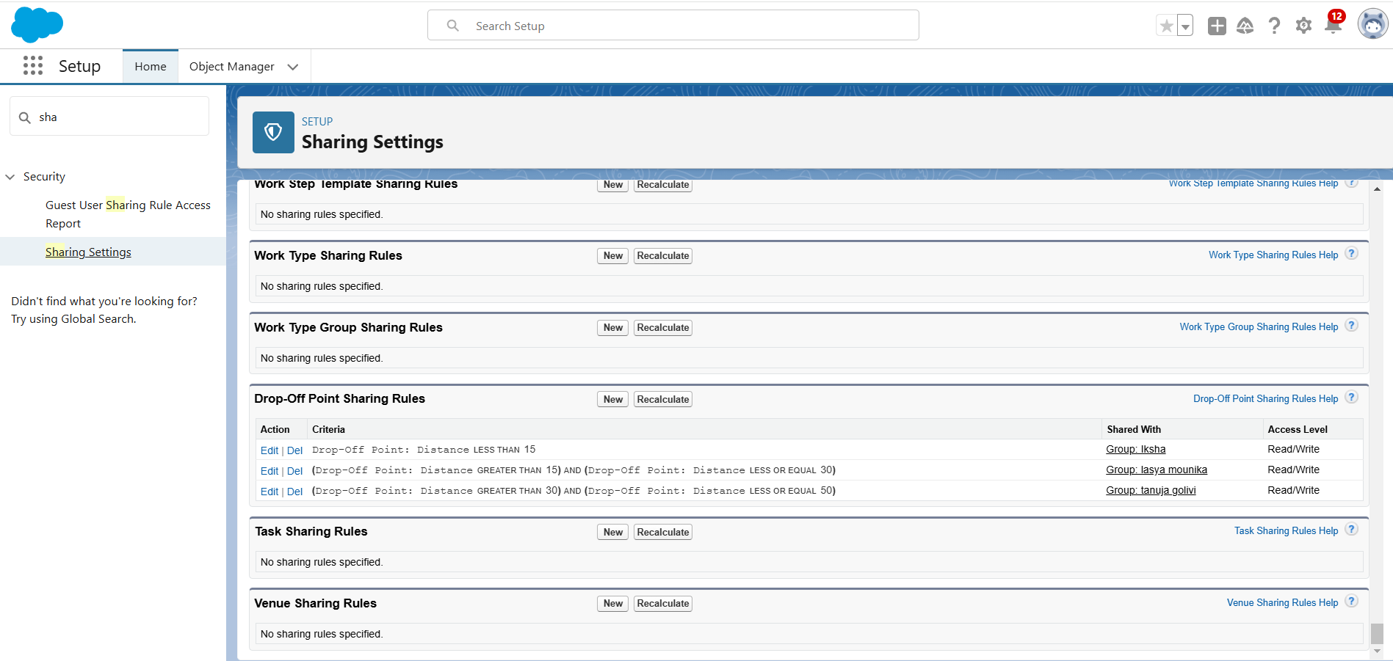

2.4 Flow and Dashboard

Flow : Venue flow

➢ Purpose : To manage and capture detailed information related to food

drop-off points.

➢ Components :

* Text component : For entering the venue name.
* Email component : For entering the contact email of the venue.
* Phone component : For entering the contact phone number of the venue.
* Text component : For entering the venue location.
* Number components : For entering latitude and longitude values of the venue.

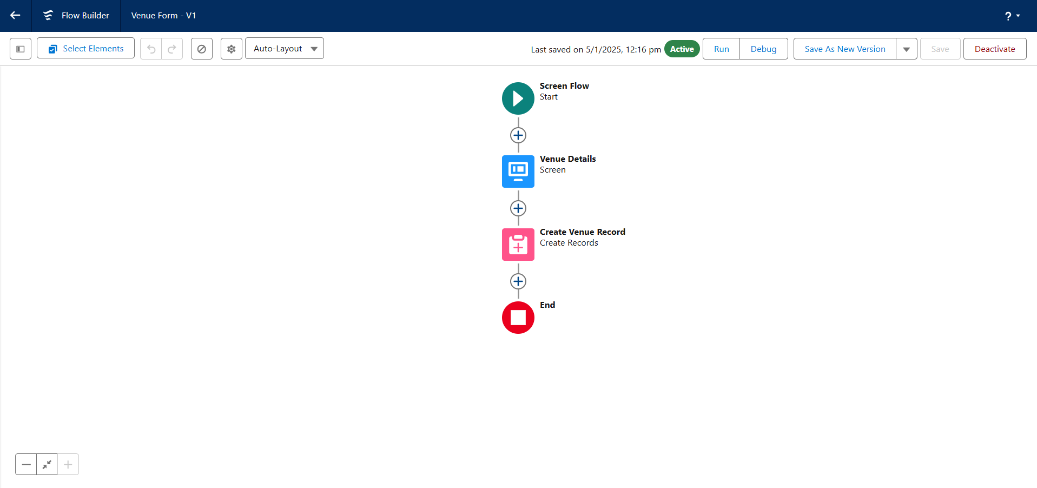

Dashboard :

➢ Name : Task Execution details

➢ Components :

* Lightning Table : Displays detailed information about venues and

drop-off points,facilitating a comprehensive view of the data.

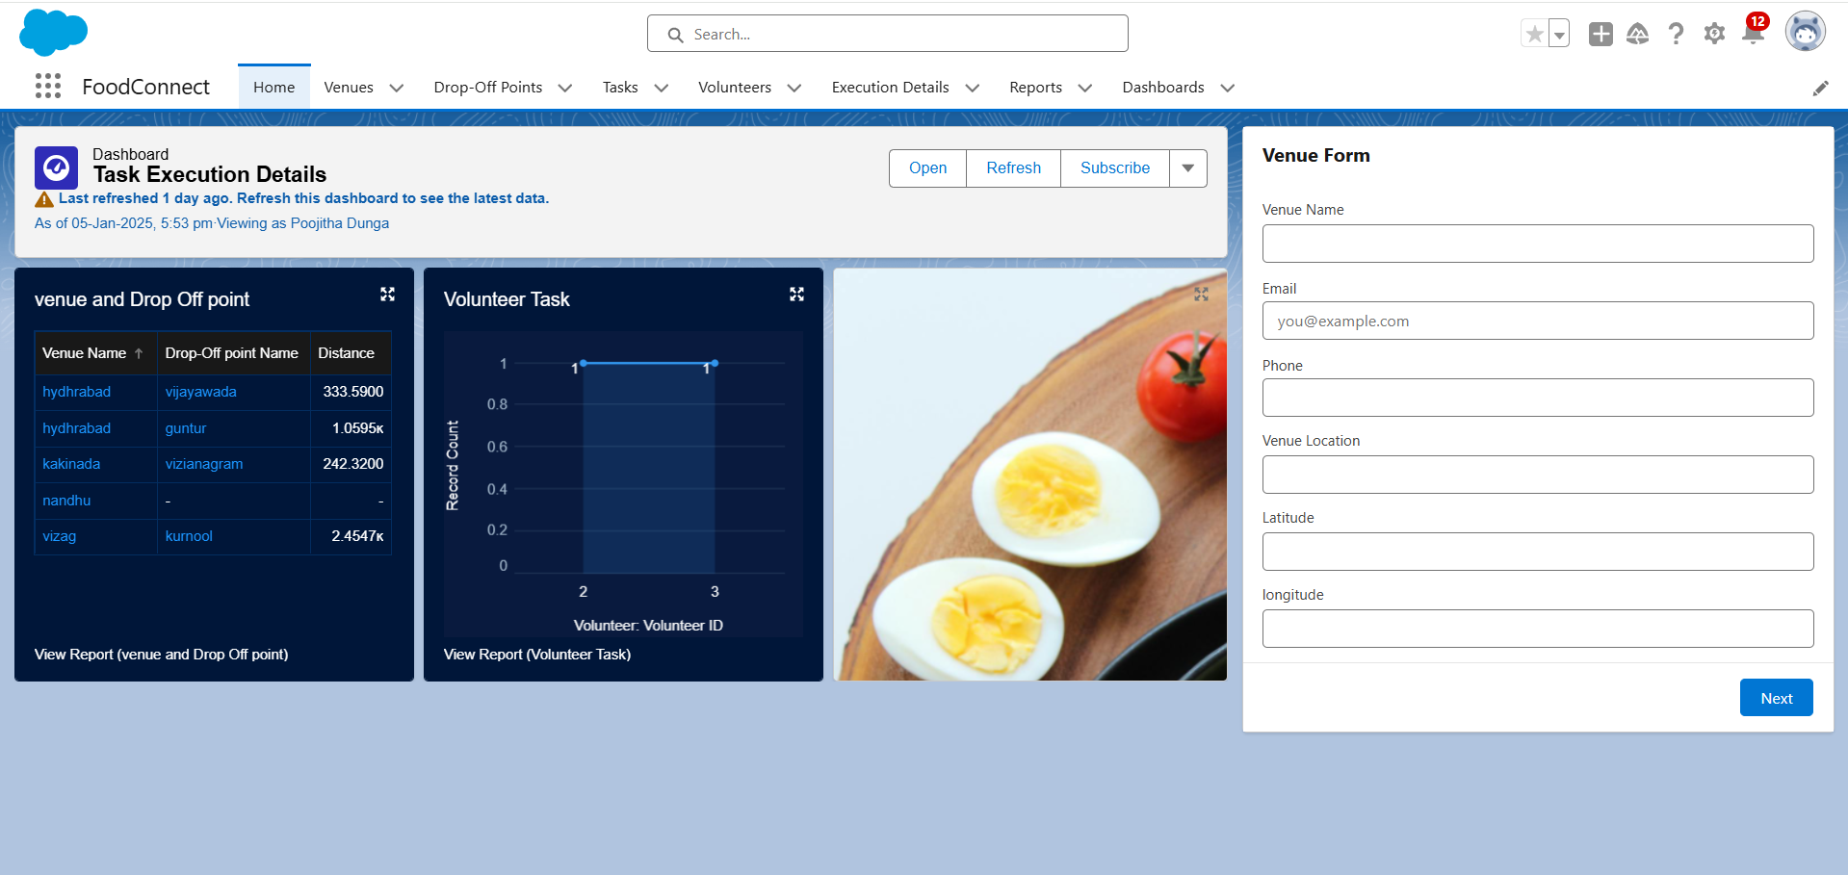

3. Configuration and Setup Instructions

3.1 Creating Custom Objects

1. Drop-off point :

● Navigate to Object manager > Create > Custom object .

● Enter details such as the label name,record name and other settings for

drop off point.

2. Task :

● Navigate to Object Manager > Create > Custom Object.

● Enter details such as the label name,record name and other settings for

Task.

3. Volunteer :

● Navigate to Object manager > Create > Custom object .

● Enter details such as the label name,record name and other settings for

Volunteer.

4. Execution Detail :

● Navigate to Object manager > Create > Custom object .

● Enter details such as the label name,record name and other settings for

Execution Detail.

3.2 Sharing Rules Setup

➢ Go to sharing settings.

➢ Define new sharing rules for drop-off point based on distance criteria,ensuring

appropriate access for different public groups.

3.3 Sharing Rules Set up

● Go to Sharing settings

● Define new sharing rules for drop-off point based on distance criteria ensuring

appropriate access for different public groups.

3.3 Lightning App Builder

1. Create Home Page :

● Go to Lightning App Builder > New

● Select Home Page and name it “HOME Page”

● Add flow component to the page.

2. Save and Activate :

● Click on Save and Activation.

● Set the page as the default for the FoodConnect app.

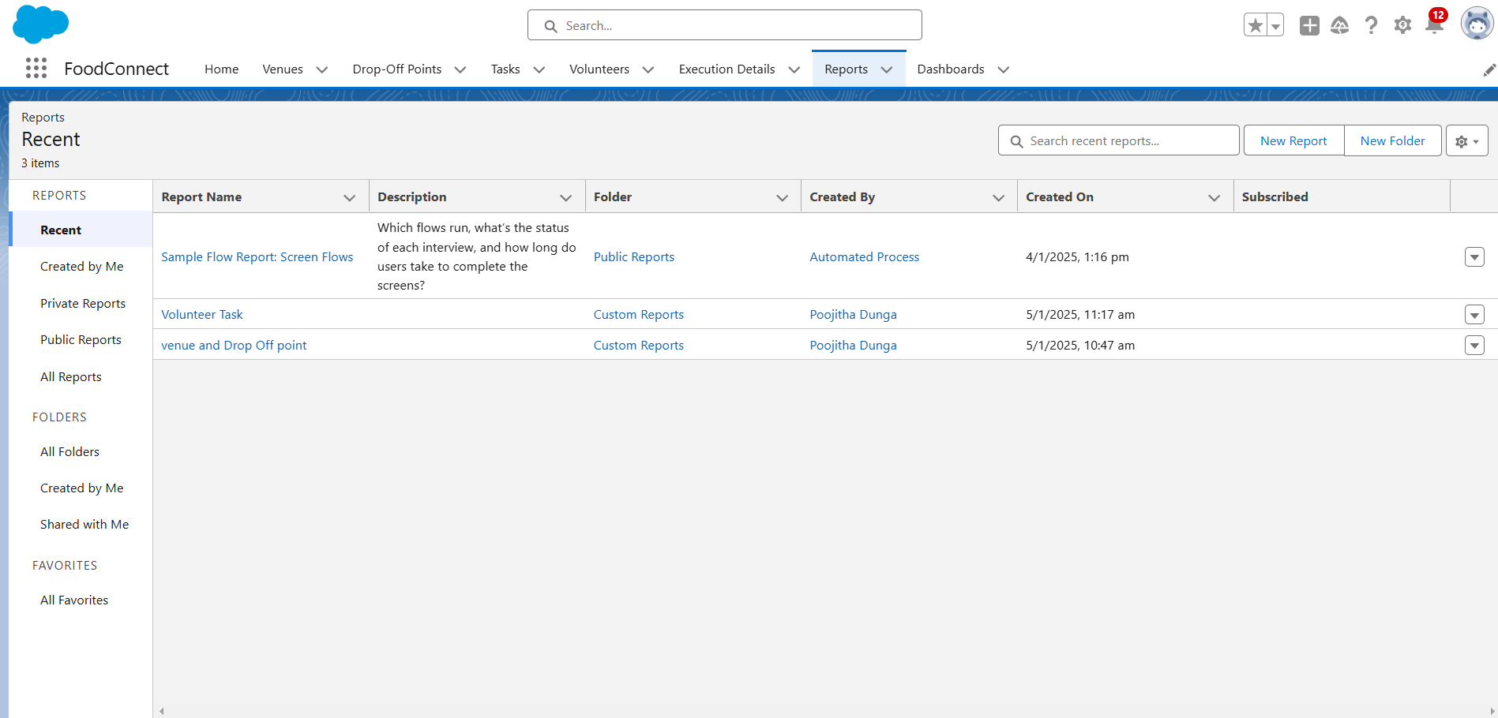

3.4 Report Types and Dashboards

1. Custom Report Types :

* Create report types for venue with Drop-off with Volunteer and Volunteers with Execution Details and Tasks.

2. Reports :

* Generate and configure reports using the custom report types to track and analyse relevant data.

3. Dashboards :

* Configure dashboards to visualise data from reports and other components,providing insights into the overall distribution process.

4. Deliverables :

* Code Files : Include Apex triggers and any other code implemented.
* Output Screenshots : Provide Screenshots of custom objects,flows,dashboards and reports to illustrate the setup.
* Project Documentation : Detailed descriptions of implemented features and set up instructions.
* Project Demonstration Video : A video showcasing the functionality of the application including key features and processes.