**Usecase:**



**Sequence:**



**Collaboration:**

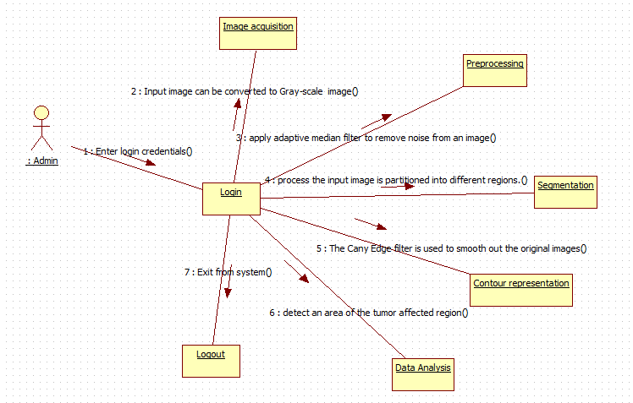

**State chart:**



**Activity:**



**Component:**



**Deployment:**

