VGG-16 Based Transfer Learning for Chest X-Ray Classification
COVID-19 vs. Lung Opacity vs. Normal vs. Viral Pneumonia
Methodology, System Block Diagram and Validation Parameters

1. Problem Statement
Develop a deep learning-based chest X-ray classification system using VGG-16 transfer learning to classify chest X-ray images into four categories: COVID-19, Lung Opacity, Normal, and Viral Pneumonia. The system is intended as a computer-aided screening/research tool that learns visual patterns from labeled chest X-ray images and predicts the class of a previously unseen image. The output should be evaluated using multiple classification metrics rather than accuracy alone.

2. Dataset
The project uses the COVID-19 Radiography Database downloaded from Kaggle. The selected four classes are COVID, Lung Opacity, Normal, and Viral Pneumonia. The original dataset is imbalanced, with Normal having the largest number of images and Viral Pneumonia the smallest. The project therefore includes a class-balancing strategy based on augmentation for the training data.
Class | Original Images | Balanced Target
COVID | 3,616 | 10,192
Lung Opacity | 6,012 | 10,192
Normal | 10,192 | 10,192
Viral Pneumonia | 1,345 | 10,192

Note: The exact counts should be verified against the downloaded Kaggle release. If augmented files are physically generated, they should be created only from the training portion after splitting, not before splitting, to prevent augmented copies of the same source image from appearing in validation or test data.
3. System Block Diagram 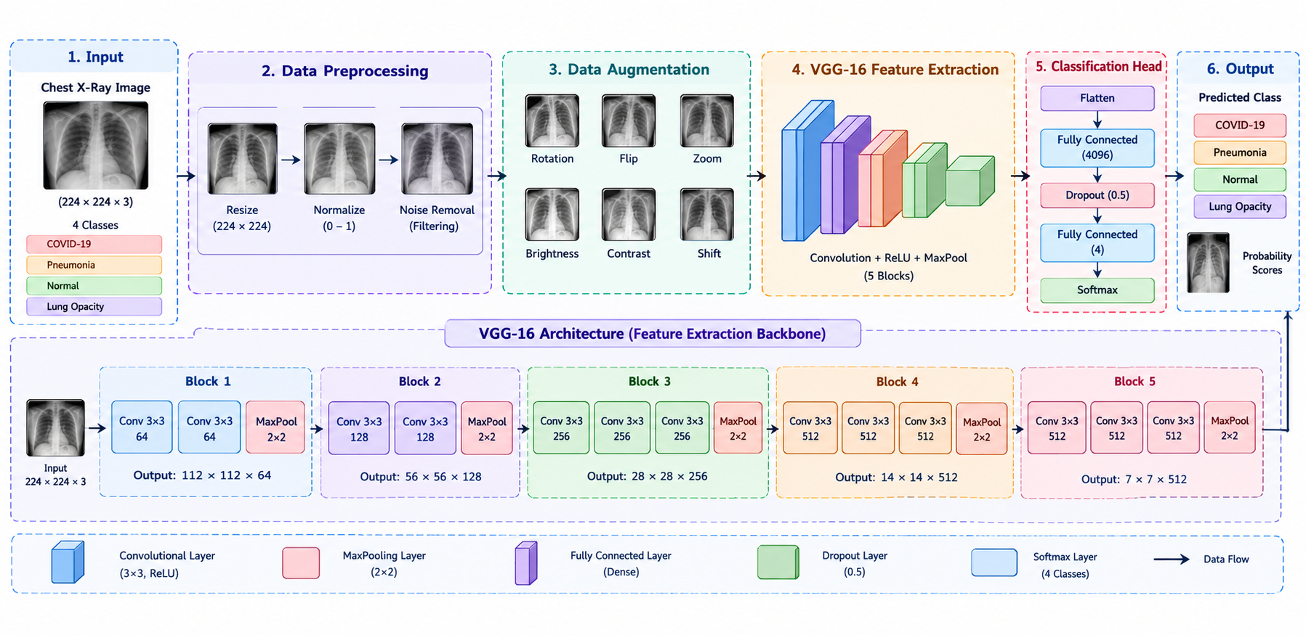
*For a medical imaging experiment, a patient-level split is preferable when patient identifiers are available. Images from the same patient should not be distributed across training, validation, and test sets.

4. Detailed Methodology

4.1 Dataset Acquisition
The dataset is downloaded directly into Google Colab using KaggleHub. The four selected folders are COVID, Lung_Opacity, Normal, and Viral Pneumonia. The mask folders are not used for ordinary image classification unless a separate lung-segmentation stage is added.

4.2 Data Cleaning
Each image is checked for readability and valid file format. Corrupted or unreadable files are removed. Class labels are verified against the directory structure. Duplicate images should be checked where practical.

4.3 Data Splitting
The data should be separated into training, validation, and test sets. A suitable starting split is 70% training, 15% validation, and 15% testing. Stratification should be used so that all four classes are represented in similar proportions across the splits. Augmentation must be applied only to training images.

4.4 Image Resizing and Preprocessing
VGG-16 accepts an input size of 224 × 224 × 3. Therefore, each chest X-ray is resized to 224 × 224 pixels. If the source image is grayscale, it is loaded as three channels (RGB) so it matches the input expected by the ImageNet-pretrained VGG16 network. Keras' VGG16 preprocess_input function is then applied.

4.5 Class Imbalance Handling
The original dataset is imbalanced. To improve representation of minority classes, training-only augmentation can generate varied versions of COVID, Lung Opacity, and Viral Pneumonia images. Suitable transformations include small rotations, modest zoom, and small translations. Large rotations and anatomically questionable transformations should be avoided. An alternative or additional strategy is to use class weights during model.fit().

4.6 VGG-16 Transfer Learning
VGG-16 is loaded with ImageNet-pretrained weights and include_top=False. The convolutional base initially remains frozen so that the pretrained visual features can be reused. A custom classification head is attached to the base.
A representative classification head is: Flatten or GlobalAveragePooling2D → Dense(512, ReLU) → Dropout(0.5) → Dense(4, softmax). The final softmax layer produces four class probabilities.

4.7 Model Compilation
Because the problem has four mutually exclusive classes, categorical cross-entropy is used as the loss function when one-hot labels are supplied. Adam can be used as the optimizer with a small learning rate such as 1e-4 during the initial classifier training stage.

4.8 Training Strategy
The model is trained on the training set and monitored on the validation set. Early stopping can stop training when validation loss stops improving, while ModelCheckpoint can save the best validation model. After the classification head has learned, selected upper VGG16 layers may be unfrozen for fine-tuning using a much smaller learning rate, for example 1e-5.

4.9 Prediction
For a new X-ray, the image is resized to 224 × 224, converted to the required three-channel format, preprocessed using VGG16 preprocessing, and passed through the trained network. The class with the highest softmax probability is reported as the predicted category.

5. Validation and Evaluation Parameters
The model should not be evaluated using accuracy alone because medical datasets can contain class imbalance. The following parameters should be reported on the untouched test set.
Parameter | Formula / Meaning | Purpose
Accuracy | (TP + TN) / (TP + TN + FP + FN) | Overall proportion of correct predictions.
Precision | TP / (TP + FP) | How many predictions for a class were actually that class.
Recall / Sensitivity | TP / (TP + FN) | How many actual cases of a class were detected.
F1-score | 2 × Precision × Recall / (Precision + Recall) | Balances precision and recall.
Specificity | TN / (TN + FP) | Ability to correctly identify non-cases in a one-vs-rest view.
Confusion Matrix | Actual class × predicted class | Shows class-wise correct and incorrect predictions.
ROC-AUC | Area under ROC curve | Measures discrimination; report one-vs-rest or macro strategy for multiclass data.

6. Recommended Validation Outputs
- Training accuracy vs. validation accuracy plot
- Training loss vs. validation loss plot
- Four-class confusion matrix
- Per-class precision, recall, and F1-score
- Macro and weighted F1-score
- Classification report on the independent test set
- Optional: one-vs-rest ROC curves and macro/micro AUC

7. Expected Final Output
The final system accepts a chest X-ray image and returns one of four predicted categories: COVID, Lung Opacity, Normal, or Viral Pneumonia, together with the predicted probability. The evaluation section reports class-wise performance so that the model's behavior on minority classes is visible.

8. Suggested Technology Stack
Component | Technology
Development | Google Colab
Dataset access | KaggleHub
Programming | Python
Deep learning | TensorFlow / Keras
Model | VGG-16 with ImageNet transfer learning
Image processing | Keras / PIL
Evaluation | scikit-learn
Visualization | Matplotlib
Optional deployment | Streamlit

9. Important Experimental Considerations
- Keep validation and test images free from augmentation.
- Do not create augmented copies before splitting; this can cause data leakage.
- If patient identifiers are available, split by patient rather than by individual image.
- Report per-class recall and F1-score, not only overall accuracy.
- Use class weights or training-only augmentation if the final training distribution remains imbalanced.
- This model should be described as a research/computer-aided screening system, not as a standalone clinical diagnosis tool.

10. Methodology Summary
The proposed methodology begins with acquisition and verification of the four-class chest X-ray dataset. Images are split into training, validation, and test sets, resized to 224 × 224, converted to the required three-channel input format, and preprocessed for VGG16. Training-only augmentation and/or class weighting are used to address imbalance. A pretrained VGG16 convolutional base extracts visual features, while a custom four-class softmax head performs classification. The model is trained with categorical cross-entropy and Adam, with early stopping and checkpointing used where appropriate. Final performance is assessed on an untouched test set using accuracy, precision, recall, F1-score, confusion matrix, and optionally ROC-AUC.

By :
2410040039 Sindhu Momula
2410040085 P.Poojitha
2410040004 Sri Vyshnavi Nuka

