1.Architecture:

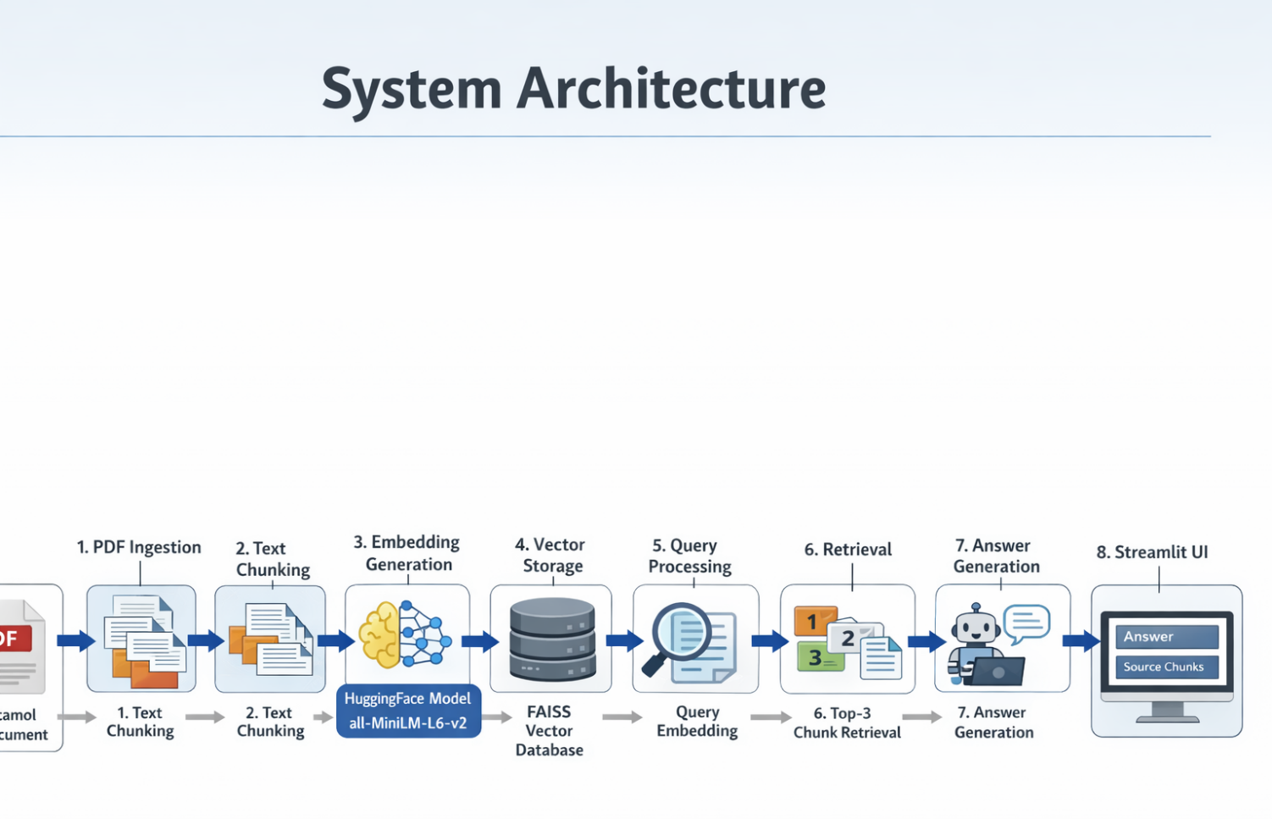
The system is built using a Retrieval-Augmented Generation (RAG) architecture, which combines information retrieval with natural language generation to provide accurate and context-aware answers. This approach is widely used in modern AI systems to overcome the limitations of standalone language models, such as hallucination and lack of domain-specific knowledge.
The pipeline begins with document ingestion, where the input PDF (in this case, related to Paracetamol) is loaded into the system. The text content is extracted using document loaders. Once the text is obtained, it moves to the preprocessing stage, where unnecessary formatting and noise are removed.
Next, the text is divided into smaller chunks to make it easier for the system to process. These chunks are then converted into embeddings using a pre-trained embedding model. The embeddings are stored in a FAISS (Facebook AI Similarity Search) vector database, which allows efficient similarity-based retrieval.
When a user submits a query, the system processes it by converting it into an embedding using the same model. The vector database is then queried to find the most relevant chunks based on similarity. These chunks are passed to a RetrievalQA chain, which integrates a language model to generate an answer grounded in the retrieved context.
Finally, the system presents the results through a Streamlit user interface, where users can upload documents, input queries, and view both the generated answers and the supporting source chunks. This architecture ensures scalability, efficiency, and improved accuracy.

2.Chunking strategy:

This splitter works by recursively breaking text based on a hierarchy of separators such as paragraphs, sentences, and characters. The goal is to maintain semantic coherence within each chunk while ensuring that the chunk size does not exceed model limits.
A typical configuration includes a chunk size of 500–1000 characters and a chunk overlap of 50–200 characters. The chunk size determines how much information each segment contains, while overlap ensures continuity between adjacent chunks. Without overlap, important information that spans across chunk boundaries might be lost, leading to incomplete or inaccurate answers.
The recursive splitting strategy prioritizes natural boundaries in the text, such as paragraph breaks, before resorting to smaller units like sentences or characters. This helps preserve the meaning and context of the original document.
Choosing the right chunking parameters is important. Smaller chunks improve retrieval precision but may lose context, while larger chunks preserve context but may reduce retrieval accuracy. Therefore, a balanced approach is required to optimize performance.
3.Embedding Concept
Embeddings are the foundation of semantic search in a RAG system. They are dense numerical vector representations of text that capture its meaning, context, and relationships with other text.
In this project, the all-MiniLM-L6-v2 model from Hugging Face is used to generate embeddings. This model converts each chunk of text into a fixed-length vector in a high-dimensional space. Similarly, user queries are also converted into vectors using the same model.
The key advantage of embeddings is that they enable semantic similarity rather than simple keyword matching. For example, a query like “pain relief medicine” can still retrieve relevant chunks about “Paracetamol” even if the exact words do not match.
Similarity between vectors is typically measured using cosine similarity, which calculates the angle between two vectors. The closer the vectors are, the more similar their meanings.
Embeddings allow the system to:
- Understand context and intent
- Handle synonyms and variations in language
- Improve retrieval accuracy
- Enable scalable search over large document collections
Without embeddings, the system would rely on keyword-based search, which is less effective and often fails to capture the true meaning of queries.
4.Retrieval process
The retrieval process is the core component that connects user queries with relevant document content. It ensures that the language model receives accurate and meaningful context for answer generation.
When a user inputs a query, the system first converts it into an embedding using the same model used for document chunks. This ensures consistency in the vector space representation.
The query vector is then compared with all stored vectors in the FAISS vector database. FAISS is optimized for fast similarity search, even with large datasets. It uses efficient indexing techniques to quickly identify the most relevant vectors.
The system retrieves the top-k most similar chunks (typically top 3). These chunks are considered the most relevant pieces of information for answering the query.
Once retrieved, these chunks are passed to a language model through a RetrievalQA chain. The model uses the provided context to generate an answer that is both accurate and grounded in the source material.
This approach significantly reduces hallucination, as the model relies on actual document content rather than generating responses purely from pre-trained knowledge.
Additionally, the system can display the retrieved chunks alongside the answer, improving transparency and allowing users to verify the source of the information.

Conclusion:
Overall, the RAG-based system provides an efficient and accurate solution for document question answering. By combining chunking, embeddings, vector search, and language models, it ensures that responses are context-aware, reliable, and scalable. The integration with Streamlit further enhances usability, making the system interactive and user-friendly.

