ServiceNow

Educational Organization Management System

1. Introduction
The Educational Organization Management System is designed on the ServiceNow platform to automate and manage core academic operations. This includes admission management, student information handling, workflow automation, and structured data processing.

2. Problem Statement
Most educational institutions still follow traditional manual processes for student admissions and data handling. These processes are error-prone, time‑consuming, and lack proper tracking. This project resolves these issues by creating a modern automated solution within ServiceNow.

3. Objectives
- To automate the student admission workflow
- To store all academic and personal information in a structured format
- To improve accuracy and reduce manual effort
- To implement UI/UX best practices using Form Builder
- To generate dynamic admission numbers
- To ensure smooth workflow transitions

4. System Requirements
Software Requirements:
- ServiceNow Developer Instance
- Modern Web Browser (Chrome/Edge)
- GitHub Account
- Doc Writer Tool

Technologies Used:
- ServiceNow Tables
-Form Builder
- Client Scripts
- Business Rules
- UI Policies
- Workflows

5. System Design
The system design includes custom tables, forms, workflows, and automation scripts.

Tables Created:
- Salesforce Table
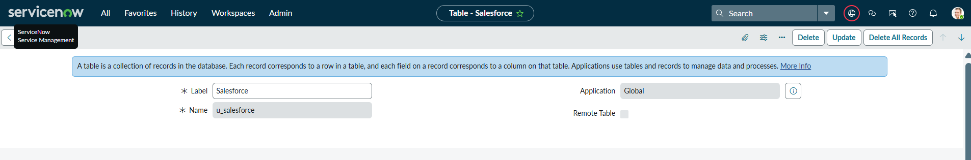

- Admission Table
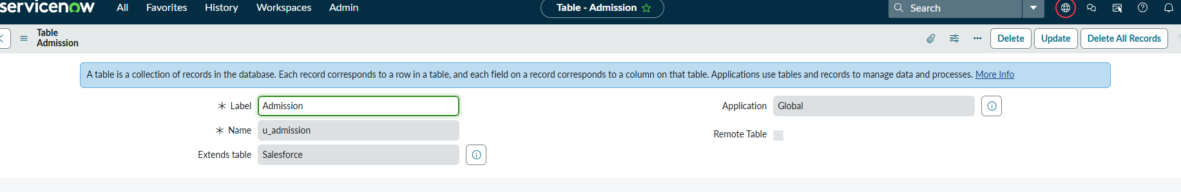
- Student Progress Table
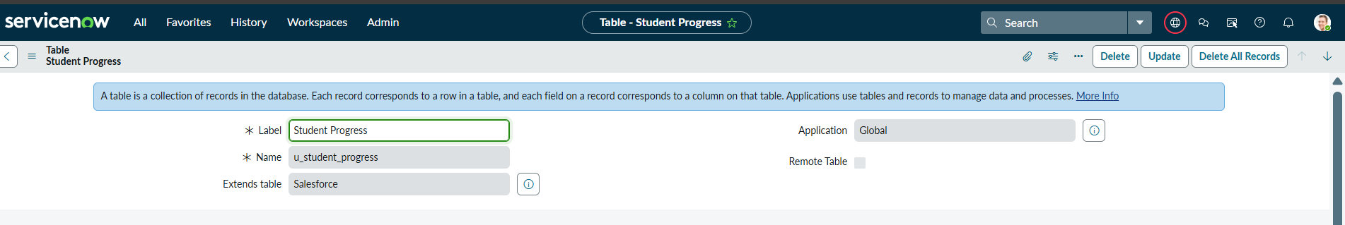

Form Sections:
- Admission Details
- Address Details
- School Details

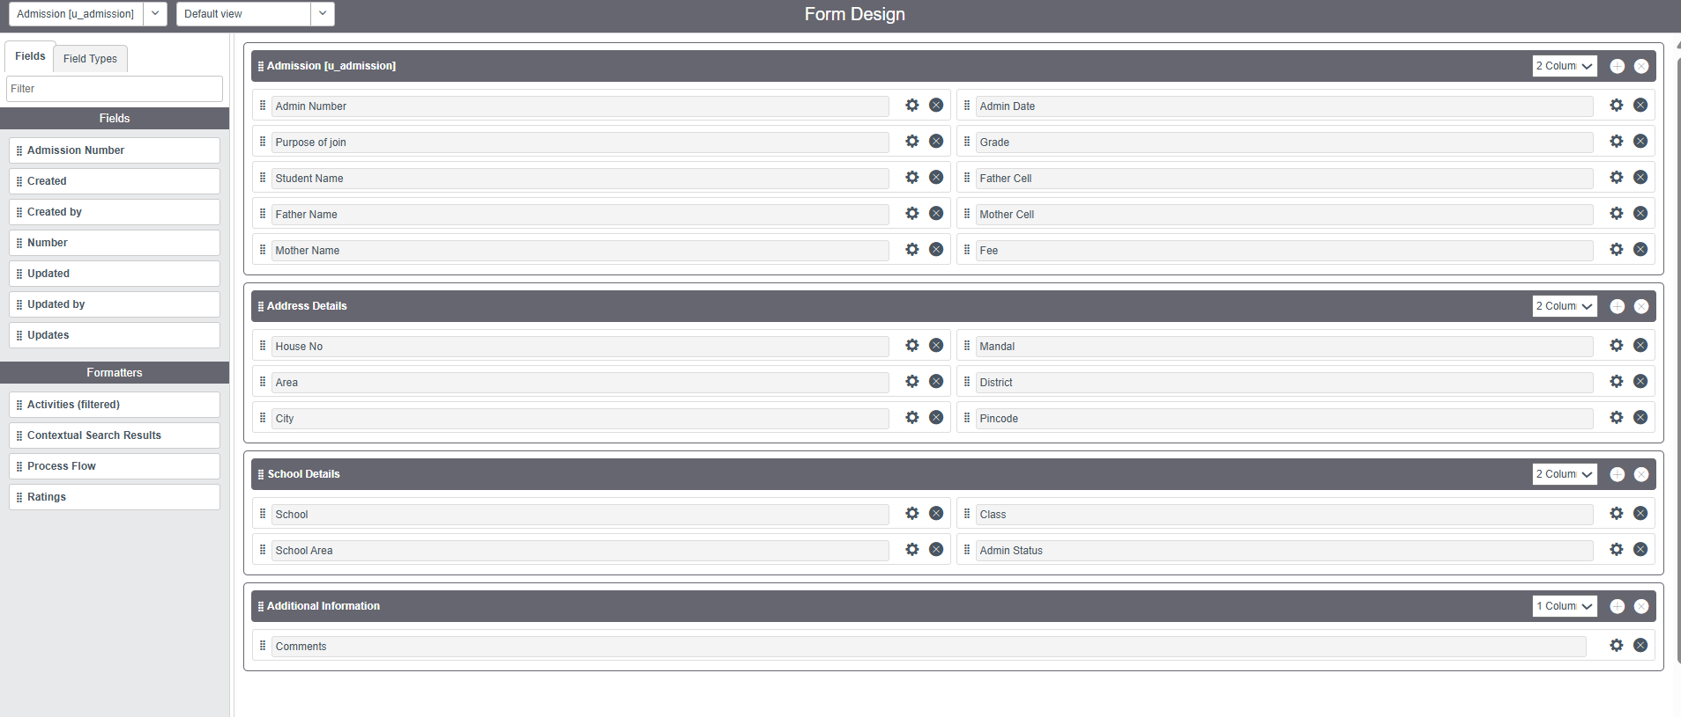

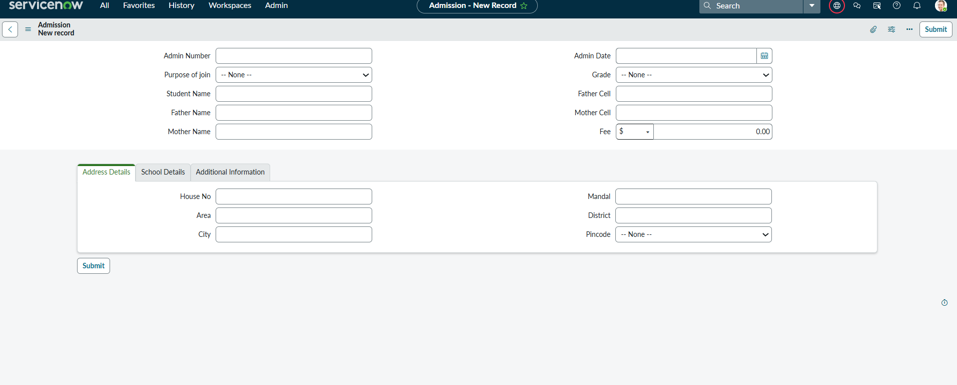

6. Implementation
6.1 Table Creation
The Salesforce table is created with key fields such as student name, Father Cell,Mother Cell, ad and more.
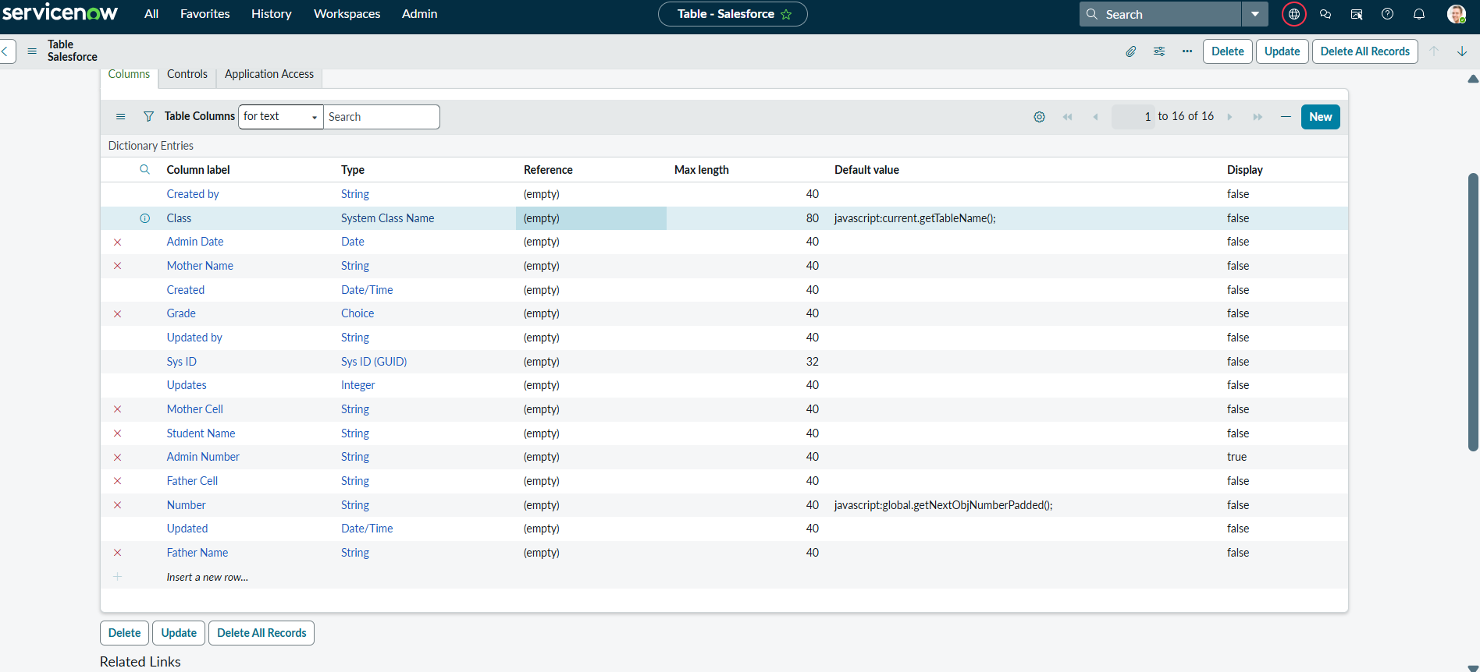

The Admission table is created with key fields such as student name, grade, admission number, address, and more.

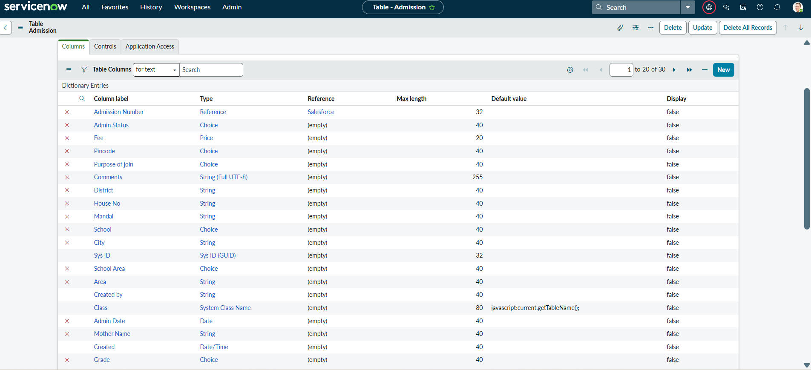

The Student Progress table is created with key fields such as student name, subjects,Total,Percentage, admission number,and more.

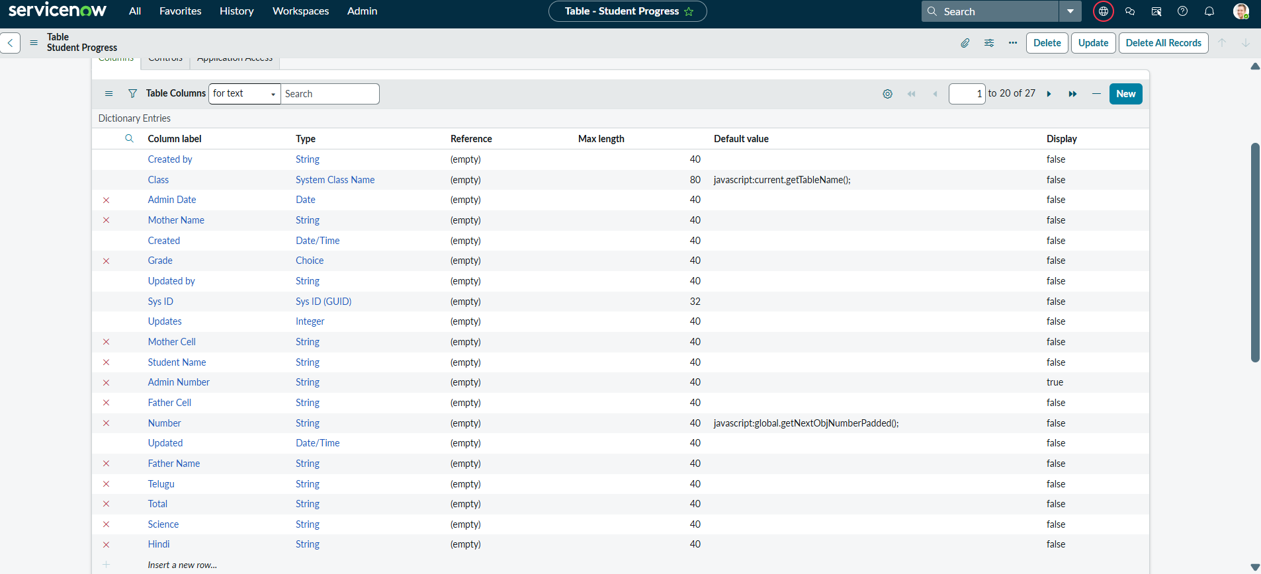

6.2 Form Builder Layout
The fields are arranged in multiple sections with a clean two‑column layout.
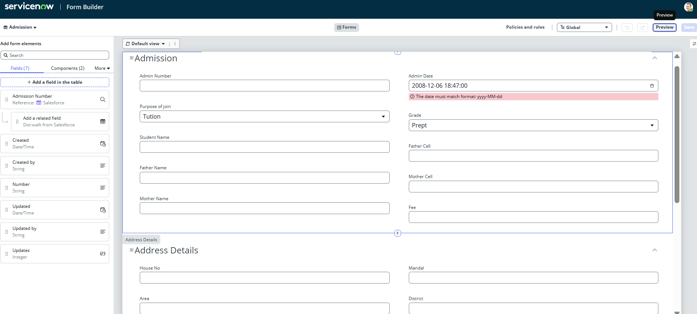

6.3 Choice Field Configuration
Admission status options:
New → In Progress → Joined → Rejected → Rejoined → Closed → Cancelled
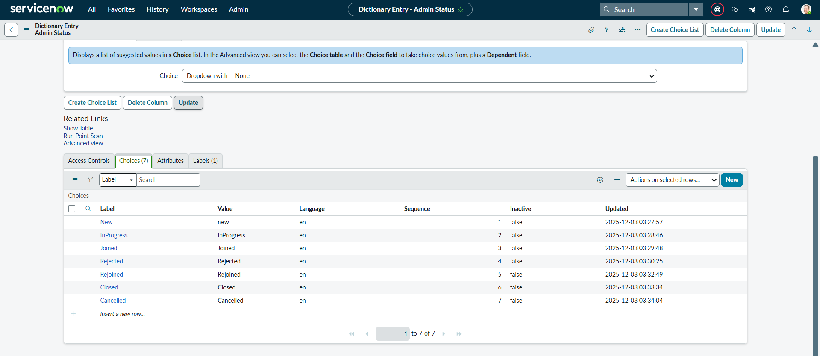

6.4 Client Script
Client scripts are used to auto‑populate fields when the Admission Number is selected.
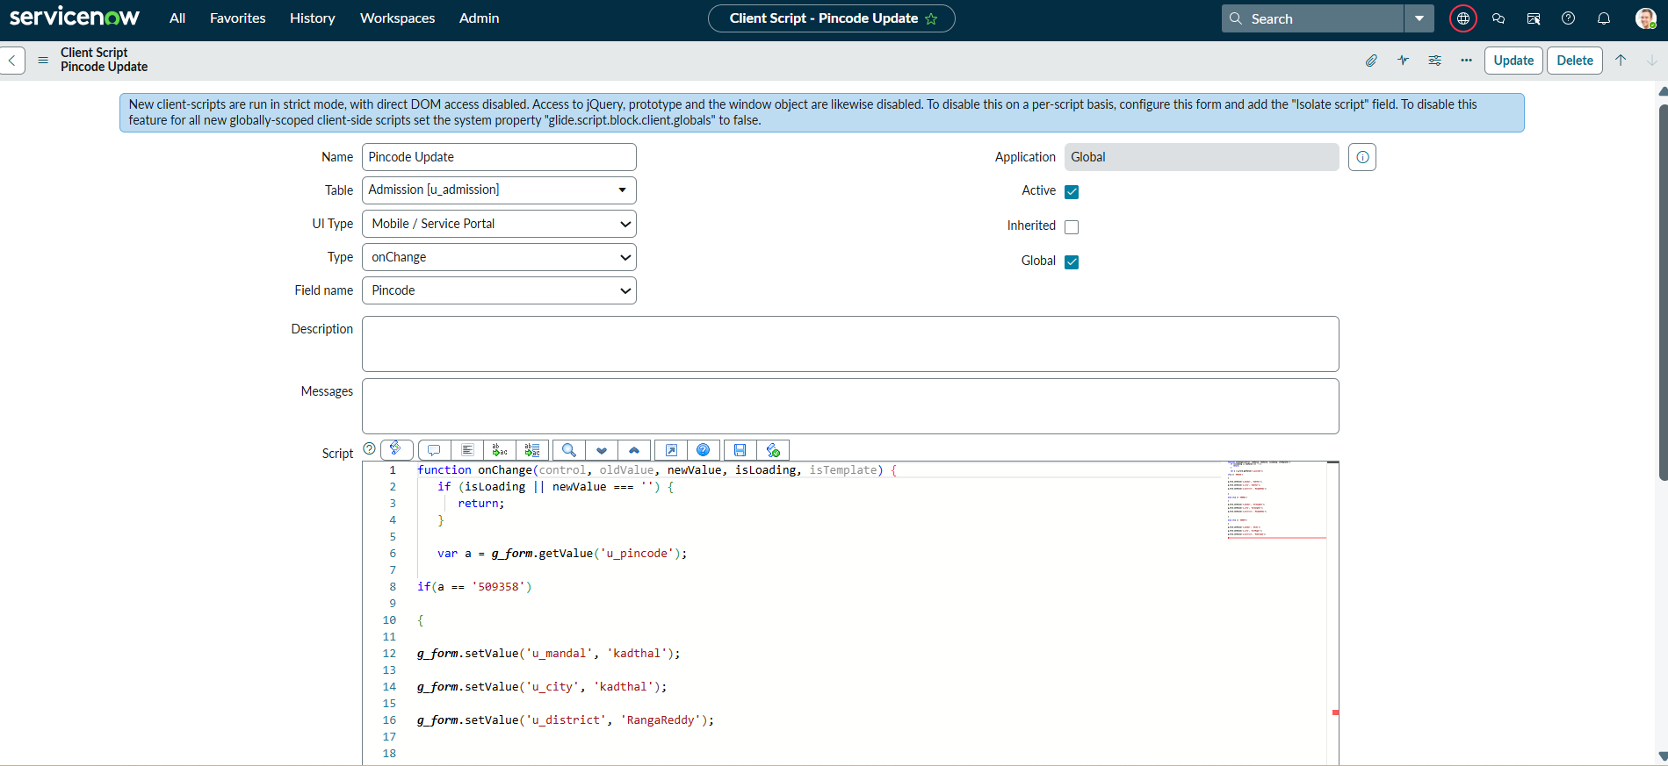

Creating “Disable Fields” Client Scripts for Student progress Table

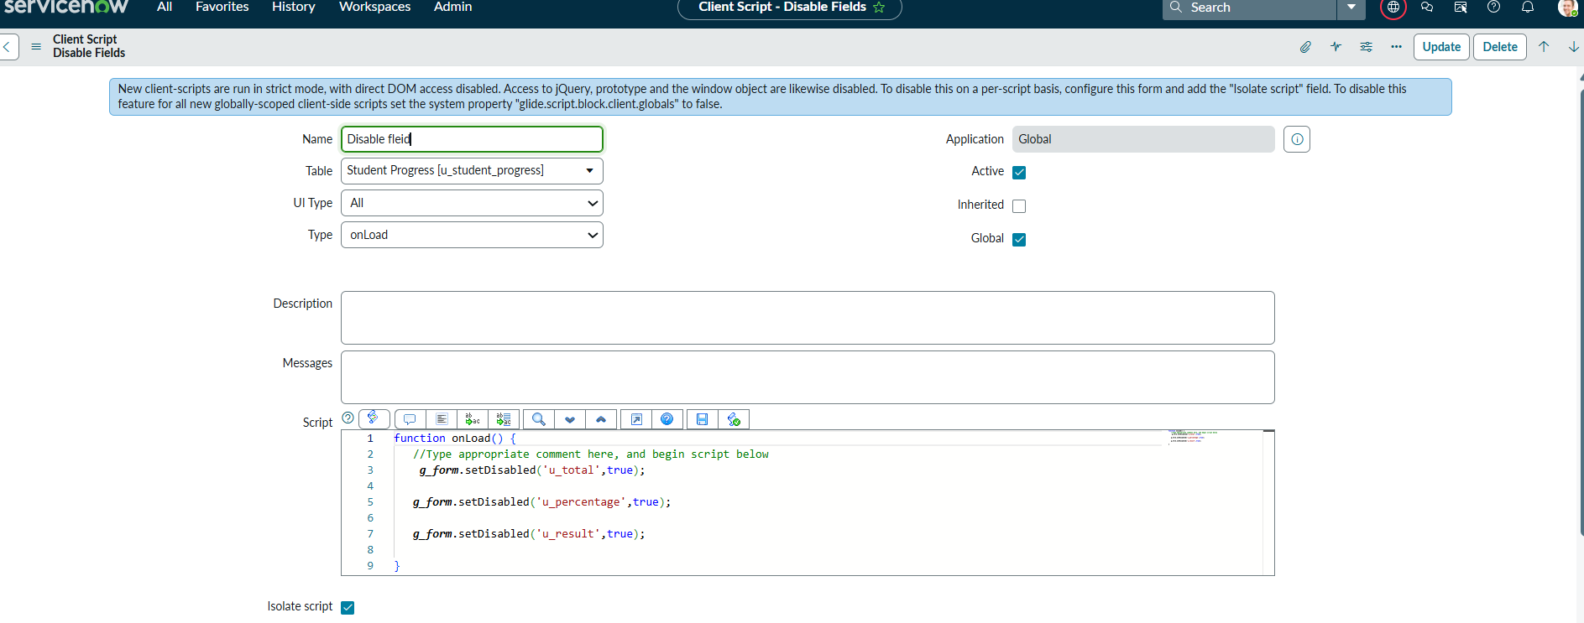

Creating “Total Update” Client Scripts for Student progress Table

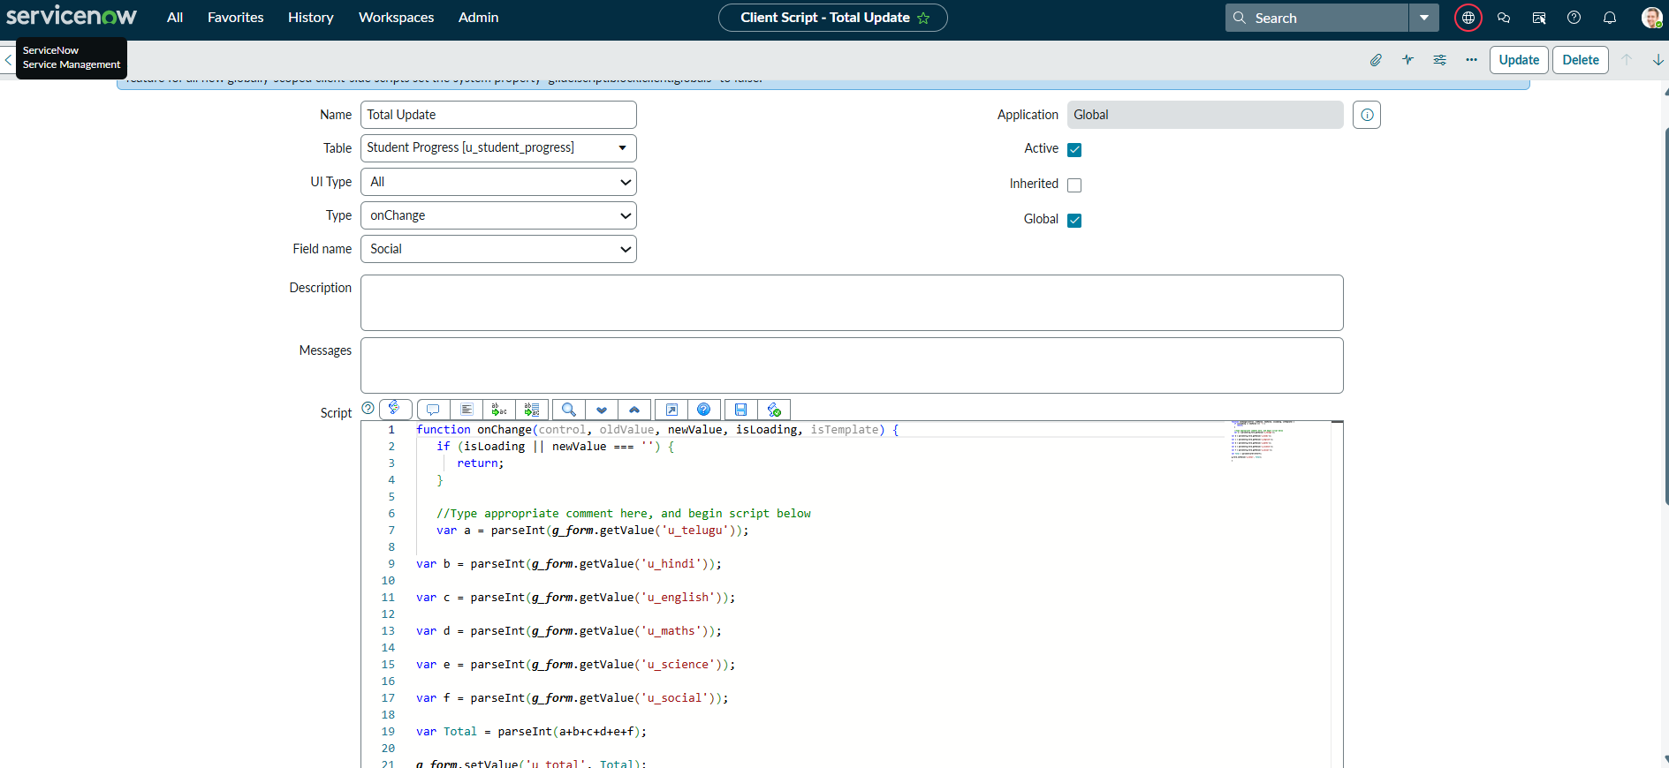

Creating “Result” Client Scripts for Student progress Table

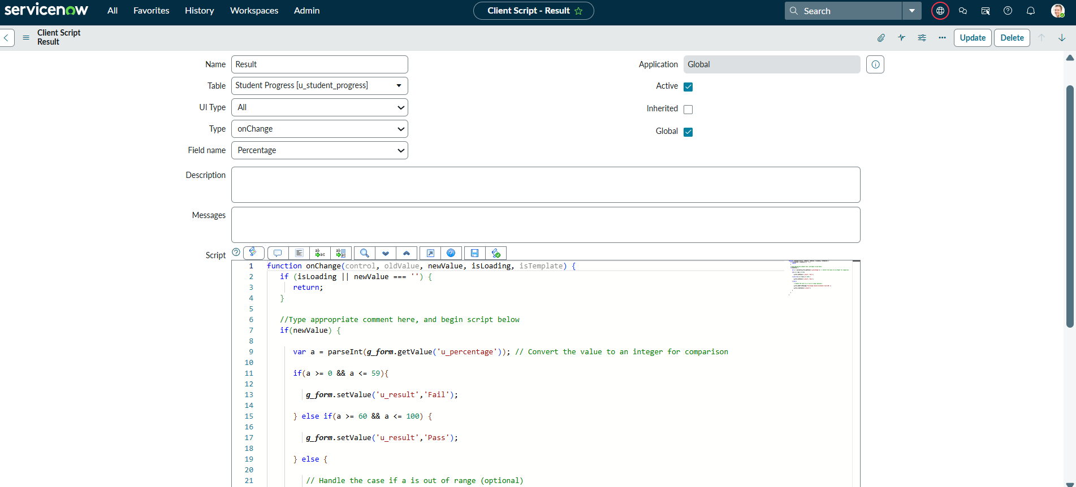

Creating “Percentage” Client Scripts for Student progress Table

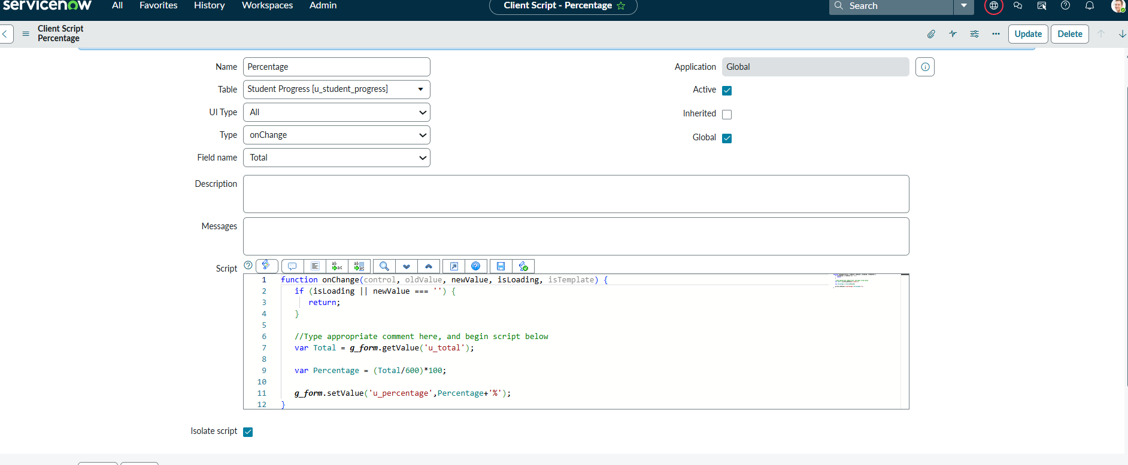

7. Workflow
The admission workflow manages the process flow from start to end:
New → In Progress → Joined → Rejected → Rejoined → Closed → Cancelled

8. Results
The system successfully automates student admission and data management. Form fields auto-populate correctly, workflows transition smoothly, and the UI layout is clean and professional.
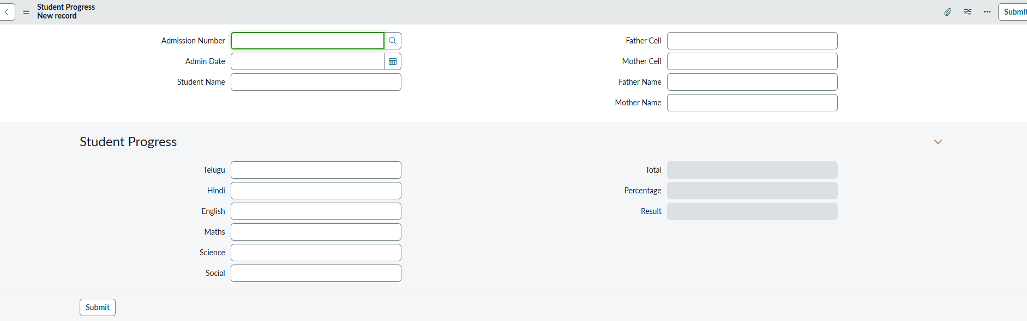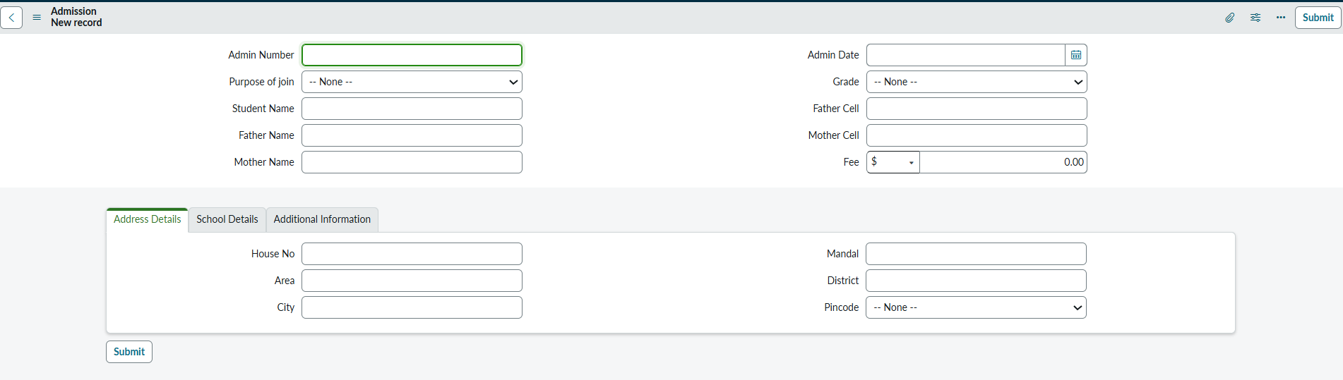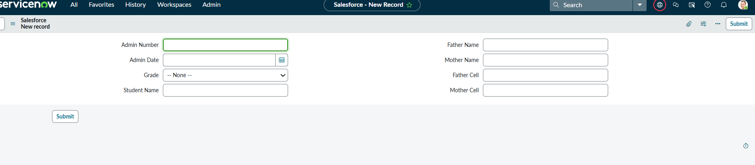

9. Conclusion
The project demonstrates strong understanding of ServiceNow components and delivers a fully functional Educational Organization Management System.

10. Future Enhancements
- Email notifications
- Student dashboard
- PDF receipt generation
- Parent portal
- Third‑party integrations

11. References
- ServiceNow Documentation
- Developer.ServiceNow.co

