ASSIGNMENT-2

NAME: K.Poojitha

EMAIL: [kotapoojitha66@gmail.com](mailto:kotapoojitha66@gmail.com)

Phone number: 9392094389

Roll Number: 20NN1A0585

College: Vignan’s Nirula Institute Of Technology And Science For Women

1. App.js

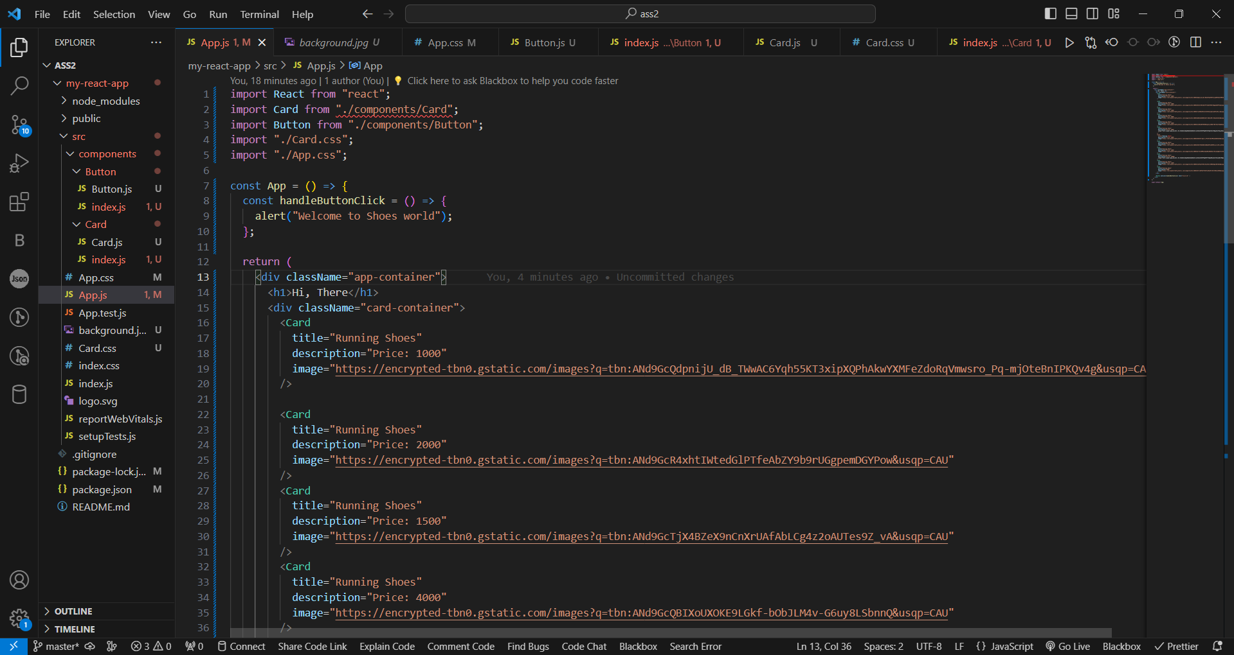

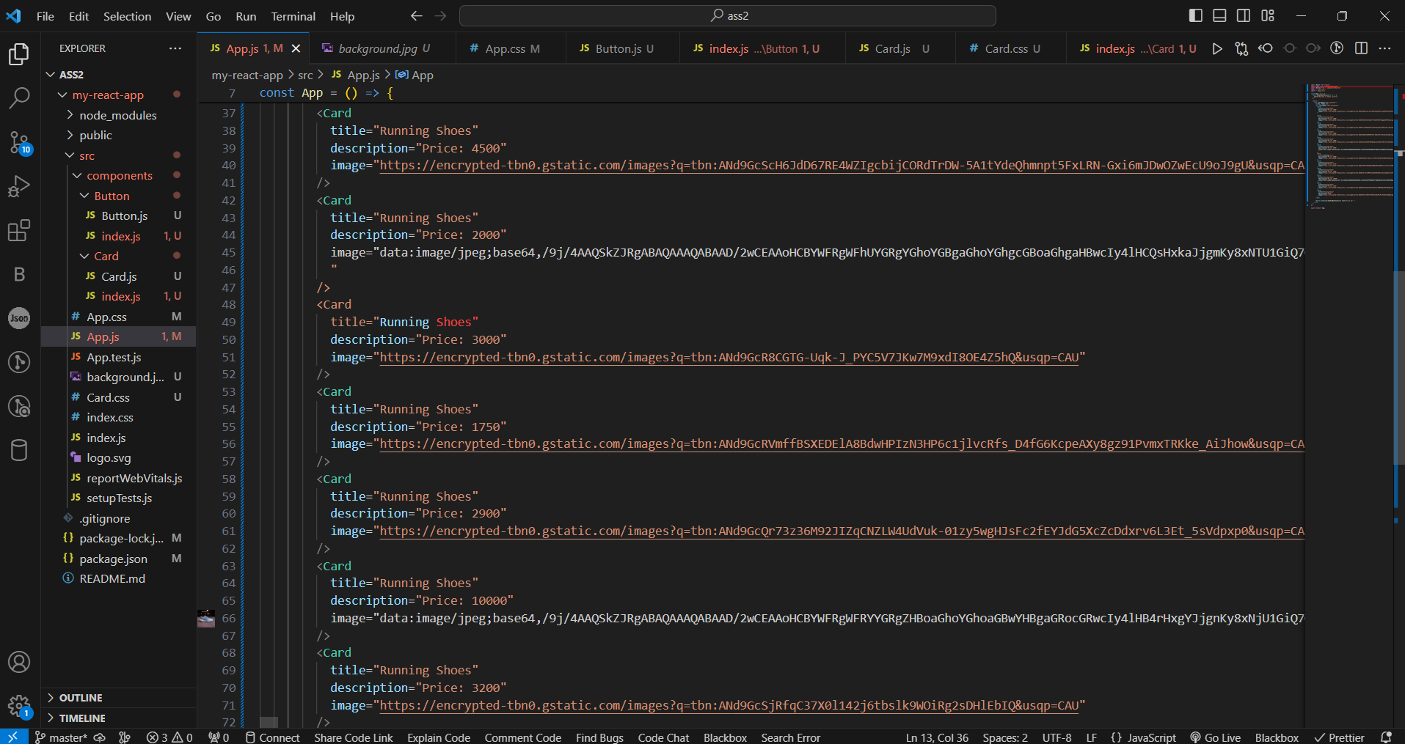

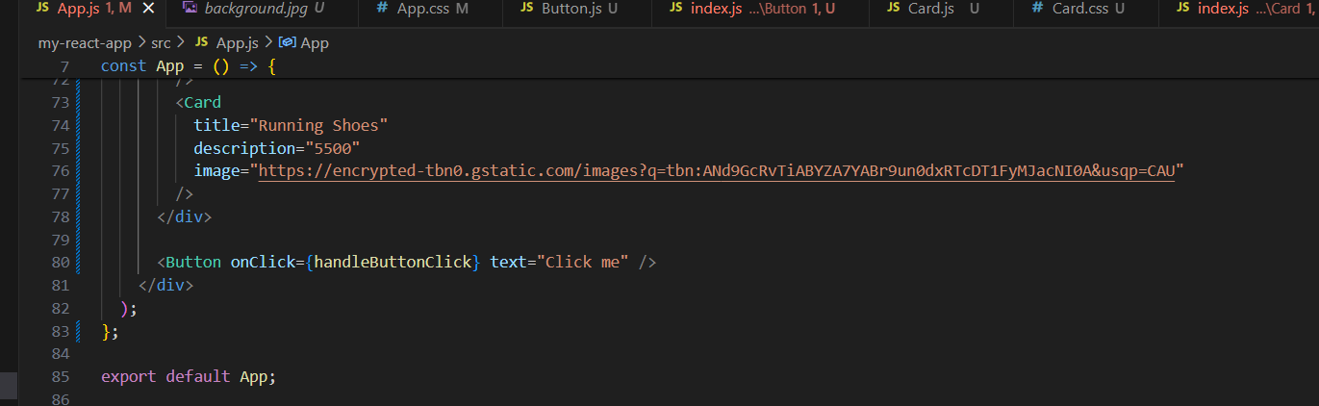

1. App.css

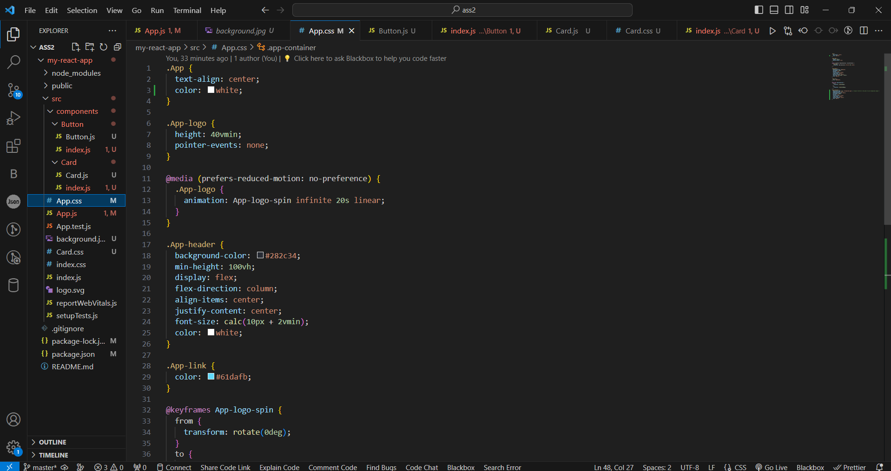

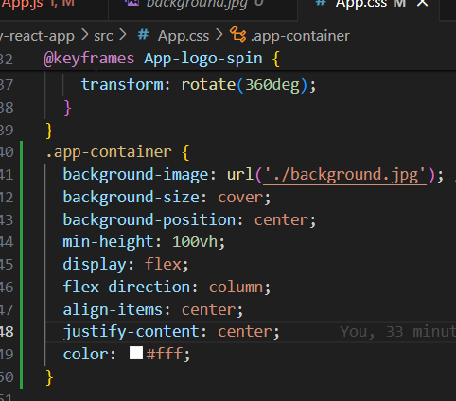

1. Card.js

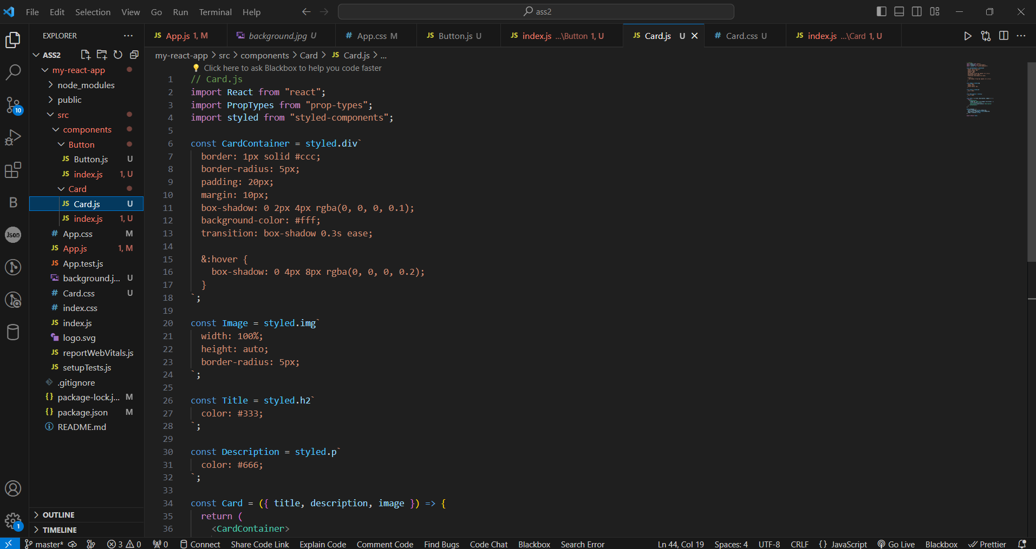

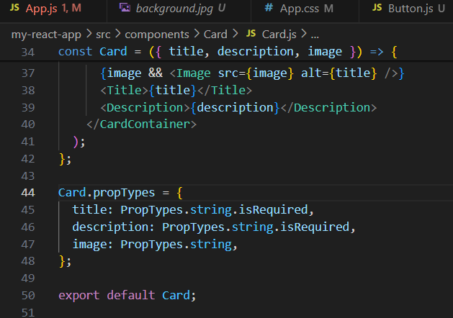

1. index.js

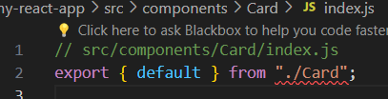

1. Button.js

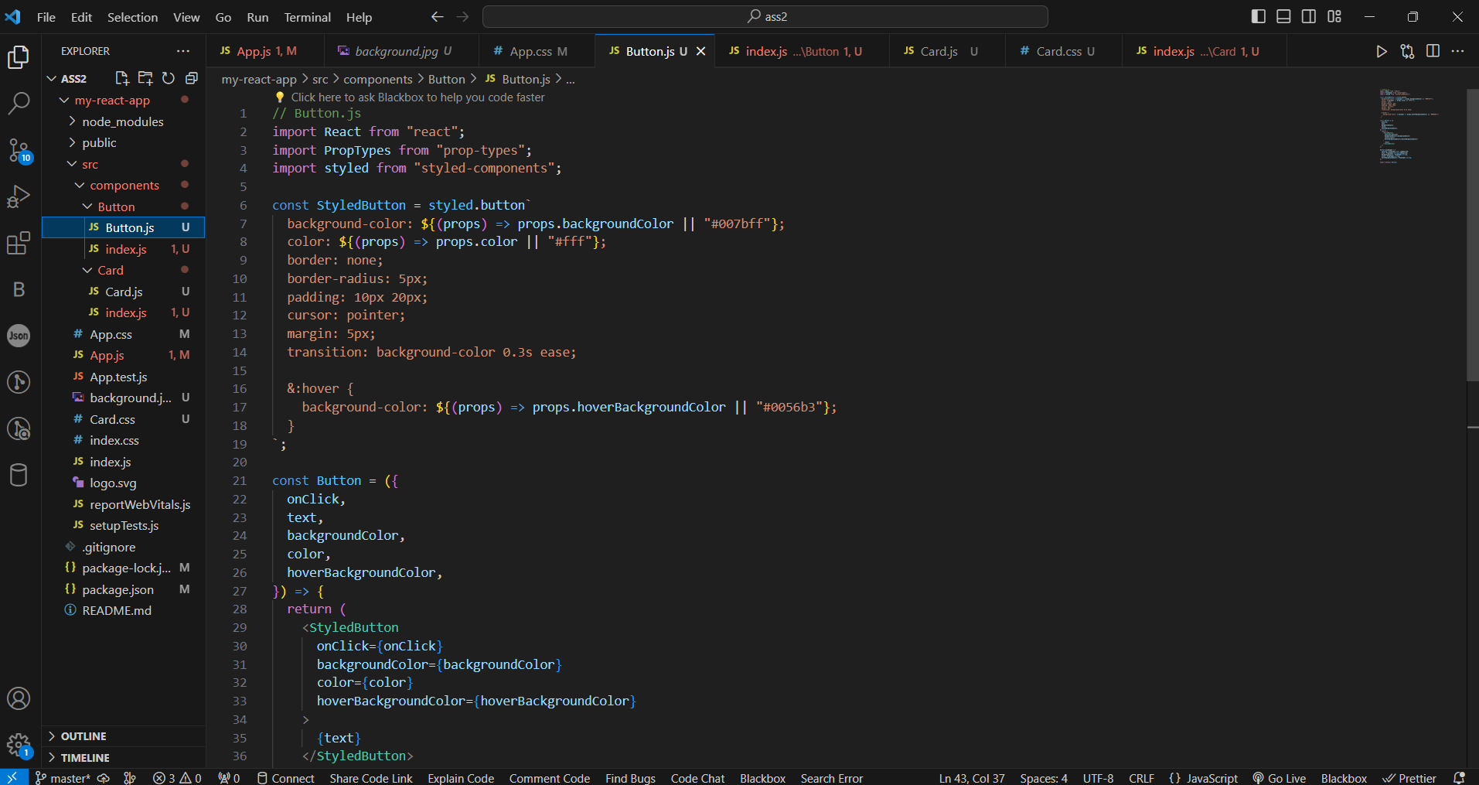

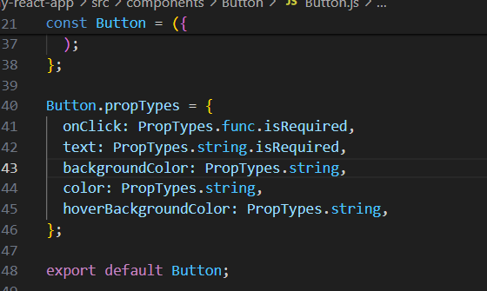

1. index.js

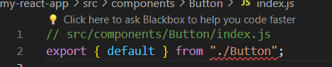

1. Card.css

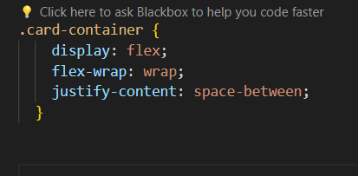

1. Output

