**ONLINE BOOK STORE**

**1. Project Overview**

**Introduction to the Online Bookstore**

The Online Bookstore application allows users to browse, search, and purchase books through a user-friendly web interface. It aims to provide a seamless online shopping experience for book lovers, offering features like easy book search, detailed product information, user accounts, and a streamlined checkout process. The app targets customers looking for an efficient way to buy books online.

**Key Features**

* **Browse and Search Books**: Users can search for books by title, author, genre, or keywords.
* **User Accounts**: Customers can create accounts, log in, and manage their profiles and order history.
* **Shopping Cart and Checkout**: A simple cart and checkout process where users can add items to their cart, apply promo codes, and make secure payments.
* **Payment Gateway**: Integration with secure payment gateways for transactions.
* **Order Tracking**: Customers can view and track their orders.
* **Review and Rating System**: Users can rate and review books after purchasing.

**2. App Survey**

**User Personas**

1. **Customer**:
   * The primary user of the bookstore. Customers browse the store for books by title, genre, or author, add books to their shopping cart, and proceed through the checkout process.
   * They have the option to create an account, which allows them to view their order history, track orders, and leave reviews and ratings for purchased books.
2. **Admin**:
   * Admins are responsible for managing the bookstore inventory. They can add new books, update existing book details (such as price, stock levels, or description), and view detailed sales reports.
   * Admins also handle any backend operations, such as processing customer returns or handling support queries.

**User Stories**

* As a **customer**, I can search for books by title, author, or genre, allowing me to quickly find the books I'm interested in.
* As a **customer**, I can add books to my shopping cart and review my cart before proceeding to checkout.
* As a **customer**, I can create an account to track my past orders and receive personalized book recommendations.
* As a **customer**, I can leave reviews and ratings for books I have purchased, contributing to the overall community feedback for other users.
* As an **admin**, I can add new books to the inventory with details such as price, description, and availability.
* As an **admin**, I can update existing books, adjusting details like pricing or stock levels as necessary.
* As an **admin**, I can view and generate sales reports to analyze which books are performing well in the store.

**Competitor Research**

To design a more competitive and user-friendly app, we conducted research on several established online bookstores, including:

1. **Amazon Books**:
   * Amazon's search functionality is highly refined, offering filters by genre, author, price, and rating.
   * Their recommendation engine is very effective, suggesting books based on user preferences and past purchases.
   * Amazon also excels in providing comprehensive book reviews and ratings, enhancing user trust and engagement.
2. **Book Depository**:
   * Book Depository focuses heavily on global accessibility, offering free worldwide shipping. This feature could inspire a competitive edge for our bookstore.
   * Their simple, clean interface makes it easy to browse and discover books, even for first-time users.
   * They provide detailed descriptions, including publisher information, release dates, and similar books to encourage users to browse further.
3. **Barnes & Noble**:
   * Barnes & Noble has strong integration between its physical and online stores, allowing customers to order online and pick up in-store.
   * Their membership system offers discounts and exclusive deals, which encourages customer loyalty.
   * They provide a platform for user-generated reviews and ratings, contributing to the community-driven aspect of the store.
4. **Bootopia**:
   * Bootopia specializes in providing a curated selection of books from smaller, independent publishers, which appeals to niche markets.
   * They prioritize personalized customer service, with features like live chat and expert book recommendations, creating a more intimate shopping experience.
   * Bootopia’s homepage features a wide range of book categories, from mainstream titles to rare or indie works, which appeals to both casual and avid readers.
   * Their focus on environmental sustainability, such as using eco-friendly packaging and offering e-book alternatives, gives them a unique selling point in the market.
   * Bootopia's community-driven approach encourages users to engage in book discussions, reviews, and recommendations, providing a social aspect to the shopping experience.

**Summary of Findings**

* **Search Functionality**: Across all platforms, an advanced search and filter system is essential for improving user experience. We plan to implement a search bar that allows users to filter books by title, author, genre, price, and rating.
* **Recommendations**: Like Amazon and Bootopia, a recommendation engine will be critical in driving user engagement. We aim to use user data (past purchases, browsing history) to recommend similar books.
* **Customer Reviews and Ratings**: All competitors provide users the opportunity to leave reviews and ratings, creating a sense of community. We will include this feature, allowing customers to share their opinions and help others make informed purchasing decisions.
* **Shipping Options**: Following Book Depository’s model of offering appealing shipping deals, we will offer a range of shipping options, including free shipping on large orders or for premium members.
* **Sustainability and Niche Offerings**: Inspired by Bootopia, we aim to incorporate sustainable practices, such as offering e-books or eco-friendly packaging, and perhaps a section dedicated to niche or independent authors.

**4. Workflow**

The workflow for the Online Bookstore app includes the following key processes:

1. **User Authentication**
   * Users register and log in to access personalized features like the shopping cart and order history.
2. **Browsing and Searching for Books**
   * Users browse books or search by category, title, or author.
3. **Add to Cart and Checkout**
   * Users add books to their cart, review the cart, and proceed to checkout by selecting payment and delivery options.
4. **Order Confirmation**
   * After successful payment, the order is confirmed, and users receive a receipt and order tracking information.
5. **Admin Workflow**
   * Admins log in to the system and manage the book inventory, view sales reports, and update stock information.

**Database Tables**

Books:

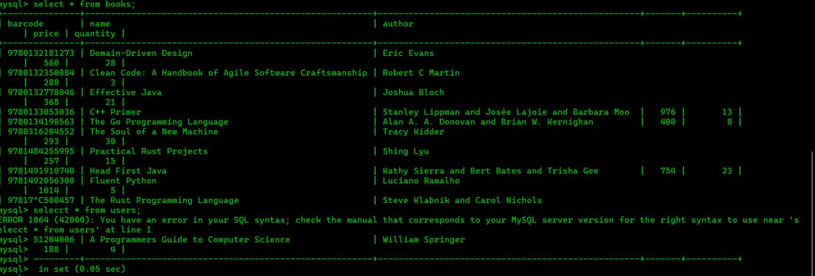

Users:

