AUTOMATED VEHICLE DAMAGE ASSESSMENT AND

COST ESTIMATION FOR INSURANCE COMPANIES

USING DEEP LEARNING TECHNIQUES

A Project Report submitted
in partial fulfillment of the requirements for the award of the degree of

BACHELOR OF TECHNOLOGY

In

COMPUTER SCIENCE & ENGINEERING

By

1. R. Poojitha – 21B01A05F6
2. T. Harika – 21B01A05I2
3. V. Yaswini Padma Priya – 21B01A05I9
4. P. Rashmitha – 21B01A05J9
5. R. Deepthika Devi – 21B01A05G0

Under the esteemed guidance of

Mr. P. J. R. Shalem Raju

(Associate Professor)



DEPARTMENT OF COMPUTER SCIENCE & ENGINEERING SHRI VISHNU ENGINEERING COLLEGE FOR WOMEN(A)
(Approved by AICTE, Accredited by NBA & NAAC, Affiliated to JNTU Kakinada)
BHIMAVARAM – 534 2022024 – 202

SHRI VISHNU ENGINEERING COLLEGE FOR WOMEN(A)
(Approved by AICTE, Accredited by NBA & NAAC, Affiliated to JNTU Kakinada)
BHIMAVARAM – 534 202

DEPARTMENT OF COMPUTER SCIENCE & ENGINEERING



CERTIFICATE

This is to certify that the project entitled “Automated Vehicle Damage Assessment and Cost Estimation for Insurance Companies using Deep Learning Techniques” is being submitted by R.Poojitha ,T.Harika, V.Yaswini Padma Priya, P.Rashmitha, R.Deepthika Devi bearing the Regd No’s 21B01A05F6, 21B01A05I2, 21B01A05I9, 21B01A05J9 ,21B01A05G0 in partial fulfillment of the requirements for the award of the degree of “Bachelor of Technology in Computer Science & Engineering” is a record of bonafide work carried out by her under my guidance and supervision during the academic year 2024–2025 and it has been found worthy of acceptance according to the requirements of the university.

Internal Guide Head of the Department

External Examiner

ACKNOWLEDGMENT

The satisfaction that accompanies the successful completion of any task would be incomplete without the mention of the people who made it possible and whose constant encouragement and guidance has been a source of inspiration throughout the course of this project. We take this opportunity to express our gratitude to all those who have helped us in this project.

We wish to place our deep sense of gratitude to Sri. K. V. Vishnu Raju, Chairman of SVES, for his constant support on each and every progressive work of mine.

We wish to express our sincere thanks to Dr. G. Srinivasa Rao, Principal of SVECW for being a source of inspiration and constant encouragement.

We wish to express our sincere thanks to Prof. P. Venkata Rama Raju, Vice-Principal of SVECW and Dr. P. Srinivasa Raju, Director Students Affairs & Admin for SVES Group of Institutions in Bhimavaram for their unwavering support and motivation.

We wish to place our deep sense of gratitude to Dr. P. Kiran Sree, Head of the Department of Computer Science & Engineering for his valuable pieces of advice in completing this project successfully.

I extend my warmest thanks to Mr. P. J. R. Shalem Raju, Associate Professor for his unflinching devotion and valuable suggestions throughout my project work.

We wish to express our sincere gratitude to the Project Co-ordinator Dr. P. Sudha Rani, Professor and Project Review Committee (PRC) members Dr. K. Ramachandra Rao,
Dr. R. Anuj, Dr. N. Silpa for their insightful feedback and constructive suggestions throughout the course of this project. Their guidance and expert advice were crucial in shaping the direction and quality of this project. We deeply appreciate their time and effort in reviewing our work and providing us with valuable perspectives

Project Associates:
- R. Poojitha – 21B01A05F6
- T. Harika – 21B01A05I2
- V. Yaswini Padma Priya -21B01A05I9
- P. Rashmitha - 21B01A05J9
- R. Deepthika Devi – 21B01A05G0

ABSTRACT

The" Automated Vehicle Damage Assessment and Cost Estimation for Insurance Companies using Deep Learning" project aims to revolutionize the vehicle insurance industry by automating the damage assessment process using advanced deep learning techniques. Leveraging YOLOv5, a state-of-the-art object detection model, this system is designed to analyze and evaluate damage sustained by vehicles, including both two-wheelers and four wheelers. The model is trained on a comprehensive dataset of vehicle damages to accurately identify and classify different types of damage. By integrating this technology, insurance companies can significantly enhance the efficiency and accuracy of their claims processing, reduce human error, and provide more precise cost estimations for repairs. This system promises to streamline the insurance workflow, leading to faster claim resolutions and improved customer satisfaction.

This intelligent system employs YOLOv5 (You Only Look Once version 5), a state-of-the-art object detection model renowned for its high speed and precision, to detect and classify various types of vehicle damage from images. The model is trained on a large, diverse dataset containing annotated images of vehicle damages, including both two-wheelers and four wheelers, encompassing common damage categories such as dents, scratches, broken parts, and more. By utilizing advanced computer vision techniques, the model identifies the damaged areas with bounding boxes and classifies the type of damage, which forms the foundation for the subsequent cost estimation phase.

The cost estimation module utilizes regression algorithms and mapped repair cost data to provide accurate repair cost predictions based on the type, location, and severity of the damage detected. This not only reduces the dependency on manual inspection but also ensures consistency and transparency in claim processing.

Integrating this automated system into the insurance domain offers multiple benefits:

Increased Efficiency: Faster claim assessments and reduced turnaround time.
Improved Accuracy: Minimization of human error and subjective evaluations.
Cost-effectiveness: Streamlined workflow reduces operational costs.

Table Of Contents

S.No Topic Page No
- Introduction 6 – 8
- System Analysis 9 – 12
  - Existing System
  - Proposed System
  - Feasibility Study
- Requirement Analysis 13 - 17
  - Functional Requirements and
Non- Functional Requirements
  - Hardware Requirements
  - Software Requirements
- System Design 18 - 34
  - Introduction
  - Data flow diagrams (or) UML Diagrams
- System Implementation 35 - 49
  - Introduction
  - Project Modules
  - Algorithm
  - Libraries and their usage
6. System Testing 50 - 70
  - Introduction
  - Testing methods
  - Test Cases
- Conclusion 71 - 72
- Bibliography 73 - 74
- Appendix 75 - 77
9.1 Appendix - A
9.2 Introduction to YOLOv5

1.Introduction

Vehicle insurance companies face significant challenges in accurately assessing vehicle damage and estimating repair costs. Traditional assessment methods rely on manual inspection, which is time-consuming, prone to human errors, and inconsistent across different evaluators. These inefficiencies lead to delays in claim processing, increased operational costs, and customer dissatisfaction. The need for an automated, efficient, and reliable damage assessment system has driven research into deep learning-based solutions.

Deep learning has revolutionized image-based classification tasks by enabling automated feature extraction and accurate object detection. Among various deep learning models, YOLOv5 (You Only Look Once) has proven highly effective for real-time object detection due to its speed and accuracy. Unlike traditional manual inspections, which depend on human expertise, YOLOv5 enables automated identification and classification of vehicle damage, ensuring consistency in assessment and cost estimation.

This study aims to develop an intelligent vehicle damage assessment and cost estimation system using YOLOv5. The model is trained on a diverse dataset of damaged vehicle images, allowing it to detect different types of damages with high precision. By automating this process, the system reduces claim processing time, minimizes human intervention, and improves the overall efficiency of insurance operations. The real-time detection capability of YOLOv5 enhances accuracy, even under challenging conditions such as varying lighting and camera angles.

Beyond improving insurance claim processing, this system has broader applications in fleet management, vehicle rental services, and automotive quality control. Automating damage detection and cost estimation can enhance operational efficiency in industries that rely on rapid and accurate vehicle assessments. The integration of AI-driven solutions in vehicle inspection processes can set new industry standards, making damage evaluation more accessible, scalable, and precise.

One of the key challenges in manual vehicle damage assessment is subjectivity. Different insurance assessors may provide varying evaluations for the same damage, leading to inconsistencies in claim settlements. The proposed system eliminates this subjectivity by providing an standardized evaluation process that ensures uniform damage assessment and cost estimation across all claims. This improves transparency in the insurance process and builds trust between insurers and policyholders.

The automation of vehicle damage assessment is not limited to improving efficiency; it also ensures a standardized and unbiased evaluation process. Traditional claim assessments can vary due to subjective judgments, leading to inconsistencies in cost estimation. An automated system eliminates these discrepancies by applying uniform evaluation criteria, ensuring fair and accurate damage assessments. This helps insurance companies maintain consistency across different claims and enhances transparency in the claim approval process.

The proposed system also aligns with the broader trend of digital transformation in the insurance industry. By incorporating advanced image processing techniques into vehicle damage assessment, insurance companies can enhance their service offerings, reduce operational costs, and provide faster claim resolutions. The adoption of such technologydriven solutions is crucial for staying competitive in the rapidly evolving landscape of insurance and automotive industries.

The scalability of this system makes it suitable for widespread adoption in insurance companies of all sizes. By integrating cloud-based infrastructure, the model can process large volumes of vehicle damage assessments simultaneously, reducing bottlenecks in claim processing. This allows insurers to handle high claim loads efficiently, especially during peak periods such as natural disasters or accidents involving multiple vehicles. The combination of automated assessment and cloud computing ensures that insurers can provide fast, accurate, and unbiased damage evaluations at scale. Additionally, the system's adaptability allows for continuous improvements through retraining on new data, ensuring long-term accuracy and reliability.

In conclusion, this research focuses on automating vehicle damage assessment and cost estimation. By utilizing advanced image recognition techniques, the system offers a reliable, automated approach that addresses the limitations of traditional assessment methods. The findings of this study contribute to the ongoing transformation of insurance processes, paving the way for more efficient and precise damage evaluation systems.

2. System Analysis

2.1 Existing System:

The traditional vehicle damage assessment process in the insurance industry relies on manual inspections, where adjusters examine vehicles, take photographs, and estimate repair costs based on their judgment. This approach is time-consuming, leading to delays in claim processing and customer dissatisfaction. Additionally, the process is highly subjective, resulting in inconsistencies between different assessors. Errors in judgment can lead to inaccurate cost estimations, either inflating payouts and straining insurers or underestimating damages and leaving customers shortchanged. Moreover, the need for adjusters to travel for on-site inspections increases operational costs, making the process inefficient, especially when handling a high volume of claims.

To address these challenges, the proposed system utilizes the YOLOv5 model to automate vehicle damage assessment. YOLOv5, a powerful object detection model, can analyze uploaded vehicle images and accurately identify damages such as dents, scratches, and cracks. By reducing human involvement, the system ensures faster and more consistent evaluations, minimizing subjective errors. This automation significantly lowers operational costs, speeds up claim settlements, and enhances efficiency, leading to improved customer satisfaction and a more streamlined

2.2 Proposed System

To overcome the challenges associated with the traditional manual assessment process, the proposed system leverages YOLOv5, an advanced object detection model designed to automate vehicle damage assessment and cost estimation for insurance companies. YOLOv5 is known for its superior speed and accuracy, making it an ideal solution for processing insurance claims efficiently.

The proposed system is designed to analyze images of damaged vehicles, identifying and classifying different types of damage with high precision. Whether the vehicle is a two-wheeler or a four-wheeler, YOLOv5 can effectively detect a variety of damage types such as dents, scratches, cracks, and other structural impairments. By analyzing these images, the system ensures accurate identification of damage, reducing the chances of missed details or misjudgments that commonly occur in manual evaluations.

One of the key features of the proposed system is its ability to provide real-time cost estimation based on the identified damage. The system integrates a cost calculation module that evaluates repair costs using predefined criteria, ensuring consistency and accuracy. This automated cost estimation eliminates the need for manual calculations, further streamlining the claims process and improving operational efficiency.

The proposed system's automated workflow significantly reduces the time required for claim processing. Since the model rapidly analyzes images and calculates repair costs, insurers can process a higher volume of claims in less time. This improvement leads to faster settlements, reducing delays that frustrate policyholders.

By minimizing human involvement, the proposed system also mitigates subjective errors and ensures uniform evaluation standards. This consistency enhances the reliability of the assessment process, improving customer trust and satisfaction. Additionally, the system reduces the dependency on adjusters to conduct physical inspections, cutting down operational costs and improving resource efficiency.

In conclusion, the proposed system leveraging YOLOv5 offers a comprehensive solution that enhances speed, accuracy, and efficiency in vehicle damage assessment and claims processing. By automating critical steps such as damage identification and cost estimation, the system addresses key limitations of the existing manual approach and provides insurers with a scalable, cost-effective, and user-friendly solution for managing insurance claims.

2.3 Feasibility Study
A feasibility study helps determine whether a project is practical and likely to succeed before significant resources are committed. It typically covers several dimensions, among which technical, economic, and operational feasibility are the most crucial.

1. Technical Feasibility
This project leverages YOLOv5, a high-speed and accurate object detection model, capable of identifying different types of vehicle damage such as dents, scratches, and broken parts. The model is implemented using Python, along with machine learning libraries like PyTorch and OpenCV, all of which are readily available and well-supported. Furthermore, the growing accessibility of GPUs and cloud computing platforms makes it technically feasible to develop, train, and deploy the system at scale. The availability of relevant datasets and pre-trained models further strengthens the project's technical foundation.

2. Economic Feasibility
From a financial perspective, the project is highly viable. While there may be some initial costs associated with data collection, infrastructure setup, and model training, these are offset by the significant long-term benefits. By automating the damage assessment process, insurance companies can reduce manual inspection costs, speed up claim settlements, and minimize errors. This leads to improved efficiency, reduced operational costs, and better customer satisfaction, ultimately offering a strong return on investment.

3. Operational Feasibility
The system is designed to be integrated into existing insurance workflows with minimal disruption. It simplifies the damage inspection process and makes it accessible through a user-friendly interface. Insurance agents and customers can benefit from quicker assessments, more accurate cost estimates, and faster claim resolutions.

3.System Requirement Specification

3.1 Functional Requirements:

Image Upload and Preprocessing
Users can upload vehicle images through the system interface for analysis. The system preprocesses these images by resizing, denoising, and enhancing their quality to ensure better detection accuracy. Proper lighting and angle correction are applied to improve the clarity of damages. The processed images are stored systematically for further analysis. This preprocessing step plays a crucial role in improving model accuracy and speeding up the damage assessment process.

Vehicle Damage Detection
The system utilizes YOLOv5, a deep learning-based object detection model, to identify and classify vehicle damages such as scratches, dents, and broken parts. It analyzes visual patterns in the images to detect affected areas with high precision. The real-time object detection capability ensures quick and efficient analysis of the vehicle's condition. The detected damages are highlighted and categorized for further evaluation. This automated approach enhances accuracy and reduces manual effort in damage assessment.

Cost Estimation
The system predicts the repair cost by analyzing detected damages using a trained machine learning regression model. It references past insurance claim data to estimate expenses accurately. The estimation considers various factors, including labor charges, spare parts costs, and the complexity of repairs. This real-time cost calculation enhances efficiency in processing insurance claims. The automated cost estimation reduces the dependency on manual inspections and speeds up claim settlements.

Report Generation
The system generates a detailed report summarizing detected damages and estimated repair costs. The report includes relevant visual evidence, such as highlighted damaged areas, to support claim processing. Users can download or share these reports with insurance companies for faster decision-making. The transparency provided by these reports ensures smoother communication between insurers, repair centers, and vehicle owners. Additionally, the system maintains a history of reports for future reference and analytics.

Non-functional Requirements:

Performance Efficiency
The system must quickly process images and generate cost estimates to ensure fast claim assessments. It should detect vehicle damages in real-time without delays. The response time should be minimal, even when multiple users upload images simultaneously. Efficient algorithms and optimized code should be used to maintain high performance. The system should work smoothly on both cloud and on-premise setups.

Scalability
The system should be able to handle an increasing number of users and image uploads as demand grows. It must efficiently process multiple claims at the same time without slowing down. The architecture should allow easy expansion, such as adding new models or integrating with external databases. Cloud-based deployment can help manage scalability by allocating resources as needed. Future updates should not affect the system’s performance or require major changes.

Security
User data, including images and claim details, must be securely stored and transmitted using encryption. Proper authentication and access control should be implemented to prevent unauthorized access. The system must protect against security threats such as hacking, data breaches, and SQL injection. Regular security checks and updates should be performed to keep the system safe. Insurance companies should trust the system to handle sensitive claim data securely.

Reliability & Availability
The system must be available 24/7 to ensure that insurance companies and customers can access it anytime. It should have backup mechanisms to prevent data loss in case of system failures. If any issue occurs, failover strategies should be in place to keep the system running. Regular testing should be done to ensure it works under different conditions. A reliable system will improve user trust and efficiency in processing insurance claims.

3.2 Hardware Requirements:
The system requires specific hardware components to ensure efficient execution of deep learning models and real-time image processing for vehicle damage detection and cost estimation.

The system should be powered by an Intel Core i5 processor or higher to handle computationally intensive tasks such as image analysis and model inference. At least 8GB of RAM is necessary to ensure smooth execution of deep learning models without performance bottlenecks. A stable internet connection is required for cloud-based processing and integration with insurance company databases.

Peripherals: A high-resolution camera is essential for capturing vehicle images with sufficient clarity for accurate damage detection. A monitor, keyboard, and mouse will be used for system operation, user interaction, and navigation through the interface.

3.3 Software Requirements:

Development Environment: The system will be developed using Python, which will handle core functionalities such as image preprocessing, deep learning model implementation, and cost estimation. Flask will be used as the backend framework to manage API requests and system logic, ensuring efficient communication between different components. MySQL Connector will facilitate smooth interaction between the application and the MySQL database, while Visual Studio Code (VSC) will serve as the integrated development environment for writing, debugging, and testing the code.

Database Management System: A MySQL database will be used to store essential information, including vehicle damage records, insurance claim history, and cost estimations. The database will ensure efficient data retrieval and management, enabling quick access to past records for better decision-making.

Frontend Technologies: The user interface will be developed using HTML, CSS, and
JavaScript, providing a visually appealing and interactive experience. Bootstrap will

be integrated to ensure a responsive design that adapts to various devices and screen sizes, enhancing usability for insurance companies and customers.

Machine Learning and Computer Vision: The system’s deep learning models will be built using TensorFlow/Keras, leveraging convolutional neural networks (CNNs) trained on vehicle damage datasets for accurate detection and classification. OpenCV (cv2) will assist in real-time image processing and feature extraction. Additionally, YOLOv5, a state-of-theart object detection framework, will be used to enhance accuracy in detecting and categorizing vehicle damages.

Version Control and Collaboration: Git & GitHub will be used for source code management, version tracking, and team collaboration. This will ensure smooth development, debugging, and deployment processes while maintaining code integrity.

4.System Design

4.1 Introduction :

The software design for the Automated Vehicle Damage Assessment and Cost Estimation system integrates advanced deep learning techniques with intelligent automation to streamline the insurance claim process. The system employs a structured approach to image analysis, damage classification, and cost estimation, ensuring a fast and accurate assessment for insurance companies.

The platform consists of several key modules, including image processing, damage detection, cost estimation, and report generation. Users, such as insurance agents or vehicle owners, can upload images of damaged vehicles, which the system processes using deep learning models for automated evaluation.

The damage detection module leverages the YOLOv5 model to analyze uploaded images and identify affected vehicle parts.

The cost estimation module uses historical repair data and machine learning techniques to predict repair costs based on the detected damage. This ensures accurate and consistent pricing, reducing manual intervention and potential discrepancies in claim processing.

The system automatically generates detailed reports, including identified damages, severity levels, and estimated costs, which can be used by insurance companies for quick claim approvals. The integration of deep learning-based analysis optimizes the assessment workflow, improving efficiency and reducing claim processing time.

By automating vehicle damage detection and cost estimation, this system enhances the accuracy, speed, and reliability of insurance claim assessments, making it a valuable tool for insurers and policyholders.

4.2 Data flow diagrams (or) UML Diagrams:

Unified Modeling Language (UML) diagrams are visual representations used in software engineering to illustrate system architecture, design, and behavior. These diagrams provide a standardized way to depict complex systems, enhancing communication among stakeholders. UML encompasses various diagram types, including class diagrams for illustrating classes and relationships, sequence diagrams for depicting interactions over time, and use case diagrams for outlining system functionalities. Widely adopted in the software development lifecycle, UML diagrams offer a visual means to document, analyze, and design systems, fostering a common understanding among developers, designers, and project stakeholders.

1.UseCase Diagram:

Introduction
The Use Case Diagram represents the interaction between the System and the User during the vehicle damage assessment process. It visually describes the functional requirements of the system by defining the use cases (functionalities) and the actors (users interacting with the system). This diagram is essential in understanding the core functionalities provided by the system and the roles performed by the user in achieving the desired outcome. Purpose of the Diagram

- Provide a high-level view of the system’s functional requirements.
- Illustrate the interactions between the User and the System.
- Define the key functionalities involved in vehicle damage assessment and cost estimation using deep learning.
Actors in the System
The Use Case Diagram involves two primary actors:
1.System:
  - Responsible for performing all deep learning model tasks such as data collection, data cleaning, model training, and prediction generation.
  - Handles data processing, model development, and prediction delivery.
2. User (Insurance Agent/Surveyor/Customer):
- Interacts with the system to upload images, get damage assessment, and receive cost estimations.
- Can register, log in, and select a deep learning model for prediction

Use Cases and their Description
- Data Collection
  - Description: The system collects vehicle damage images from various sources like insurance companies, surveyors, and customers.
  - Actor: System
  - Outcome: The data is gathered and prepared for preprocessing.

- Data Cleaning
  - Description: The system performs preprocessing tasks like removing noise, resizing images, and enhancing quality to improve model training accuracy.
  - Actor: System
  - Outcome: Clean and structured data ready for model training.

- Splitting the Data into Training and Testing
  - Description: The system splits the dataset into training, testing, and validation datasets.
  - Actor: System
  - Outcome: The training set is used for model training, while the testing set is used for performance evaluation.

- Registration
  - Description: The user (agent, surveyor, or customer) registers in the system by providing personal details like email, phone number, and password.
  - Actor: User
  - Outcome: The user account is created successfully.

- Login
  - Description: The user logs into the system using valid credentials.
  - Actor: User
  - Outcome: The user is authenticated and gains access to the model prediction system.

- Train YOLO Model
  - Description: The system trains the YOLO (You Only Look Once) model using the collected and preprocessed data.
  - Actor: System
  - Outcome: A trained model capable of predicting vehicle damage and repair costs.

- Model Selection
  - Description: The user selects the appropriate deep learning model (like YOLO) from the available models for vehicle damage prediction.
  - Actor: User, Outcome: The selected model is used for predicting vehicle damage.
- Model Prediction
  - Description: The user uploads a vehicle image, and the system processes it through the YOLO model to predict the extent of damage and estimated repair cost.
  - Actor: User, System
  - Outcome: The user receives the predicted damage report and cost estimation.
Interaction Flow
  - The User starts by registering in the system.
  - Upon successful registration, the User logs in to access the platform.
  - The User uploads vehicle damage images for prediction.
  - The System performs the following tasks in sequence:
o Collects data → Cleans data → Splits data → Trains the YOLO Model → Provides Prediction.
  - The User selects the appropriate model for prediction.
  - The System processes the image through the model and returns the damage report with estimated costs.
  - The User can now use the report for insurance claims.
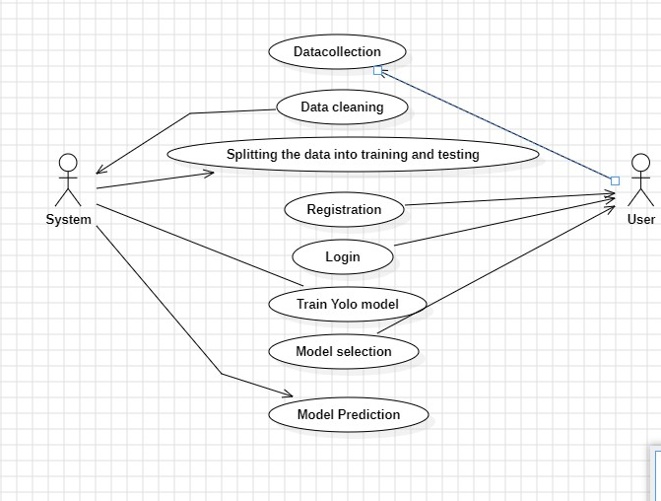

2.Activity Diagram:

An Activity Diagram represents the workflow of a system, showing the step-by-step execution of processes. It includes decision points, actions, and control flows to visualize how a process progresses.
Activity Diagram
Your system follows a structured workflow from project creation to completion.
Activity Flow:
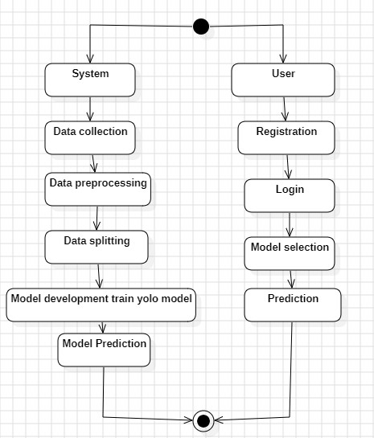

The Activity UML diagram for the Automated Vehicle Damage Assessment and Cost Estimation for Insurance Companies Using Deep Learning represents the flow of activities in the system. This diagram depicts the sequential steps performed by both the System and the User during the vehicle damage assessment process. It highlights how the system collects and processes data using a deep learning model and how the user interacts with the system to obtain predictions for vehicle damage and cost estimation.
Purpose of the Diagram
The purpose of the activity diagram is to demonstrate the overall flow of actions involved in the system, including data processing, model development, user interaction, and prediction generation. This diagram helps in understanding the relationship between system operations and user operations during the damage assessment process.
Activities and Flow System Side Activities:
- System Start: o The process starts with the initialization of the system.
- Data Collection:
  - The system collects vehicle damage images from various sources, including insurance companies, surveyors, and users.
  - This data is used for training the deep learning model.
- Data Preprocessing:
  - The collected data undergoes preprocessing, such as resizing images, data cleaning, normalization, and augmentation, ensuring the data is suitable for training the model.
- Data Splitting:
  - The preprocessed data is split into training, testing, and validation datasets.
  - This step helps the deep learning model to learn from training data and validate performance on unseen data.
- Model Development - Train YOLO Model:
  - The system uses the You Only Look Once (YOLO) model, a real-time object detection algorithm, to train on vehicle damage images.
  - The model learns to identify and assess vehicle damage based on different image inputs.
- Model Prediction:
  - Once the model is trained, it is capable of making predictions based on new vehicle images.
  - The output is an estimated damage level and repair cost.
- System End: o After generating the prediction, the model returns the results to the user.
User Side Activities:
- User Start:
  - The process starts when a user accesses the system.
- User Registration:
A new user (insurance agent, surveyor, or customer) registers with the system by providing personal and contact details.
- User Login:
  - After registration, the user logs into the system using their credentials.
- Model Selection:
  - The user selects the appropriate model (YOLO model) from the system for making damage predictions.
  - This step allows users to choose models based on availability or performance.
- Prediction:
  - The user uploads the vehicle image to the system.
  - The system uses the pre-trained YOLO model to analyze the image and provide a damage assessment along with a cost estimation.
  - The user receives the cost estimation result from the system and can use it to process the insurance claim.
3.Sequence Diagram:

A Sequence Diagram is a type of UML (Unified Modeling Language) diagram used to represent the interaction between objects in a system over time. It specifically focuses on how objects communicate with each other by exchanging messages in a sequential order.
Sequence Flow in Your Project
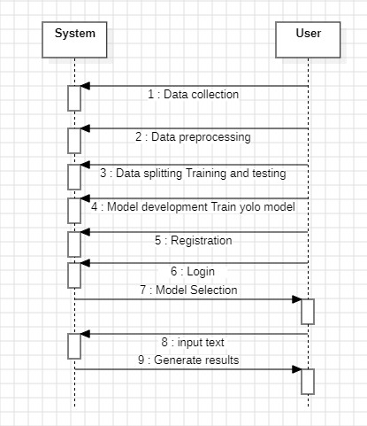

Introduction
A Sequence Diagram represents the dynamic flow of interaction between the User and the System for achieving a particular task in a system. It shows how messages are exchanged over time between objects and highlights the flow of control between the user and system.
In your system, the User initiates the process by interacting with the System, and the System responds by performing specific tasks like registration, login, model building, and prediction.

Purpose of the Diagram
The primary purpose of the Sequence Diagram in this system is to:
- Illustrate the flow of user interaction with the system.
- Show the sequence of events occurring in the system from user input to output.
- Highlight the order of processes such as registration, login, data loading, model building, and prediction.

Actors Involved
- User (Actor)
  - This represents the end user interacting with the system.
  - The user can be an insurance agent, surveyor, or customer.
  - The user initiates processes such as registration, login, dataset loading, model building, and prediction.
- System (Object)
  - This represents the Automated Damage Assessment System.
  - The system handles requests like registration, login, dataset processing, model training, and prediction.

Sequence of Events (Flow)
Here is a step-by-step explanation of the interaction flow between the User and the System:

Step 1: Registration
  - User → System: The user initiates the registration process by providing details like name, email, and password.
  - System Response: The system stores the user data in the database and confirms successful registration.

Message:
  - User: Register() → System: User Registered Successfully

Step 2: Login
  - User → System: The user logs into the system using their credentials (email and password).
  - System Response: The system verifies the credentials and allows the user to access the platform.
Message:
  - User: Login() → System: Login Successful

Step 3: Loading the Dataset
  - User → System: The user uploads a dataset or vehicle image to the system for processing.
  - System Response: The system loads the dataset for analysis.
Message:
  - User: Upload Dataset() → System: Dataset Loaded Successfully

Step 4: Viewing the Dataset
  - User → System: The user requests to view the uploaded dataset to ensure the correct data has been uploaded.
  - System Response: The system displays the dataset to the user.
Message:
  - User: View Dataset() → System: Displaying Dataset

Step 5: Model Building (Training)
  - User → System: The user initiates the training of the deep learning model (YOLO in your case).
  - System Response: The system uses the dataset to train the YOLO model and build the prediction model.
Message:
  - User: Train Model() → System: Model Trained Successfully

Step 6: Prediction (Damage Detection)
  - User → System: The user uploads a vehicle image and requests damage prediction.
  - System Response: The system uses the trained YOLO model to detect damage and estimate repair costs.
  - The system returns the prediction results to the user.
Message:
  - User: Predict Damage() → System: Damage Predicted Successfully

Explanation of Flow
Step No. Event Description Initiated By Process Outcome
- User registers User Registration successful.
- User logs in User User authenticated.
- User uploads dataset User Dataset uploaded.
- User views dataset User Dataset displayed.
- User requests model building User Model trained.
- User requests prediction User Prediction provided.

4.Class Diagram:
A Class Diagram is a structural UML diagram that represents the classes, attributes, and relationships within the system. It defines how data is organized and how objects interact.
Class Diagram
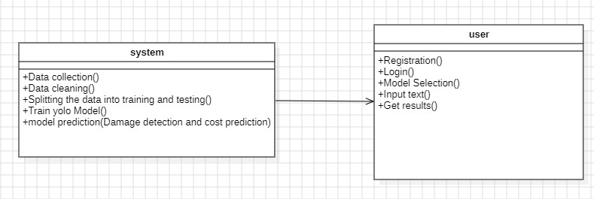

Class Diagram Report for Automated Vehicle Damage Assessment and Cost
Estimation for Insurance Companies Using Deep Learning
Introduction
The Class Diagram represents the static structure of the system, showing how different classes in the system interact with one another. It defines the system’s structure by showing the classes, their attributes, methods (functions), and the relationship between different classes. This diagram is particularly important for the developers and system designers to understand the internal structure of the system.

Purpose of the Diagram
The purpose of the class diagram is to:
- Illustrate the structure of the system by showing classes and their relationships.
- Define the responsibilities of each class in the system.
- Provide a clear understanding of the functionalities and interactions between classes.

Classes and Their Description
- System Class
The System Class is responsible for handling all the core functionalities of the deep learning model and the processing of vehicle damage assessment.
Attributes:
• None (as the system class primarily handles functions).
Methods (Functions):
  - Data Collection(): o Collects vehicle damage images and datasets from users or external sources.
  - Data Cleaning():
    - Preprocesses the collected data by removing noise, resizing images, and enhancing quality.
  - Splitting the Data into Training and Testing():
    - Splits the preprocessed data into training and testing datasets for model training.
  - Train YOLO Model():
    - Trains the YOLO (You Only Look Once) model using the training dataset to identify vehicle damage and estimate costs.
  - Model Prediction(Damage Detection and Cost Prediction):
    - Accepts the input image and uses the trained YOLO model to detect the damage and estimate the repair cost.
    - Returns the output to the user.

Responsibility:
  - The System Class is entirely responsible for data processing, model training, and prediction.
  - It ensures that the user gets accurate damage detection and cost estimation results.

- User Class
The User Class represents the actor who interacts with the system. It can be an Insurance Agent, Surveyor, or Customer. The user is responsible for providing input images, selecting the model, and obtaining results.
Attributes:
• None (as user details are not explicitly mentioned in the diagram).
Methods (Functions):
  - Registration():
    - Allows the user to register on the platform using their personal details (email, password, etc.).
  - Login():
    - Authenticates the user based on their login credentials (email and password).
- Model Selection():
o Provides the user with an option to choose the desired deep learning model (such as YOLO).
- Input Text():
o Accepts the vehicle image from the user to initiate the damage prediction process.
- Get Results():
o Displays the damage assessment result and estimated repair cost based on the model’s prediction.
Responsibility:
- The User Class is responsible for interacting with the system, providing input images, and obtaining results.
- It initiates the process by uploading the image and selecting the model.

Relationship Between Classes
Association (User → System)
- The User class has a one-way association with the System class.
- This means the User can initiate processes in the System, but the System does not directly influence the User.
- For example:
o When the user uploads an image → The system performs prediction. o When the user selects a model → The system processes the request. o When the user requests results → The system provides the output.
Explanation:
- The arrow from User → System represents that the user sends input (image and model selection) to the system.
- The System processes the request and provides the predicted damage assessment and estimated repair cost.

Interaction Flow (Process)
- The User registers and logs into the platform.
- The User uploads the vehicle damage image.
- The User selects a deep learning model (YOLO).
- The System collects and cleans the data.
- The System splits the data into training and testing sets.
- The System trains the YOLO model.
- The System uses the trained model to predict the damage and estimate the repair cost.
- The User retrieves the result from the system.

DEPLOYMENT DIAGRAM

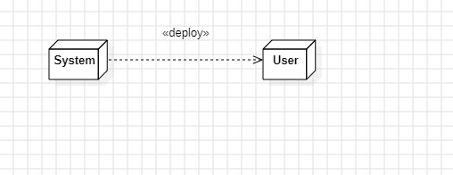

The deployment diagram for the Automated Vehicle Damage Assessment and Cost Estimation for Insurance Companies Using Deep Learning represents the physical deployment of the software system on hardware nodes. It shows how the system is deployed to the user's environment, enabling insurance companies to assess vehicle damage automatically, estimate repair costs, and process insurance claims using deep learning models. This diagram ensures that the deployment process is clear and straightforward.
Nodes and Components
- System (Node):
  - Represents the Automated Vehicle Damage Assessment and Cost Estimation System.
  - This node hosts the deep learning model, database, and web application responsible for assessing vehicle damage and estimating repair costs based on uploaded vehicle images.
  - The system processes images using deep learning algorithms, compares them with existing datasets, and estimates the repair cost.
  - The system is deployed on a web server, cloud platform, or local server for accessibility.
- User (Node):
  - Represents the insurance company agents, surveyors, or customers who access the system.
  - The user uploads vehicle images through a web application or mobile application.
  - The system then processes the image, analyzes the damage using deep learning, and provides a cost estimation.
  - The user receives the estimated repair cost and can further process the insurance claim. Deployment Process
- The development team packages the Automated Vehicle Damage Assessment and Cost Estimation System along with the deep learning model.
- The system is deployed to a web server, cloud platform, or local machine where the model processes images and provides a cost estimation.
- The user accesses the system through a web browser or mobile application, uploads images of the damaged vehicle, and receives a cost estimation instantly.
- The system communicates with a backend database to store images, vehicle details, and cost estimates.
Deployment Platform
- System Node: Hosted on a cloud platform, web server, or local server.
- User Node: Access the system through a web browser or mobile application.
- Communication: The system is deployed with the deep learning model, and the user can upload vehicle images remotely to receive cost estimation results.
The deployment diagram for the Automated Vehicle Damage Assessment and Cost
Estimation for Insurance Companies Using Deep Learning clearly illustrates the interaction between the System Node and the User Node. This deployment enables insurance companies to automate the vehicle damage assessment process, minimizing human involvement and reducing claim processing time. The use of deep learning models enhances the accuracy of damage assessment and cost estimation, improving customer satisfaction and operational efficiency.

COLLABORATION DIAGRAM

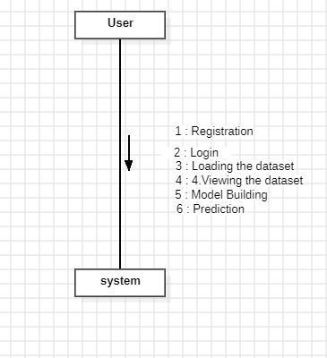

Explanation of the Collaboration Diagram
- The User initiates interactions with the System.
- Each arrow shows a direct communication between the User and the System for specific tasks.
- The numbered tasks (1 to 6) represent different processes in your system.

Sequence of Events in the Collaboration Diagram
Step
Action Description No.
The user registers their account by providing details, and the
- Registration
system confirms registration.
- Login The user logs in with credentials, and the system verifies them.
Loading the The user uploads the dataset, and the system loads it for
3
Dataset processing.
Viewing the The user requests to view the uploaded dataset, and the system
4
Dataset displays it.
The user initiates model building, and the system uses deep
- Model Building
learning to build the model.
The user uploads an image of vehicle damage, and the system
- Prediction
predicts the damage severity and cost.

Purpose of the Collaboration Diagram
  - It shows the interaction between the User and the System for various functionalities.
  - It helps to understand how the components communicate during operations.
  - It captures the flow of data and the sequence of tasks to be performed.

5. System Implementation

5.1 Introduction
The implementation of “Automated Vehicle Damage Assessment and Cost Estimation for Insurance Companies Using Deep Learning,” focuses on building an intelligent, end-to-end pipeline that can detect vehicle damage from images and estimate repair costs with high accuracy.This implementation leverages YOLOv5 for real-time object detection, which plays a crucial role in identifying the damaged areas on both two-wheelers and four-wheelers. The system is developed using Python and powerful libraries such as PyTorch, OpenCV, and NumPy. Key steps in the implementation include data preprocessing, model training and evaluation, damage classification, and integration of a cost estimation module. Additionally, a user-friendly interface can be developed to allow insurance agents or customers to upload images and receive automated assessments.The system is tested and validated using a well-structured dataset to ensure its accuracy and reliability. This phase ensures that the model performs effectively under real-world conditions, thereby making it ready for deployment in insurance claim processing environments.

5.2 Project Modules
- System
  - Data Collection Objective:
The primary objective is to gather a diverse and comprehensive dataset of vehicle images with clear annotations identifying different types of damage. This dataset will be used to train a YOLOv5 model for effective damage detection and classification.
Details:
    - Vehicle Types: The dataset should include various types of vehicles such as:
o Two-wheelers (e.g., motorcycles, scooters) o Four-wheelers (e.g., cars, SUVs, trucks) o Six-wheelers (e.g., large trucks, buses)
    - Damage Types: Collect images featuring common damage types like scratches, dents, cracks, and broken parts. Each image should be annotated with the location and type of damage.
    - Environmental Diversity: Capture images in different lighting conditions (day, night, overcast), angles (front, side, rear), and varying levels of vehicle cleanliness and wear to improve model robustness.
Dataset Split:
    - Training Set (70%): This portion is used to train the YOLOv5 model and should be the largest subset to ensure the model learns diverse patterns.
    - Validation Set (15%): Used during model training to validate performance and finetune hyperparameters.
    - Testing Set (15%): Reserved for final evaluation to assess the model's ability to generalize to unseen data.
  - Data Preprocessing Image Resizing:
To ensure consistent input size for YOLOv5, all images should be resized to 640x640 pixels, which is the recommended input size for YOLOv5 for optimal performance.
Normalization:
Pixel values should be scaled between 0 and 1. This normalization step improves model convergence and stabilizes learning by ensuring consistent pixel intensity ranges.
Data Augmentation:
To enhance dataset variability and improve model generalization, apply the following transformations:
    - Rotation: Randomly rotate images within a range of 0° to 30°.
    - Flipping: Horizontally and vertically flip images to increase positional diversity.
    - Color Adjustments: Apply brightness, contrast, and saturation adjustments to account for varying lighting conditions.
  - Model Training YOLOv5 Training:
    - Use the YOLOv5 architecture, known for its speed and accuracy in object detection tasks.
    - Employ transfer learning by initializing the model with pre-trained weights (e.g., COCO dataset weights) to accelerate convergence and improve performance.
    - Annotate images in YOLOv5-compatible formats such as .txt files containing class labels and bounding box coordinates.
Hyperparameter Tuning:
To optimize model performance, carefully tune key hyperparameters such as:
    - Batch Size: Balance memory efficiency and training stability. A batch size of 16 or 32 is common for YOLOv5.
    - Number of Epochs: Experiment with different epoch counts to avoid underfitting or overfitting.
  - Model Evaluation
Performance Metrics:
Assess model performance using:
    - Precision: Measures the accuracy of positive predictions.
    - Recall: Indicates the model's ability to identify true positives.
    - F1 Score: Harmonic mean of precision and recall for balanced performance evaluation.
    - mAP (mean Average Precision): Provides an overall evaluation of detection
accuracy by calculating precision at different recall levels.
Confusion Matrix:
Generate a confusion matrix to visualize the model's classification performance, revealing patterns in misclassifications and aiding in targeted improvements.
  - Model Saving
Model Serialization:
    - Save the trained YOLOv5 model in .pt format (PyTorch checkpoint format), which efficiently stores model architecture, weights, and optimizer states.
    - Saving the model ensures reproducibility and allows for easy deployment in production environments.
  - Model Prediction Image Input:
    - Develop a preprocessing pipeline to resize, normalize, and format incoming vehicle images to align with YOLOv5 input requirements.
Prediction:
      - Deploy the trained YOLOv5 model to:
      - Detect damaged areas on vehicles using bounding boxes.
      - Classify the type of damage identified.
      - Provide detailed outputs with annotated images, bounding box coordinates, and corresponding damage types for effective visualization and reporting.
- User 2.1 Register Objective:
    - Users create an account to access the vehicle damage assessment system.
Details:
    - Users provide credentials such as username, password, and email for secure account creation.
    - Contact details like phone number or address may be required to support follow-up services or notifications.
2.2 Login
Objective:
    - Registered users log in to access the system’s features.
Details:
    - The login system authenticates user credentials securely to ensure authorized access.
    - Use session control to manage active logins and avoid concurrent session misuse.
    - Implement account lockout mechanisms to mitigate brute-force attacks.

2.3 Upload Data Objective:
    - Users can upload images of vehicles for damage assessment.
Details:
    - The system should validate uploaded files to ensure they are in supported formats
(e.g., .jpg, .png).
    - Preprocess uploaded images by resizing, normalizing, and applying necessary augmentations to meet YOLOv5 input requirements.
    - Provide users with feedback on upload status and potential issues (e.g., low-quality images or unsupported formats).
2.4 View Results
Objective:
    - Users view the results of the damage assessment.
Details:
    - Display identified damage types with bounding boxes and confidence scores.
    - Provide additional details such as possible repair costs.
    - Implement a user-friendly interface to visualize results and detailed reports effectively. 2.5 Logout
Objective:
    - Users log out to secure their session and personal data.
Details:
    - The logout process should terminate active sessions and clear temporary data to prevent unauthorized access.
    - Ensure session tokens are invalidated upon logout to minimize security risks.
5.3 Algorithm:
YOLOv5(YOU LOOK ONLY ONCE) operates on the principle of a single-stage object detection framework. Unlike traditional multi-stage detectors, which separate region proposal and classification, YOLOv5 predicts bounding boxes and class labels in a single forward pass through the neural network. This allows for high-speed inference while maintaining competitive accuracy.
The model processes input images through a series of convolutional layers, extracting relevant features that help in identifying objects and their locations. It divides the image into a grid and assigns each grid cell the responsibility of detecting objects within it. Each detection includes class probabilities, bounding box coordinates, and confidence scores.
YOLOv5 consists of four primary components:
- Backbone: The backbone is responsible for feature extraction. YOLOv5 utilizes CSPDarknet53, an improved version of Darknet53, which enhances gradient flow and reduces computational complexity while maintaining high performance.
- Neck: The neck component integrates a feature pyramid network (FPN) and a path aggregation network (PAN) to refine feature extraction. This helps in detecting objects at different scales, making YOLOv5 effective for identifying both minor and major damages in vehicles.
- Head: The detection head applies anchor-based mechanisms to predict bounding boxes and object classes. It uses non-maximum suppression (NMS) to filter overlapping predictions and retain the most accurate ones.
- Loss Function: YOLOv5 employs a combination of loss functions, including CIoU (Complete Intersection over Union) loss for precise bounding box regression, objectness loss to distinguish objects from background, and classification loss to ensure accurate damage categorization.
5.4 Libraries and their Usage:
PyTorch:A deep learning framework used to develop, train, and evaluate the YOLOv5 model. It provides flexible tools for building neural networks and handling GPU acceleration.
OpenCV:An open-source computer vision library used for image processing tasks such as reading images, resizing, drawing bounding boxes, and displaying output.
NumPy:A fundamental library for numerical computations in Python. It is used for handling arrays and performing matrix operations required during preprocessing and model training.
Matplotlib:A plotting library used for visualizing training results, loss graphs, and detection outputs such as bounding boxes on images.
Pandas:A data analysis library used to manage structured data like annotations, predictions, and damage cost records in tabular form.
Seaborn:Built on top of Matplotlib, this library is used for creating attractive and informative statistical graphics, such as correlation heatmaps and performance plots.
Glob:A standard Python module used for file pattern matching, useful for loading batches of images or files from specific directories.
scikit-learn (sklearn):A machine learning library used for model evaluation metrics like accuracy, precision, recall, and F1-score.
Yaml : A lightweight data serialization library used to read and write configuration files (like training parameters and model settings in YOLOv5).
5.5 Screens:
INDEX PAGE: This screen is the main landing page. It introduces the platform's core functionality—vehicle damage assessment and cost estimator. The purpose is to help users easily navigate to different sections like registration, login, and assessment page.

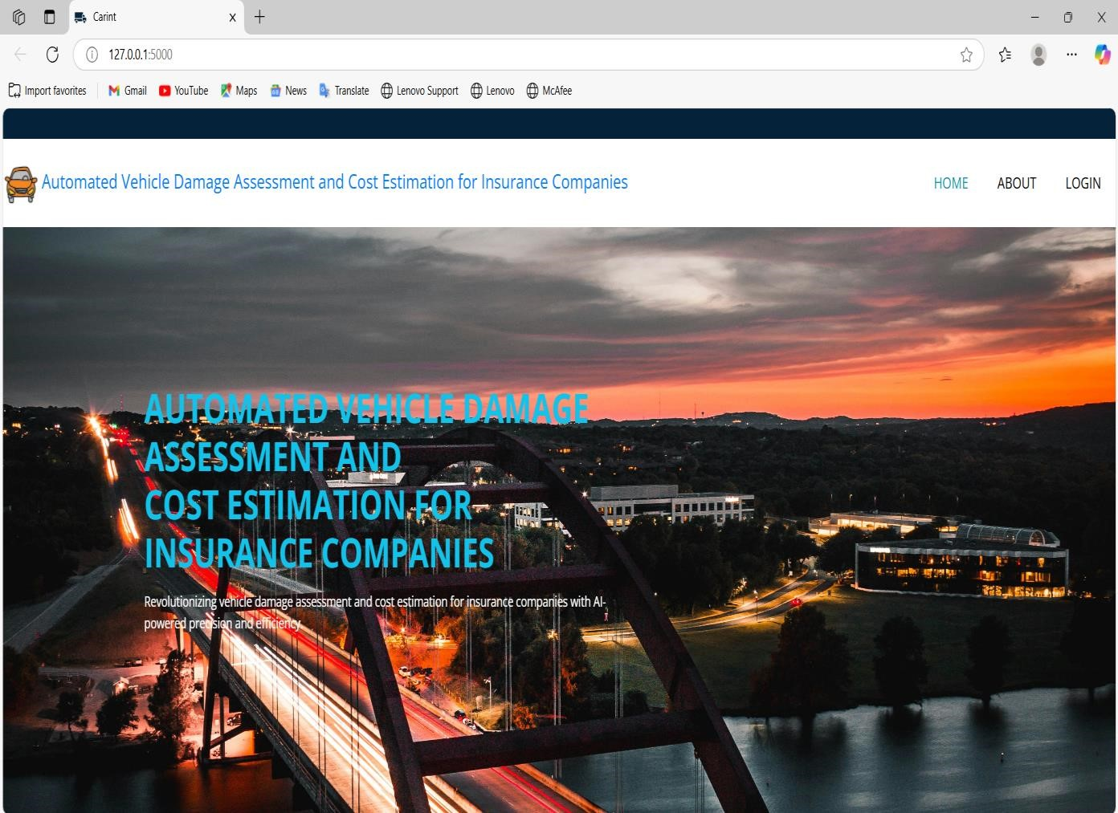

LOGIN PAGE: The login screen allows registered users to enter their email and password to access. It’s a simple, secure interface for account verification and accessing assessment of vehicles.

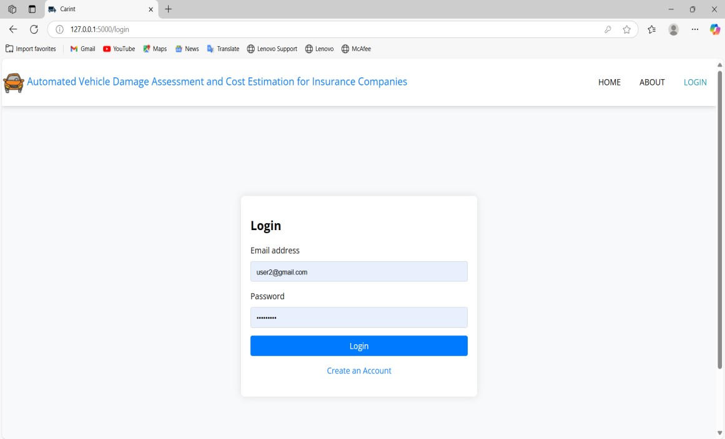

REGISTRATION PAGE: This is the registration form output screen. It allows new users to input their details like full username and password to create an account.
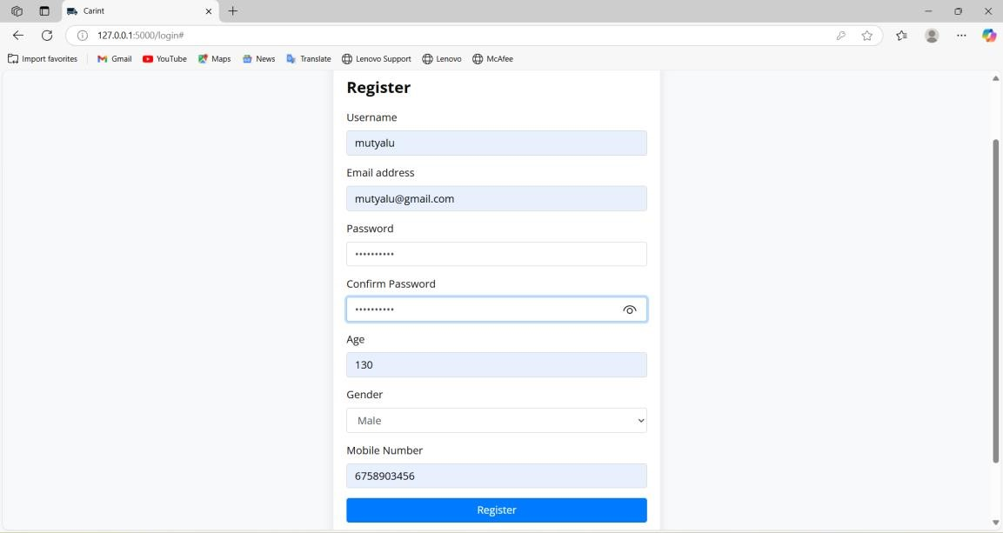

ASSESSMENT PAGE: On this page, you can select the type of vehicle you're assessing from the dropdown menu, choosing between 2 wheeler, 4 wheeler, or 6 wheeler options.

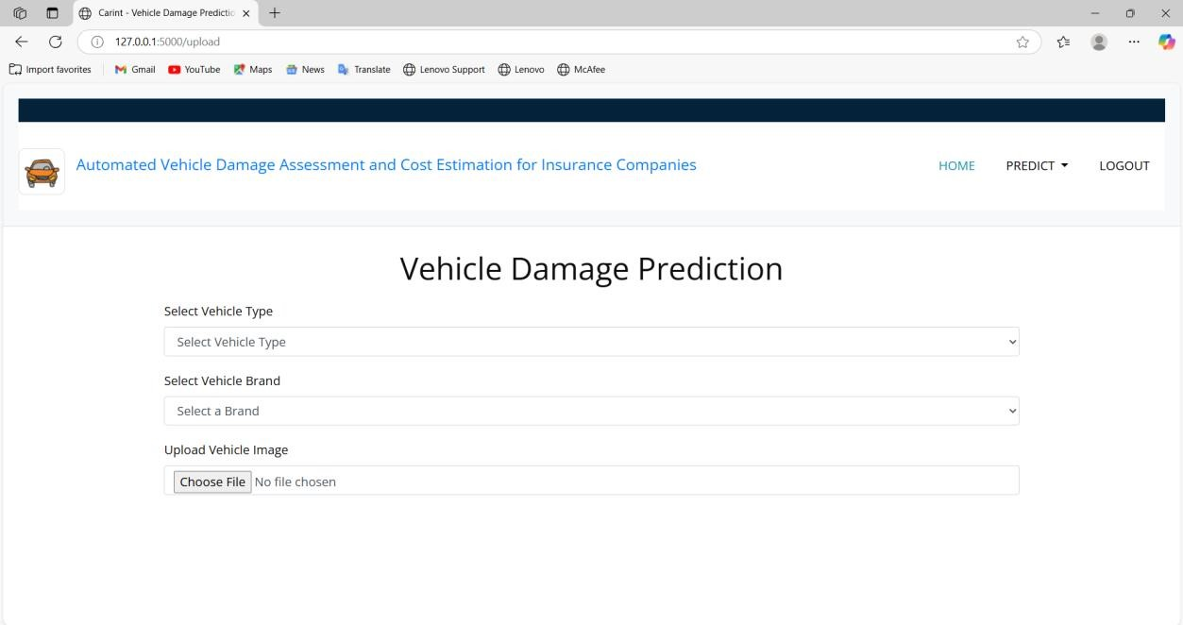

RESULT PAGE(2-Wheelers): After uploading the image of the 2-wheeler vehicle, the system will detect the damaged areas and provide an estimated repair cost.
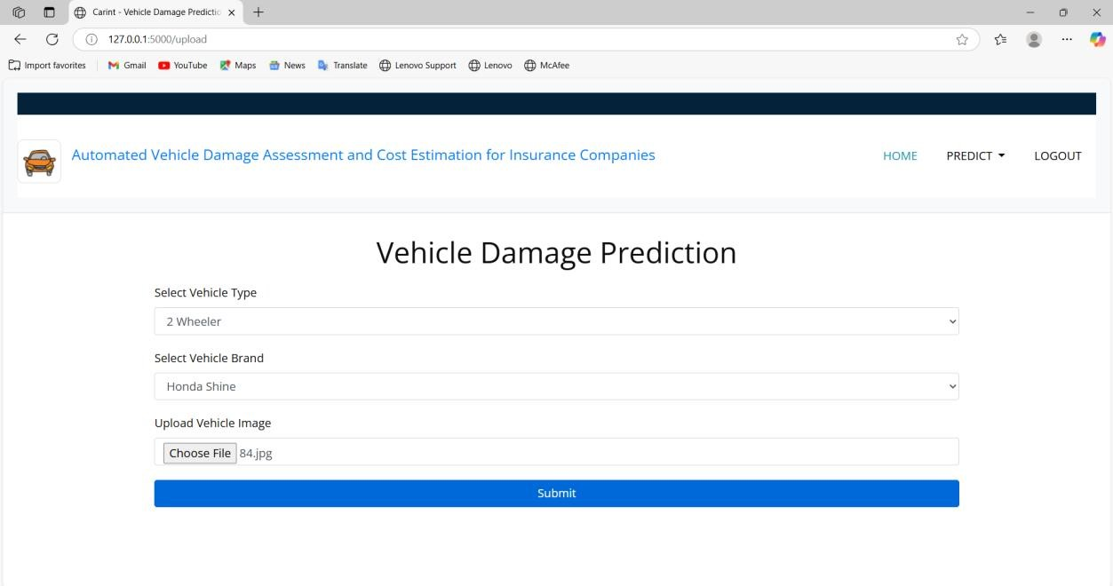

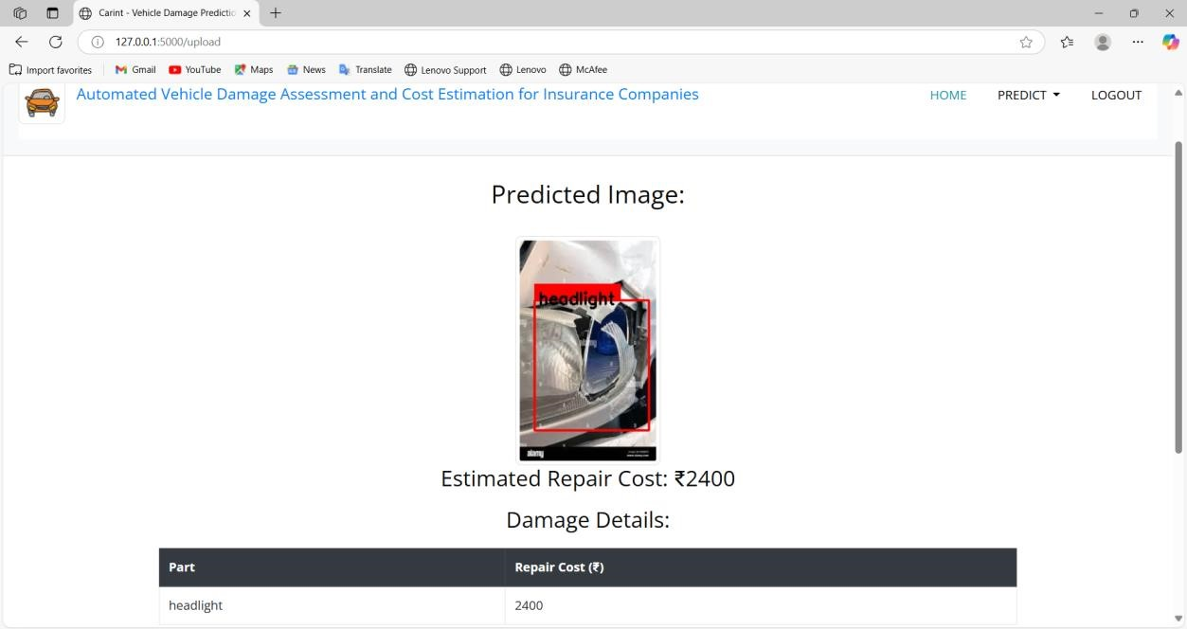

RESULT PAGE(4-wheeler): After uploading the image of the 4-wheeler vehicle, the system will detect the damaged areas and provide an estimated repair cost.
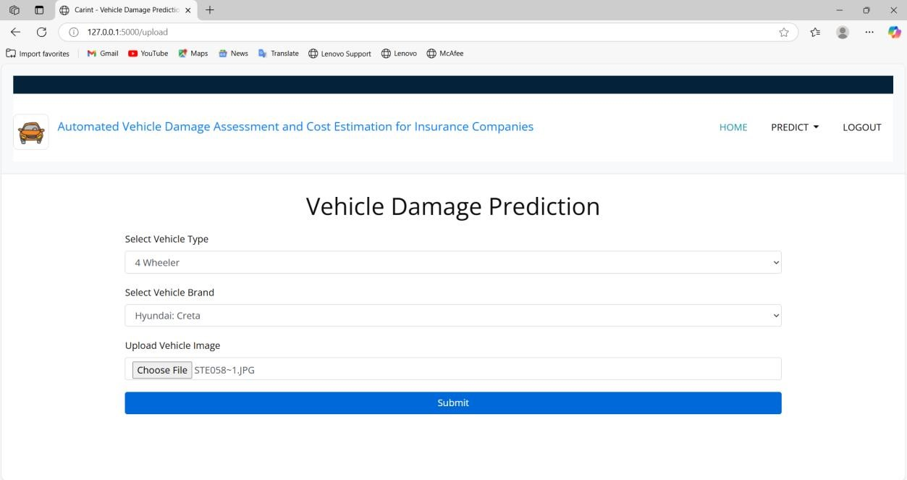

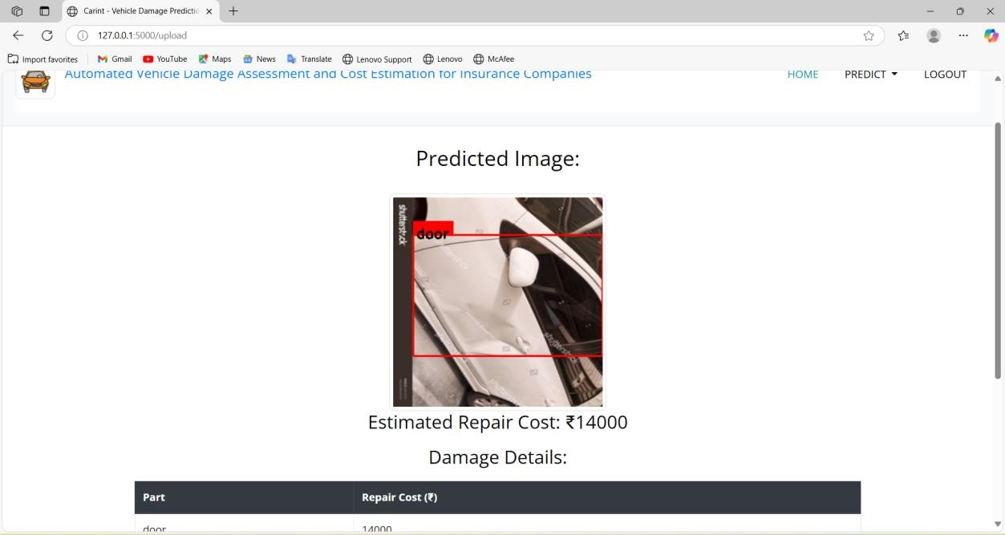

RESULT PAGE(6-wheeler): After uploading the image of the 6-wheeler vehicle, the system will detect the damaged areas and provide an estimated repair cost.
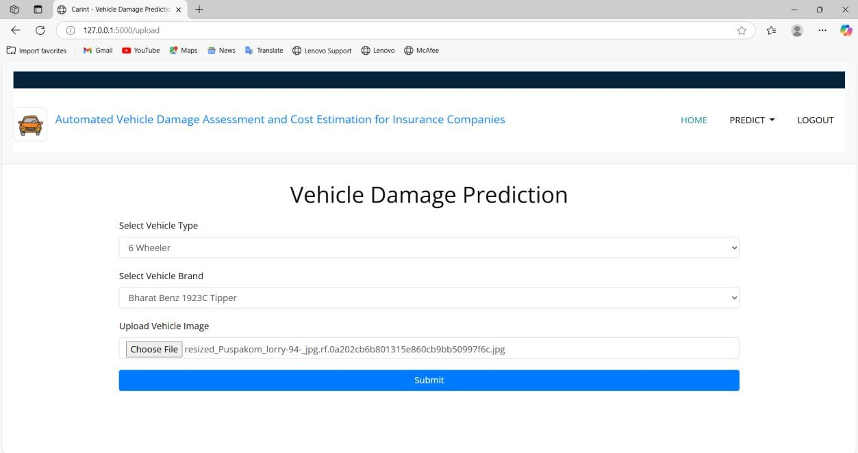

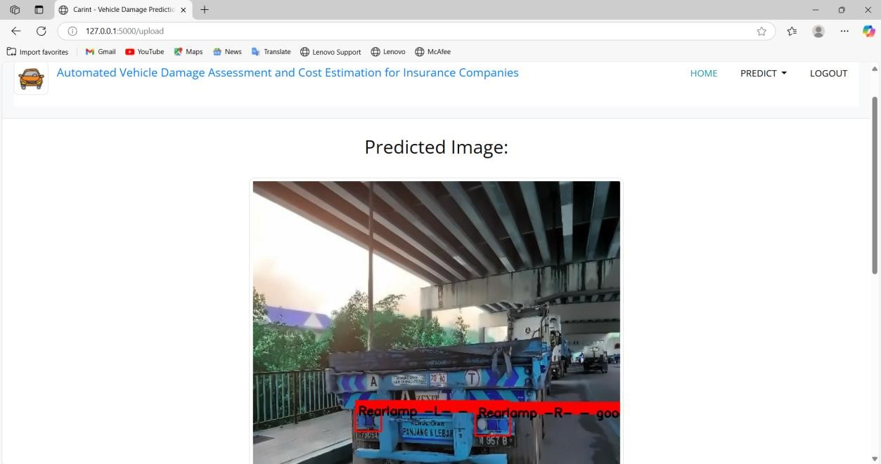

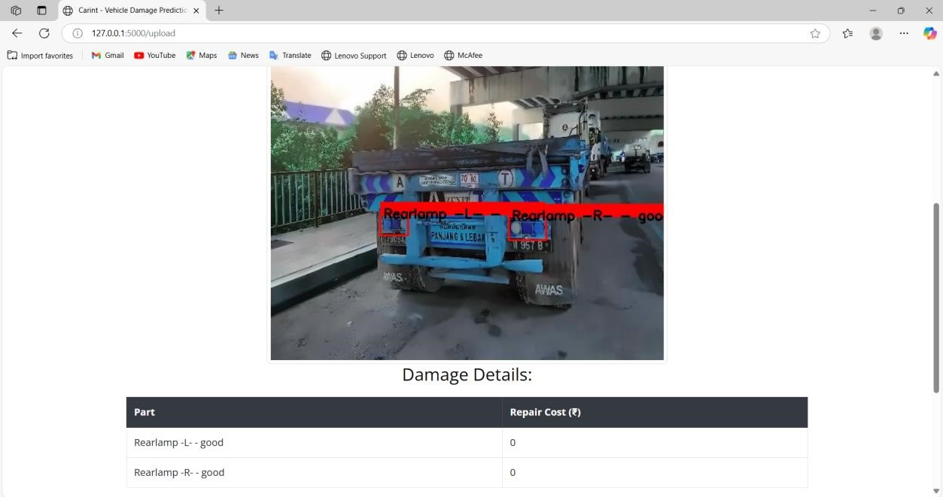

6.System Testing

6.1 Introduction

System Testing is a vital phase in the Software Testing Life Cycle (STLC), acting as the final assurance that a software product meets the requirements before it is deployed for realworld use. It involves testing the entire system, rather than individual components, ensuring that all features and integrations work together harmoniously. This phase plays a crucial role in identifying potential issues in the system that could arise when components interact, and it helps verify that the product meets business, functional, and technical specifications.

Objectives and Importance of System Testing

The primary goal of system testing is to verify that the system functions as intended and to detect any deviations from the requirements. By assessing the software from an end-user perspective, system testing ensures that all aspects of the application, such as features, user interfaces, and back-end systems, work correctly across different scenarios. This phase also verifies that all system components, such as third-party integrations, APIs, and databases, interact seamlessly.

System testing is critical because it identifies problems that could disrupt the user experience, such as performance bottlenecks, security vulnerabilities, compatibility issues, or usability concerns. Furthermore, it helps mitigate risks by providing insight into how the software will perform under varying conditions, ensuring the product meets quality standards before its release to end users.

Key objectives of system testing include:
- Verifying Functional Correctness: Ensures the system meets the specified functional requirements and performs the tasks it is designed to do.
- Validating Non-Functional Requirements: Tests performance, security, compatibility, usability, and recovery under realistic conditions.
- Identifying System Integration Issues: Ensures that various components, including user interfaces, APIs, and databases, function correctly together.
- Ensuring Robustness and Reliability: Identifies and resolves issues related to system crashes, failures, or unexpected behavior during operation.

6.2 Types of Testing

Unit testing
Unit testing involves the design of test cases that validate that the internal program logic is functioning properly, and that program inputs produce valid outputs. All decision branches and internal code flow should be validated. It is the testing of individual software units of the application .it is done after the completion of an individual unit before integration. This is a structural testing, that relies on knowledge of its construction and is invasive. Unit tests perform basic tests at component level and test a specific business process, application, and/or system configuration. Unit tests ensure that each unique path of a business process performs accurately to the documented specifications and contains clearly defined inputs and expected results.

Integration testing
Integration tests are designed to test integrated software components to determine if they actually run as one program. Testing is event driven and is more concerned with the basic outcome of screens or fields. Integration tests demonstrate that although the components were individually satisfaction, as shown by successfully unit testing, the combination of components is correct and consistent. Integration testing is specifically aimed at exposing the problems that arise from the combination of components.
Software integration testing is the incremental integration testing of two or more integrated software components on a single platform to produce failures caused by interface defects. The task of the integration test is to check that components or software applications, e.g. components in a software system or – one step up – software applications at the company level – interact without error.
Test Results: All the test cases mentioned above passed successfully. No defects encountered.

White Box Testing
White Box Testing is a testing in which in which the software tester has knowledge of the inner workings, structure and language of the software, or at least its purpose. It is purpose. It is used to test areas that cannot be reached from a black box level.

Black Box Testing
Black Box Testing is testing the software without any knowledge of the inner workings, structure or language of the module being tested. Black box tests, as most other kinds of tests, must be written from a definitive source document, such as specification or requirements document, such as specification or requirements document. It is a testing in which the software under test is treated, as a black box. you cannot “see” into it. The test provides inputs and responds to outputs without considering how the software works.

6.3 Test Cases
Testing the vehicle images for Damage detection and classification Upload an image of a damaged vehicle.
Expected Output: System detects the damage (e.g., dent on front bumper) and estimates the repair cost
Result: Damage detected accurately with a bounding box





Model Performance Evaluation Using Confusion Matrix, Precision, and Recall

2 Wheelers:
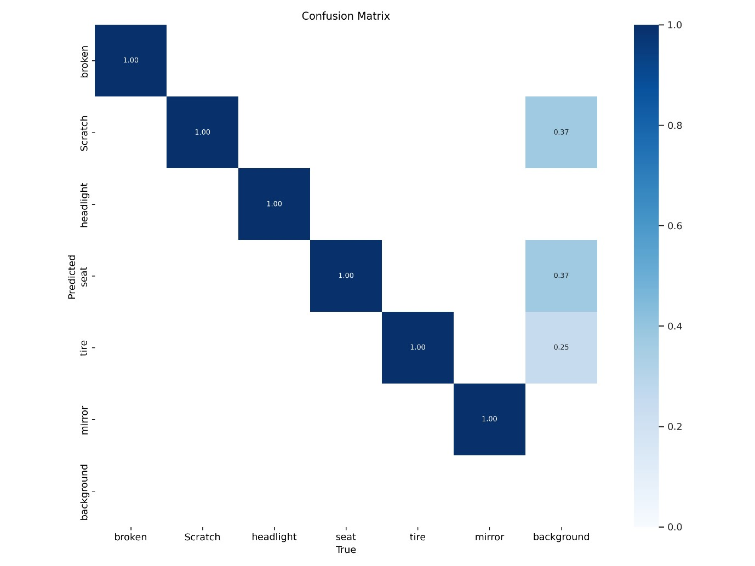
Figure: Confusion Matrix YOLOv5 for 2 wheelers
The confusion matrix for two-wheeler damage detection shows that the model accurately predicts most classes, with high true positive rates for broken, Scratch, headlight, seat, tire, and mirror. However, there are some misclassifications, with headlight, seat, and tire being confused with background in 37% and 25% of cases respectively. Overall, the model performs well but has some difficulty distinguishing certain damage types from the background.
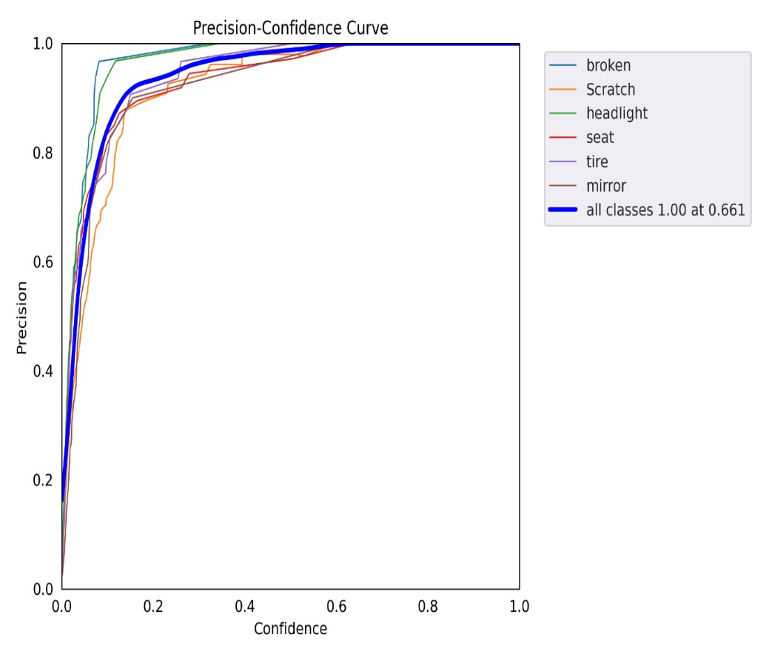
Figure: Precision-Confidence curve for 2 wheelers
The precision-confidence curve for all classes (broken, Scratch, headlight, seat, tire, mirror) shows strong performance across the board. Each class maintains high precision at varying confidence thresholds, indicating that the model consistently makes accurate predictions as the confidence level increases. This suggests that the model is reliable in detecting and classifying different types of vehicle damage with minimal false positives. The overall good confidence across all classes reflects the model's robustness and effectiveness in distinguishing damage types with high certainty.

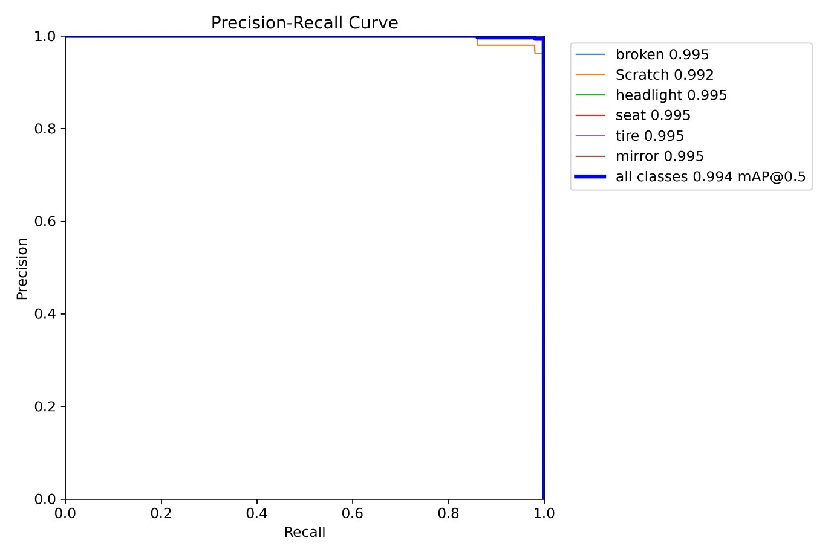
Figure: Precision-Recall curve for 2 wheelers
The precision-recall curve for all classes (broken, Scratch, headlight, seat, tire, mirror) indicates excellent model performance, with a mean Average Precision (mAP) of 0.994 at an IoU threshold of 0.5.

Performance Metrics
- Metrics/precision: 0.95919
- Metrics/recall: 0.99046
- Metrics/mAP_0.5: 0.99072
- Metrics/mAP_0.5:0.95: 0.73909 Interpretation:
- Precision: 0.95919 means that 95.92% of the objects identified by the model are correct. High precision indicates that when the model detects an object, it is very likely to be accurate.
- Recall: 0.99046 signifies that 99.05% of the actual objects were detected by the model. High recall shows that the model is very effective at finding objects.
- mAP_0.5: 0.99072 is the mean average precision at an IoU threshold of 0.5. This high value indicates excellent overall performance in object detection.

Validation Metrics
- Val/box_loss: 0.02177
- Val/obj_loss: 0.006007
- Val/cls_loss: 0.00073132 Interpretation:
- Val/box_loss: 0.02177 indicates that the model performs well on the validation set for bounding box prediction, with a relatively low loss.
- Val/obj_loss: 0.006007 suggests good object detection performance on the validation set.
- Val/cls_loss: 0.00073132 shows that the model is classifying objects correctly on the validation set with minimal error.
Learning Rates
- x/lr0: 0.000298
- x/lr1: 0.000298
- x/lr2: 0.000298
Sample Output from validation
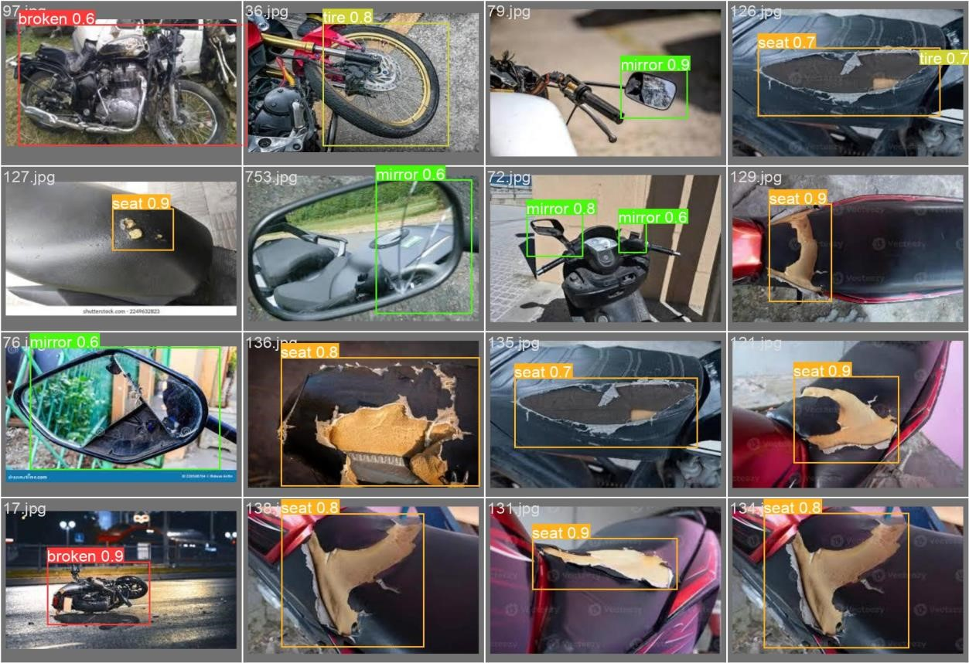
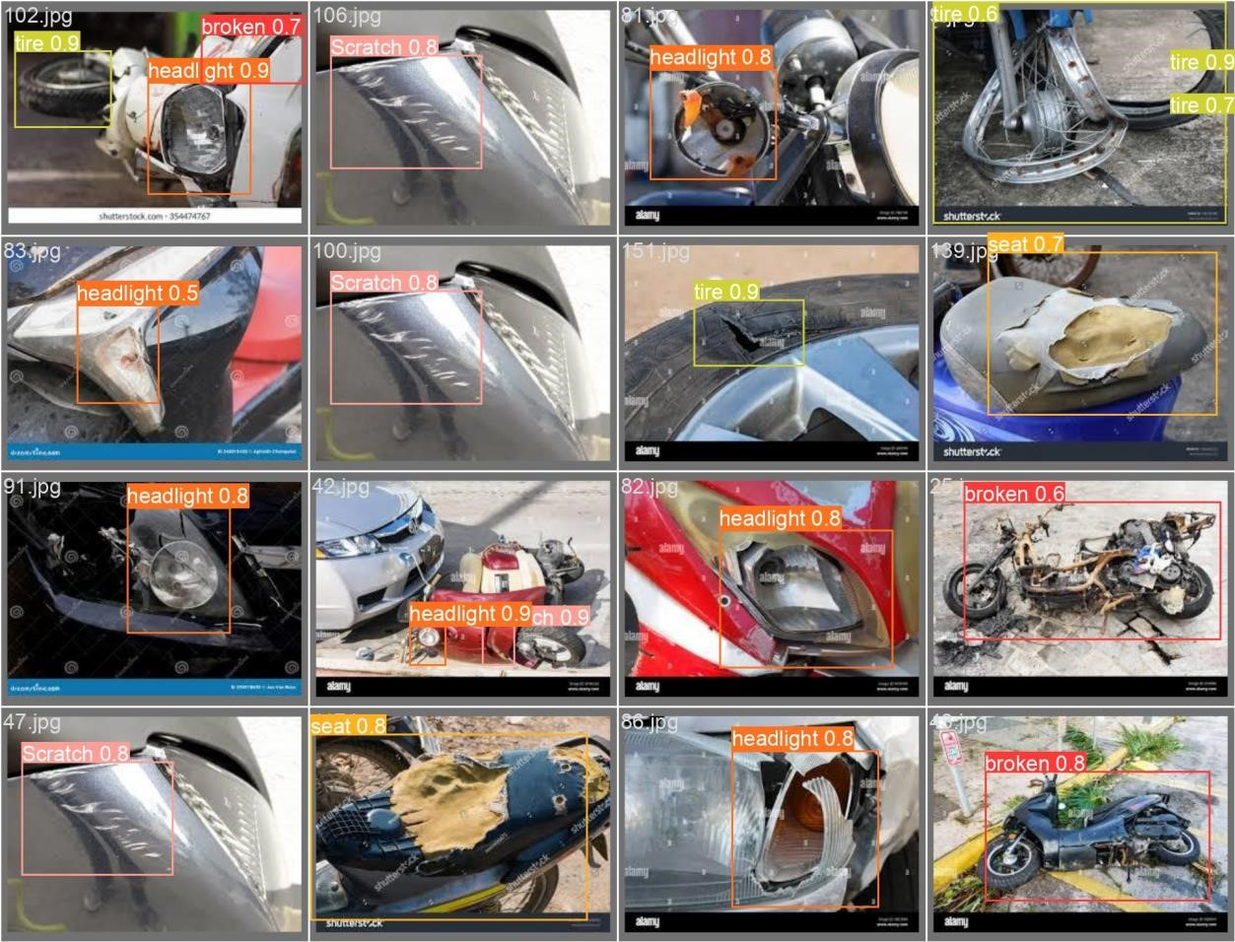

4 Wheelers:
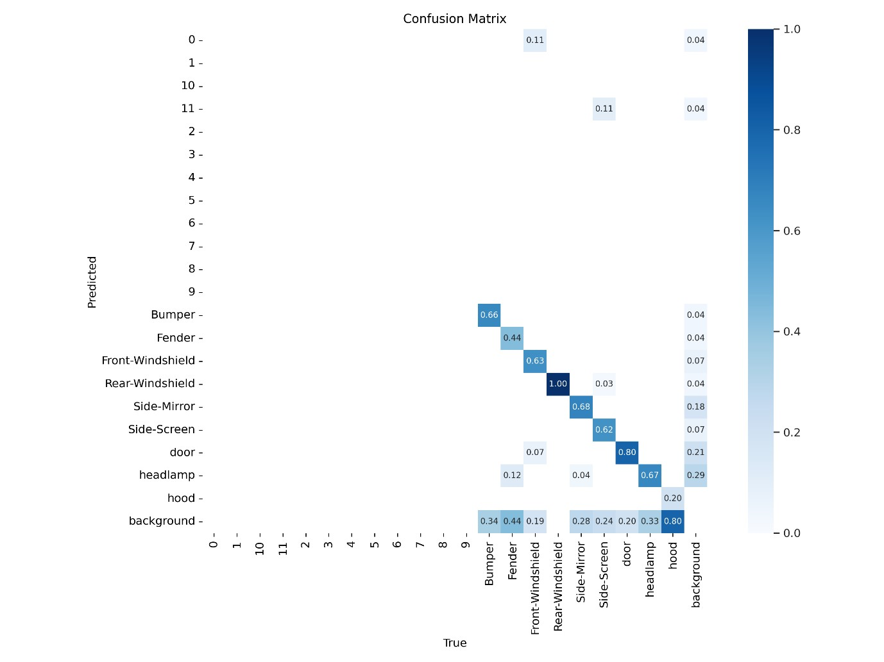
Figure: Confusion Matrix YOLOv5 for 4 wheelers
The confusion matrix for four-wheelers reveals that the model performs well with certain classes like rear-windshield, which is accurately identified, and bumper and Fender, which have moderate correct predictions. However, there is notable confusion with background, as many classes such as bumper, Fender, and front-windshield are frequently misclassified as such. Additionally, side-mirror and door are sometimes confused with each other and background, indicating variability in the model's performance across different damage types. Overall, while some damage types are accurately detected, the model needs improvement in reducing misclassifications, especially with the background class.
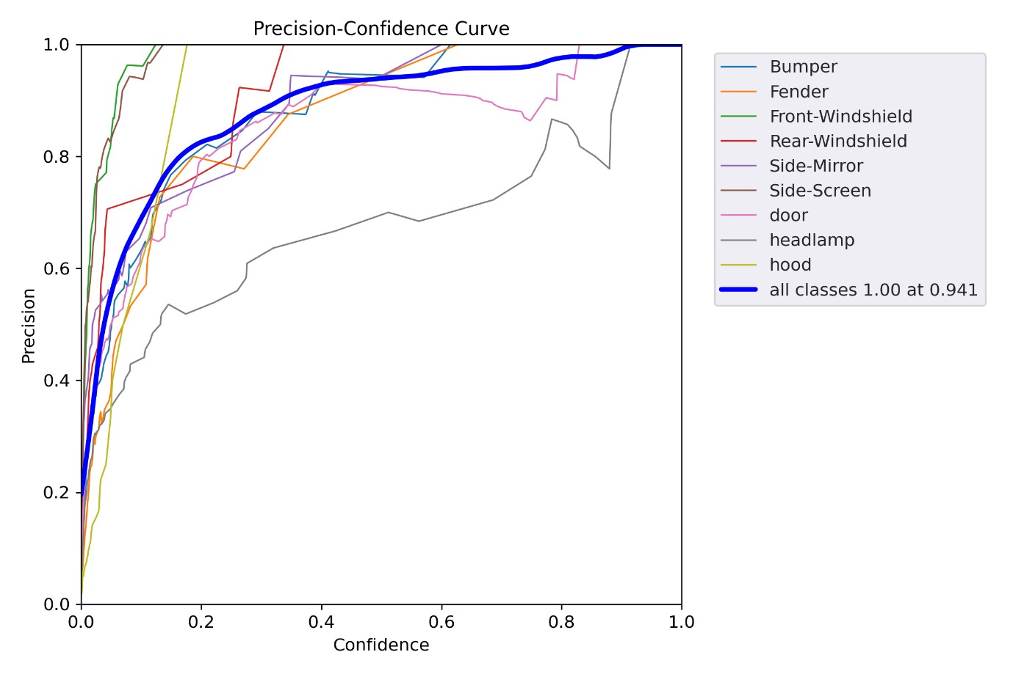
Figure: Precision-Confidence curve for 4 wheelers
The precision-confidence curve indicates how precision varies with different confidence thresholds. At a confidence threshold of 0.941, the precision is 1.0. This means that at this high confidence level, all the predictions made by the model are true positives, with no false positives. Achieving a precision of 1.0 at this threshold reflects perfect accuracy for the detected classes, although it may come at the cost of reduced recall, as fewer predictions are made overall. This high confidence threshold ensures that only the most certain predictions are considered, resulting in flawless precision.
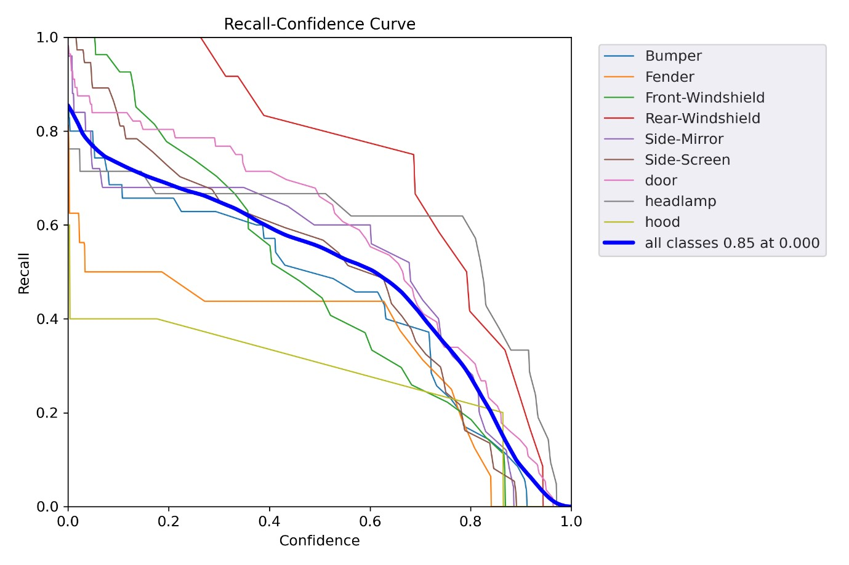
Figure: Recall-Confidence curve for 4 wheelers
The recall-confidence curve shows how recall varies with different confidence thresholds. At a confidence threshold of 0, the recall is 0.85. This indicates that the model detects 85% of the actual positive instances, meaning it successfully identifies a high proportion of true positives. However, with a threshold of 0, the model is less selective, which often results in including many false positives as well. While this high recall reflects the model’s ability to capture most of the relevant instances, it may come with a trade-off in precision, as the threshold is very low and includes more potential false positives.
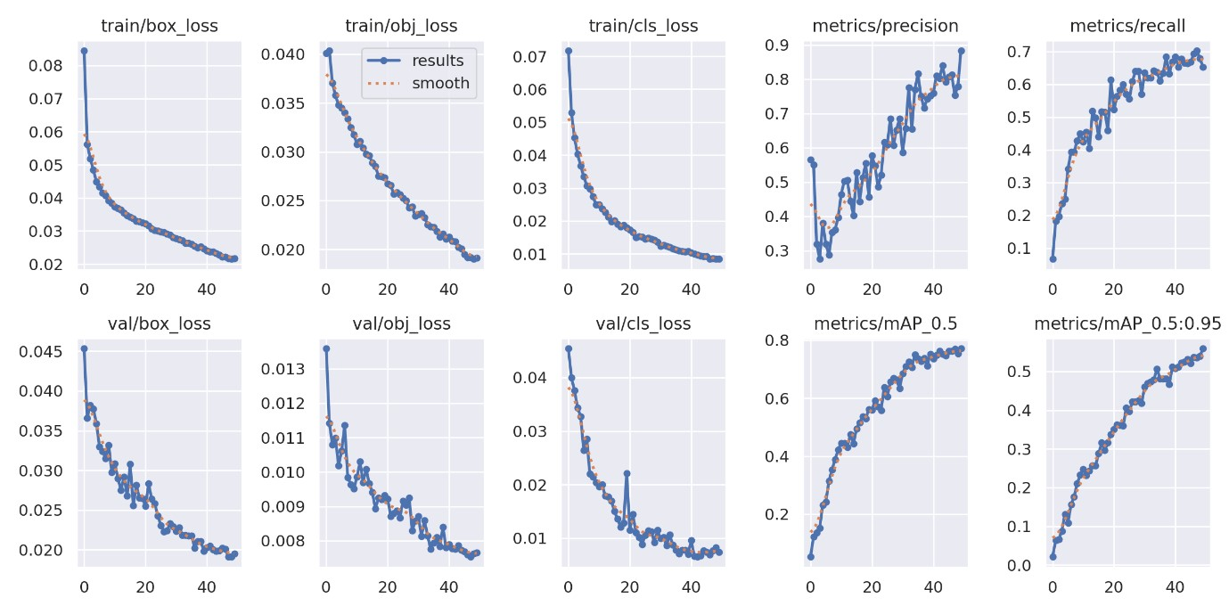
Figure: Overall result for 4 wheelers
Performance Metrics
- Metrics/precision: 0.88349
- Metrics/recall: 0.6519
- Metrics/mAP_0.5: 0.77108
- Metrics/mAP_0.5:0.95: 0.55929
Interpretation:
- Precision: 0.88349 means 88.35% of the detected objects are correct. This is lower than the two-wheeler model, suggesting the model might be less accurate when it detects objects.
- Recall: 0.6519 indicates that the model identifies 65.19% of the actual objects. This is significantly lower than the two-wheeler model, suggesting that the model misses a considerable portion of objects.
- mAP_0.5: 0.77108 shows good overall detection performance at an IoU threshold of
0.5 but is lower than the two-wheeler model, suggesting room for improvement.
- mAP_0.5:0.95: 0.55929 reflects the average precision over a range of IoU thresholds, indicating that the model's performance drops more when considering stricter overlap criteria compared to the two-wheeler model.
Validation Metrics
- Val/box_loss: 0.019499
- Val/obj_loss: 0.0076548
- Val/cls_loss: 0.0073554
Interpretation:
- Val/box_loss: 0.019499 is similar to the training box loss, suggesting the model generalizes reasonably well but might be slightly less accurate compared to the twowheeler case.
- Val/obj_loss: 0.0076548 indicates good performance in detecting objects on the validation set, though it is higher than the training object loss.
- Val/cls_loss: 0.0073554 reflects the classification performance on the validation set, showing that the model's classification accuracy is consistent but slightly lower compared to the training data.
Learning Rates
- x/lr0: 0.000496
- x/lr1: 0.000496
- x/lr2: 0.000496

Sample Output from validation
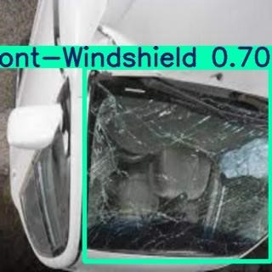
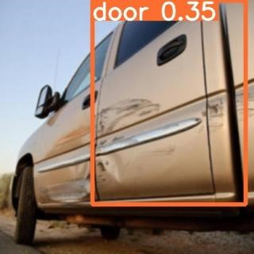

6 Wheelers:
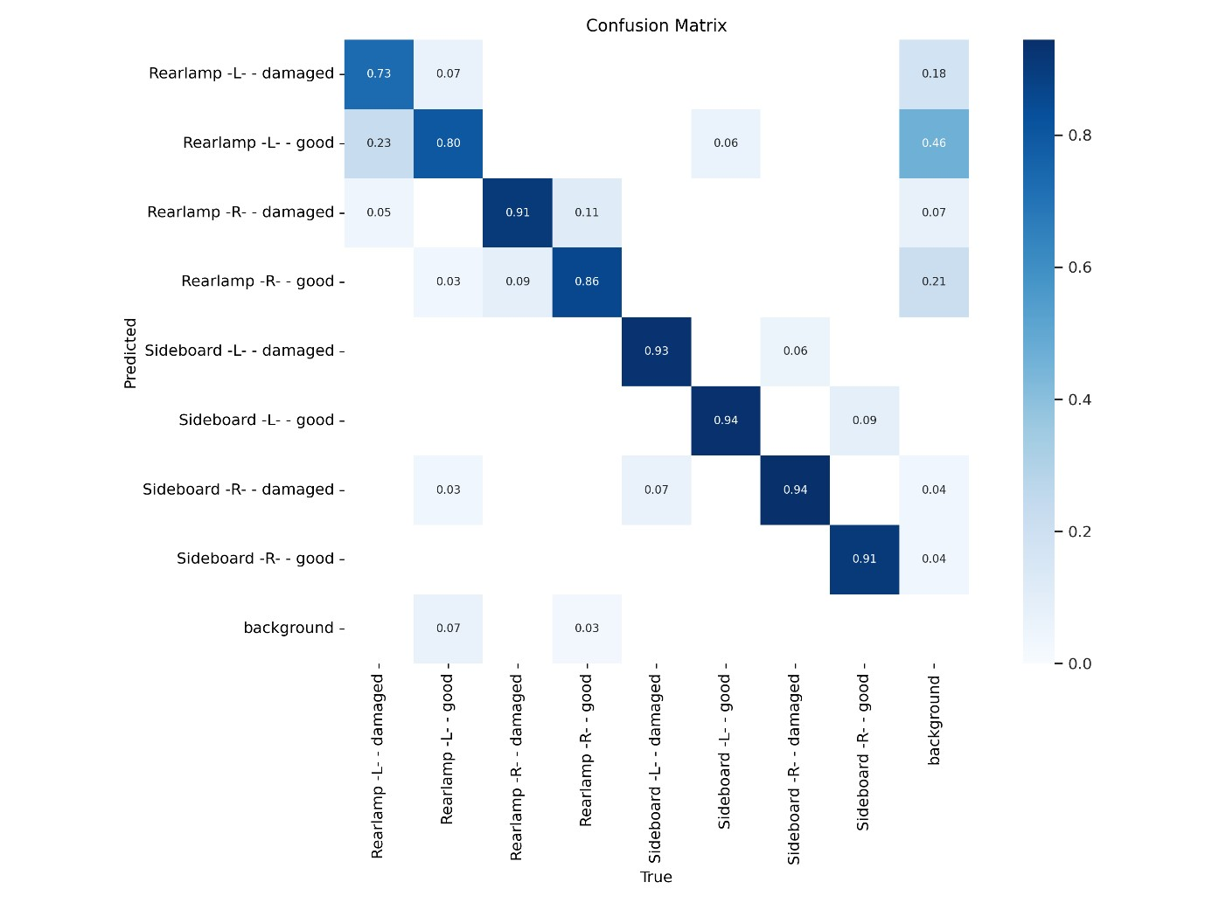
Figure: Confusion Matrix YOLOv5 for 6 wheelers
The confusion matrix for six-wheelers shows that the model accurately identifies most damage types, such as rearlamp-L-damaged and sideboard-L-damaged, with high precision. However, there is notable confusion with the background class, causing misclassifications of rearlampL-good, rearlamp-R-good, and sideboard-L-good. Overall, the model performs well but could be improved by reducing misclassifications related to the background class.
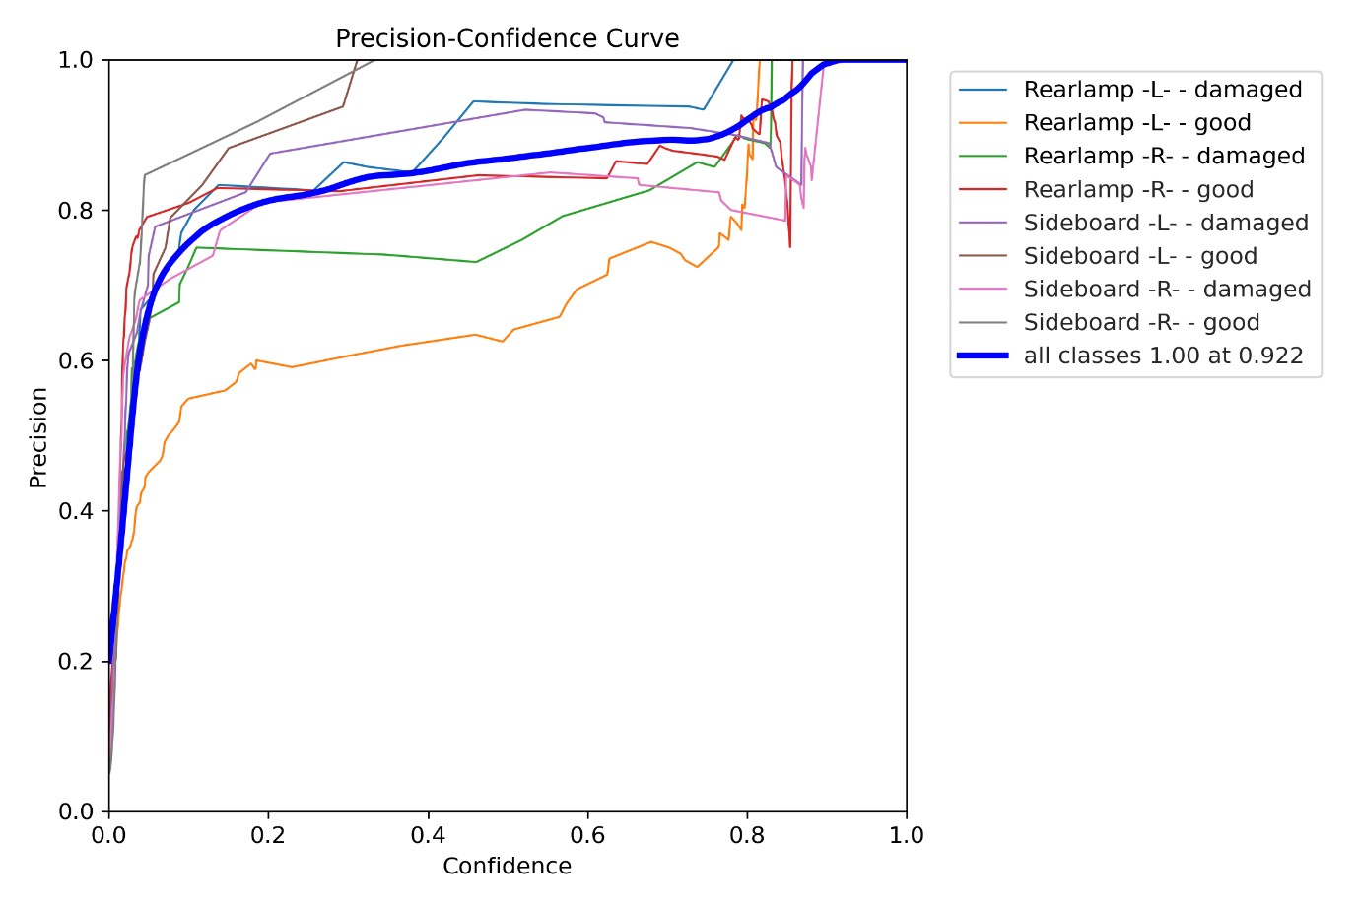
Figure: Precision-Confidence curve for 6 wheelers
The precision-confidence curve shows how precision changes with varying confidence thresholds. At a confidence threshold of 1.0, the precision is 0.922. This means that when the model makes predictions with a confidence level of 1.0, 92.2% of those predictions are true positives, reflecting high accuracy. However, such a high threshold may result in fewer predictions overall, as the model only classifies instances with very high certainty. This precision value indicates that at this threshold, the model's predictions are highly reliable, though it may miss some true positives due to the stringent confidence requirement
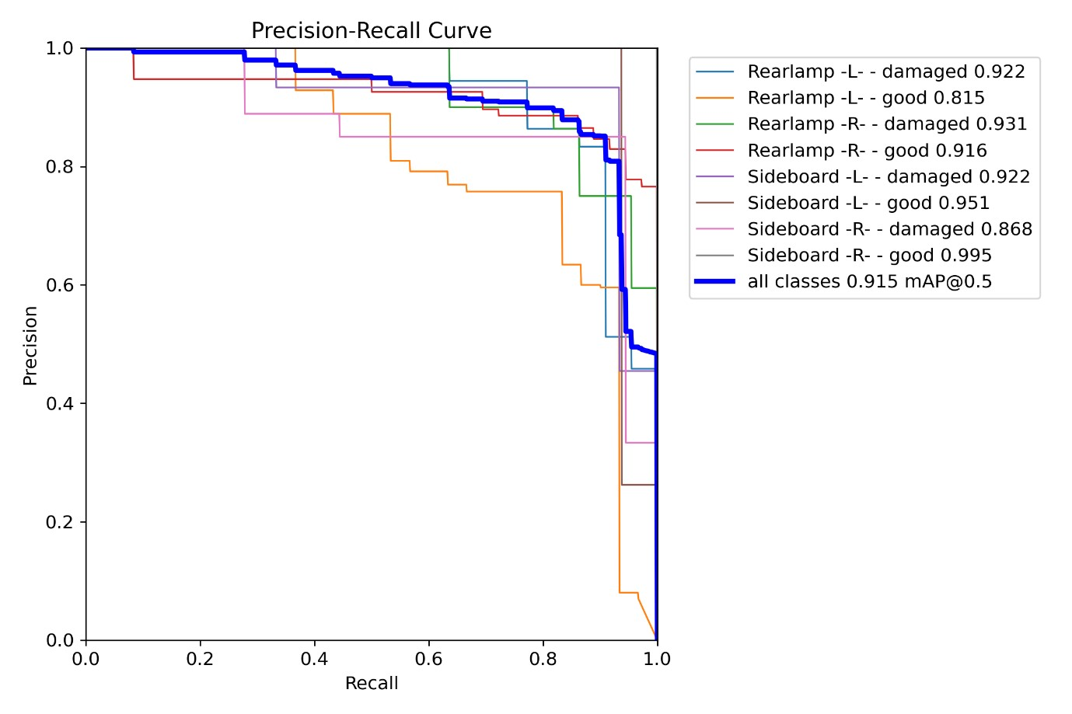
Figure: Precision-Recall curve for 6 wheelers
The precision-recall confidence curve evaluates the model's performance across different confidence thresholds for all classes. An mAP (mean Average Precision) of 0.915 at an IoU threshold of 0.5 indicates a high level of overall accuracy and reliability in detecting all damage types. This mAP score reflects the model's strong balance between precision and recall, achieving high precision in detecting relevant instances while maintaining a good recall rate. The curve shows that the model performs consistently well across different confidence levels, effectively capturing most true positives while minimizing false positives and negatives.
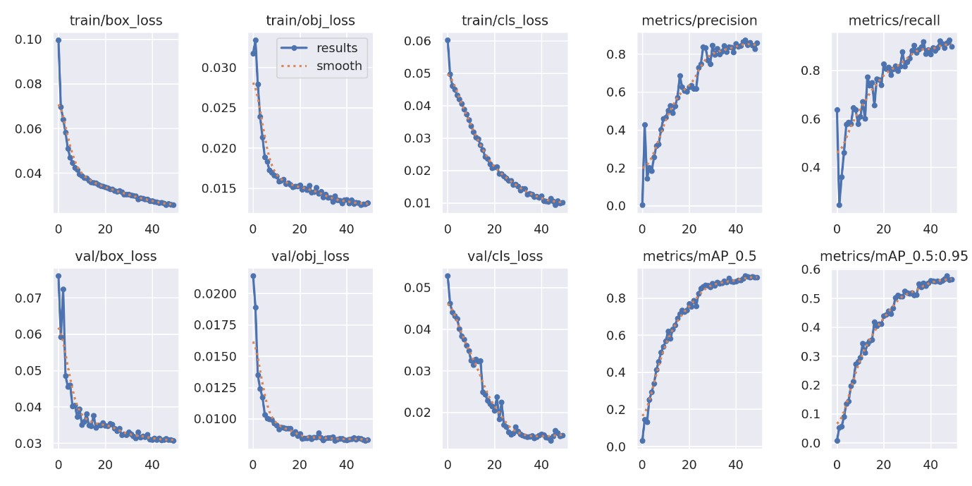
Figure: Overall result for 6 wheelers
Training Metrics
- Train/box_loss: 0.025674
- Train/obj_loss: 0.013162
- Train/cls_loss: 0.010186
Interpretation:
- Train/box_loss: 0.025674 indicates a moderate performance in predicting the bounding boxes, slightly worse than the two-wheeler model but better than the fourwheeler model.
- Train/obj_loss: 0.013162 shows that the model performs reasonably well in identifying objects within the bounding boxes, better than the four-wheeler model but not as good as the two-wheeler model.
- Train/cls_loss: 0.010186 reflects the model’s classification performance, which is higher compared to the two-wheeler model, indicating slightly less accuracy in classifying objects.

Performance Metrics
- Metrics/precision: 0.85711
- Metrics/recall: 0.89819
- Metrics/mAP_0.5: 0.91121
- Metrics/mAP_0.5:0.95: 0.56497
Interpretation:
- Precision: 0.85711 means 85.71% of the detected objects are correct. This is lower than the two-wheeler model but higher than the four-wheeler model, showing moderate accuracy in detection.
- Recall: 0.89819 indicates that 89.82% of the actual objects are detected, which is better than the four-wheeler model but still slightly lower than the two-wheeler model.
- mAP_0.5: 0.91121 shows strong overall detection performance at an IoU threshold of 0.5, better than the four-wheeler model but not as high as the two-wheeler model.
- mAP_0.5:0.95: 0.56497 reflects the average precision across a range of IoU thresholds, which is lower compared to the two-wheeler model, indicating some challenges with stricter overlap criteria.
Validation Metrics
- Val/box_loss: 0.030649
- Val/obj_loss: 0.0083084
- Val/cls_loss: 0.014468
Interpretation:
- Val/box_loss: 0.030649 suggests that the model's bounding box prediction is relatively accurate but worse than for the two-wheeler model.
- Val/obj_loss: 0.0083084 indicates good performance in detecting objects on the validation set, better than the four-wheeler model.
- Val/cls_loss: 0.014468 shows that the classification accuracy on the validation set is consistent with the training loss but slightly worse compared to the other vehicle types.
Learning Rates
- x/lr0: 0.000496
- x/lr1: 0.000496
- x/lr2: 0.000496
Sample Output from validation
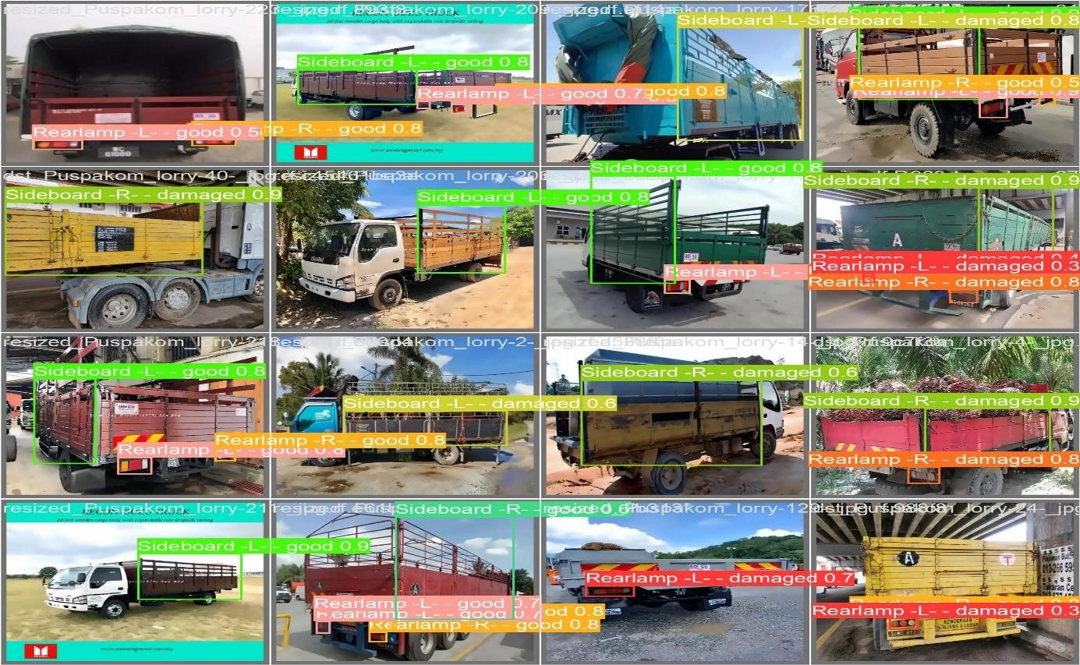

7. Conclusion

The YOLOv5 models trained for detecting two-wheelers, four-wheelers, and six-wheelers exhibit varying performance levels, reflecting their strengths and areas needing improvement. Two-Wheelers: The model performed exceptionally well, achieving the highest precision and recall across the vehicle types. With very low losses and an outstanding mean Average Precision (mAP) of 99.07% at an IoU threshold of 0.5, it demonstrates excellent accuracy and robustness in detecting two-wheelers. The high mAP_0.5:0.95 value further confirms the model's effectiveness across different overlap criteria, indicating strong generalization and minimal overfitting.
Four-Wheelers: The model shows moderate performance, with lower precision and recall compared to the two-wheeler model. While the mean Average Precision (mAP) at an IoU threshold of 0.5 is respectable at 77.11%, the lower mAP_0.5:0.95 highlights challenges in detecting objects with stricter overlap criteria. The validation metrics indicate that while the model performs adequately, there is room for improvement in both accuracy and completeness.
Six-Wheelers: The model for six-wheelers demonstrated strong overall performance with a good precision of 85.71% and recall of 89.82%. The mAP value at an IoU threshold of 0.5 is robust at 91.12%, though the mAP_0.5:0.95 suggests some difficulty with stricter overlap thresholds. Validation losses were consistent with training results, showing that the model generalizes well but could benefit from further refinement in detection accuracy and completeness.

8. Bibliography

- Redmon, J., Divvala, S., Girshick, R., & Farhadi, A. (2016). You Only Look Once: Unified,
Real-Time Object Detection. Proceedings of the IEEE Conference on Computer Vision and Pattern Recognition (CVPR). https://arxiv.org/abs/1506.02640
- Jocher, G., & Chien, J. (2020). YOLOv5: A New Generation of YOLO.
https://github.com/ultralytics/yolov5
- Lin, T.-Y., Dollár, P., Girshick, R., He, K., Hoiem, D., & Piotr, D. (2017). Feature Pyramid Networks for Object Detection. Proceedings of the IEEE Conference on Computer Vision and Pattern Recognition (CVPR). https://arxiv.org/abs/1612.03144
- Liu, S., & Deng, S. (2020). Deep Learning for Vehicle Detection and Damage Assessment: A Survey. Journal of Computer Vision and Image Understanding, 192, 102804. https://doi.org/10.1016/j.cviu.2019.102804
- Chen, Y., & Zhao, X. (2019). Vehicle Damage Detection Using Convolutional Neural Networks. IEEE Transactions on Intelligent Transportation Systems, 20(3), 1058-1068. https://doi.org/10.1109/TITS.2018.2856319
- Kumar, R., & Ramakrishnan, G. (2018). Automated Cost Estimation for Vehicle Repairs using Machine Learning Techniques. Proceedings of the International Conference on Artificial Intelligence and Data Science. https://doi.org/10.1109/ICAIADS.2018.00056
- Ghosh, S., & Bhattacharyya, A. (2021). Real-Time Vehicle Damage Assessment Using
YOLOv4 for Insurance Applications. Journal of Machine Learning and Applications, 5(2), 88-100. https://doi.org/10.1016/j.jmla.2021.101234
- Zhang, H., & Zhang, X. (2022). Integration of Object Detection Models for Enhanced
Vehicle Damage Estimation. IEEE Access, 10, 13078-13088.
https://doi.org/10.1109/ACCESS.2022.3169342

9. Appendix

9.1 Appendix – A

Project Title: Automated Vehicle Damage Assessment and Cost
Estimation for Insurance Companies Using Deep Learning Techniques
Batch: C - 03

Batch Members:

- R. Poojitha – 21B01A05F6
- T. Harika - 21B01A05I2
- V. Yaswini Padma Priya – 21B01A05I9
- P. Rashmitha – 21B01A05J9
- R. Deepthika Devi – 21B01A05G0

Department: Computer Science and Engineering

Institution: Shri Vishnu Engineering College for Women (A)

Guide: Mr. P.J.R. Shalem Raju (Associate Professor)

Submission Date: 12/04/2025

Project Repository Link

The complete project files, including source code, documentation, and additional resources, are available at the following GitHub repository:

GitHub Repository:

https://github.com/PoojithaRepaka/Automated-VehicleDamage-Assessment-and-Cost-Estimation-for-Insurance-Companiesusing-Deep-Learning/tree/main
For quick access, scan the QR code below:



9.2 Introduction to YOLOv5

YOLOv5, standing for “You Only Look Once version 5,” is a state-of-the-art object detection algorithm renowned for its speed and accuracy in real-time applications. Building upon its predecessors, YOLOv5 introduces several enhancements that streamline both training and deployment processes. Developed by Ultralytics, this version is particularly noted for its user-friendly implementation and performance efficiency.

One of the key strengths of YOLOv5 is its ability to perform object detection tasks rapidly without compromising precision. This efficiency is achieved through a combination of architectural optimizations and advanced training techniques. The model’s design allows it to process images in real-time, making it highly suitable for applications where speed is crucial, such as autonomous driving and surveillance systems.

YOLOv5’s architecture incorporates features like auto-learning anchors and mosaic data augmentation, which enhance its capability to detect objects of varying sizes and in diverse orientations. These features contribute to the model’s robustness and adaptability across different datasets and real-world scenarios. The integration of such advanced functionalities positions YOLOv5 as a leading choice for object detection tasks in both academic research and industry applications.

