CREATE INSURANCE DB:
create database insuranceDB;
use insuranceDB;
CUSTOMERS TABLE:
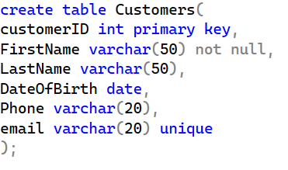
POLICIES TABLE:
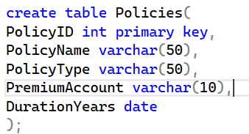
AGENTS:
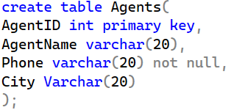
POLICY ASSIGNMENTS:
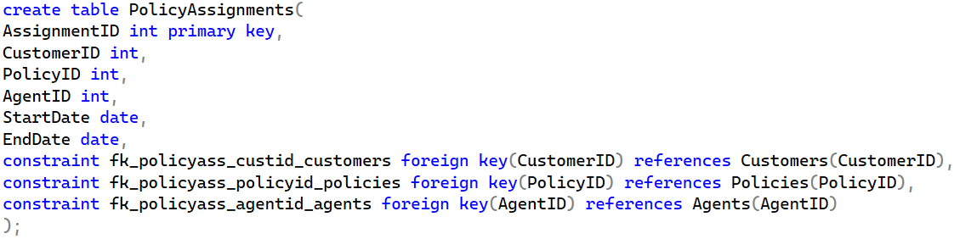

CLAIMS:
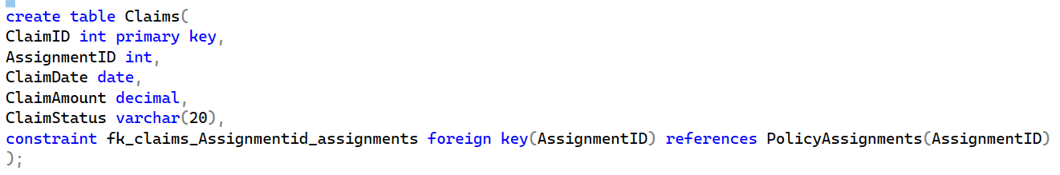
Modifying datatype from date to int(incompatible types where conversion is not possible):

Insertion:
1.Customers
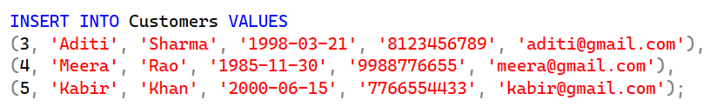
2.Policies:
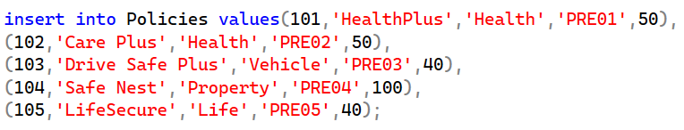

3.PolicyAssignments:

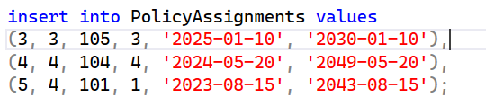
4.Agents:
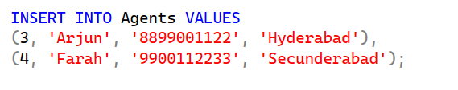
5.Claims:
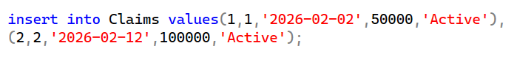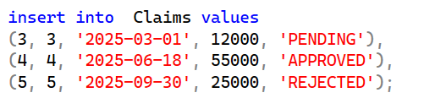
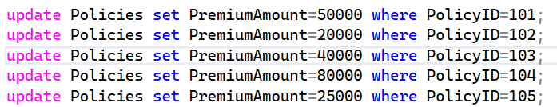

1.Select * from customers;
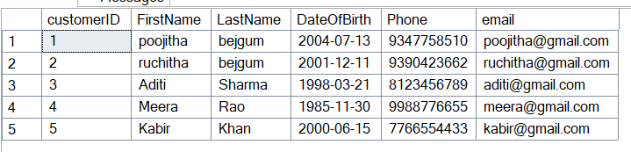
2.View all records of PolicyAssignment table with CustomerId, PolicyId, StartDate and EndDate columns only
Query:
select CustomerId,PolicyId,StartDate,EndDate from PolicyAssignments;
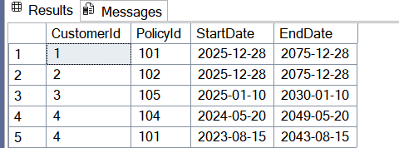

3.Display all policies of Health type.
Query:
Select * from Policies where PolicyType like ‘Health%’;
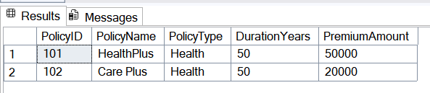
4. select * from Policies where PremiumAmount>10000 and DurationYears=1;
Query:
select * from Policies where PremiumAmount>10000 and DurationYears=1;
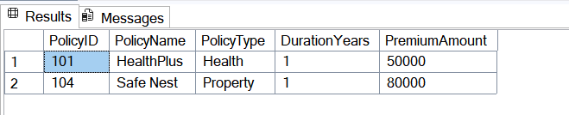
5. Display unique city names from where agents belong to.
Query: select distinct city from Agents;
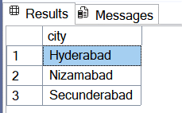

6. List policies of type Life, Health, Motor use OR clause.
Query:select * from Policies where Policytype like 'Life%' or PolicyType like 'Health%' or PolicyType like 'Motor%';
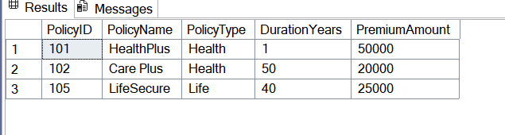
7. List policies of type Life, Health, Motor use IN operator.
Query:select * from Policies where PolicyType in ('Life','Health','Motor');
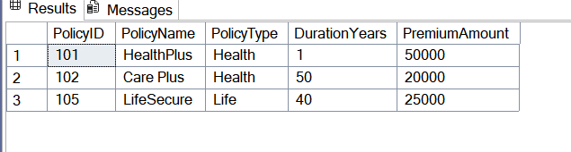
8. Display list of customers born after January 1st, 2001 and before December 31st, 2020 using >= and <= operators.
Query:select * from Customers where DateOfBirth>='2001-01-01' and DateOfBirth<='2020-12-31';
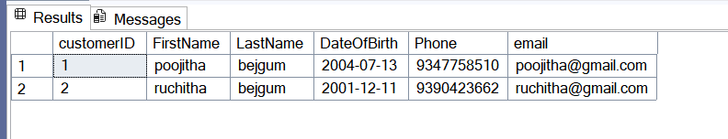

9. Display list of customers born after January 1st, 2001 and before December 31st, 2020 using between operator.
Query:select * from Customers where DateOfBirth>='2001-01-01' and DateOfBirth<='2020-12-31';
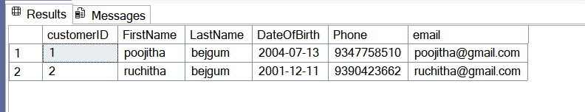
10. Display claims data where claim status is Rejected.
Query:select * from Claims where ClaimStatus like 'Rejected';
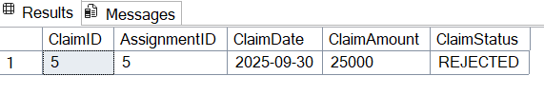
11. Display records of Agents who stay in a city whose second letter is 'a'.
Query:Select * from Agents where city like ‘_a%’;
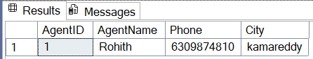
12. Display highest and lowest claimAmount from Claims table.
Query:
select min(ClaimAmount) as lowest_claim_amount,max(ClaimAmount) as highest_claim_amount from Claims;

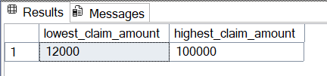

13. Display latest claim record.
select top 1 * from Claims order by ClaimDate desc;
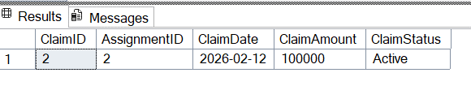
14. Increase premium amount to 10% for all health insurance policies.
update Policies set PremiumAmount=PremiumAmount*1.1 where PolicyType='Health';
select * from Policies where PolicyType='Health';
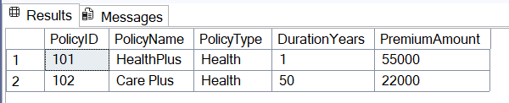

15. Delete the record of PolicyAssignments whose EndDate is before today's date.
As PolicyAssignments contains primary key is referred by claims we need to delete claims data first and then delete Policyassignments data
Query:delete from Claims
where AssignmentID in (
select AssignmentID from PolicyAssignments where EndDate < getdate()
);
delete from PolicyAssignments
where EndDate < getdate();
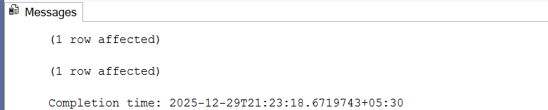

16. Display no of claims rejected.
select * from Claims where ClaimStatus='Rejected';
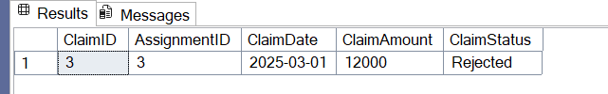

17. Display PolicyId, PolicyName, PremiumAmount along with computed fields not in table à 6% LocalTaxes, PremiumAmountWithTax and MonthlyPremiumAmount considering PremiumAmount is Annual.
Query:
select PolicyId,PolicyName,PremiumAmount,PremiumAmount*0.06 as tax,PremiumAmount-0.06*PremiumAmount as PremAmount_withtax,PremiumAmount/12 as PremAmount_monthly from Policies;
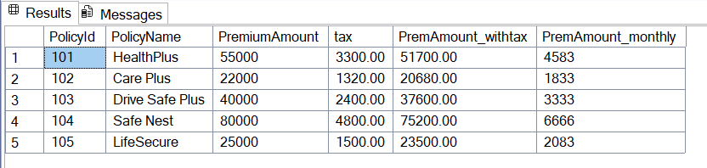
18. Write a command to add Address and City Columns in the Customers table.
alter table Customers add Address varchar(20),city VarChar(20);
select * from Customers;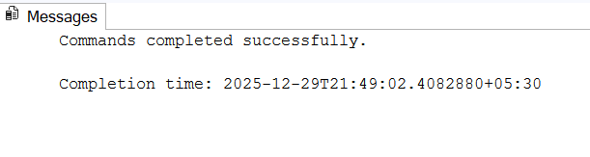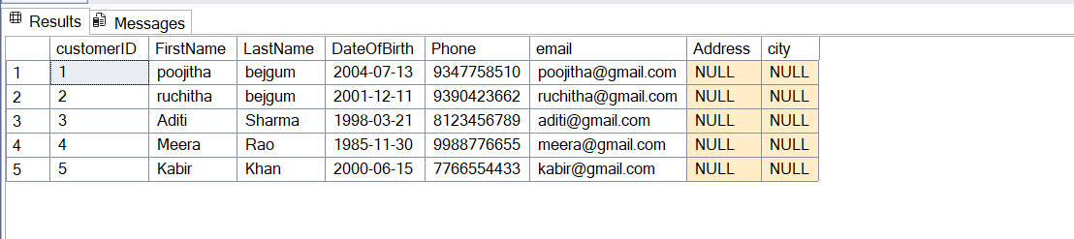

19. Write a command to add a new column named DevOfId (DevelopmentOfficerId) in an existing Agents table.
alter table Agents add DevOfID int;
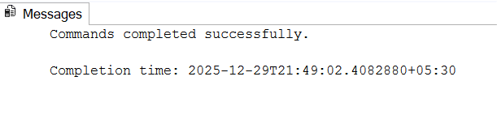
Select * from Agents;
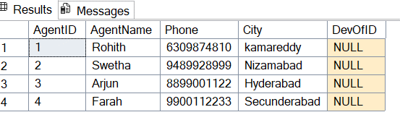
20. Write command to make the above DevOfId as a recursive foreign key to AgentId as Parent.
alter table Agents add constraint recfk_DevOfID_AgentID foreign key(DevOfID) references Agents(AgentID);

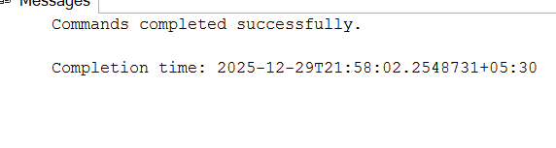

5. Queries using Joins, Group By, Having etc
1.List all Policies for a CustomerId 4.
select * from Policies p join PolicyAssignments pl on pl.PolicyID=p.PolicyID
join Customers c on pl.CustomerID=c.customerID where c.customerID=4;
2. View all customers with their policies.
select * from customers c join PolicyAssignments pl on c.customerID=pl.CustomerID
join Policies p on pl.PolicyID=p.PolicyID;
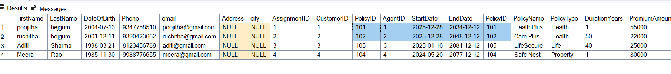3. View claims with customer name.
Query:
select c.FirstName,cl.ClaimID from Claims cl join PolicyAssignments pl on cl.AssignmentID=pl.AssignmentID
join Customers c on pl.CustomerID=c.customerID;
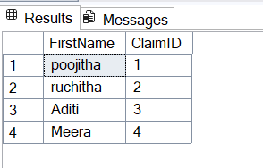
4. Display FirstName, PolicyName, AgentName, StartDate and EndDate from their respective tables.
select c.FirstName,p.PolicyName,a.AgentName,pl.StartDate,pl.EndDate
from Policies p join PolicyAssignments pl on p.PolicyID=pl.PolicyID
join Customers c on c.customerID=pl.CustomerID
join Agents a on a.AgentID=pl.AgentID;
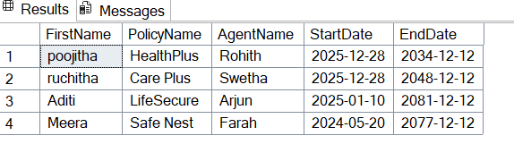
5. Display claims report with FirstName, PolicyName, ClaimAmount, ClaimStatus, and ClaimDate from their respective tables.
Query:
select p.PolicyName,c.FirstName,a.AgentName,cm.ClaimAmount,
cm.ClaimStatus,cm.ClaimDate
from Policies p join PolicyAssignments pl on p.PolicyID=pl.PolicyID
join Customers c on c.customerID=pl.CustomerID
join Agents a on a.AgentID=pl.AgentID
join Claims cm on cm.AssignmentID=pl.AssignmentID;
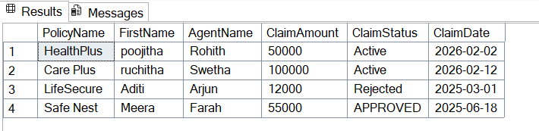
6.Display records of Customers with or without Policies.
Query:
select c.FirstNAme,p.PolicyName from Customers c left join PolicyAssignments pl on pl.CustomerID=c.customerID
left join Policies p on pl.PolicyID=p.PolicyID;
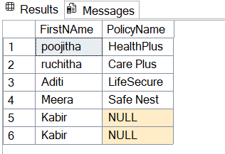

7. Display all Customers with NO Claims.
select c.FirstName,cl.ClaimID from Customers c join PolicyAssignments pl on pl.CustomerID=c.customerID left join Claims cl on cl.AssignmentID=pl.AssignmentID where cl.ClaimID is null;
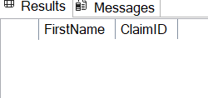

8. Show CustomerName with Total Claim Amount per Customer.
select concat(c.FirstName,c.LastName),sum(cl.ClaimAmount) as tot_amt from Customers c join PolicyAssignments pl on pl.CustomerID=c.customerID join Claims cl on cl.AssignmentID=pl.AssignmentID group by c.FirstName,c.LastName;
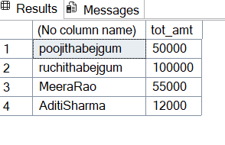
9. Show names and total claim amount of Customers With Claim Amount > 50000 (Use HAVING Clause).
select concat(c.FirstName,c.LastName),sum(cl.ClaimAmount) as tot_amt from Customers c join PolicyAssignments pl on pl.CustomerID=c.customerID join Claims cl on cl.AssignmentID=pl.AssignmentID group by c.FirstName,c.LastName having sum(cl.ClaimAmount)>50000;
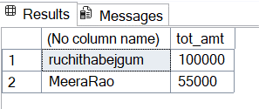
10. Display list with Agent Wise Policy Count.
select a.AgentID,count(*) as number_of_policies from Policies p join PolicyAssignments pl on pl.PolicyID=p.PolicyID join Agents a on a.AgentID=pl.AgentID group by a.AgentID;
