DSA0404
FUNDAMENTALS OF DATA SCIENCE
Using various Python Libraries

- Data Processing, Aggregation, and Visualization using Python

Code :
import matplotlib.pyplot as plt
import numpy as np
import pandas as pd
import seaborn as sns
raw_data = {
"Employee_Name": [" Alice ", "Bob", "Charlie", "Diana", "Evan"],
"Department": ["HR", "Engineering", "HR", "Engineering", "Marketing"],
"Salary": [50000, 85000, np.nan, 92000, 60000], # Missing value
"Join_Date": [
"2022-01-15",
"2021-06-20",
"2023-03-11",
"2020-11-01",
"2024-02-28",
],
}
df = pd.DataFrame(raw_data)
print("--- Raw Data ---")
print(df, "\n")
df["Employee_Name"] = df["Employee_Name"].str.strip()
median_salary = df["Salary"].median()
df["Salary"] = df["Salary"].fillna(median_salary)
df["Join_Date"] = pd.to_datetime(df["Join_Date"])
df["Years_of_Service"] = 2026 - df["Join_Date"].dt.year
print("--- Preprocessed Data ---")
print(df, "\n")
dept_summary = (
df.groupby("Department")
.agg(
Avg_Salary=("Salary", "mean"),
Total_Employees=("Employee_Name", "count")
)
.reset_index()
)
print("--- Aggregated Summary ---")
print(dept_summary, "\n")
sns.set_theme(style="whitegrid")
fig, axes = plt.subplots(1, 2, figsize=(14, 5))
sns.barplot(
data=dept_summary,
x="Department",
y="Avg_Salary",
hue="Department",
ax=axes[0],
palette="Blues_d",
legend=False,
)
axes[0].set_title("Average Salary by Department")
axes[0].set_xlabel("Department")
axes[0].set_ylabel("Salary ($)")
# Plot 2: Scatter plot mapping experience against compensation
sns.scatterplot(
data=df,
x="Years_of_Service",
y="Salary",
hue="Department",
style="Department",
s=200,
ax=axes[1],
)
axes[1].set_title("Salary vs. Years of Service")
axes[1].set_xlabel("Years of Service")
axes[1].set_ylabel("Salary ($)")

plt.tight_layout()
plt.show()

OUTPUT :
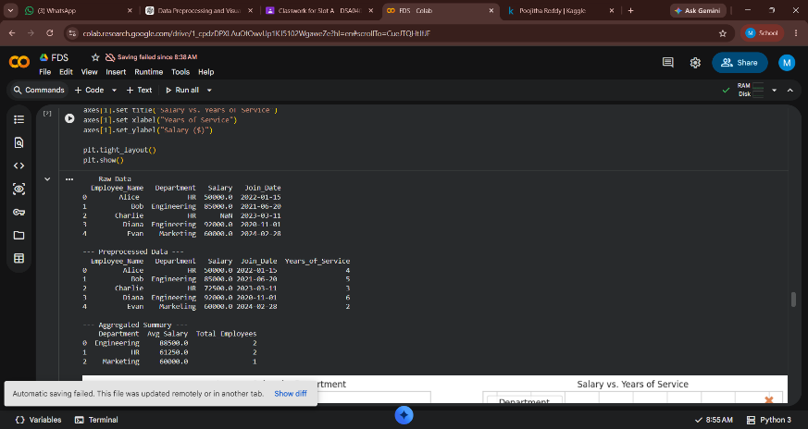

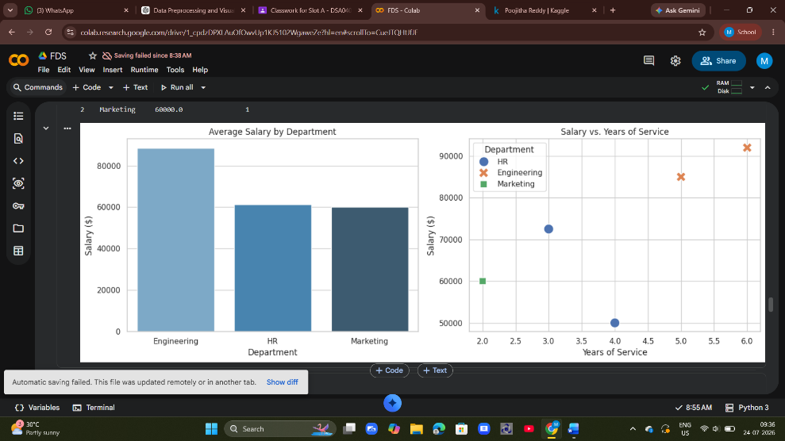

- Creating Sample Data Frame

Code :
import pandas as pd
df = pd.DataFrame()
df['Name'] = ['John','Emma','Liam', 'Olivia']
df['Age'] = [20, 19, 21, 18]
df['Student'] = [True, True, False, True]
print(df)
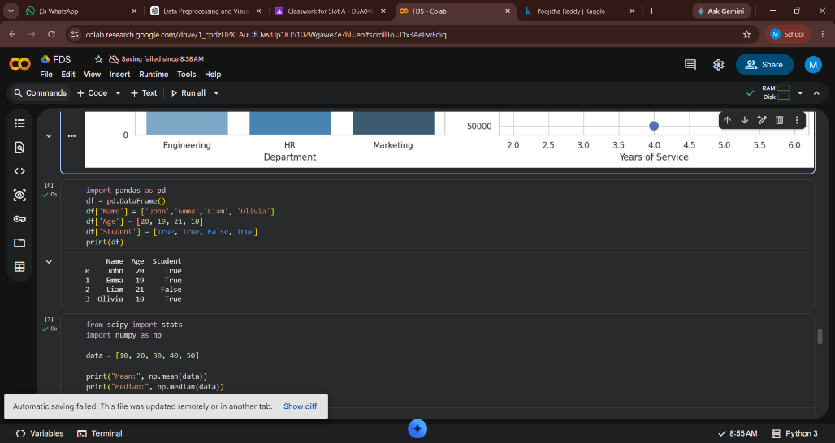

- Data analysis with SciPy
from scipy import stats
import numpy as np

data = [10, 20, 30, 40, 50]

print("Mean:", np.mean(data))
print("Median:", np.median(data))
print("Mode:", stats.mode(data))
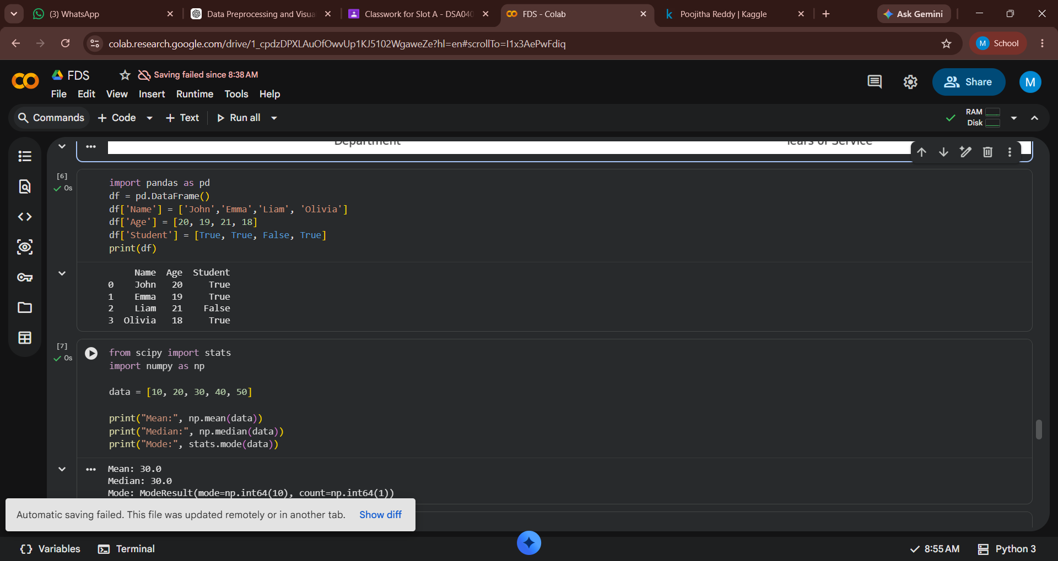

- Probability Distribution Analysis Using SciPy

from scipy.stats import norm
probability = norm.cdf(85, loc=70, scale=10)
print("Probability:", probability)

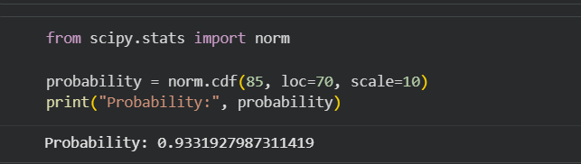

- Hypothesis Testing

from scipy import stats
data = [22, 25, 19, 24, 28, 30]
t_stat, p_value = stats.ttest_1samp(data, 25)
print("T-Statistic:", t_stat)
print("P-Value:", p_value)

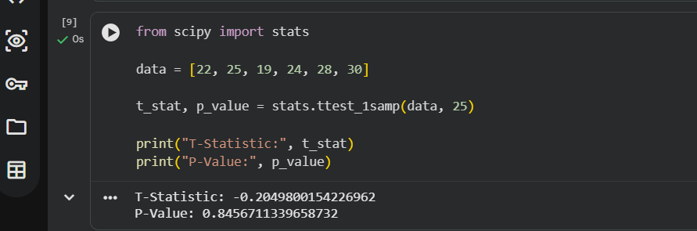

- Correlation Analysis
from scipy.stats import pearsonr
x = [1, 2, 3, 4, 5]
y = [2, 4, 6, 8, 10]
corr, p_value = pearsonr(x, y)
print("Correlation:", corr)
print("P-Value:", p_value)

- Linear Algebra Operations
from scipy import linalg
A = [[3, 2], [1, 2]]
B = [5, 5]
solution = linalg.solve(A, B)
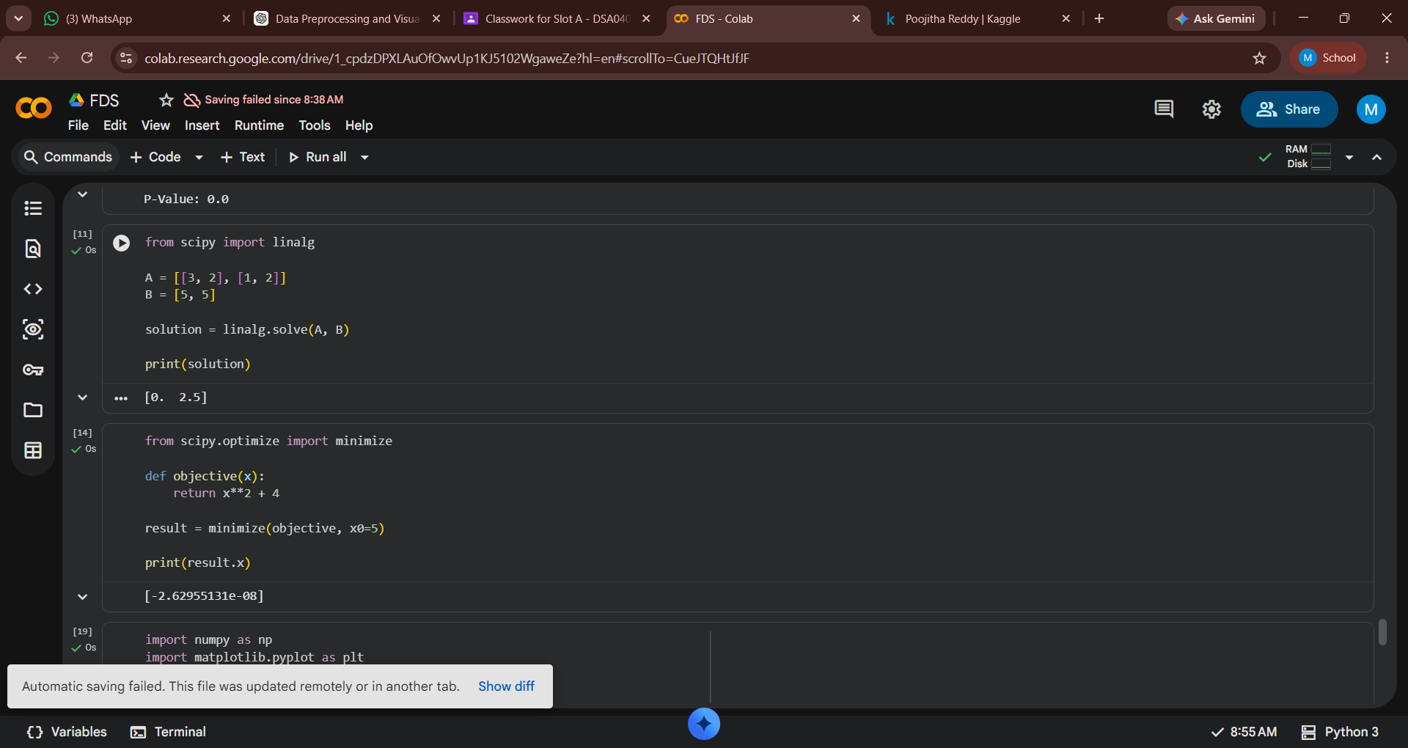
print(solution)

- Optimization Using SciPy
from scipy.optimize import minimize
def objective(x):
return x**2 + 4
result = minimize(objective, x0=5)
print(result.x)


- Logistic Regression Algorithm
import numpy as np
import matplotlib.pyplot as plt
from sklearn import datasets
from sklearn.model_selection import train_test_split
from sklearn.preprocessing import StandardScaler
from sklearn.linear_model import LogisticRegression
from sklearn.metrics import accuracy_score, classification_report
iris = datasets.load_iris()
X = iris.data
y = iris.target
X_train, X_test, y_train, y_test = train_test_split(X, y, test_size=0.3, random_state=42)
scaler = StandardScaler()
X_train = scaler.fit_transform(X_train)
X_test = scaler.transform(X_test)

log_reg = LogisticRegression()
log_reg.fit(X_train, y_train)
y_pred = log_reg.predict(X_test)
accuracy = accuracy_score(y_test, y_pred)
print('Accuracy', accuracy)
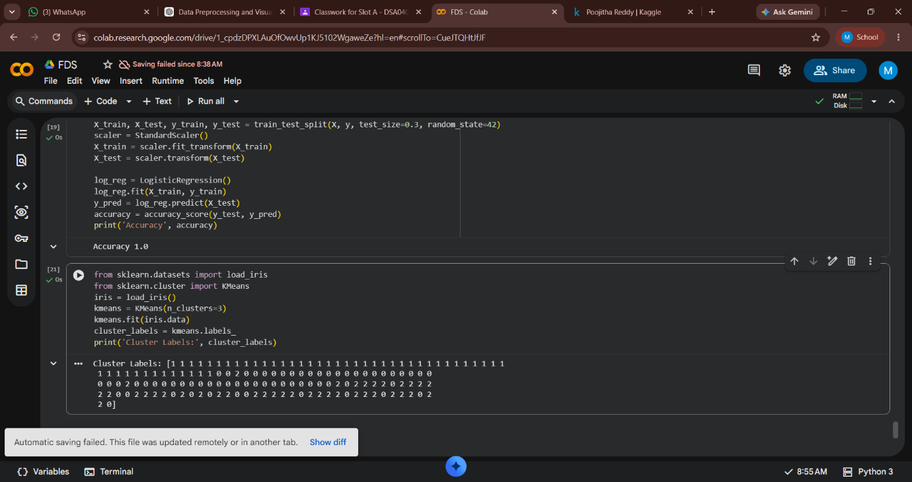

- KMeans Algorithm
from sklearn.datasets import load_iris
from sklearn.cluster import KMeans
iris = load_iris()
kmeans = KMeans(n_clusters=3)
kmeans.fit(iris.data)
cluster_labels = kmeans.labels_
print('Cluster Labels:', cluster_labels)

