SIMATS ENGINEERING
ASSESSMENT TOOL 3

COURSE NAME: MLA0302
COURSE CODE: Reinforcement learning for Environment and Agent
COURSE OUTCOME COVERED
CO1: Analyze reinforcement learning frameworks and Markov Decision Process concepts to model decision-making problems.( BL2, BL3)
Assessment Tool Weightage: 30%

Code of Conduct:
I __M Poojitha Reddy- 192472352___ (Name / Reg No) certify that this submission is my original work and that I have adhered to the guidelines specified for this assessment.
I understand that any violation of academic integrity rules will result in disciplinary action.

Signature of the student:

RUBRICS FOR CALCULATION

Criteria | Weightage | Level 4 (Exemplary) | Level 3 (Proficient) | Level 2 (Developing) | Level 1 (Beginning)
Problem Understanding | 25% | Clearly defines the problem and identifies all relevant constraints accurately | Identifies most constraints with minor gaps | Partial understanding; misses key constraints | Fails to identify constraints correctly
Constraint Analysis | 25% | Analyzes constraints effectively and prioritizes them logically | Provides reasonable analysis with some prioritization | Limited analysis; weak prioritization | No meaningful analysis or prioritization
Solution Development | 25% | Develops optimal and feasible solutions satisfying all constraints | Develops workable solutions with minor limitations | Solutions partially satisfy constraints | Solutions do not meet constraints
Application of Concepts | 15% | Effectively applies appropriate concepts, methods, or tools | Applies concepts with minor errors | Limited application; requires guidance | Unable to apply relevant concepts
Justification | 10% | Provides strong justification for decisions with logical reasoning | Provides justification with some clarity | Weak or unclear justification | No justification provided

QUESTIONS: 10 Total Marks:50

Annexure A

Constraint - Based Problem-Solving Duration: 2Hrs
- Develop a Python-based Reinforcement Learning model using the OpenAI Gym environment to solve a Grid World navigation problem where the agent must reach the goal while avoiding obstacles. Explain how the state space, action space, reward function, and constraints are defined.
CODE :
import gymnasium as gym
from gymnasium import spaces
import numpy as np
import random
class GridWorld(gym.Env):
def __init__(self):
self.size = 5
self.start = 0
self.goal = 24
self.obstacles = [6, 13, 17]
self.observation_space = spaces.Discrete(25)
self.action_space = spaces.Discrete(4)
def reset(self, seed=None, options=None):
self.state = self.start
return self.state, {}
def step(self, action):
r, c = divmod(self.state, 5)
if action == 0: r -= 1
if action == 1: r += 1
if action == 2: c -= 1
if action == 3: c += 1
new = r * 5 + c
if r < 0 or r >= 5 or c < 0 or c >= 5:
return self.state, -1, False, False, {}
self.state = new
if self.state in self.obstacles:
return self.state, -10, True, False, {}
if self.state == self.goal:
return self.state, 10, True, False, {}
return self.state, -1, False, False, {}
env = GridWorld()
Q = np.zeros((25,4))
for episode in range(500):
state,_ = env.reset()
done = False
while not done:
action = random.randint(0,3) if random.random()<0.1 else np.argmax(Q[state])
next_state,reward,done,_,_ = env.step(action)
Q[state,action] += 0.1 * (
reward + 0.9*np.max(Q[next_state]) - Q[state,action]
)
state = next_state
print("Training Completed")
state,_ = env.reset()
while state != 24:
action = np.argmax(Q[state])
state,_,_,_,_ = env.step(action)
print("Agent at:", state)
print("Goal Reached!")
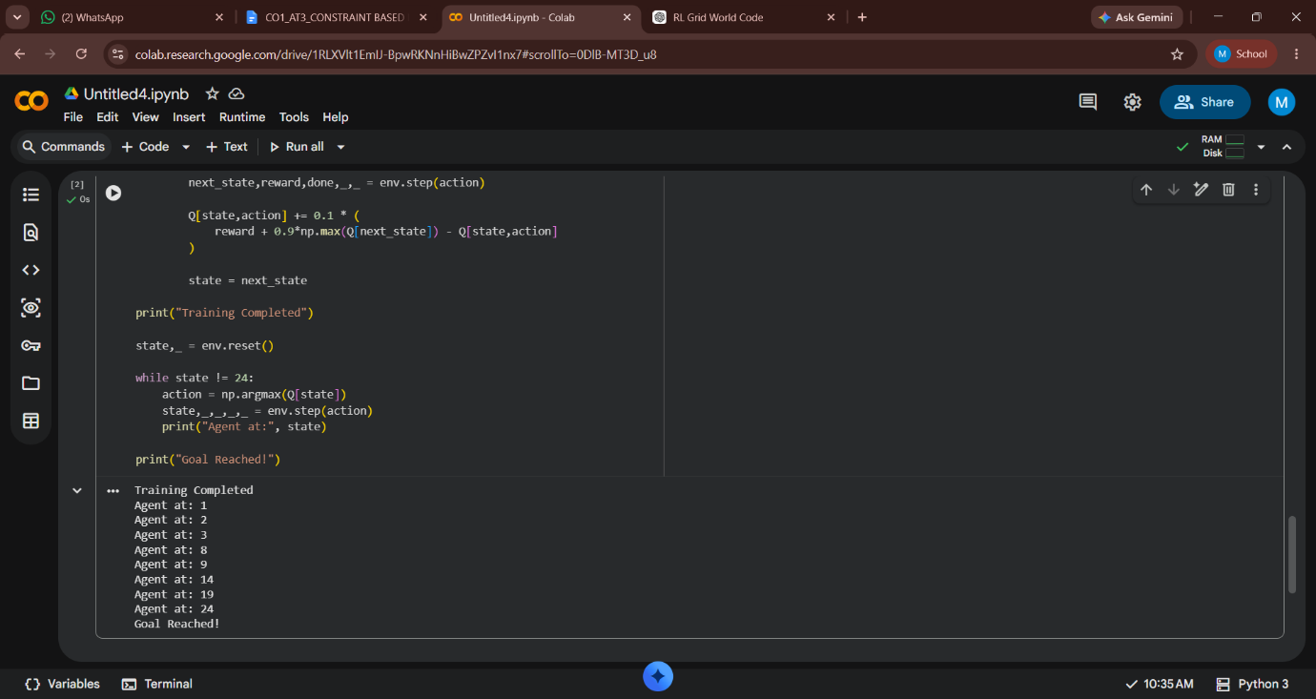
OUTPUT :

- Design a Markov Decision Process (MDP) for an autonomous robot that must reach a destination while minimizing energy consumption. Define the states, actions, transition probabilities, rewards, and energy constraints.
CODE :
import numpy as np
states = ["Start", "A", "B", "Goal"]
actions = ["Move", "Charge"]
P = {
"Start":{"Move":"A"},
"A":{"Move":"B","Charge":"A"},
"B":{"Move":"Goal","Charge":"B"}
}
R = {
"Start":-2,
"A":-3,
"B":-2,
"Goal":10
}
energy = 100
state="Start"
while state!="Goal":
action="Move"
state=P[state][action]
energy-=10
print("Robot at:",state,"Energy:",energy)
print("Destination Reached")

OUTPUT :

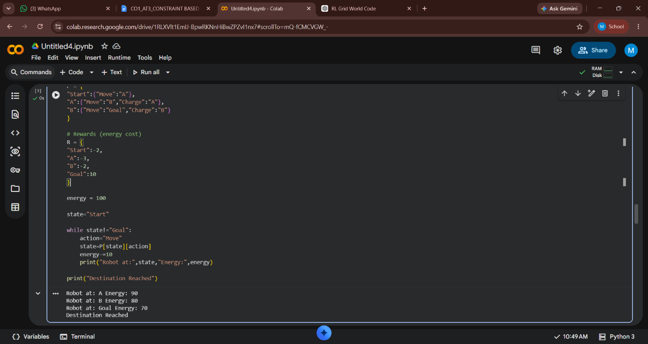

- A warehouse robot has a battery capacity of only 30 minutes. Design an RL framework that enables the robot to complete the maximum number of deliveries without exceeding the battery limit. Explain the constraints, policy, and reward design.
CODE :
import random
import numpy as np
deliveries = 0
battery = 30
Q = np.zeros((31,2)) # state = battery, actions = deliver/recharge
for episode in range(100):
battery = 30
while battery > 0:
action = random.choice([0,1])
if action == 0:
reward = 10
deliveries += 1
battery -= 5
else:
reward = -2
battery += 5
battery = min(30,battery)
print("Maximum Deliveries:",deliveries)

OUTPUT :

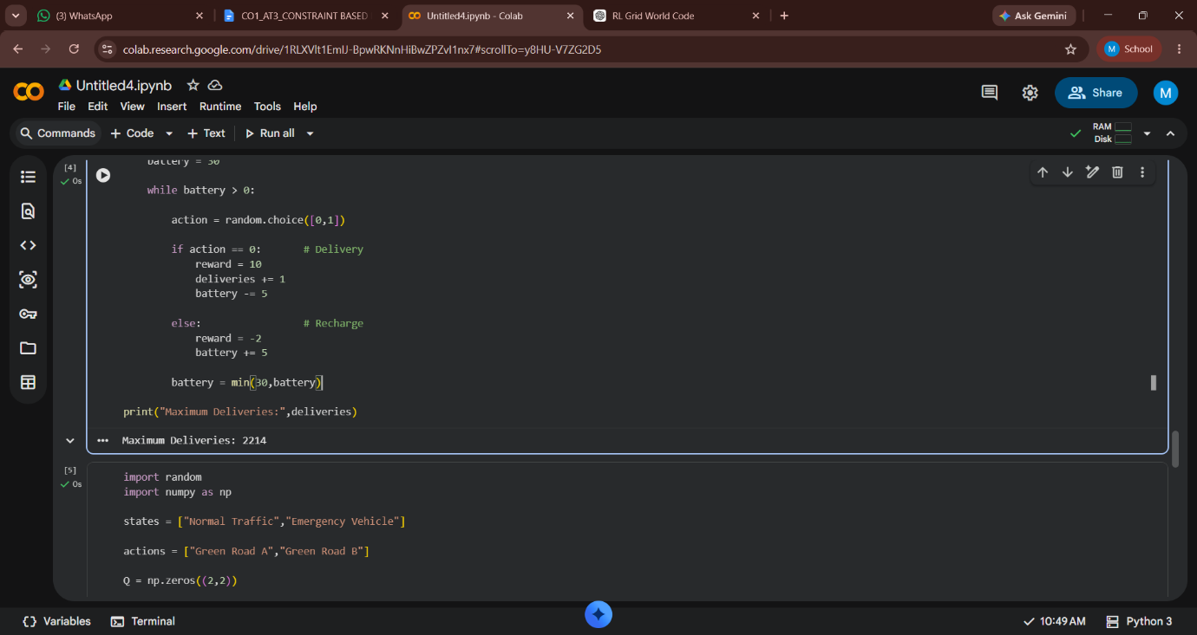

- Implement a Reinforcement Learning agent that controls traffic signals at an intersection while ensuring that emergency vehicles receive immediate priority. Explain how exploration, exploitation, and policy learning are modified to satisfy the safety constraint.

CODE :
import random
import numpy as np
states = ["Normal Traffic","Emergency Vehicle"]
actions = ["Green Road A","Green Road B"]
Q = np.zeros((2,2))
for episode in range(100):
state = random.randint(0,1)
if state == 1:
action = 0
reward = 20
else:
action = np.argmax(Q[state])
reward = 5
Q[state,action] += 0.1 * (
reward + 0.9*np.max(Q[state]) - Q[state,action]
)

print("Traffic Signal Policy Learned")
print(Q)

OUTPUT :

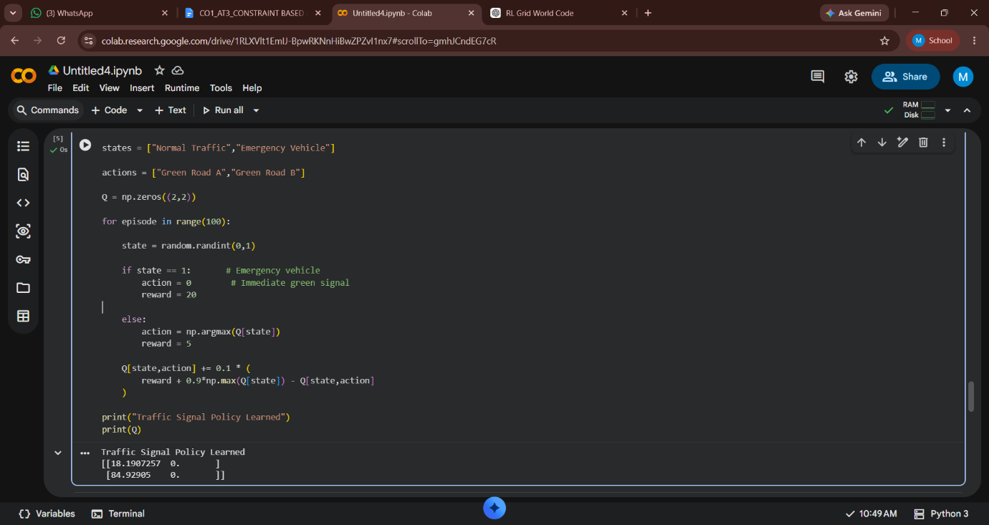
- Implement a Reinforcement Learning solution using Python for a smart energy management system where electricity consumption must remain below a specified threshold. Explain how reward shaping, policy learning, and feasibility constraints improve decision-making.
CODE :
import numpy as np
import random
Q = np.zeros((11,2))
threshold = 10
for episode in range(100):
energy = random.randint(0,10)
while energy <= threshold:
action = random.choice([0,1])
if action == 0:
energy -= 1
reward = 5
else:
energy += 2
reward = -10 if energy > threshold else 2
state = min(max(energy,0),10)
Q[state,action] += 0.1 * (
reward + 0.9*np.max(Q[state]) - Q[state,action]
)
break
print("Energy Management Policy Learned")
print(Q)

OUTPUT :
