🏠 Project Report: HouseHunt - Finding Your Perfect Rental Home

# 📌 Project Title

HouseHunt: Finding Your Perfect Rental Home

# 👩‍💻 Internship Platform

SmartInternz Internship – SmartBridge

# Developer Details

1. Poolakunta Dakshayani – Full Stack Developer  
2. T Vamshibhavani – Frontend Developer  
3. P Vijay– Backend Developer  
4. P sainathreddy– UI/UX Designer or Database Admin  
  
GitHub Repo: https://github.com/PoolakuntaDakshayani03/househunt-project

# 📖 Project Description

HouseHunt is a full-stack MERN (MongoDB, Express, React, Node.js) web application that facilitates rental property listings, inquiries, bookings, and role-based access for three user types: Renters, Owners, and Admins.  
  
The platform aims to simplify the rental process by providing features for property browsing, bookings, owner management, and admin approvals.

# 🛠️ Technologies Used

|  |  |
| --- | --- |
| Layer | Technologies |
| Frontend | React.js, Axios, React Router |
| Backend | Node.js, Express.js |
| Database | MongoDB (Cloud: MongoDB Atlas) |
| Tools | Git, GitHub, VS Code, Postman |
| Deployment | [Add deployment info if applicable] |

# 🎯 Core Features

* ✔ Role-based Authentication & Authorization (JWT)
* ✔ Property Listing, Editing, Deletion by Owners
* ✔ Property Browsing and Booking by Renters
* ✔ Admin Approval for Property Listings
* ✔ Booking Management and Confirmation
* ✔ Direct Messaging between Renters and Owners
* ✔ RESTful API Integration

# 📁 Complete Folder Structure

🔸 Frontend Structure

frontend/  
 public/  
 index.html  
 favicon.ico  
 src/  
 App.js  
 index.js  
 components/  
 Navbar.js  
 PropertyCard.js  
 Login.js  
 Register.js  
 Dashboard.js  
 pages/  
 Home.js  
 PropertyList.js  
 PropertyDetail.js  
 OwnerDashboard.js  
 services/  
 api.js  
 App.css  
 index.css  
 package.json  
 .env

🔸 Backend Structure

backend/  
 models/  
 User.js  
 Property.js  
 Booking.js  
 Message.js  
 routes/  
 authRoutes.js  
 propertyRoutes.js  
 bookingRoutes.js  
 messageRoutes.js  
 controllers/  
 authController.js  
 propertyController.js  
 bookingController.js  
 messageController.js  
 middleware/  
 authMiddleware.js  
 errorHandler.js  
 config/  
 connectDB.js  
 server.js  
 .env  
 package.json

# 🚀 How to Run the Project

1. Clone the Repository

git clone https://github.com/PoolakuntaDakshayani03/househunt-project.git  
cd househunt-project

2. Setup Frontend

cd frontend  
npm install  
npm start

3. Setup Backend

cd ../backend  
npm install  
npm start

📌 Ensure MongoDB URI and JWT secrets are set in `.env` inside `/backend`

# 🖼️ Screenshots

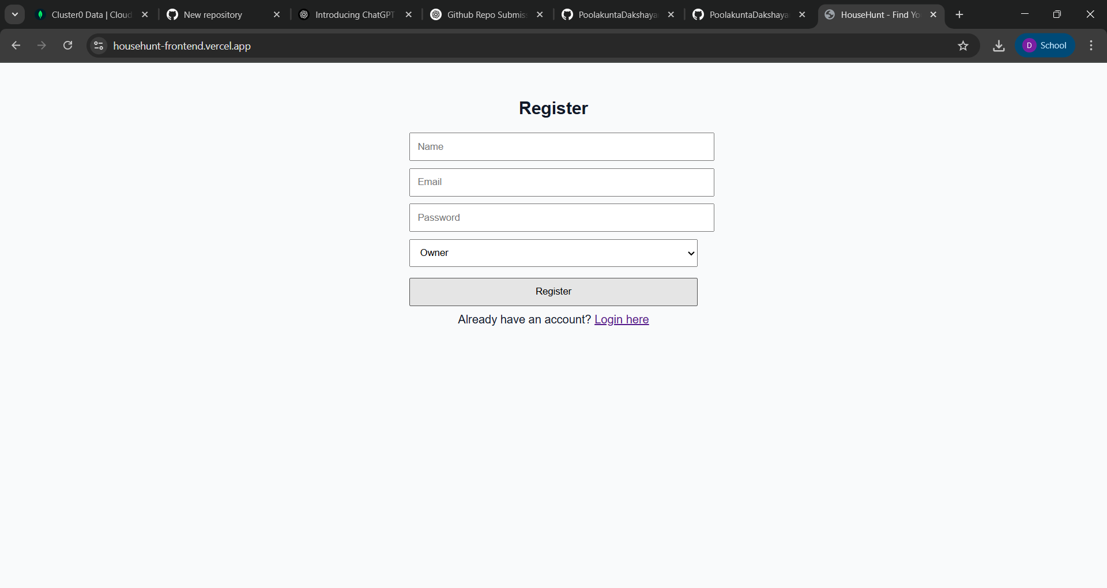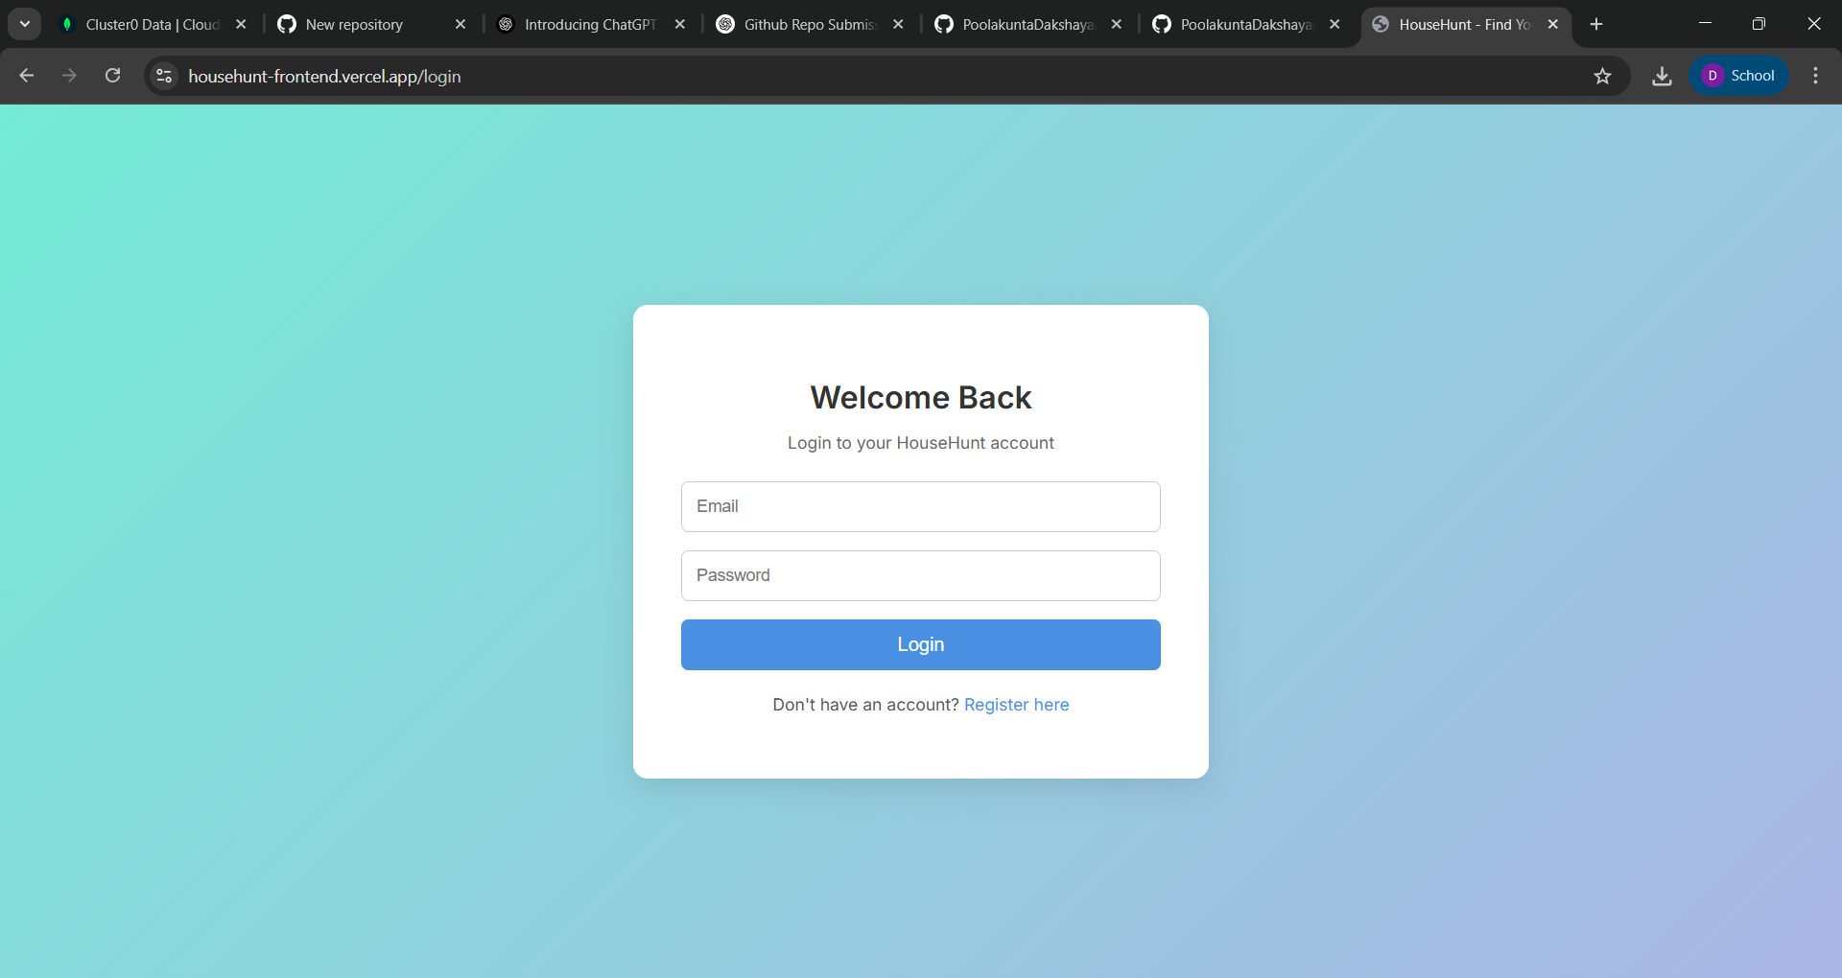

Register page/home page Login page

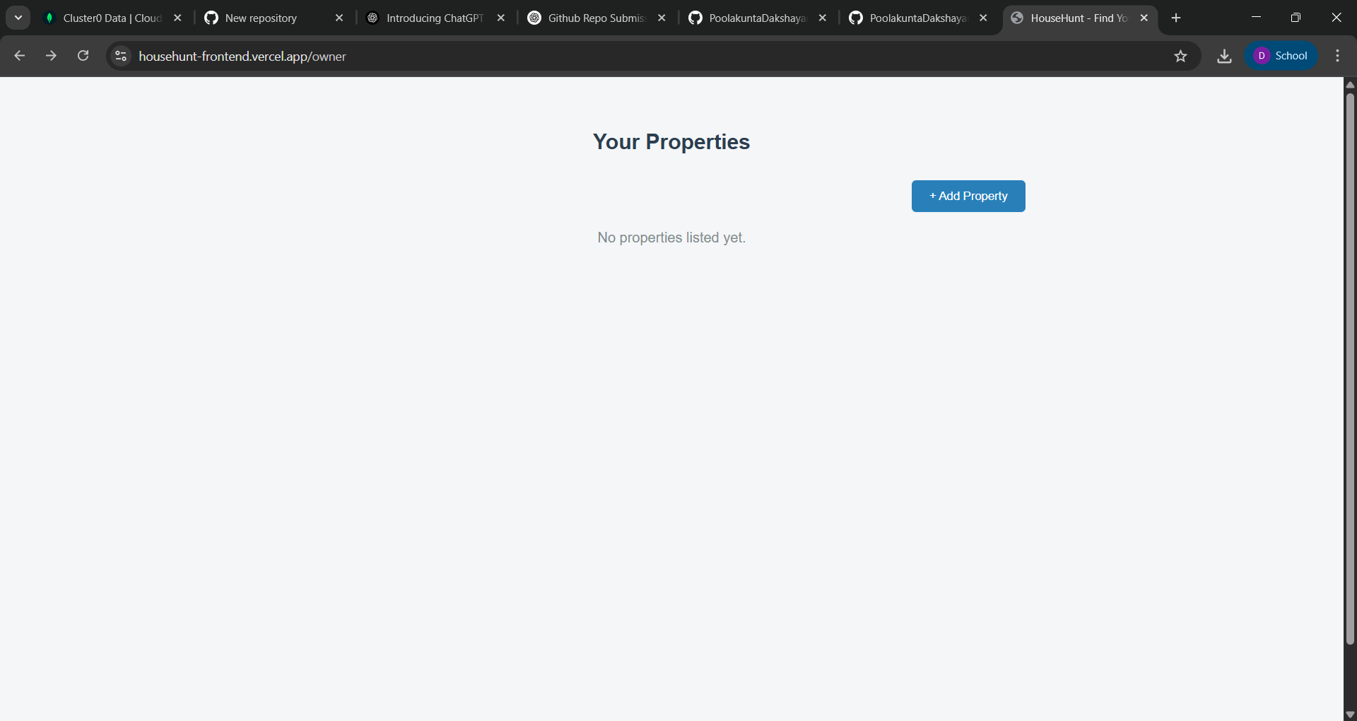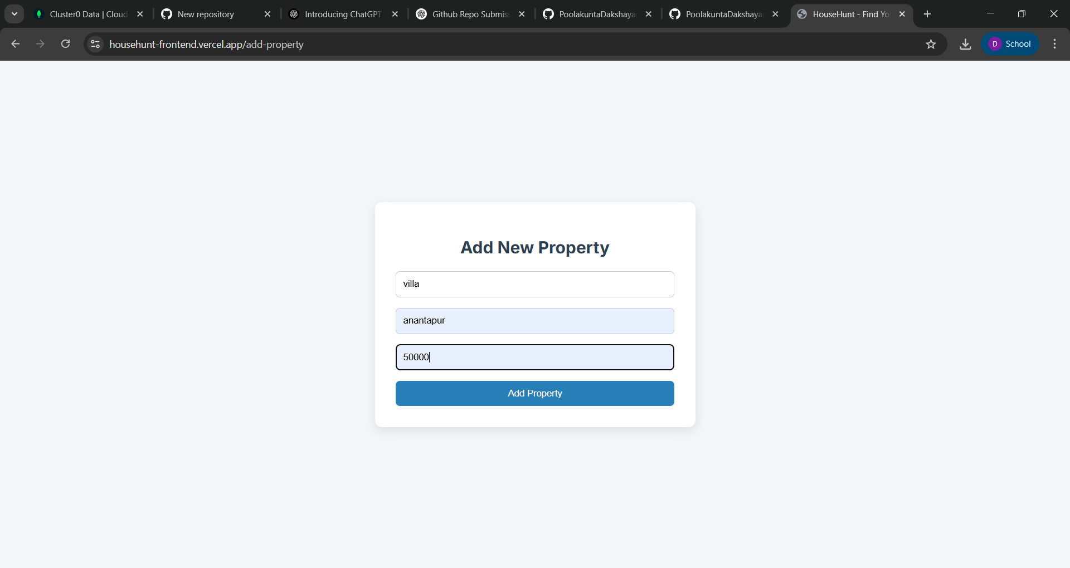

Owner Dashboard page property adding page

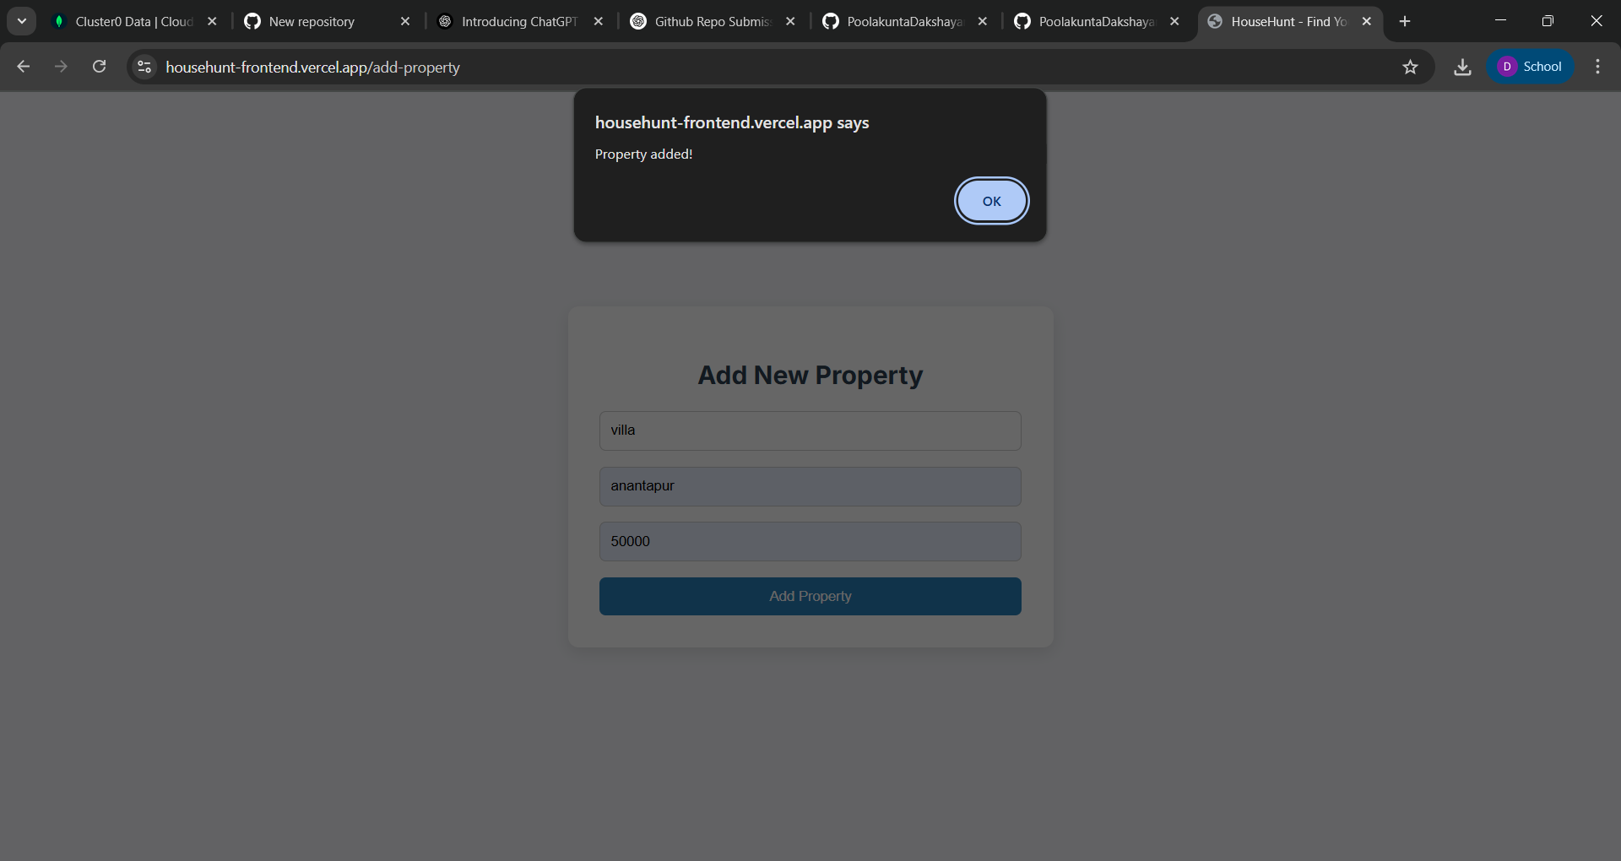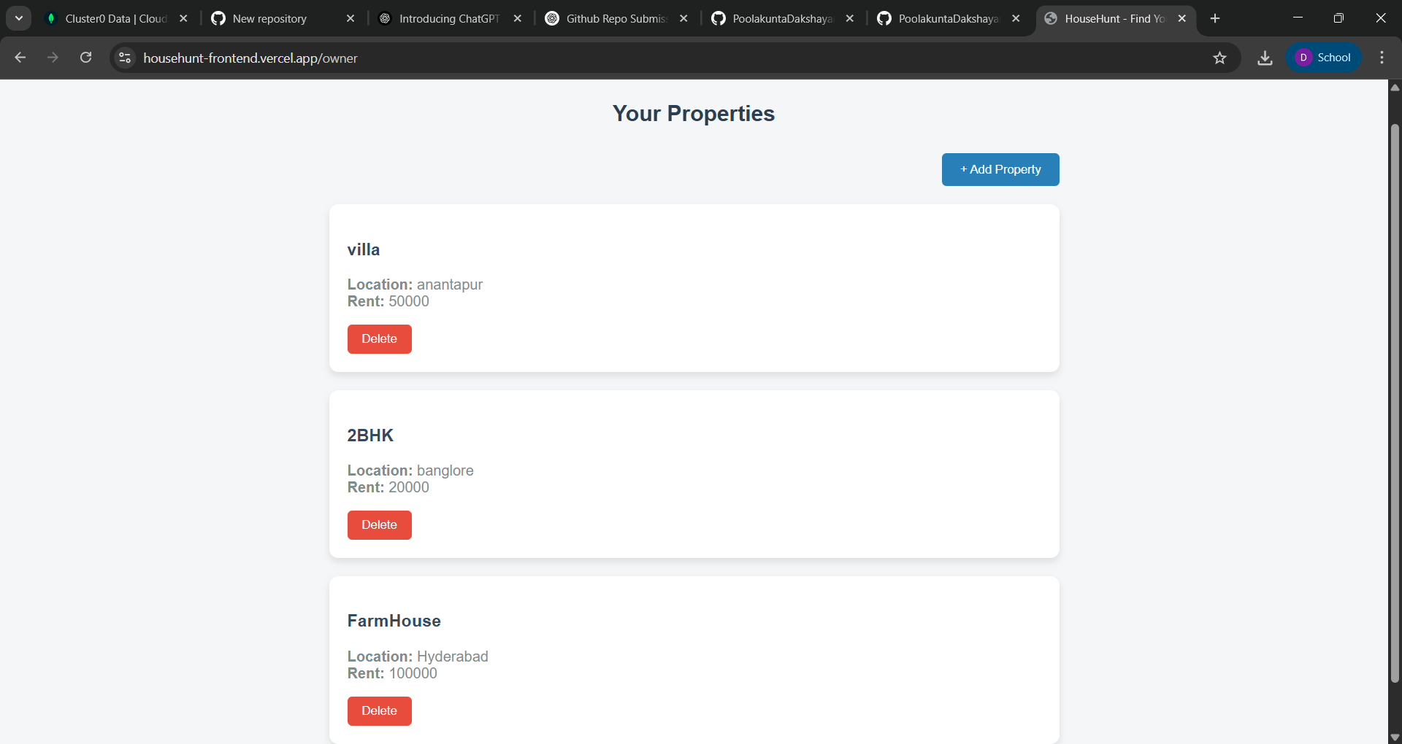

# 📊 Project Learnings

This project helped reinforce my understanding of full-stack development using the MERN stack. I gained practical experience with user authentication, routing, frontend-backend integration, database operations, and REST API design. Working on a real-world problem like rental property management has sharpened my coding and problem-solving skills.

# ✅ Conclusion

HouseHunt is a scalable and secure rental property management platform that enables smooth interaction among renters, property owners, and admins. The project demonstrates my ability to build a complete full-stack web application and adhere to modern development practices.

“This project was successfully delivered as a collaborative effort by a team of four members, each contributing to different parts of the system including frontend, backend, UI/UX, and testing.”

# 📎 Appendix

GitHub Repository: https://github.com/PoolakuntaDakshayani03/househunt-project  
Tech Stack: MERN (MongoDB, Express.js, React.js, Node.js)