**Week 5 - Handson**

**Creating Microservices for account and loan**

**CODE:**

**Account Microservice**

<project xmlns="http://maven.apache.org/POM/4.0.0" ...>

<modelVersion>4.0.0</modelVersion>

<groupId>com.cognizant</groupId>

<artifactId>account</artifactId>

<version>0.0.1-SNAPSHOT</version>

<name>account</name>

<description>Account Microservice</description>

<parent>

<groupId>org.springframework.boot</groupId>

<artifactId>spring-boot-starter-parent</artifactId>

<version>3.2.4</version>

</parent>

<dependencies>

<dependency>

<groupId>org.springframework.boot</groupId>

<artifactId>spring-boot-starter-web</artifactId>

</dependency>

<dependency>

<groupId>org.springframework.boot</groupId>

<artifactId>spring-boot-devtools</artifactId>

<scope>runtime</scope>

</dependency>

</dependencies>

<build>

<plugins>

<plugin>

<groupId>org.springframework.boot</groupId>

<artifactId>spring-boot-maven-plugin</artifactId>

</plugin>

</plugins>

</build>

</project>

**AccountApplication.java**

package com.cognizant.account;

import org.springframework.boot.SpringApplication;

import org.springframework.boot.autoconfigure.SpringBootApplication;

@SpringBootApplication

public class AccountApplication {

public static void main(String[] args) {

SpringApplication.run(AccountApplication.class, args);

}

}

**AccountController.java**

package com.cognizant.account.controller;

import org.springframework.web.bind.annotation.*;

import java.util.Map;

@RestController

@RequestMapping("/accounts")

public class AccountController {

@GetMapping("/{number}")

public Map<String, Object> getAccountDetails(@PathVariable String number) {

return Map.of(

"number", number,

"type", "savings",

"balance", 234343

);}}

**OUTPUT:**

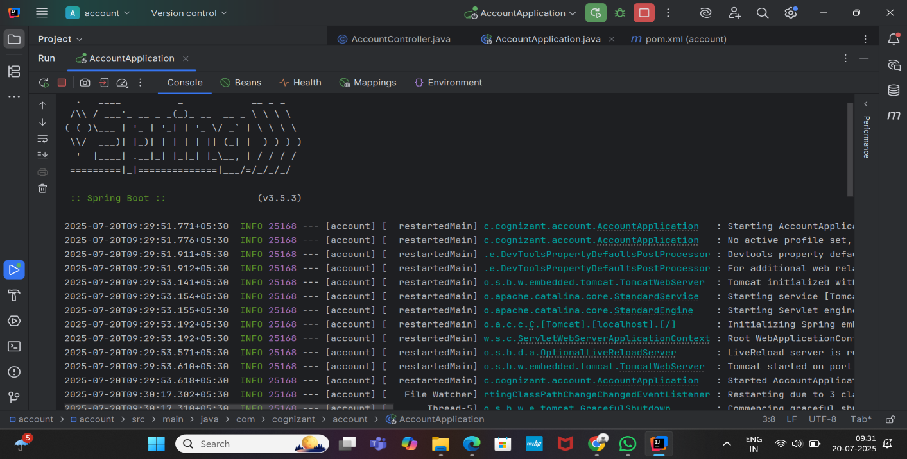

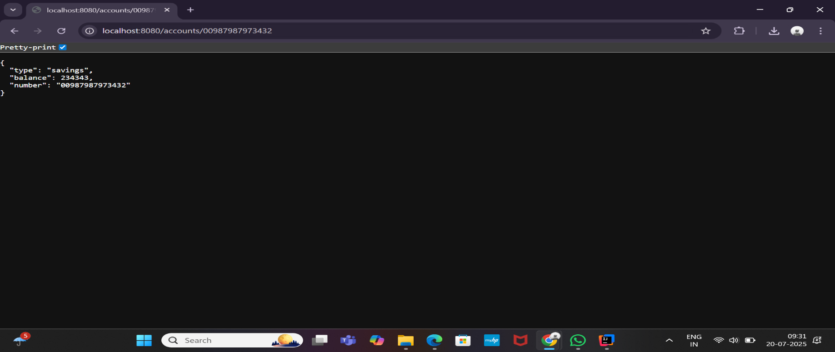

**Loan Microservice**

**pom.xml**

<artifactId>loan</artifactId>

<name>loan</name>

<description>Loan Microservice</description>

**LoanApplication.java**

package com.cognizant.loan;

import org.springframework.boot.SpringApplication;

import org.springframework.boot.autoconfigure.SpringBootApplication;

@SpringBootApplication

public class LoanApplication {

public static void main(String[] args) {

SpringApplication.run(LoanApplication.class, args);

}

}

**LoanController.java**

package com.cognizant.loan.controller;

import org.springframework.web.bind.annotation.*;

import java.util.Map;

@RestController

@RequestMapping("/loans")

public class LoanController {

@GetMapping("/{number}")

public Map<String, Object> getLoanDetails(@PathVariable String number) {

return Map.of(

"number", number,

"type", "car",

"loan", 400000,

"emi", 3258,

"tenure", 18

);

}

}

**application.properties**

server.port=8081

**OUTPUT:**

