**Week_6 React Exercises**

**1.React Application To Display “Welcome to the first session of React”**

***Steps:***

* **Install Create React App**

npm install -g create-react-app

* **Create React App**

npx create-react-app myfirstreact

* **Navigate to App Folder**

cd myfirstreact

* **Open in Visual Studio Code**

**App.js**

import React from 'react';

function App() {

return (

<div>

<h1>Welcome to the first session of React</h1>

</div>

);

}

export default App;

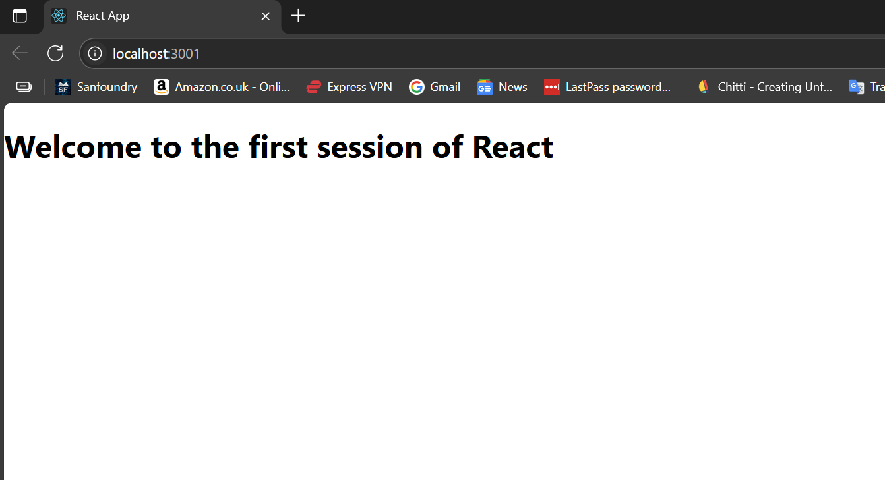

**2.React Exercise -2**

**Command to create folder structure**

cd C:\Users\mozhi\studentapp\src

mkdir Components

cd Components

ni Home.js

ni About.js

ni Contact.js

**Code for Home.js**

import React from 'react';

function Home() {

return <h1>This is the Home Page</h1>;

}

export default Home;

**Code for About.js**

import React from 'react';

function About() {

return <h1>This is the About Page</h1>;

}

export default About;

**Code for Contact.js**

import React from 'react';

function Contact() {

return <h1>This is the Contact Page</h1>;

}

export default Contact;

**Code for App.js**

import React from 'react';

import { BrowserRouter as Router, Routes, Route, Link } from 'react-router-dom';

import Home from './Components/Home';

import About from './Components/About';

import Contact from './Components/Contact';

function App() {

return (

<Router>

<nav>

<Link to="/">Home</Link> |{" "}

<Link to="/about">About</Link> |{" "}

<Link to="/contact">Contact</Link>

</nav>

<Routes>

<Route path="/" element={<Home />} />

<Route path="/about" element={<About />} />

<Route path="/contact" element={<Contact />} />

</Routes>

</Router>

);

}

export default App;

**Output -2**  
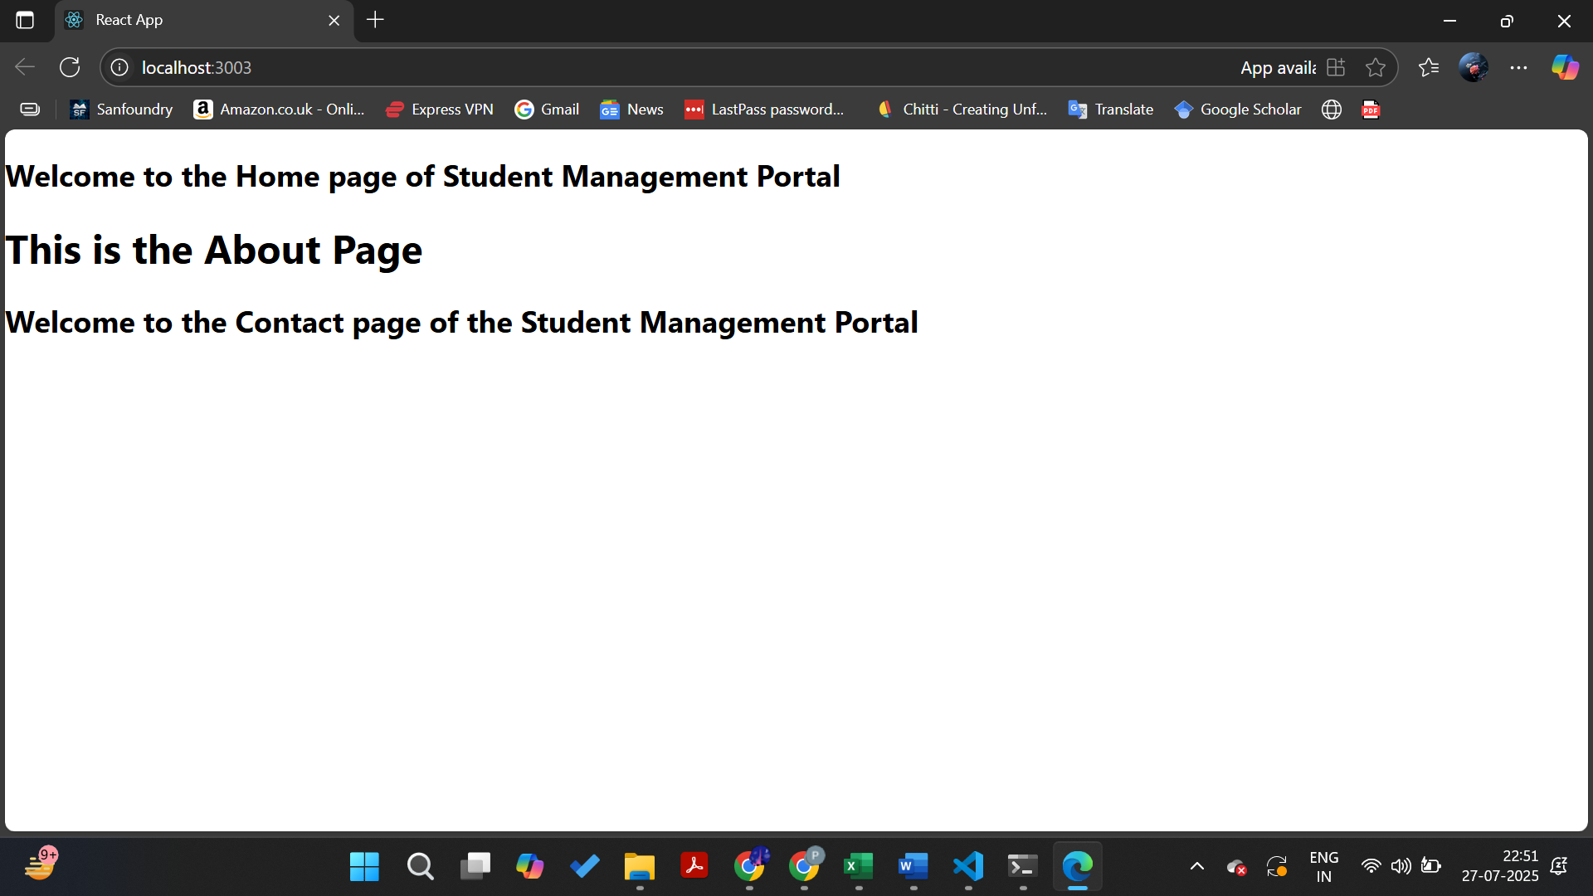

**3.React Exercise  
App.js**

import React from 'react';

import './Stylesheets/mystyle.css';

function App() {

return (

<div className="App">

<h1>Score Calculator</h1>

<div className="info-box">

<p><strong>Name:</strong> Poomoli</p>

</div>

</div>

);

}

export default App;

**Stylesheets/mystyle.css**

.App {

text-align: center;

margin-top: 50px;

font-family: 'Segoe UI', Tahoma, Geneva, Verdana, sans-serif;

}

.info-box {

margin-top: 20px;

padding: 10px;

display: inline-block;

border: 2px solid #4CAF50;

border-radius: 8px;

background-color: #f0fff0;

color: #333;

}

**Output 3**  
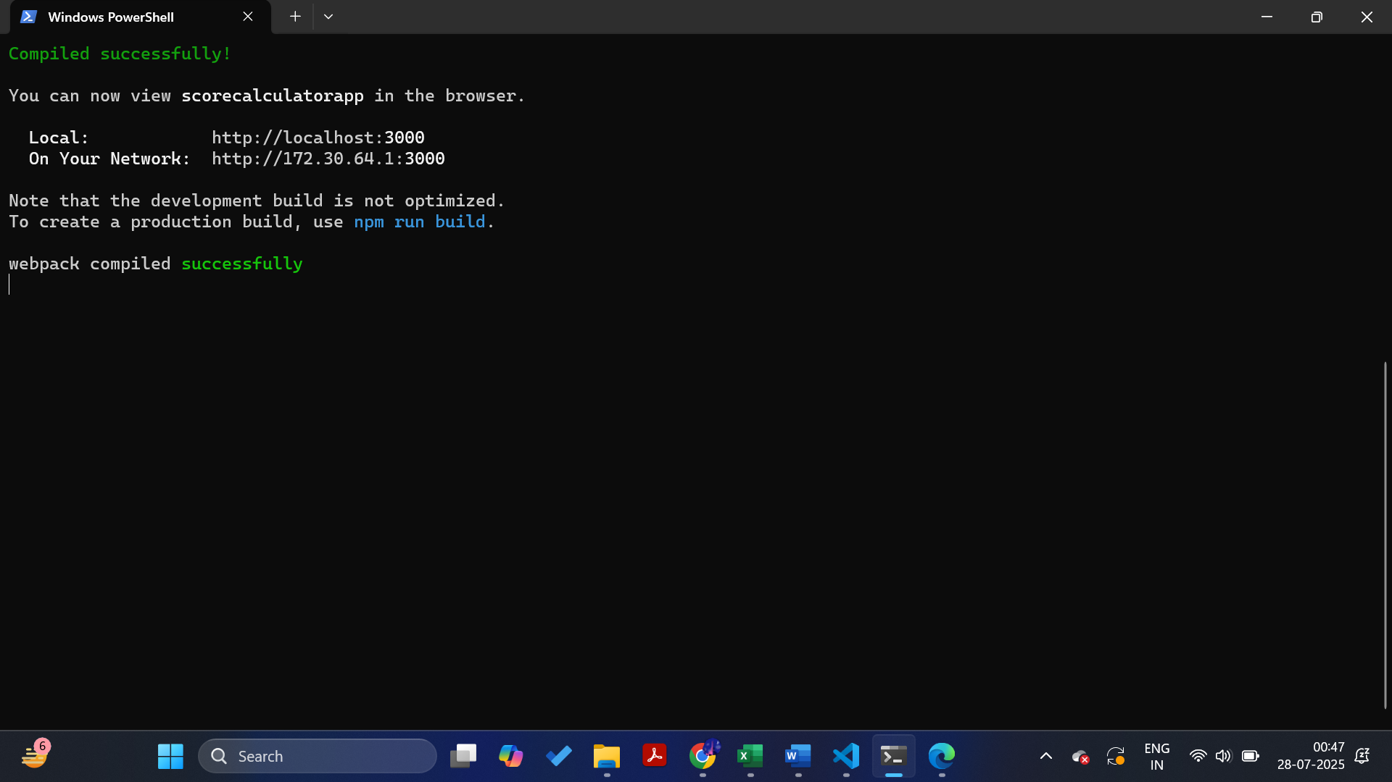

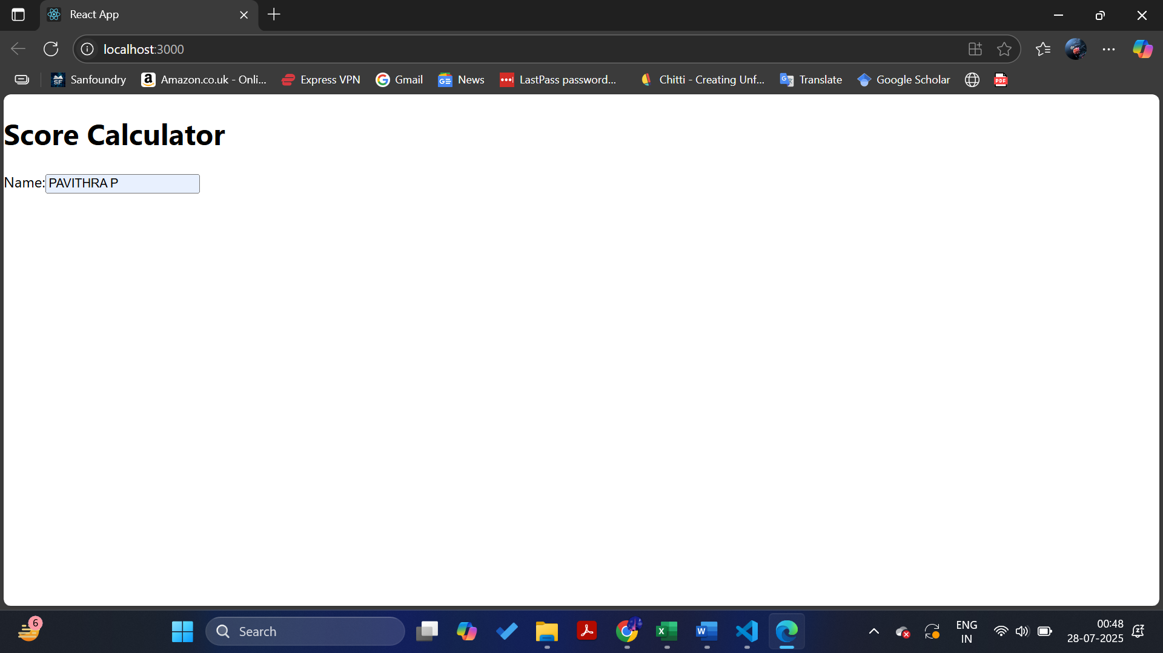

**React 4:**

**✅ src/App.js**

import React, { useState } from 'react';

import './App.css';

function App() {

const [score, setScore] = useState(0);

return (

<div className="App">

<h1>Score Calculator</h1>

<h2>Name: Poomoli</h2>

<h3>Score: {score}</h3>

<button onClick={() => setScore(score + 1)}>Increase</button>

<button onClick={() => setScore(score - 1)}>Decrease</button>

<button onClick={() => setScore(0)}>Reset</button>

</div>

);

}

**export default App;**

**✅ src/App.css**

.App {

text-align: center;

font-family: Arial, sans-serif;

margin-top: 50px;

}

button {

margin: 10px;

padding: 10px 20px;

font-size: 16px;

cursor: pointer;

}

Output:

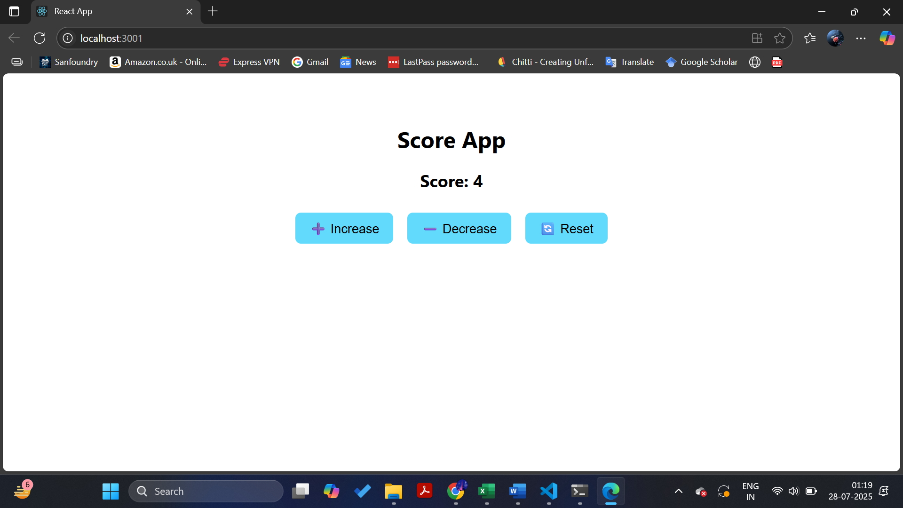

5.React App

**1. CohortDetails.module.css**

Create a new file in src folder:

.box {

width: 300px;

display: inline-block;

margin: 10px;

padding: 10px 20px;

border: 1px solid black;

border-radius: 10px;

}

dt {

font-weight: 500;

}

**CohortDetails.js**

import React from 'react';

import styles from './CohortDetails.module.css';

function CohortDetails({ name, status, startDate, endDate }) {

const statusStyle = {

color: status === 'ongoing' ? 'green' : 'blue',

};

return (

<div className={styles.box}>

<h3 style={statusStyle}>{name}</h3>

<dl>

<dt>Status:</dt>

<dd>{status}</dd>

<dt>Start Date:</dt>

<dd>{startDate}</dd>

<dt>End Date:</dt>

<dd>{endDate}</dd>

</dl>

</div>

);

}

export default CohortDetails;

**3. App.js**

import React from 'react';

import CohortDetails from './CohortDetails';

function App() {

const cohorts = [

{

name: 'React Training Batch 1',

status: 'ongoing',

startDate: '2025-07-01',

endDate: '2025-07-30',

},

{

name: 'Node.js Training Batch 2',

status: 'completed',

startDate: '2025-06-01',

endDate: '2025-06-30',

},

];

return (

<div>

<h2>My Academy Dashboard</h2>

{cohorts.map((cohort, index) => (

<CohortDetails

key={index}

name={cohort.name}

status={cohort.status}

startDate={cohort.startDate}

endDate={cohort.endDate}

/>

))}

</div>

);

}

export default App;

**Output:**

