Feedback on the news app

Date – 22 August

For each page, we have given feedback separately and at the end there are general pointers that apply to the whole app.

Home Page

1. As mentioned in the Figma file, change the home page.

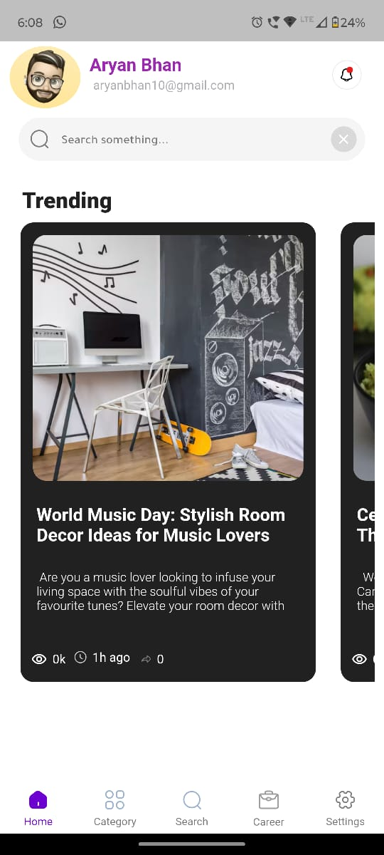

1. Remove the search bar from the home page.

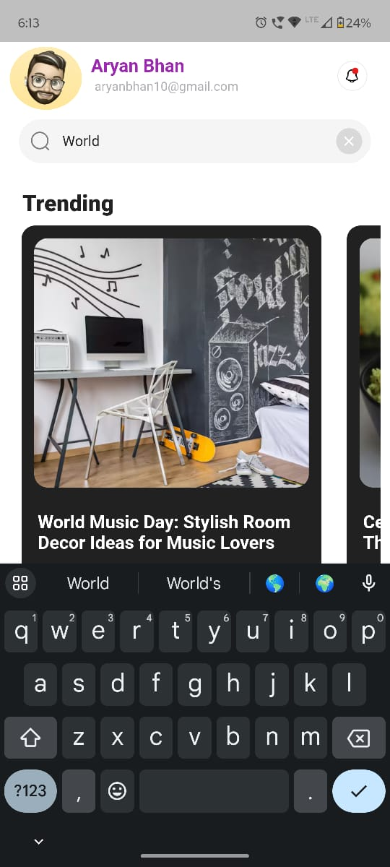

1. After updating the password and leaving the page, the columns are empty again

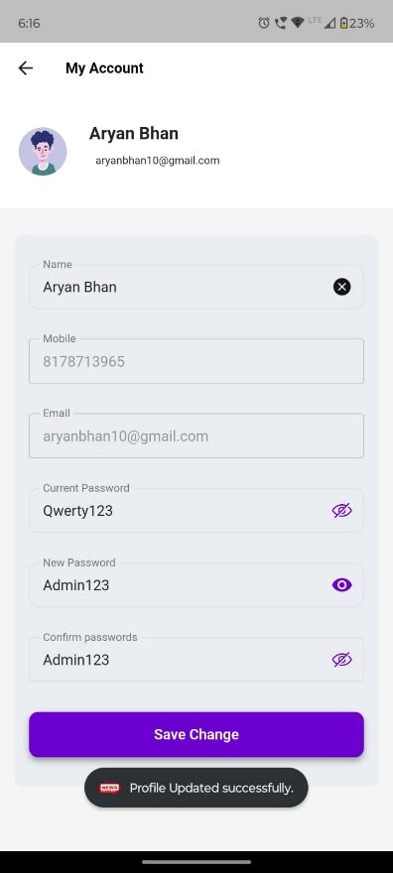 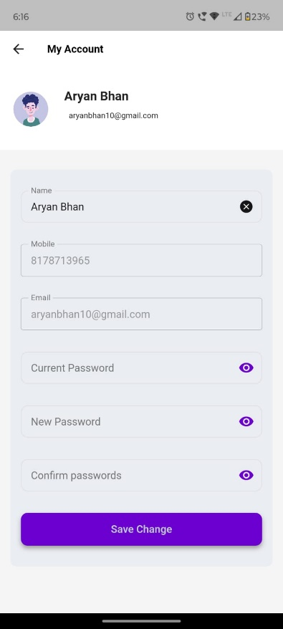

1. There are no criteria and restriction for setting passwords.
2. Notifications should have more spacing between them. Currently it’s looking very clustered.

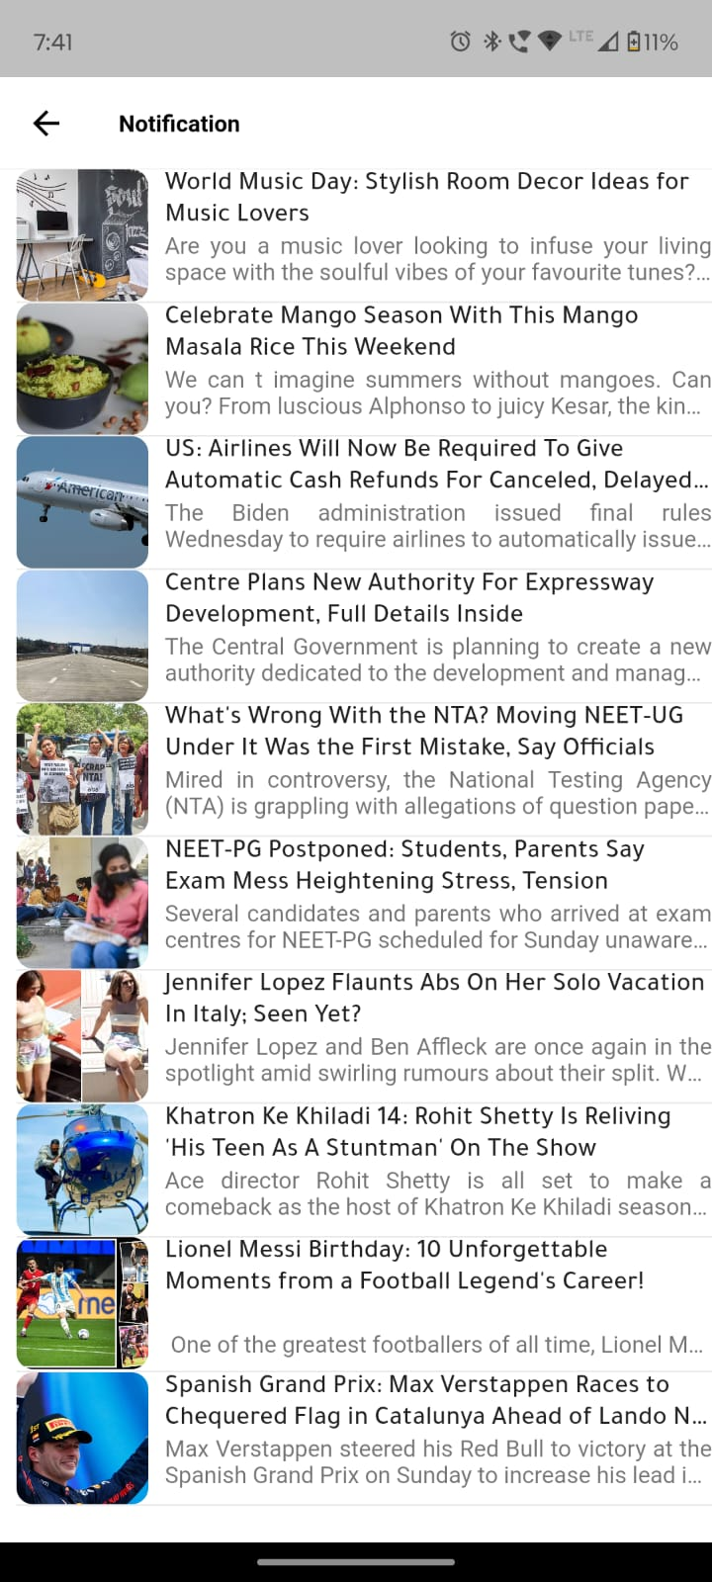

1. Update the bottom panel. Keep settings there, and remove it from the other profile side menu.





1. Notifications are on the home page as well as in the menu which opens up after clicking the photo on the front page. It should be only on the home page.

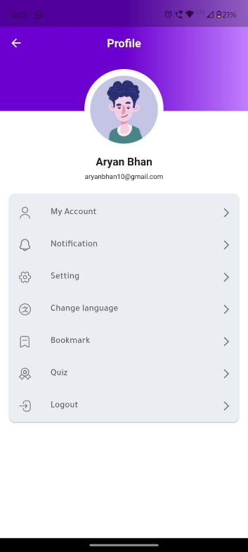

1. When opening a news, follow button, like button and share button are not working.

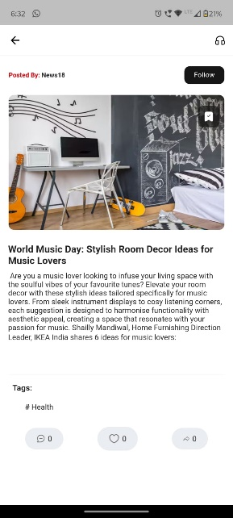

1. The comment button works but I can only see the comments. I can’t actually comment anything.

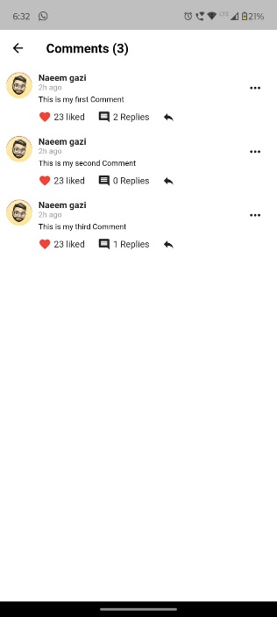 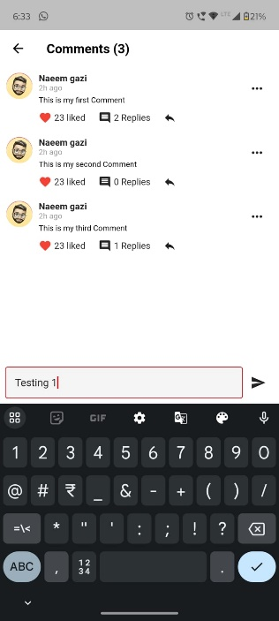

1. If I reply to a comment, it doesn’t show and is not even increasing the count.
2. I can’t see what replies there are on the existing comments.
3. The three dots in front of the comment are not operable. Remove them instead.
4. If we click on a trending news, then the other news should be scrollable.
5. Home should be in centre.

 Sequence - career category home search real estate

1. When scrolling through the trending page, add a feature which makes it so that when scrolled, the final position of the story is in the middle with equal spacings.

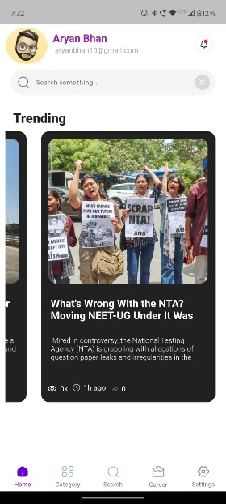 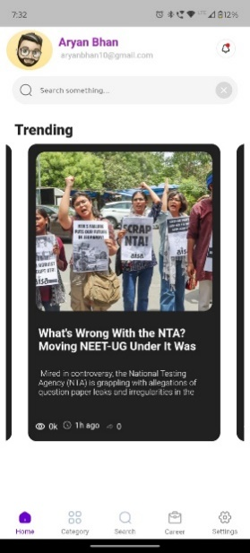



Category

1. Category page also has a notification bell icon. There should be rather a button from which the user can select multiple preferences.

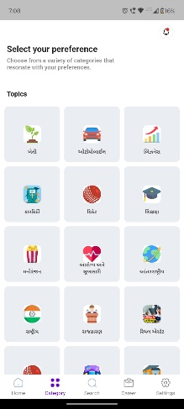

1. The background behind icons should be removed.
2. Stories under many sections have improper spacings and punctuations. If it’s a bug, fix it.

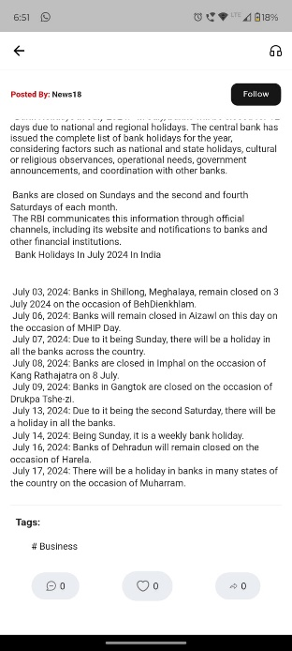 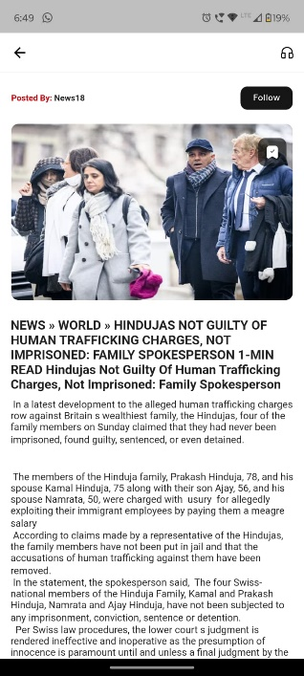

1. Counter on stories should start from 0. If its has less 1000 views, it should show the number. For example, if there are 200 views, it should show 200 views rather than 0.2k views.

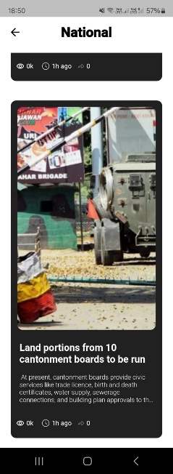

Search

1. At the top, Politics should have capital P.
2. 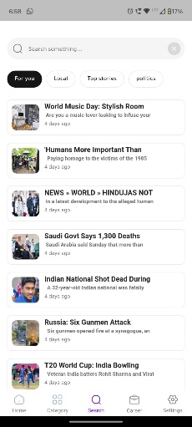 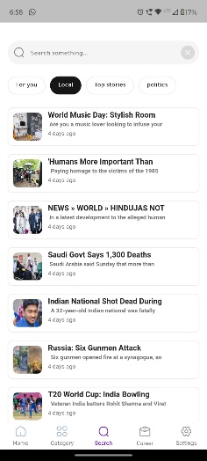 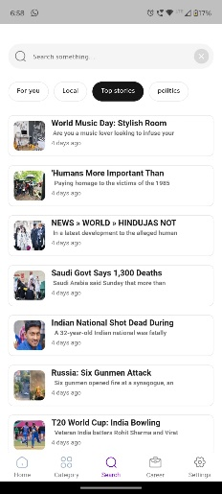 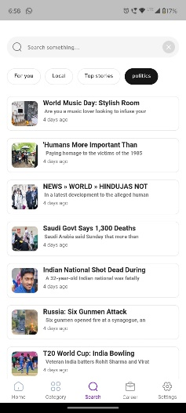
3. The 4 categories on top – For you, Local, Top Stories & Politics don’t do anything.
4. The spacings in each news should have proper alignments. Some have improper spacings.
5. If we click on a news on this page, then we should be able to scroll down to read all the news that have been filtered out by either using those categories on top or by a key word.

Career

1. Career page is not working. The links are broken and not directing to anywhere.

Settings

1. For languages other than English and Hindi, home and search page have nothing to show.
2. Rather than short form for the applied language, use the whole word in the local language. For example, Hindi should be “हिन्दी” instead of “hi”.
3. Icons for languages are missing.

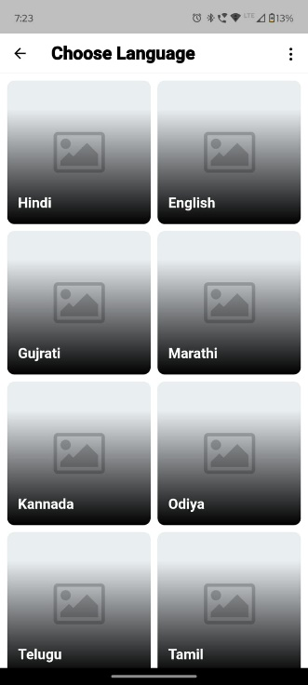

1. The three dots are not functional. Remove them.
2. Dark mode is not working for pages other than Settings page.

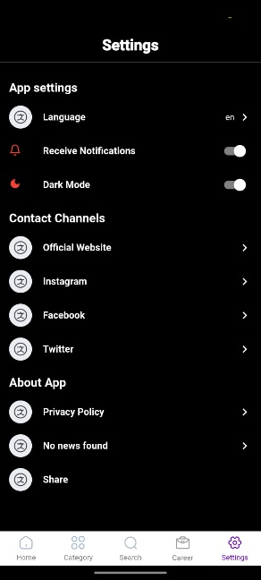 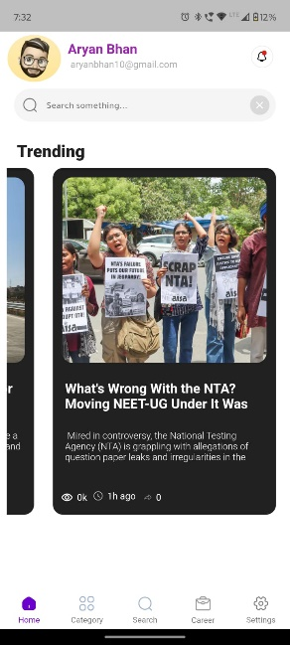

1. The logos should be different and relevant.
2. While sharing the app, the link is not opening as there is no space between the text and the link.

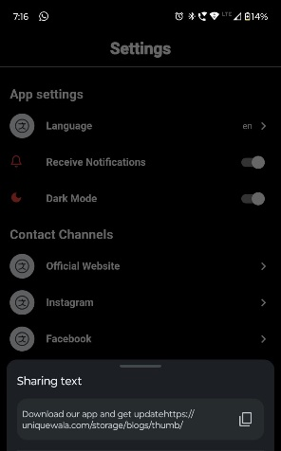

1. Between Privacy Policy and Share, there is an empty field.

General

1. The app is not optimised for all aspect ratios. Make it universal like other apps.

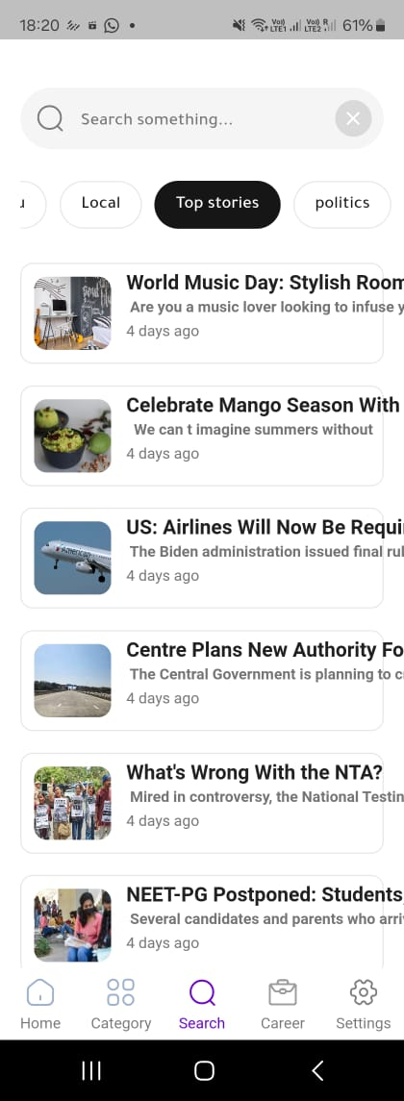 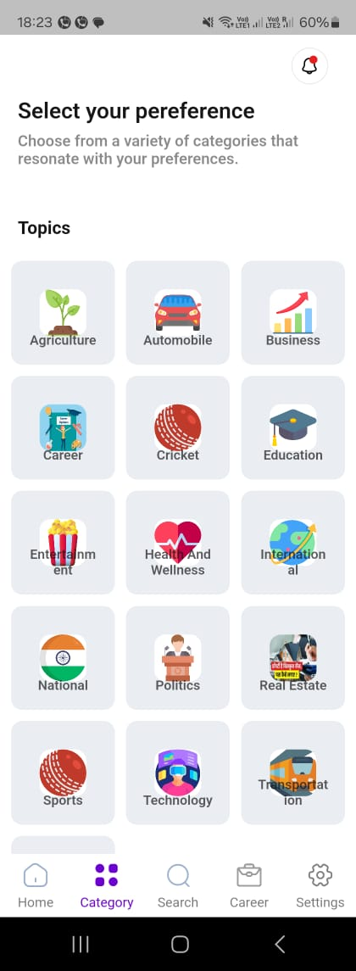

1. In our testing, the app is directly landing the user to the home page and there is no page to select preferences.
2. While initially selecting the preferences, there should be a feature like, when we select the first preference, it should have a small 1 in the corner, and the next one should have 2, and the next 3, and so on. And if the user deselects any field, then the count should adjust accordingly.
3. There should be an option to change the text size.

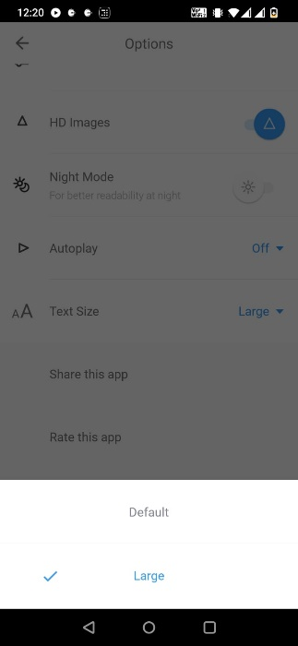 2 options – Default & Large

1. Notifications should directly open on the home page and should not lead to the notification icon.
2. There should be an option in settings from which the user can edit their current preferences.