Full Name- Poonam Langote
Task no-04 &Task name: Launch a Free-Tier EC2 Instance, connect via SSH, Install Apache, and Serve a Custom Webpage
AWS region- (ap-south-1)
EC2 instance launched
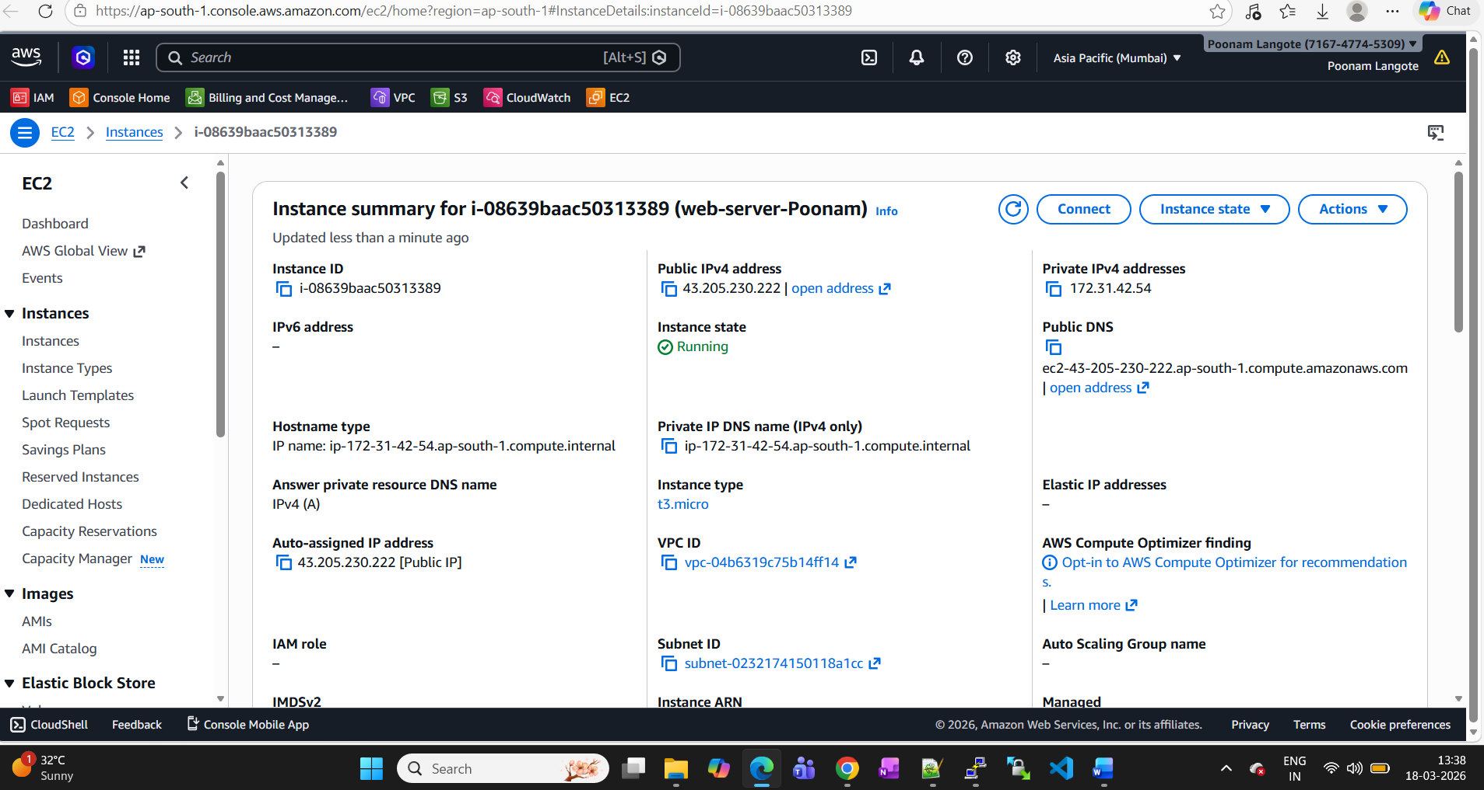

Security group details.
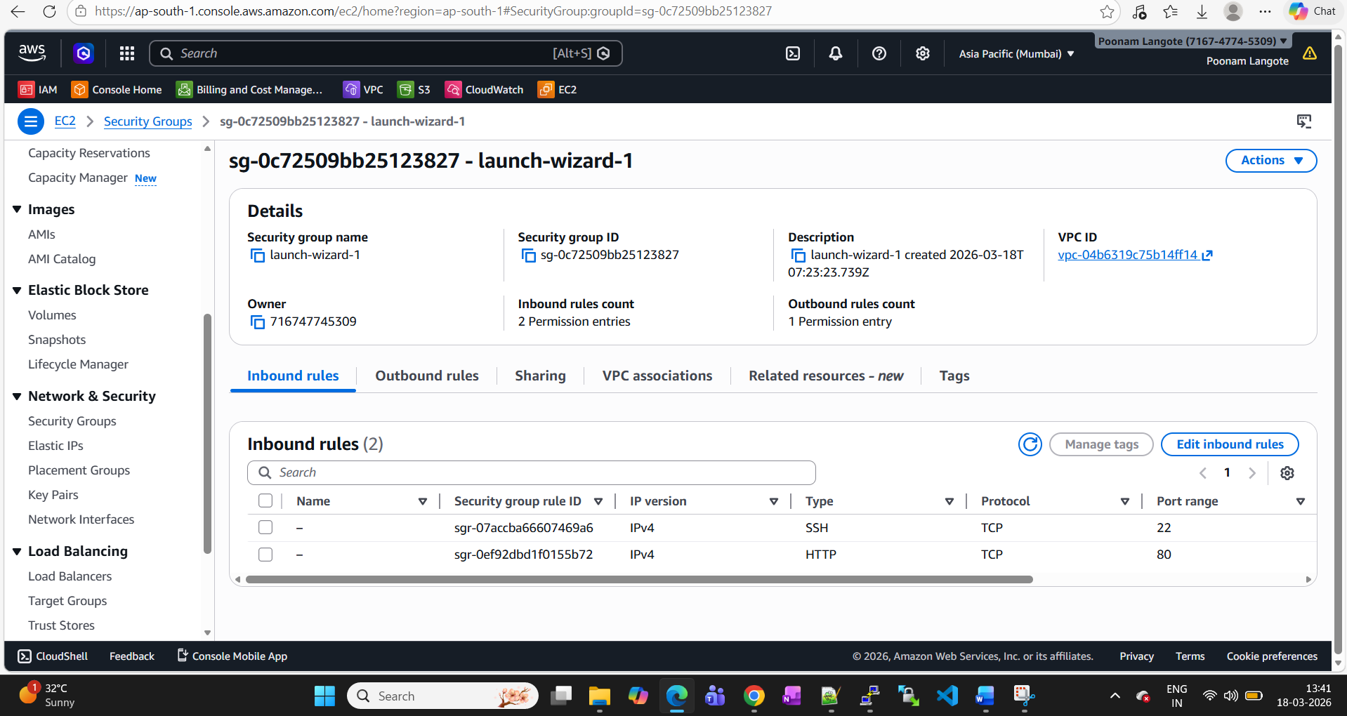

Login steps- logged in via putty
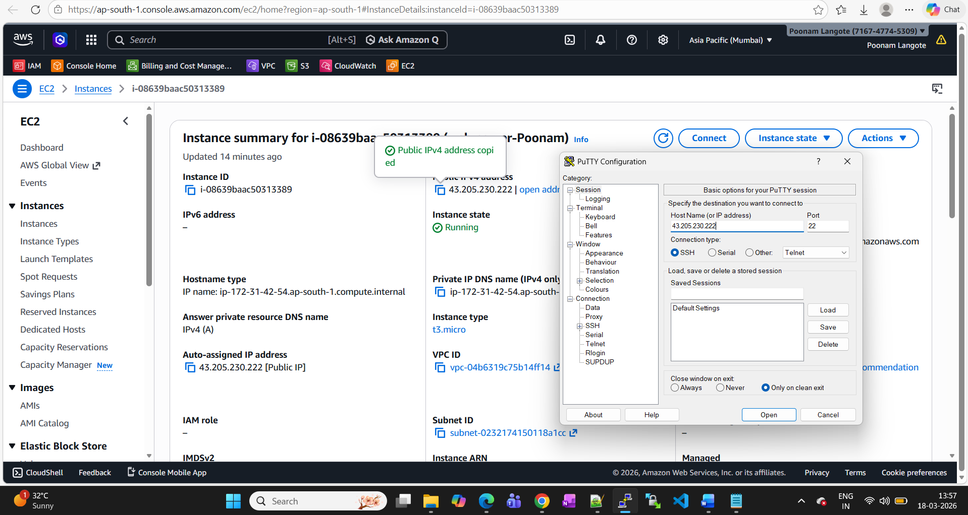

Loaded ppk file
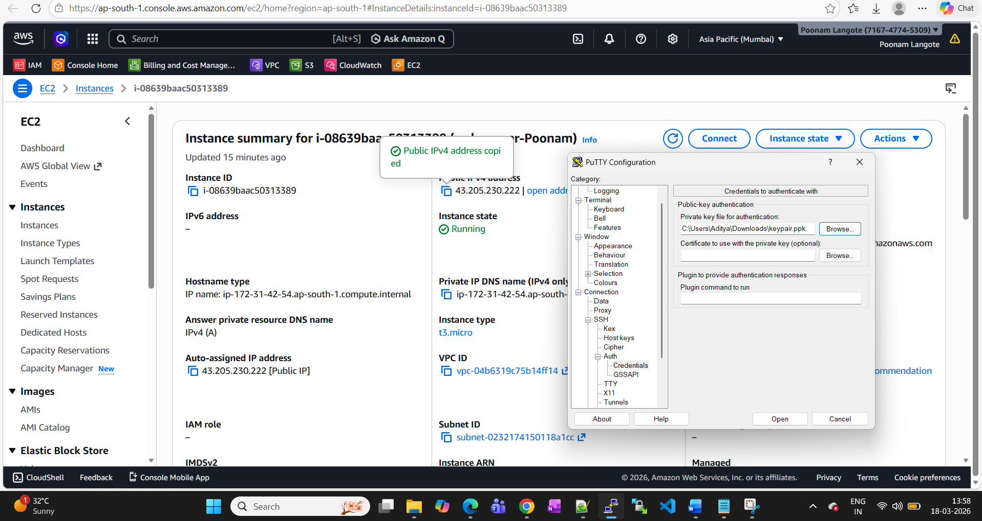

Connected to EC2 server
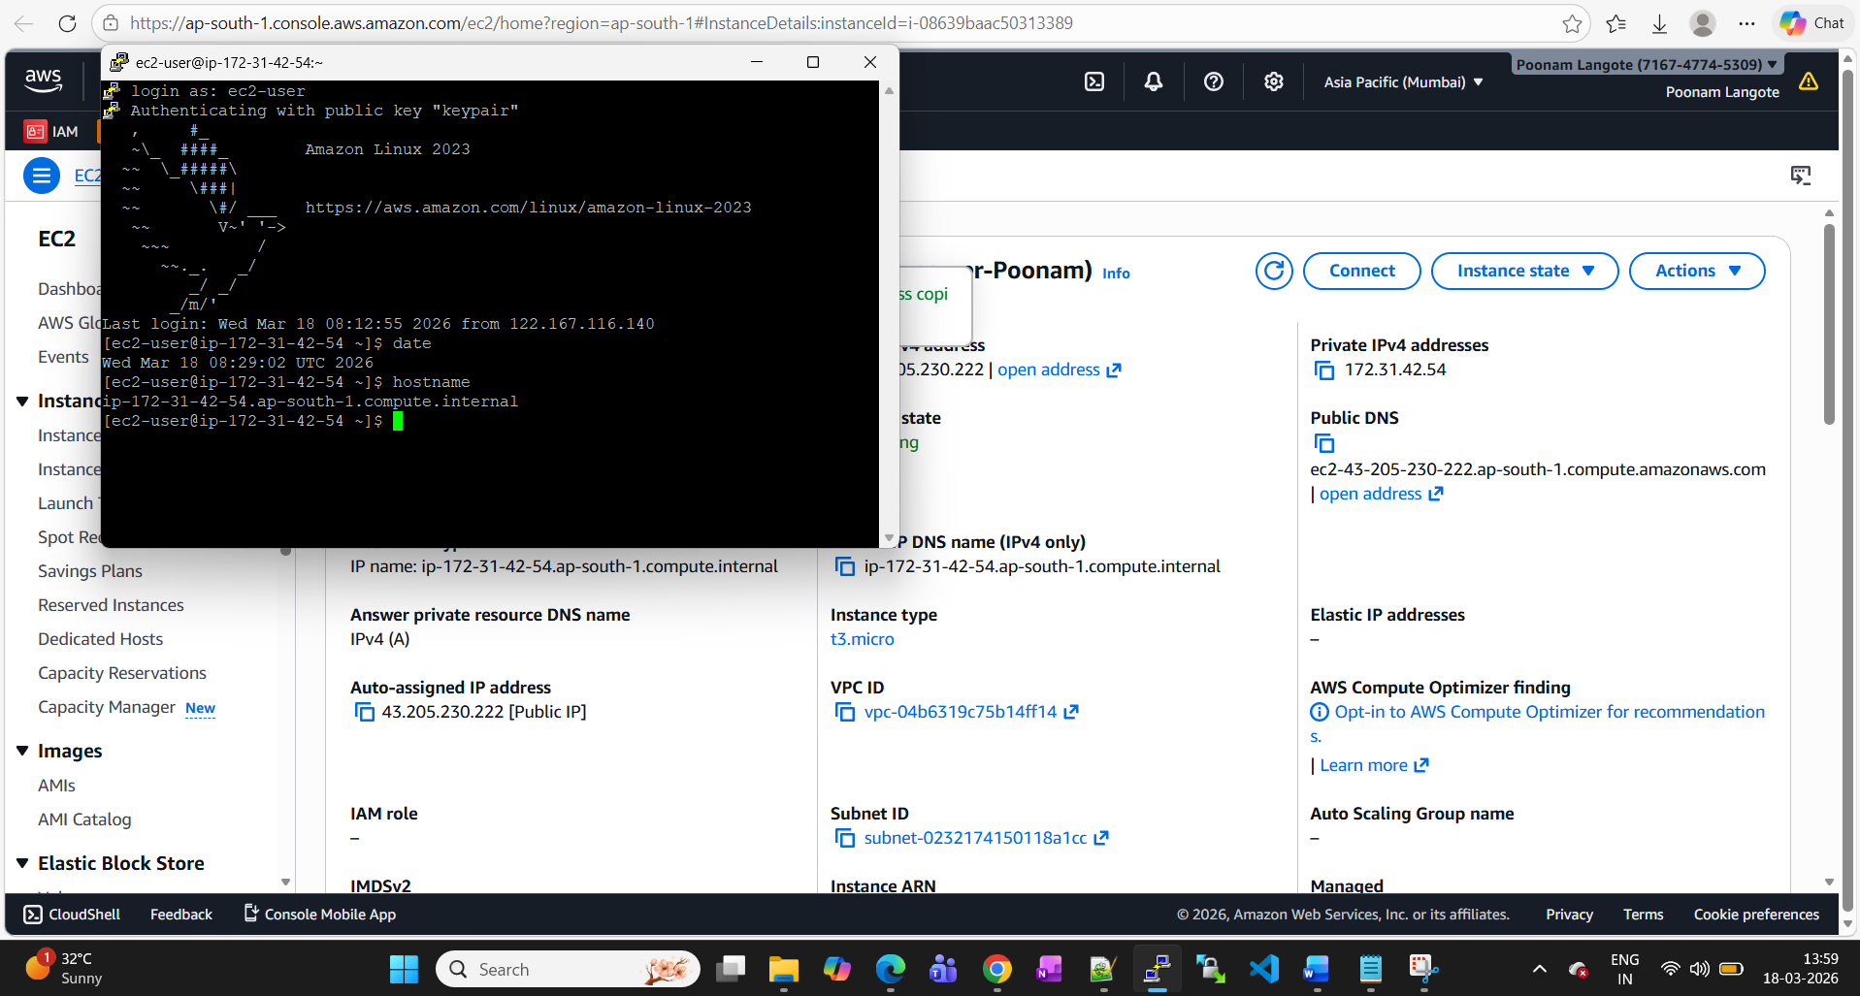
Final output-
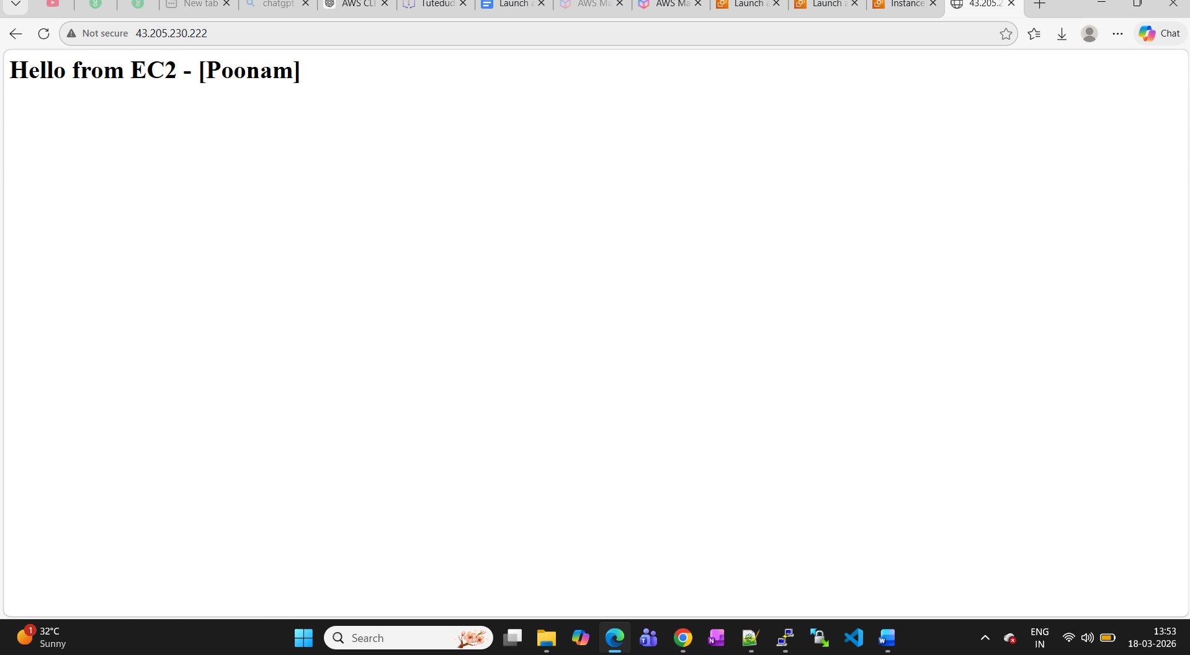
Commands used-
sudo yum update -y
sudo yum install httpd -y
sudo systemctl start httpd
sudo systemctl enable httpdecho "<h1>Hello from EC2 - [Poonam]</h1>" | sudo tee /var/www/html/index.html
http://<43.205.230.222>

