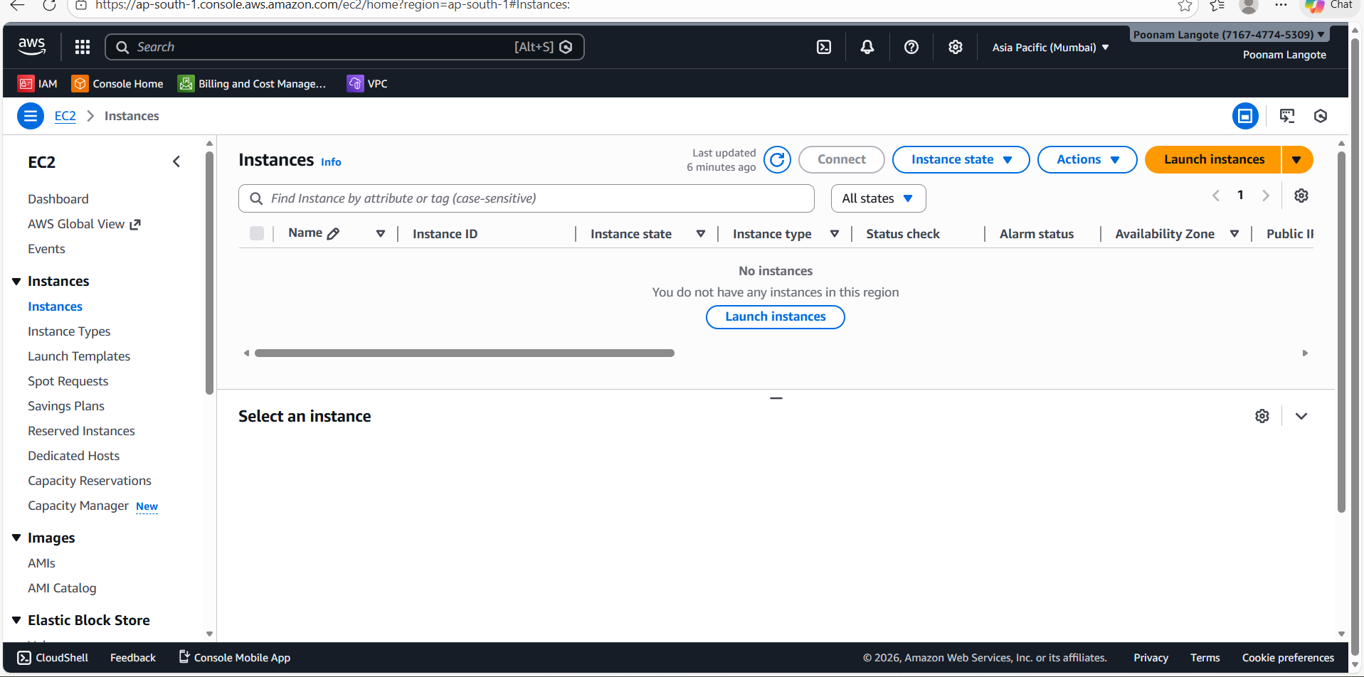
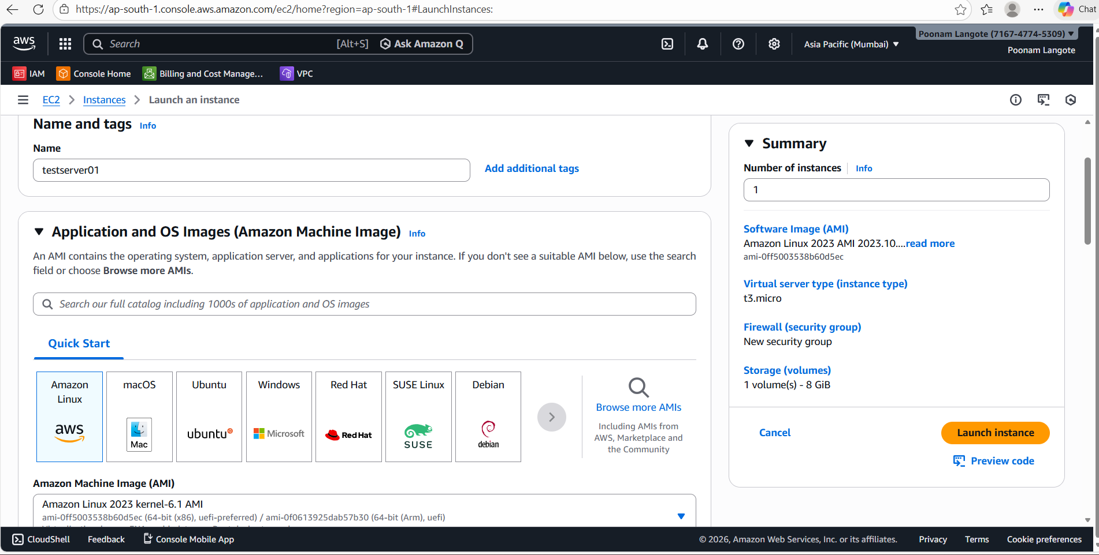
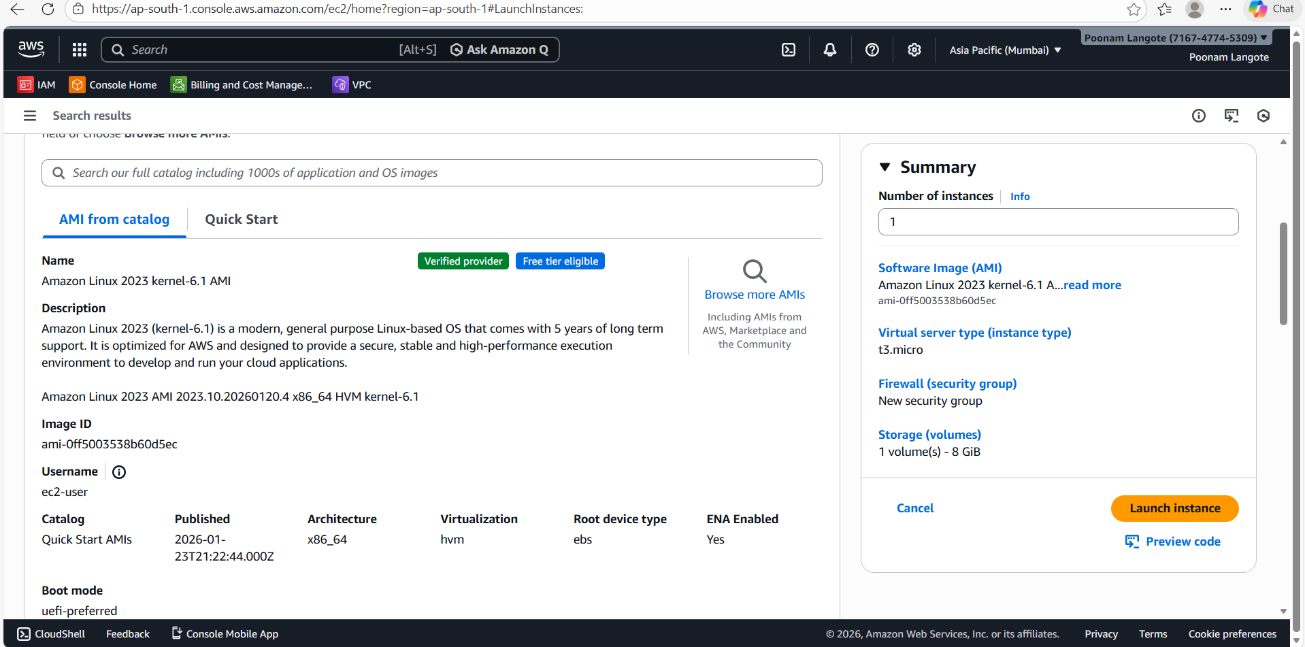
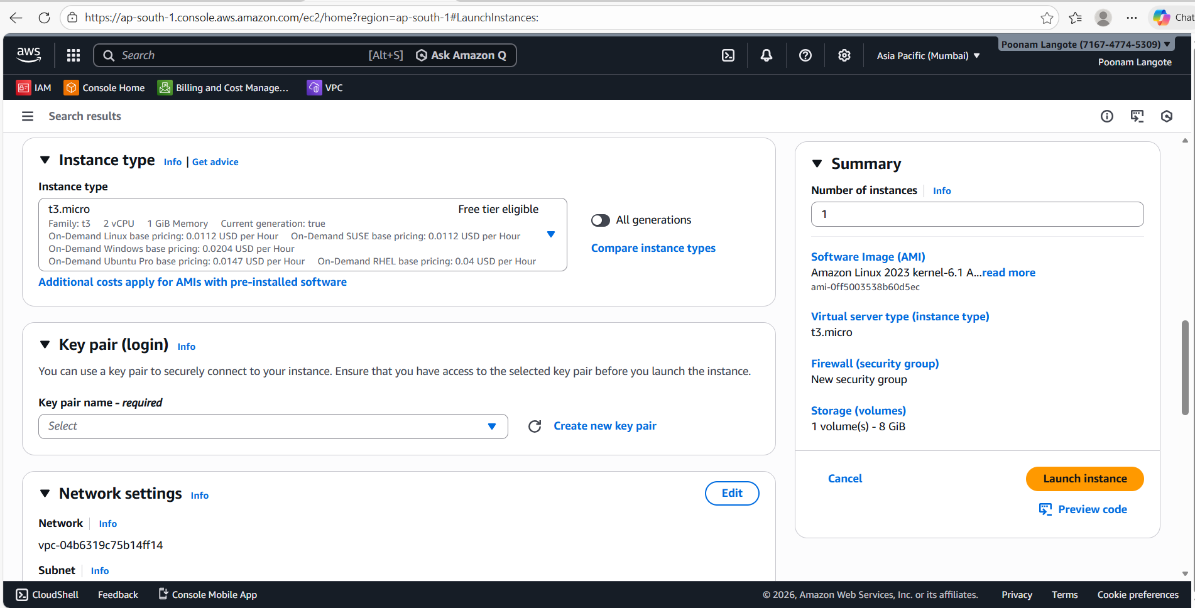
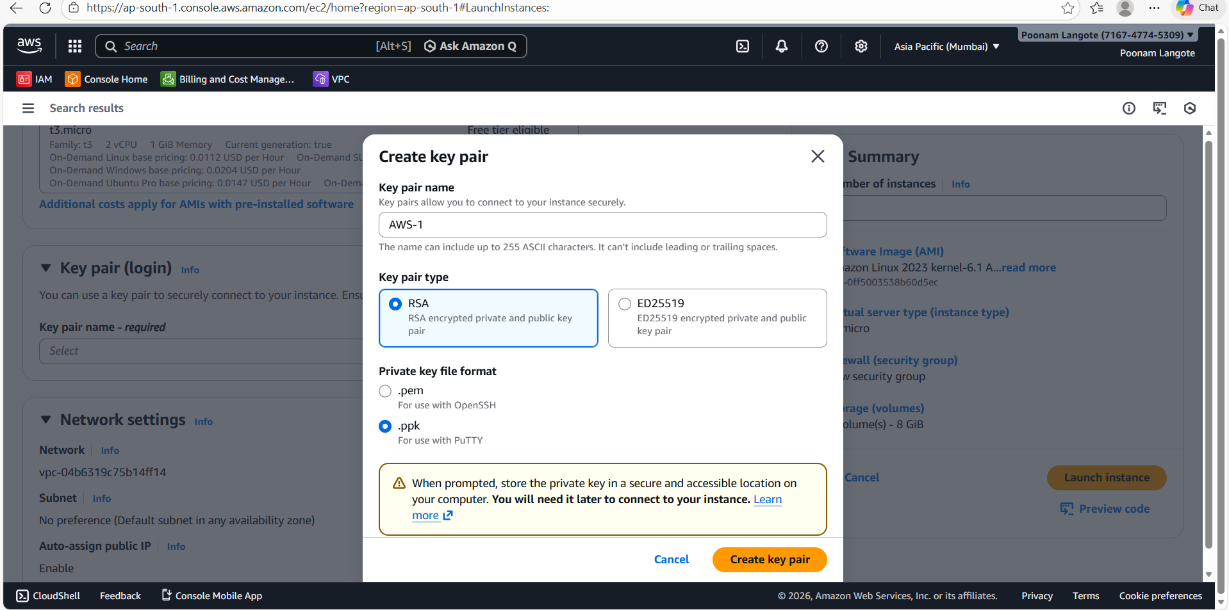
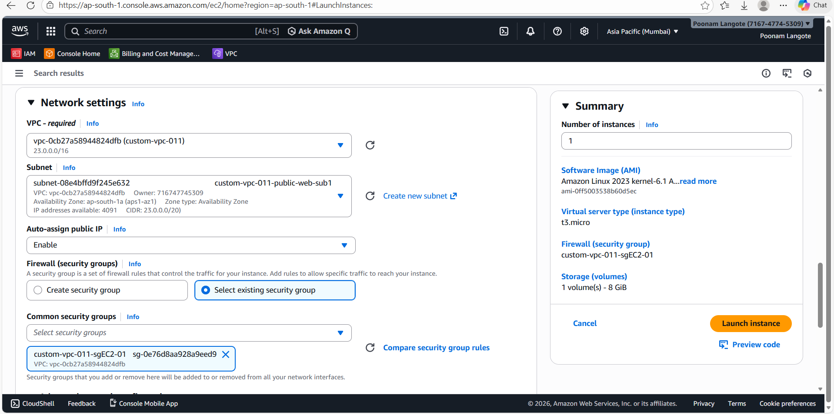
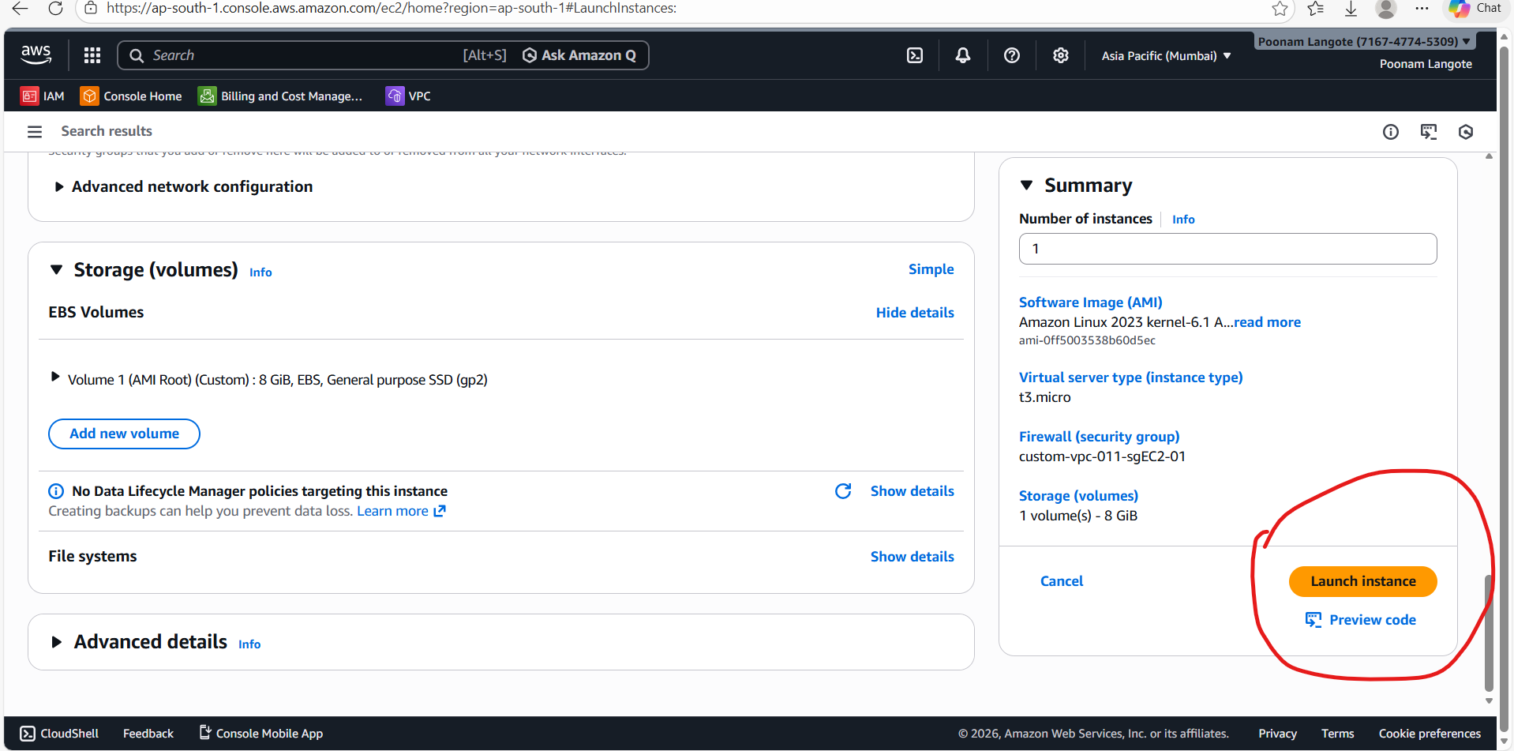
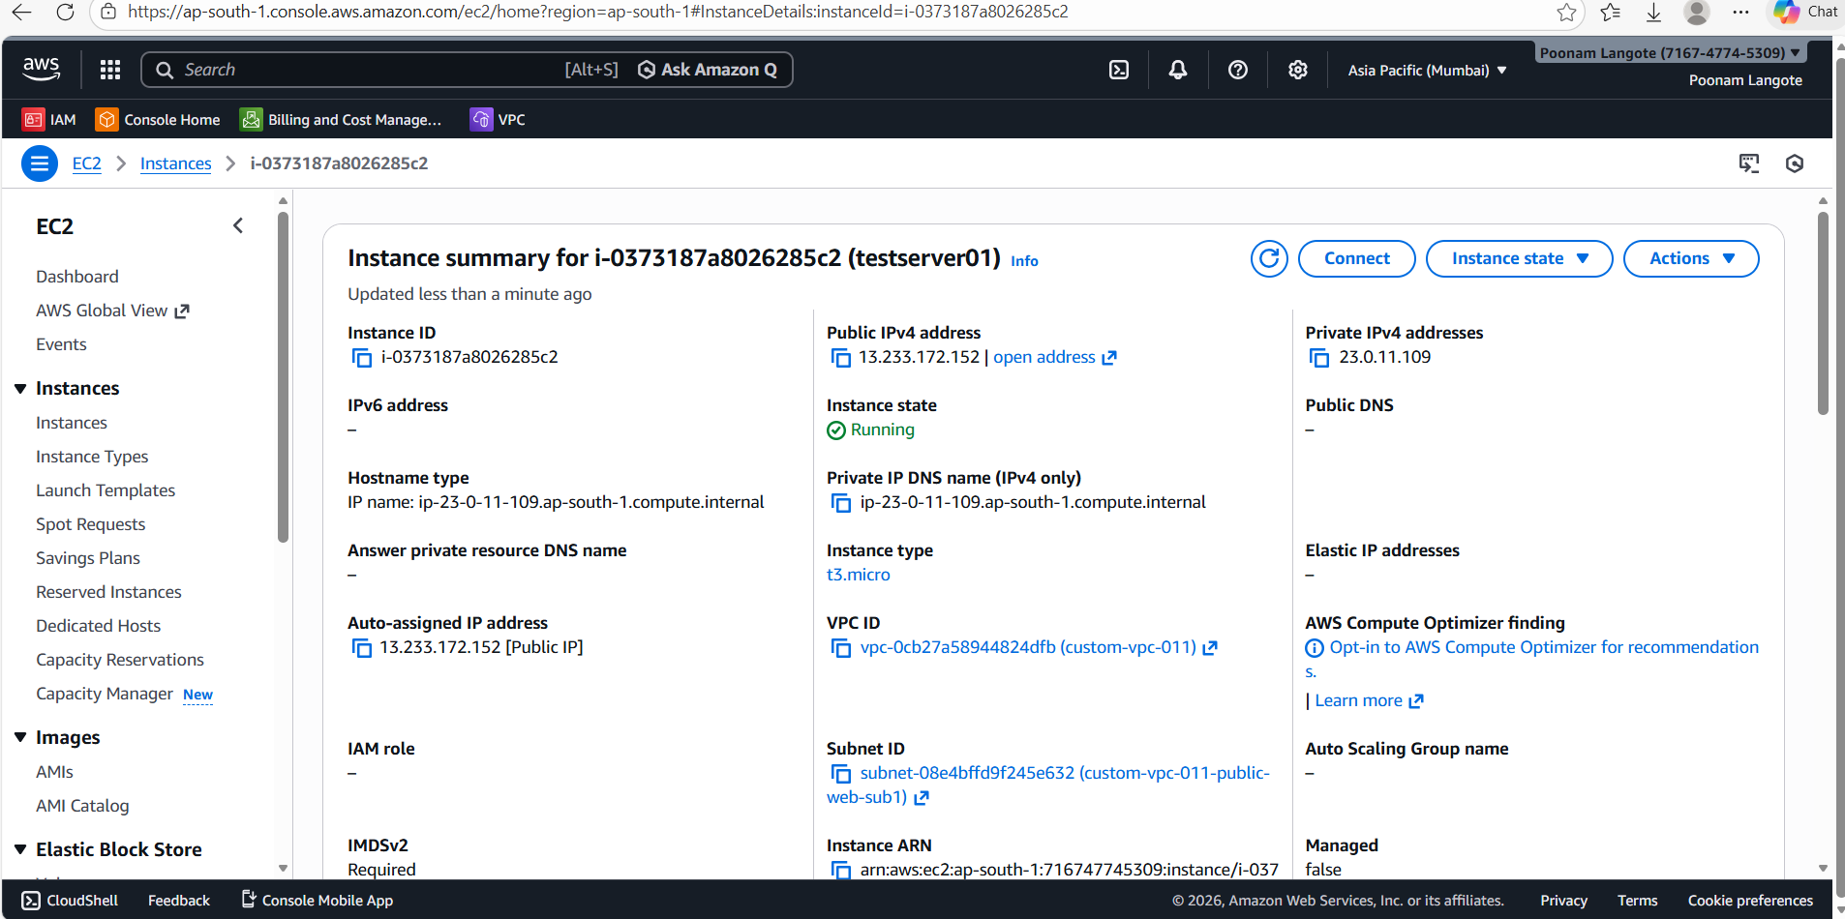
Open AWS Console → EC2 → Instances
- Click Launch instances
- Enter Instance name (e.g., testserver01)
- Choose AMI → Select Amazon Linux 2023
- Choose Instance type → t3.micro (or as needed)
- Select/Create Key pair (for SSH)
- Configure Security group
  - Allow SSH (22) from your IP
  - Add other ports if needed (e.g., 80)
- Configure Storage (default 8 GB is fine)
- Review Summary
- Click Launch instance
Your instance will appear in EC2 → Instances and move to Running state.

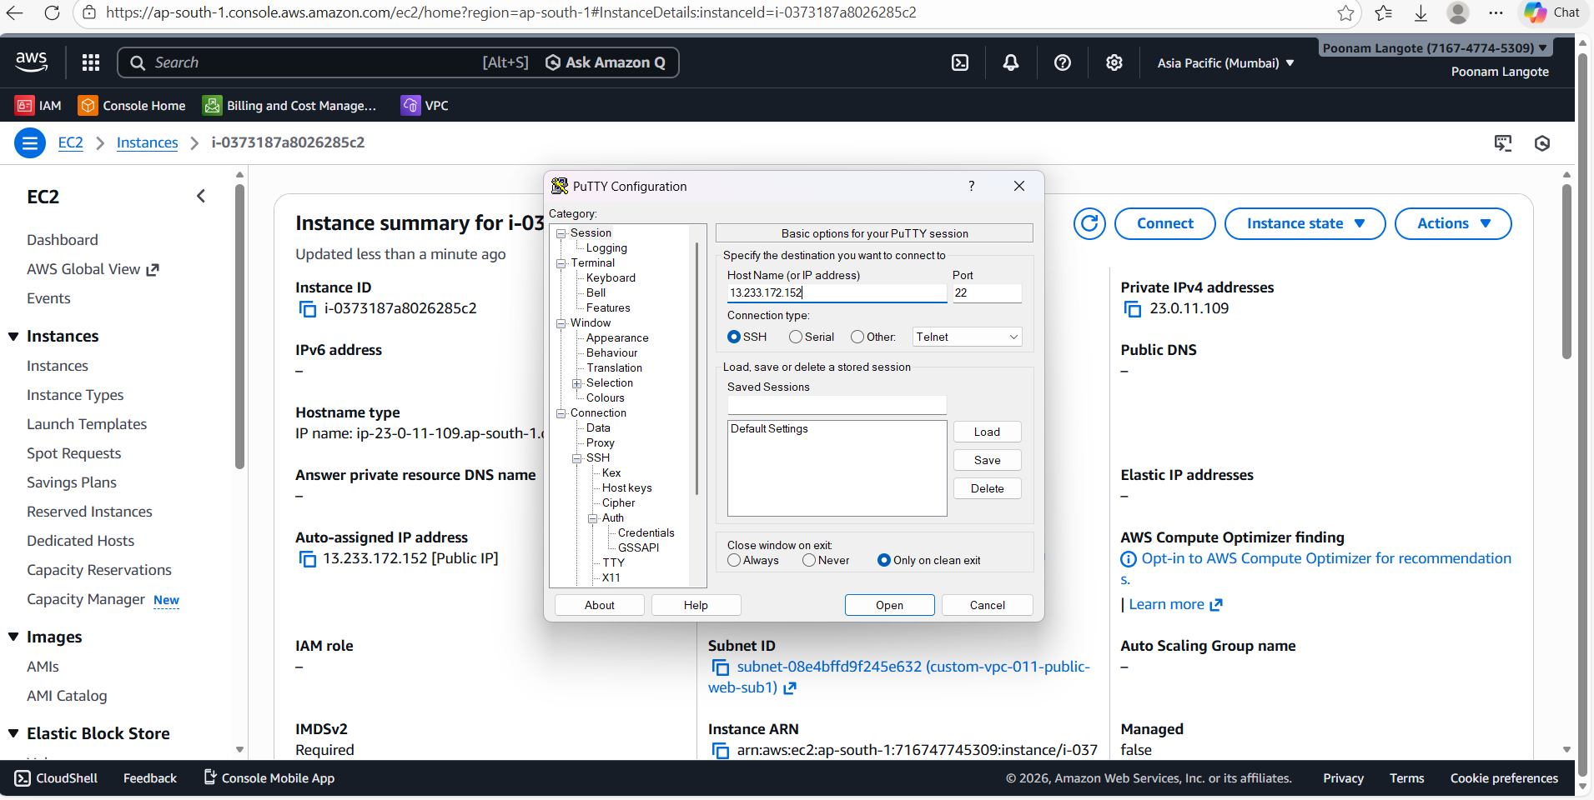
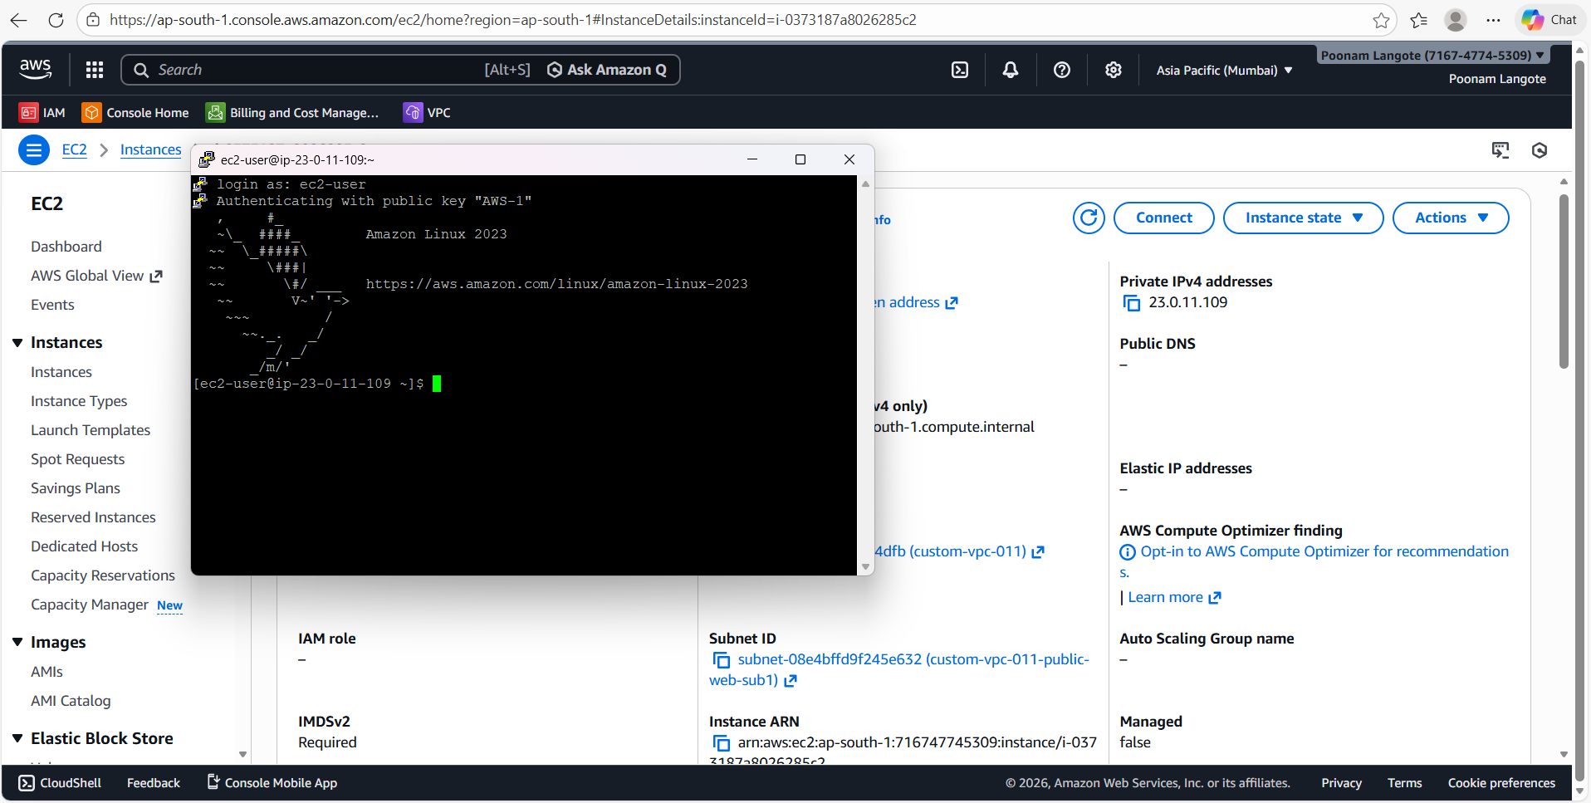

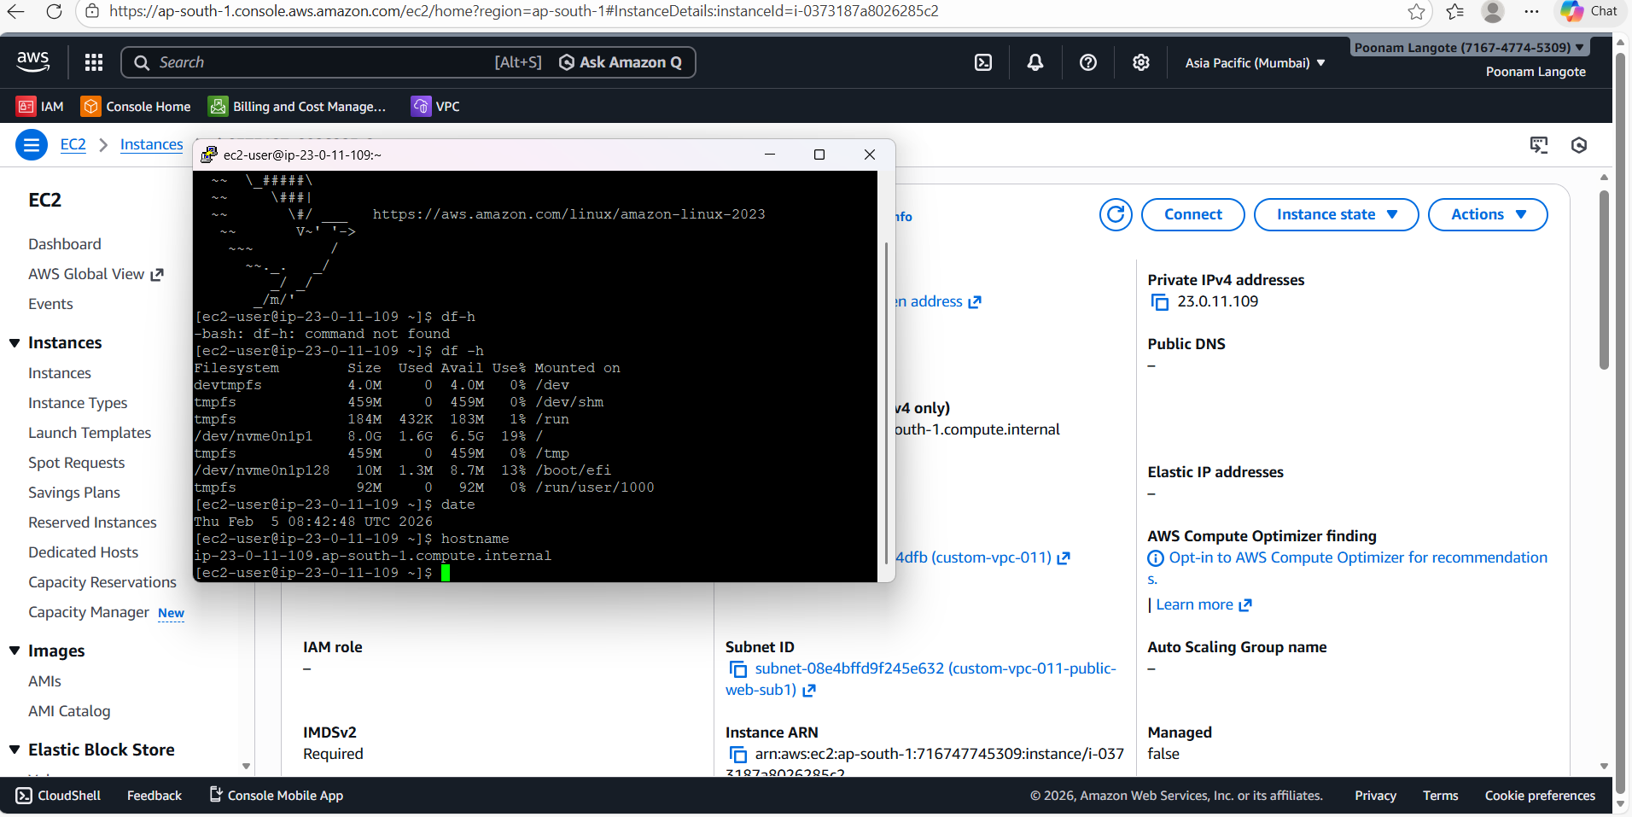

steps to connect EC2 using PuTTY (Windows):
- Go to EC2 → Instances → Select instance
- Copy Public IPv4 address
- Open PuTTY
- In Host Name:
ec2-user@<Public-IP>
Port: 22, Connection: SSH
- Go to Connection → SSH → Auth
- Browse and select your. ppk key file
- Click Open
- Type yes (first time only)
- Login successful → you’ll see Amazon Linux 2023 prompt

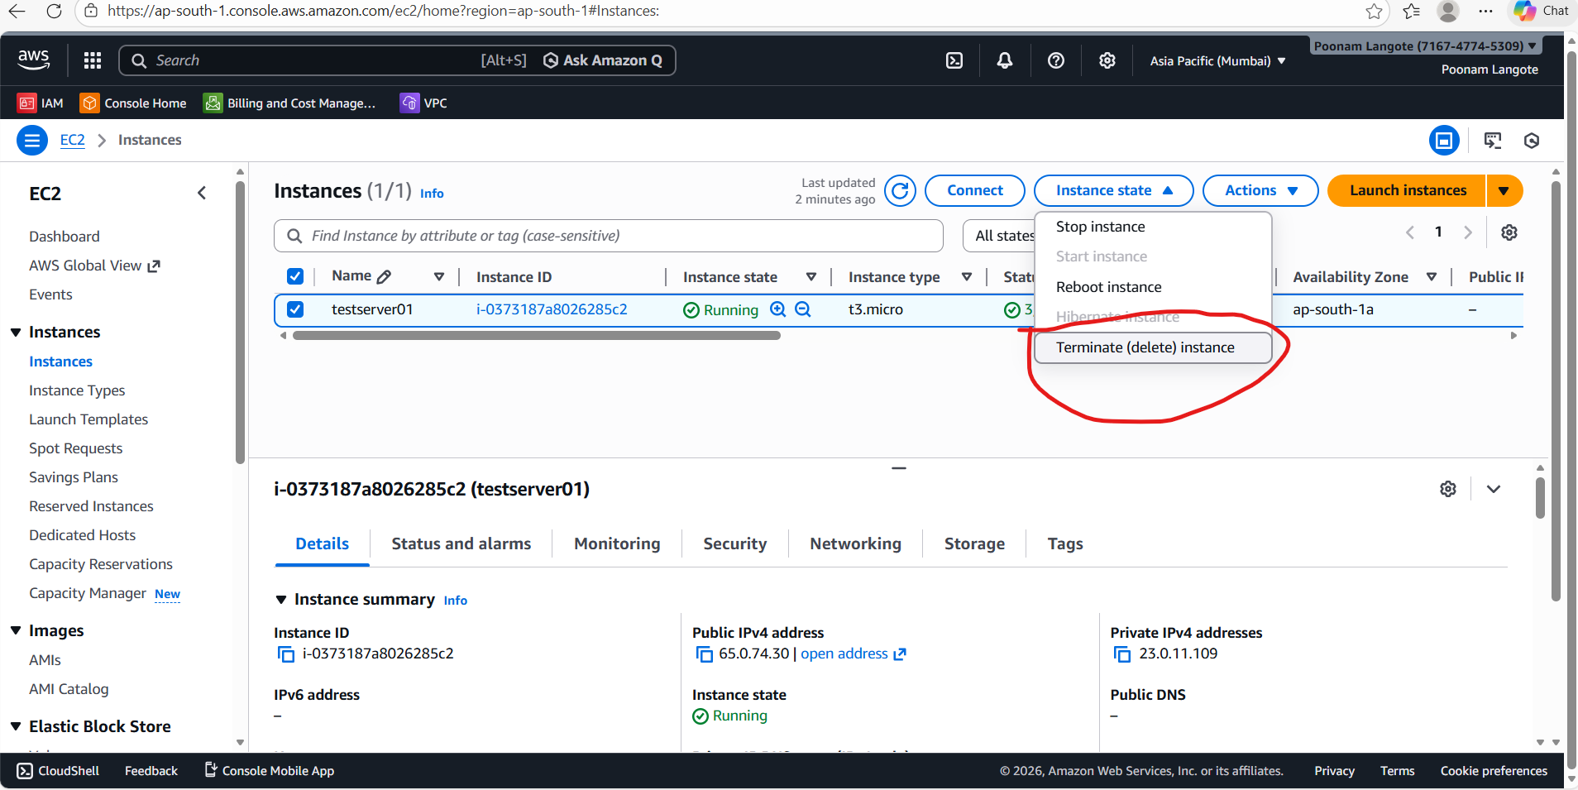
EC2 Instance Actions
- Stop instance
  - Shuts down the Linux server
  - Data on EBS disk is safe
  - Public IP may change when restarted
  - No compute charges while stopped
- Start instance
  - Starts the server again
  - New Public IP (unless Elastic IP used)
- Reboot instance
  - Like a Linux reboot command
  - OS restarts, IP stays the same
  - Used for applying updates
- Terminate (delete) instance ❌
  - Deletes the server permanently
  - Instance is gone forever
  - EBS volume may also be deleted
  - Do NOT click unless you are sure

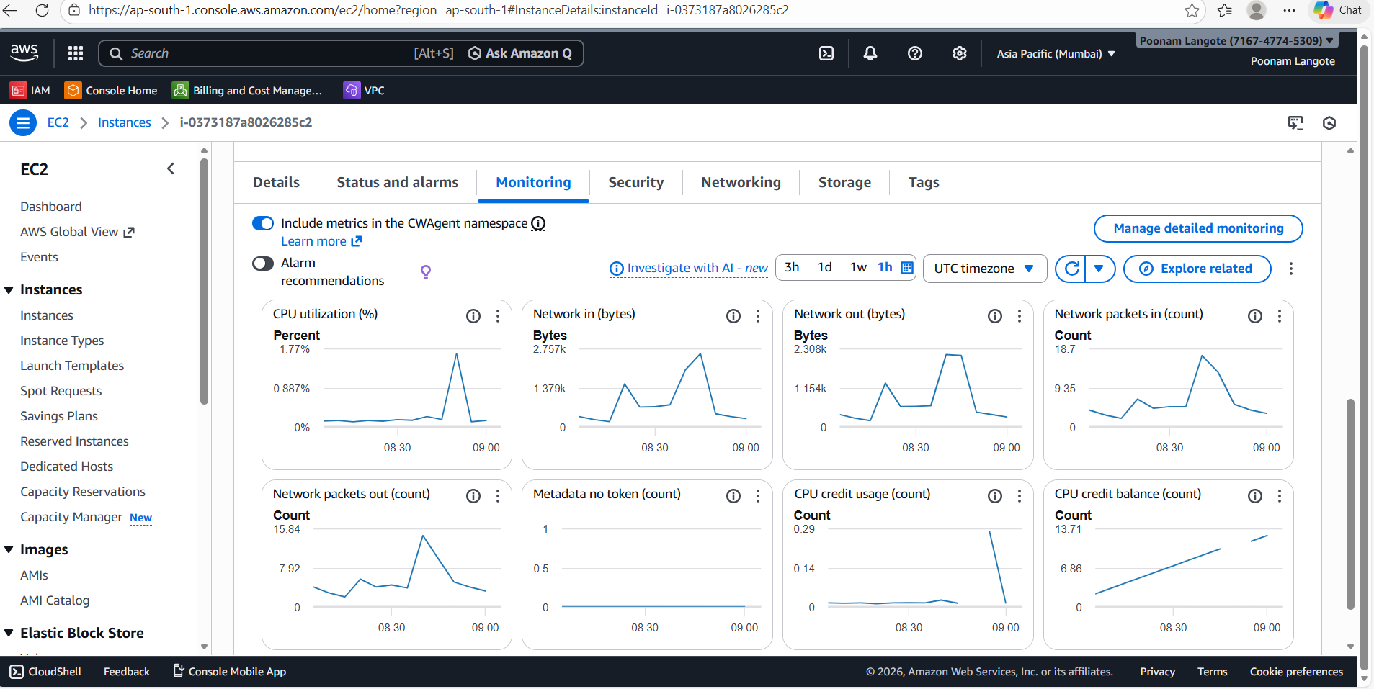

Monitoring tab:
- Shows CPU usage, network in/out, and packets
- Helps check server load & performance
- Used for troubleshooting and capacity monitoring
- Data comes from CloudWatch metrics
👉 If CPU/network is high → server is under load
👉 If flat → server is idle

