- Full Name- Poonam Langote
- Submission Date- 30/03/2026
- AWS Region used- US East (N. Virginia) us-east-1
- Task 7: Enable Default SSE-S3 Encryption and Generate Pre-Signed URLS
- Objective- Enable default SSE-S3 encryption on a private S3 bucket and generate time-limited pre-signed URLs for secure sharing.

- Create a new private S3 bucket: secure-bucket-[yourname].
- Keep Block all public access enabled. Create.
- Go to Properties -> Default Encryption -> Edit. Select SSE-S3 (Server-side encryption with Amazon S3 managed keys). Save.
- Upload any file to the bucket. Click the file -> Properties tab -> confirm Server-side encryption shows SSE-S3.
- Copy the Object URL and paste it in a browser - you should get Access Denied
- (bucket is private).
- Select the file -> Object Actions -> Share with a presigned URL. Set expiry: 5 minutes. Copy the URL.
- Open the pre-signed URL in a browser - the file downloads or displays successfully.
- Wait 5 minutes. Try the same URL again - it returns Access Denied (URL has expired).
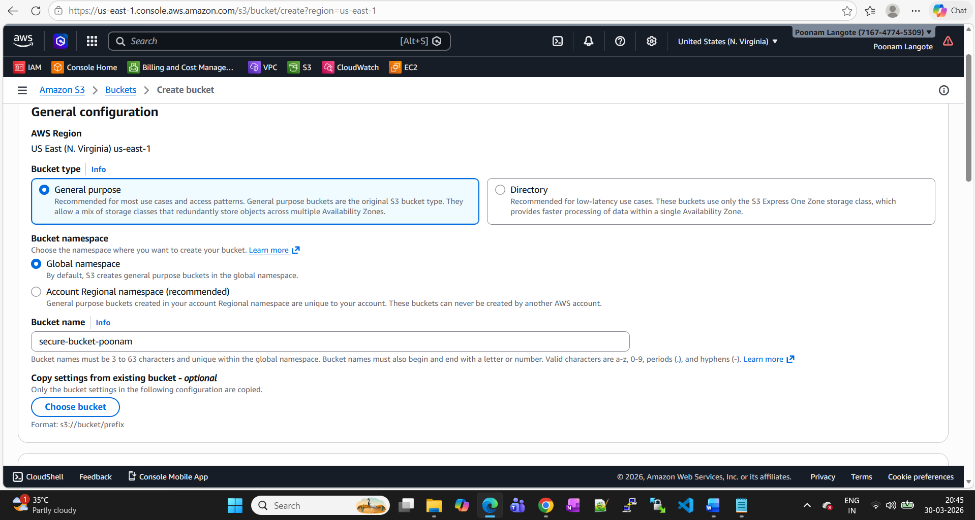

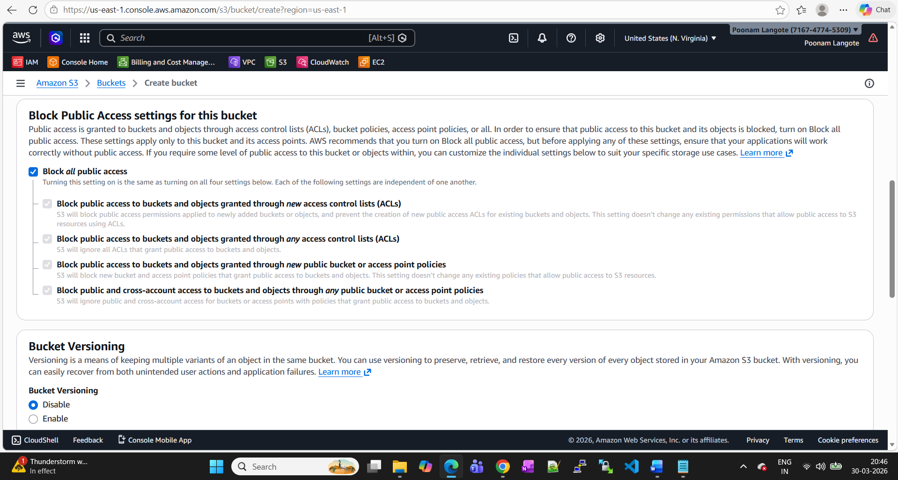

Bucket created (secure-bucket-poonam )
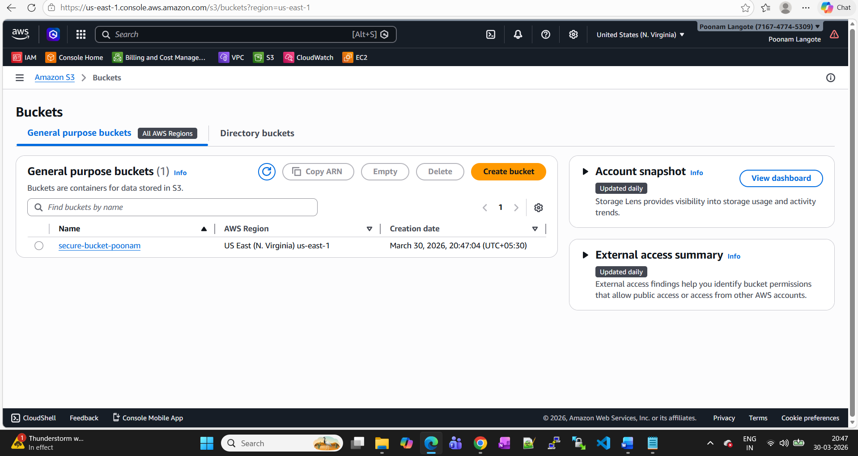
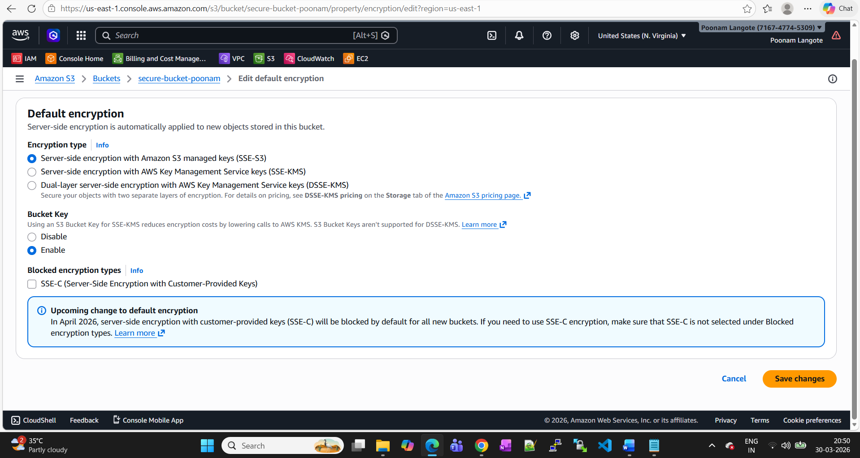
Index.html file uploaded to bucket.
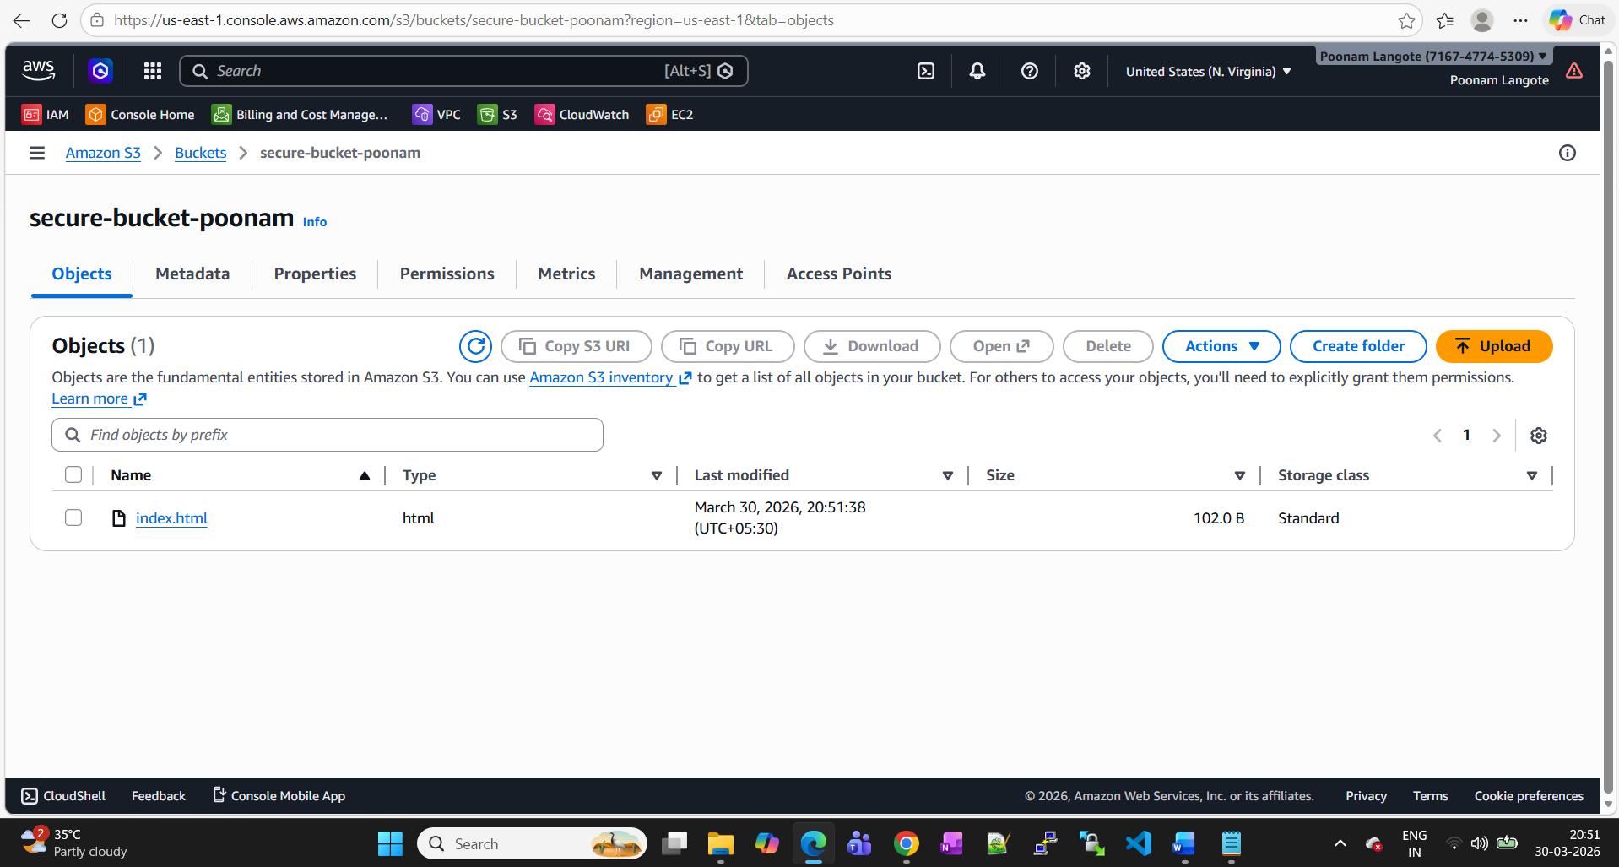

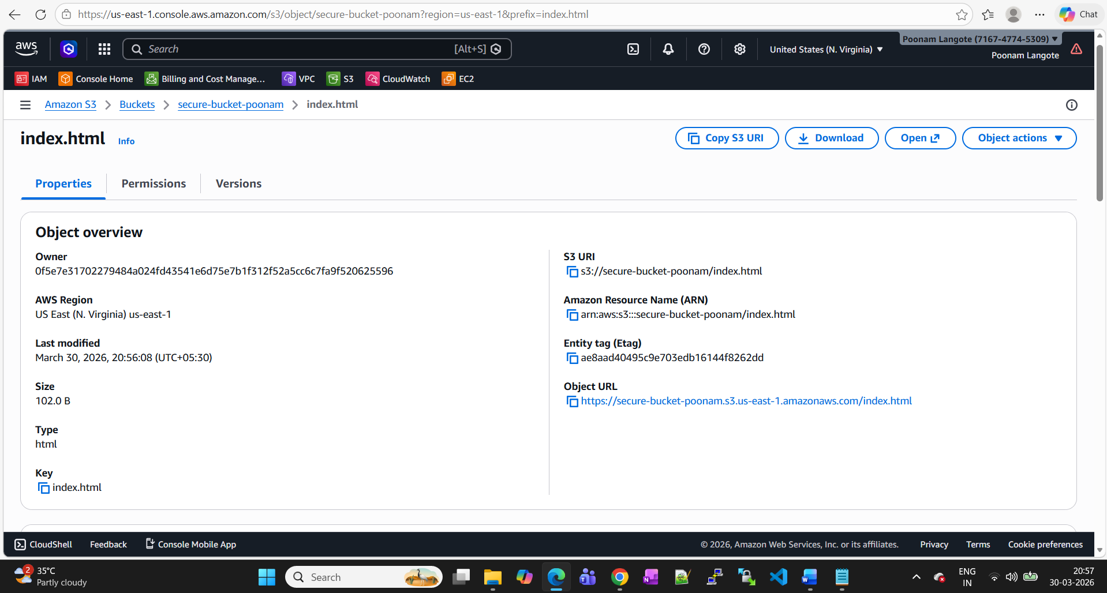
Access denied
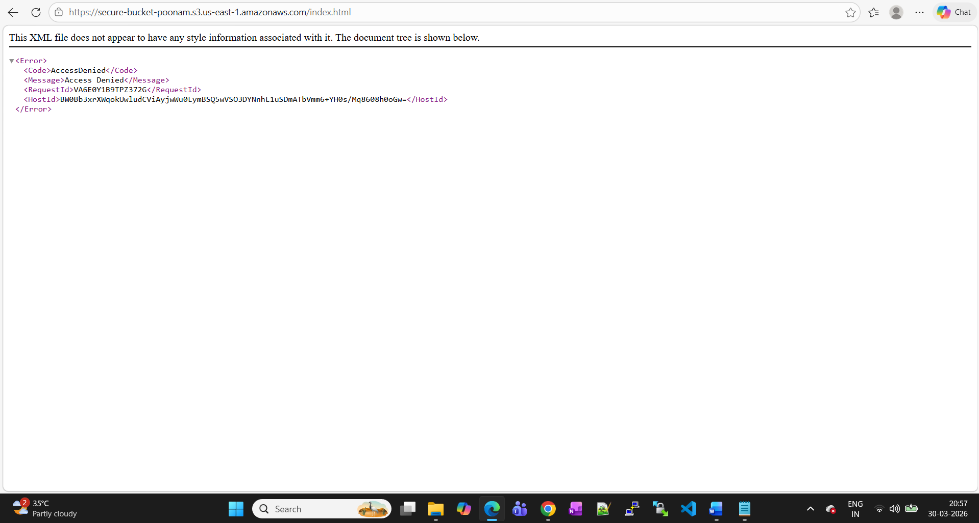

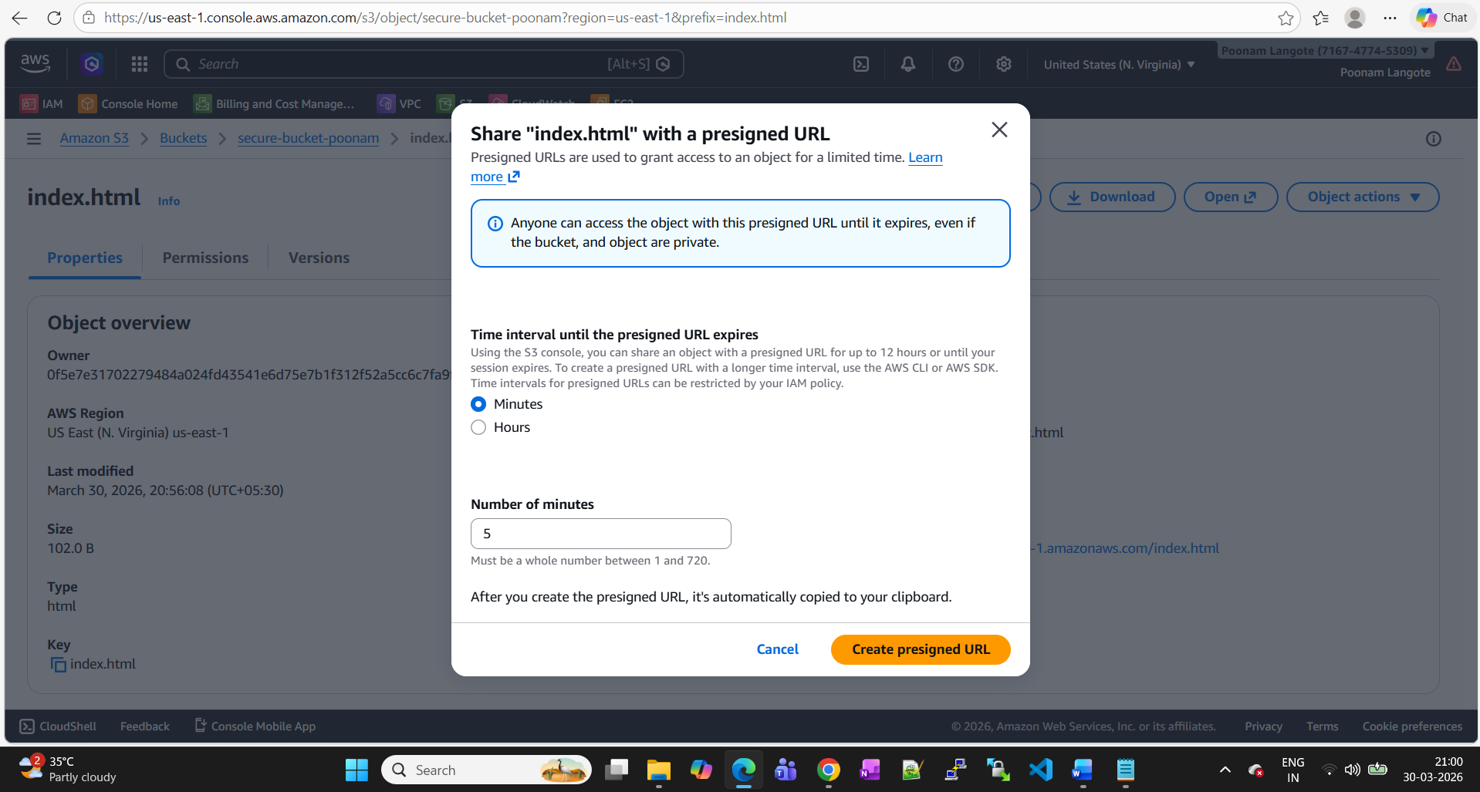

Pre signed URL worked successfully.

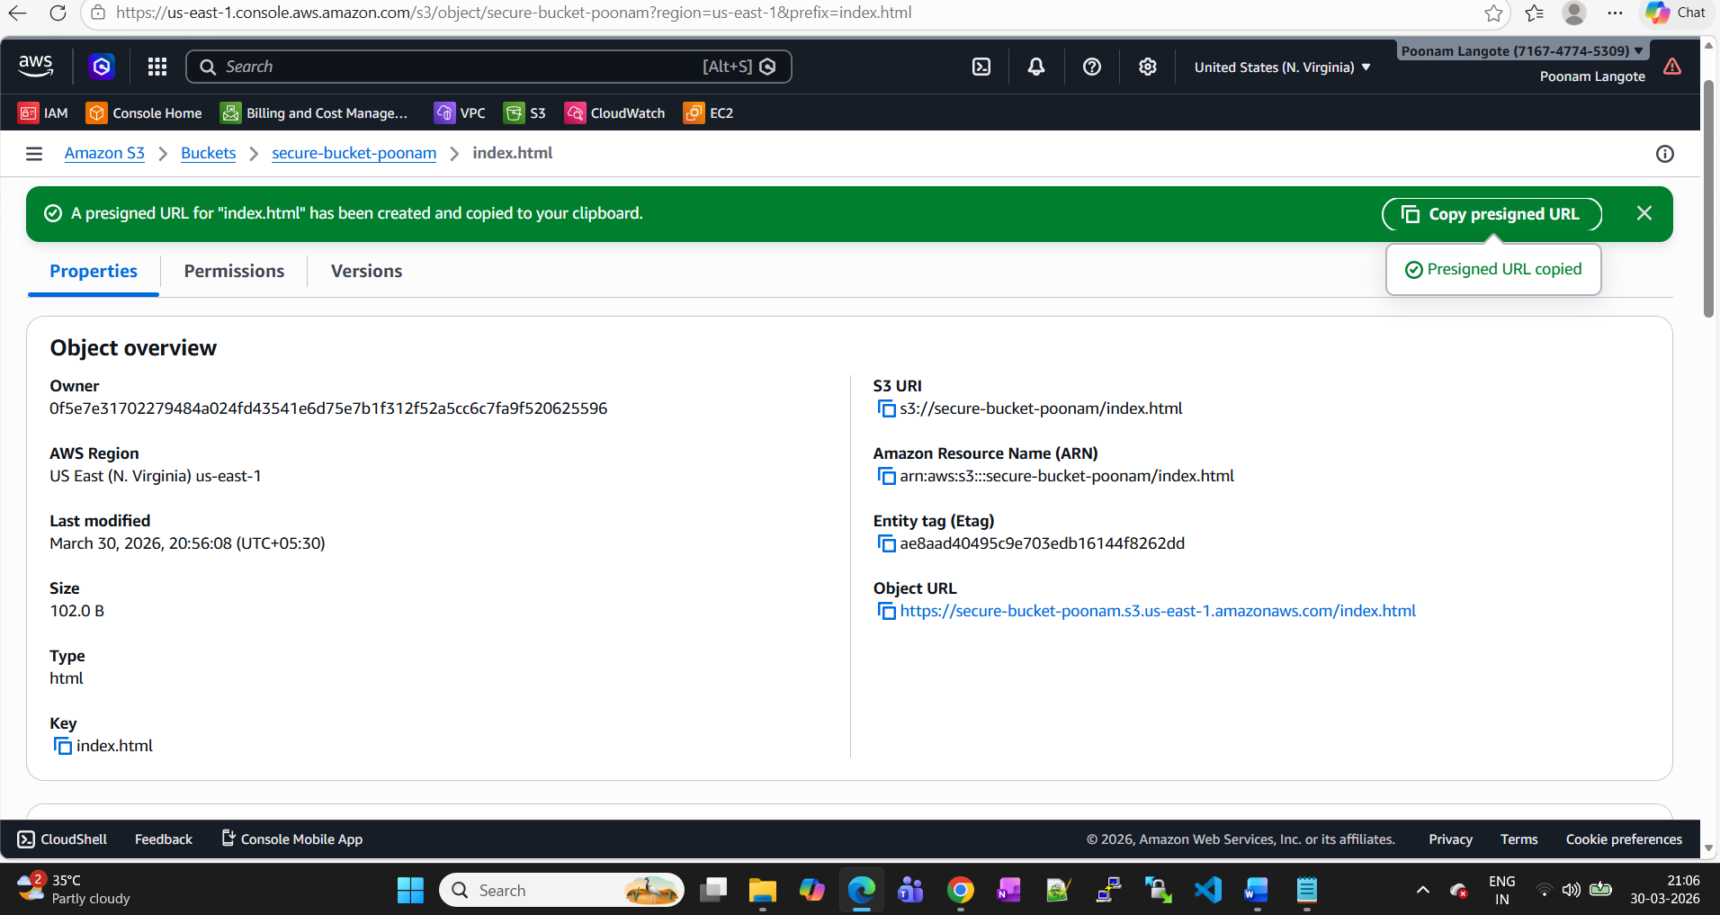

Access denied error
