PIZZA SALES SQL QUERIES
A. KPI’s
1. Total Revenue:
select round(SUM(total_price),2) as 'Total Revenue' from pizza_sales;
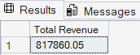

2. Average Order Value
select round(SUM(total_price) / COUNT(distinct order_id),2) as 'Avg OrderValue' from pizza_sales;
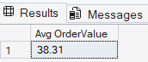

3. Total Pizzas Sold
select SUM(quantity) as 'Total PizzaSold' from pizza_sales;
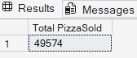

4. Total Orders
select count(distinct order_id) as 'Total Orders' from pizza_sales;
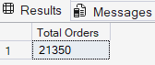

5. Average Pizzas Per Order
select cast(cast(SUM(quantity) as decimal(10,2)) /
cast(COUNT(distinct order_id) as decimal(10,2)) as decimal(10,2)) as 'Avg Pizzas/Order' from pizza_sales;
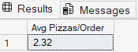

B. Daily Trend for Total Orders
select DATENAME(DW, order_date) as 'Order Day', count(distinct order_id) as 'Total Orders'
from pizza_sales
group by DATENAME(DW, order_date);
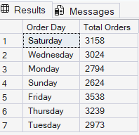

C. Monthly Trend for Orders
select DATENAME(MONTH, order_date) as 'Month', count(distinct order_id) as 'Total Orders'
from pizza_sales
group by DATENAME(MONTH, order_date)
order by 'Total Orders' desc;
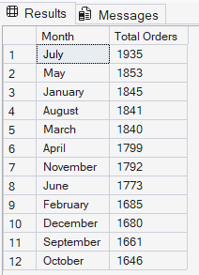

D. % of Sales by Pizza Category
select pizza_category, round(sum(total_price),2) as 'Total Revenue',
round(sum(total_price) * 100 /
(select sum(total_price) from pizza_sales),2) as '% of TotalSales'
from pizza_sales
group by pizza_category;
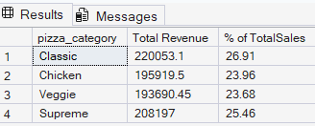
E. % of Sales by Pizza Size
select pizza_size, round(sum(total_price),2) as 'Total Revenue',
round(sum(total_price) * 100 /
(select sum(total_price) from pizza_sales),2) as '% of TotalSales'
from pizza_sales
group by pizza_size
order by '% of TotalSales' desc;
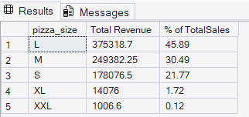
F. Total Pizzas Sold by Pizza Category
select pizza_category, sum(quantity) as 'Total Quantity Sold'
from pizza_sales
group by pizza_category
order by 'Total Quantity Sold' desc;
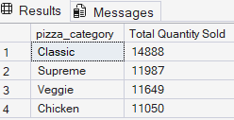
G. Top 5 Pizzas by Revenue
select top 5 pizza_name, sum(total_price) as 'Total Revenue'
from pizza_sales
group by pizza_name
order by 'Total Revenue' desc;
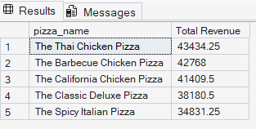

H. Bottom 5 Pizzas by Revenue
select top 5 pizza_name, sum(total_price) as 'Total Revenue'
from pizza_sales
group by pizza_name
order by 'Total Revenue';
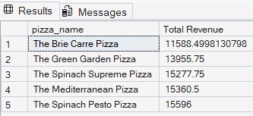

I. Top 5 Pizzas by Quantity
select top 5 pizza_name, sum(quantity) as 'Total Quantity'
from pizza_sales
group by pizza_name
order by 'Total Quantity' desc;
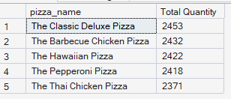

J. Bottom 5 Pizzas by Quantity
select top 5 pizza_name, sum(quantity) as 'Total Quantity'
from pizza_sales
group by pizza_name
order by 'Total Quantity';
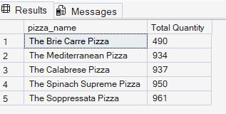
K. Top 5 Pizzas by Total Orders
select top 5 pizza_name, count(distinct order_id) as 'Total Orders'
from pizza_sales
group by pizza_name
order by 'Total Orders' desc;
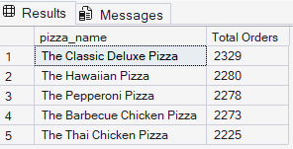

L. Borrom 5 Pizzas by Total Orders
select top 5 pizza_name, count(distinct order_id) as 'Total Orders'
from pizza_sales
group by pizza_name
order by 'Total Orders';
