Assignment-1.R

PoonamDighe

2022-01-19

#Q.1. Print your name at the top of the script   
print("POONAM DIGHE")

## [1] "POONAM DIGHE"

#Q.2. Install the vcd package   
r=getOption("repos")  
r["CRAN"]="http://cran.us.r-project.org"  
options(repos=r)  
install.packages("vcd")

## Installing package into 'C:/Users/poonam/Documents/R/win-library/4.1'  
## (as 'lib' is unspecified)

## package 'vcd' successfully unpacked and MD5 sums checked  
##   
## The downloaded binary packages are in  
## C:\Users\poonam\AppData\Local\Temp\RtmpaI2eVr\downloaded_packages

#package 'vcd' successfully unpacked and MD5 sums checked  
#  
#The downloaded binary packages are in  
#C:\Users\poonam\AppData\Local\Temp\RtmpiM9c2l\downloaded_packages  
  
#Q.3. Import the vcd library   
library(vcd)

## Loading required package: grid

#Loading required package: grid  
  
#Q.4. Plot a sales~temp scatter plot using the data below:Sales data:(7,11,15,20,19,11,18,10,6,22) Temperature data: (69,81,77,84,80,97,87,70,65,90)   
  
Sales <- c(7,11,15,20,19,11,18,10,6,22)   
Sales

## [1] 7 11 15 20 19 11 18 10 6 22

Temperature <- c(69,81,77,84,80,97,87,70,65,90)   
Temperature

## [1] 69 81 77 84 80 97 87 70 65 90

plot (Sales~Temperature,xlab="Temperature",ylab="Sales",main="Scatter Plot", sub="Sales vs Temperature")

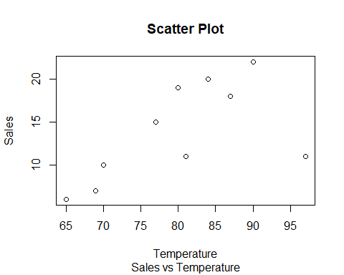

#Q.5. Find the mean temperature (pg 9)   
mean(Temperature)

## [1] 80

#Q.6. Delete the 3rd element from the sales vector   
Sales <- Sales[-3]  
Sales

## [1] 7 11 20 19 11 18 10 6 22

#Q.7. Insert 16 as the 3rd element into the sales vector.  
Sales <- c(Sales[1:2],16,Sales[3:9])  
Sales

## [1] 7 11 16 20 19 11 18 10 6 22

#Q.8. Create a vector <names> with elements Tom, Dick, Harry (pg 22)  
names <- c("Tom","Dick","Harry")  
names

## [1] "Tom" "Dick" "Harry"

#Q.9. Create a 5 row and 2 column matrix of 10 integers   
matrix(1:10, nrow=5, ncol=2)

## [,1] [,2]  
## [1,] 1 6  
## [2,] 2 7  
## [3,] 3 8  
## [4,] 4 9  
## [5,] 5 10

#Q.10. Create a data frame <icSales> with sales and temp attributes  
icSales <- data.frame(Sales,Temperature)  
  
#Q.11. Display the data frame structure of icScales  
structure(icSales)

## Sales Temperature  
## 1 7 69  
## 2 11 81  
## 3 16 77  
## 4 20 84  
## 5 19 80  
## 6 11 97  
## 7 18 87  
## 8 10 70  
## 9 6 65  
## 10 22 90

#Q.12. Display a summary of the icScales data frame   
summary(icSales)

## Sales Temperature   
## Min. : 6.00 Min. :65.00   
## 1st Qu.:10.25 1st Qu.:71.75   
## Median :13.50 Median :80.50   
## Mean :14.00 Mean :80.00   
## 3rd Qu.:18.75 3rd Qu.:86.25   
## Max. :22.00 Max. :97.00

#Q.13. Import the dataset Student.csv   
library(readxl)  
Student <- read_excel("C:/Users/poonam/Documents/NEU/Student.xls")  
View(Student)  
  
#Q.14. Display only the variable names of the Student.csv dataset   
ls(Student)

## [1] "First" "Last" "Math" "Science"   
## [5] "Social Studies" "StudentID"