Here some are data visualizations that we tried using the tool Power BI Desktop. These visualizations give us some insights into our dataset and help us to conclude few things.

1. **Prediction -** What is the role of Gross and Budget in movie’s success?

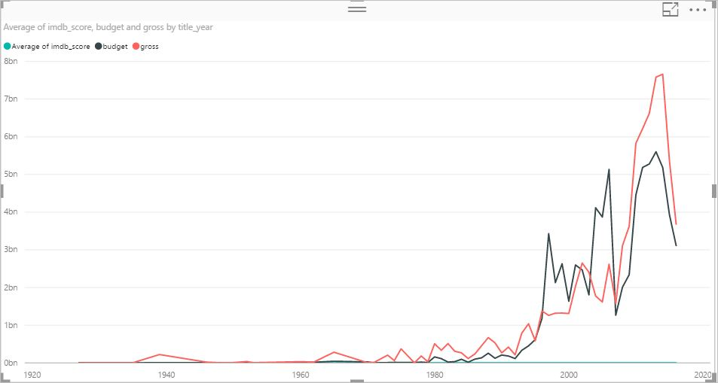

Above is the data which visualize how Gross and Budget are influencing the movie success rate.

It's taking data from the year 1927 to 2016 and will help as to predict the future analysis.

If we hover at the year 1927, budget and gross of the movie is not high, but IMDB score is quite good that is 8.3.

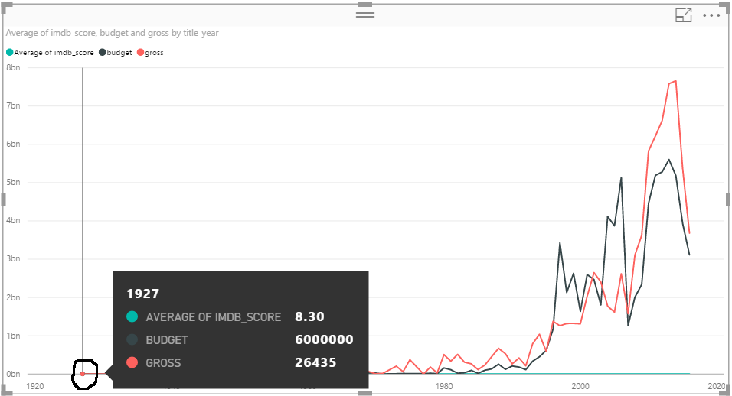

And further, if we analyze the movie with the highest budget and Gross both are giving IMDB score within the range of 6 - 7.

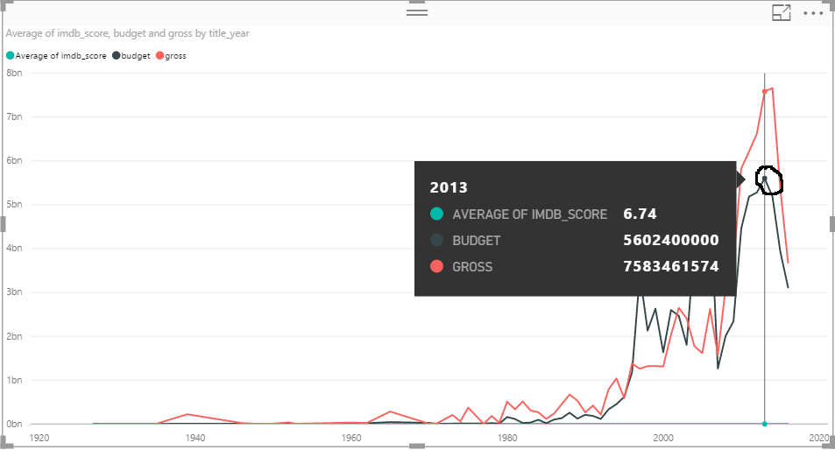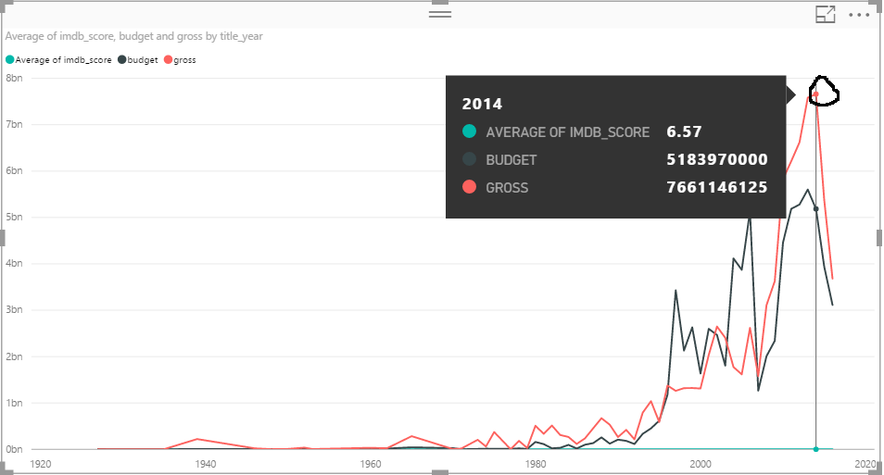

**Conclusion** - After this analysis, we concluded that Budget and Gross has some impact on the movie's success but not that much. Few movies with the small budget have good IMDB scores. If a movie which has a high budget and gross does not necessarily mean that it will be a successful film.

1. **Prediction -** What is the role of Actor’s and Director’s popularity in movie’s success?

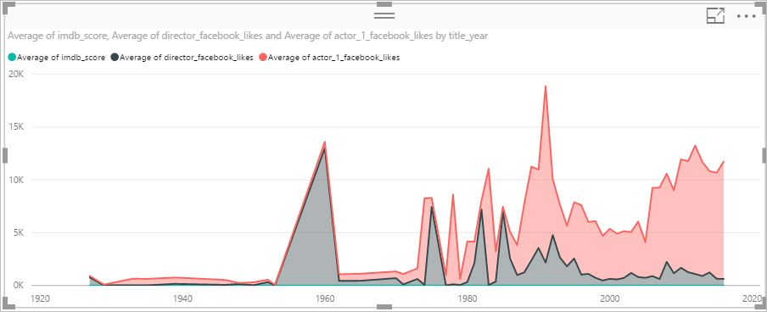

Above graph shows that how an actor's and director's fame are making a difference in Movie's success rate.

We have analyzed that popularity of director has a good impact on the success rate, but Actor's popularity doesn't guarantee success.

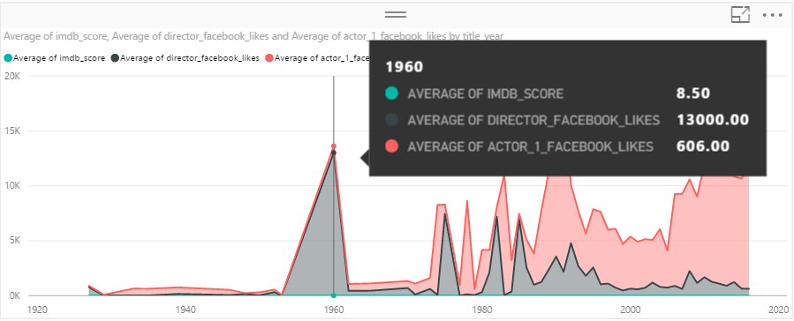

Here we can see that the movies that are made in 1960's have good IMDB score (8.50) and director's and actor's popularity is also very high(average).

On further analysis, we saw that the director's fame is making a huge impact on movie's success as compare to actor's fame.

So, we can say that there is a high correlation between a director's reputation and movie's performance.

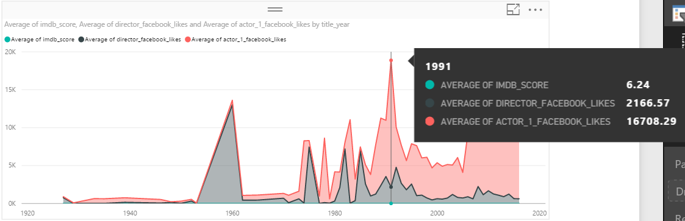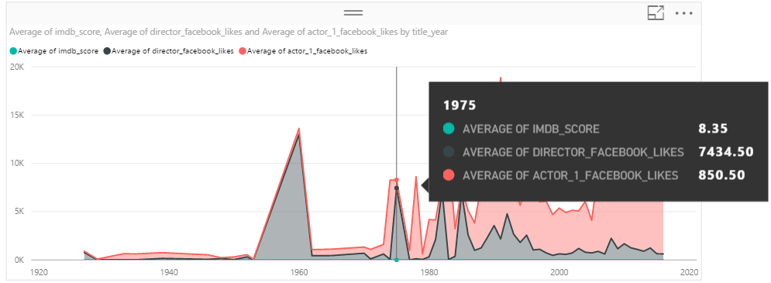

**Conclusion** – In future, it can be easily predicted that the movies whose director's are known and recognized have higher chances of success.

1. Profit and Loss by year and what are the factors influencing Profit?

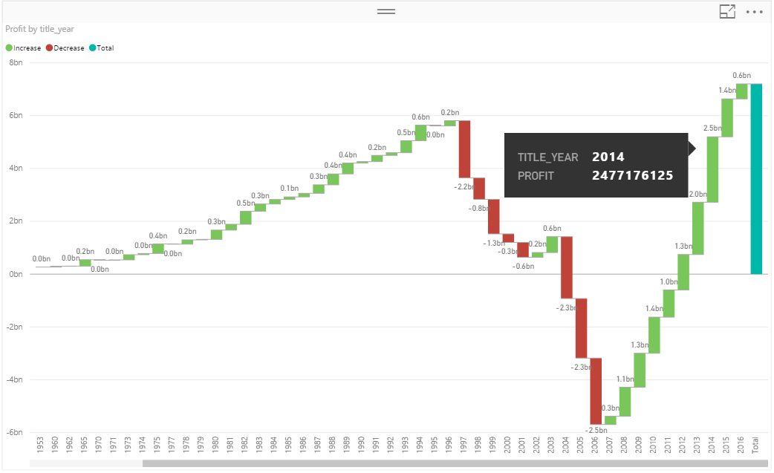

By the graph, we can see that from 1997 to 2001, there was a big loss for the movie industry. And again the graph started raising from 2007 to 2016 which shows a notable profit for the film industry. Now let's see what the factors that played a significant role for the benefits of the movie industry.

There were total 95 movies during 2014, which made the profit.

The dashboard below shows the top directors and actors who were part of the movies. And it's also showing the Movie title along with the IMDB score which is quite good.

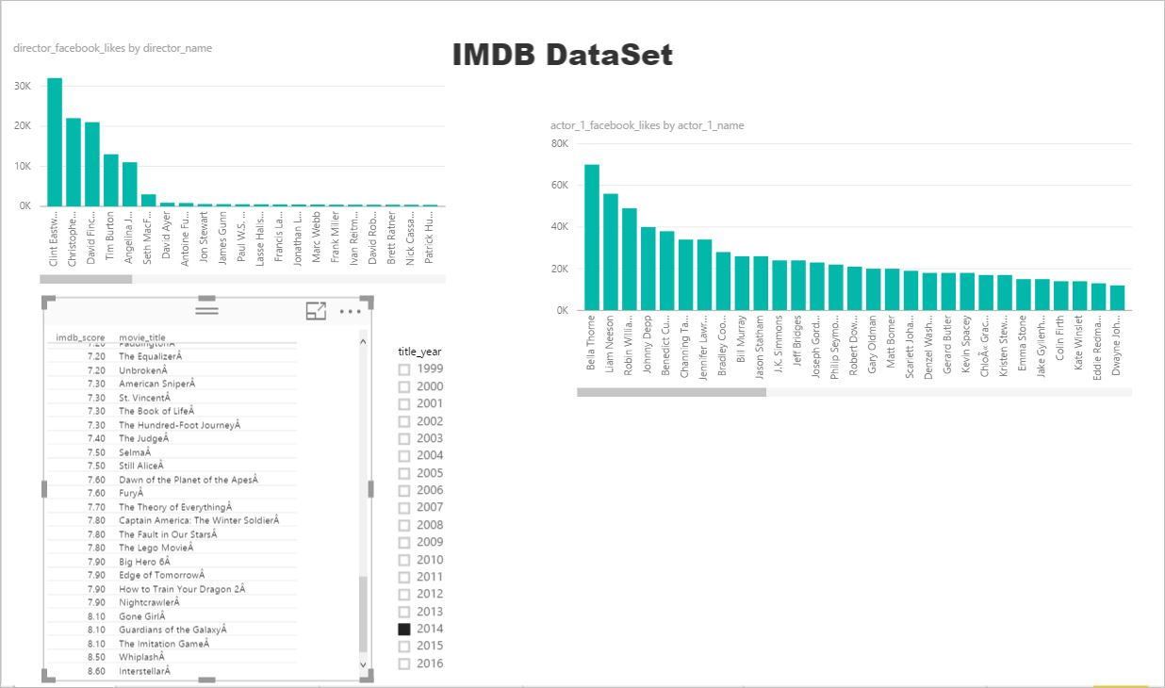

1. Top profitable Actors and Directors of last 10 years.

Top Profitable Actors

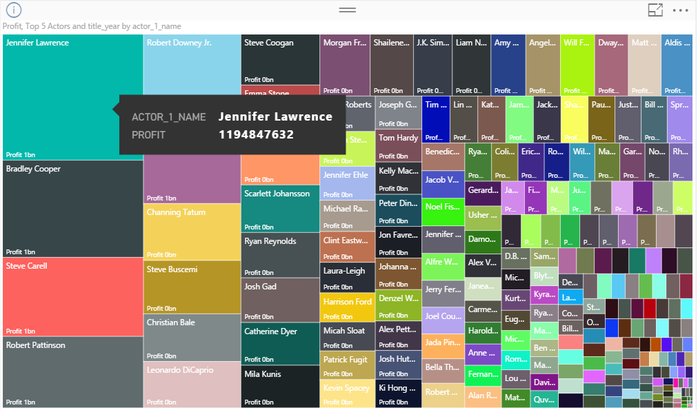

Profitable Director

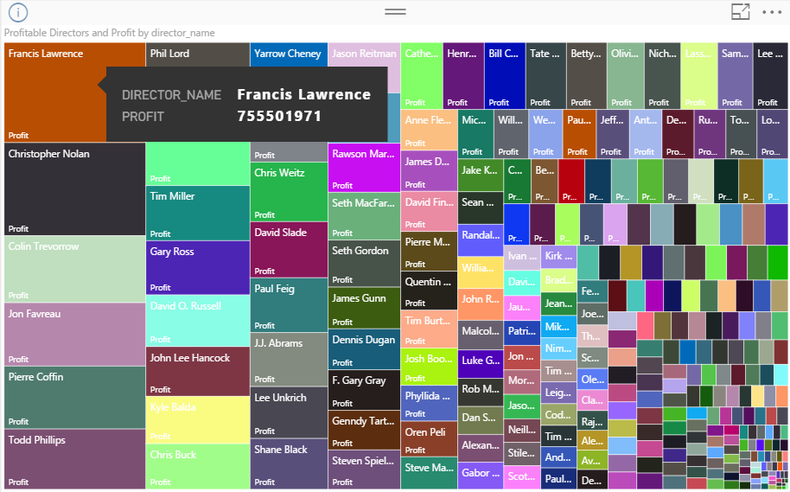

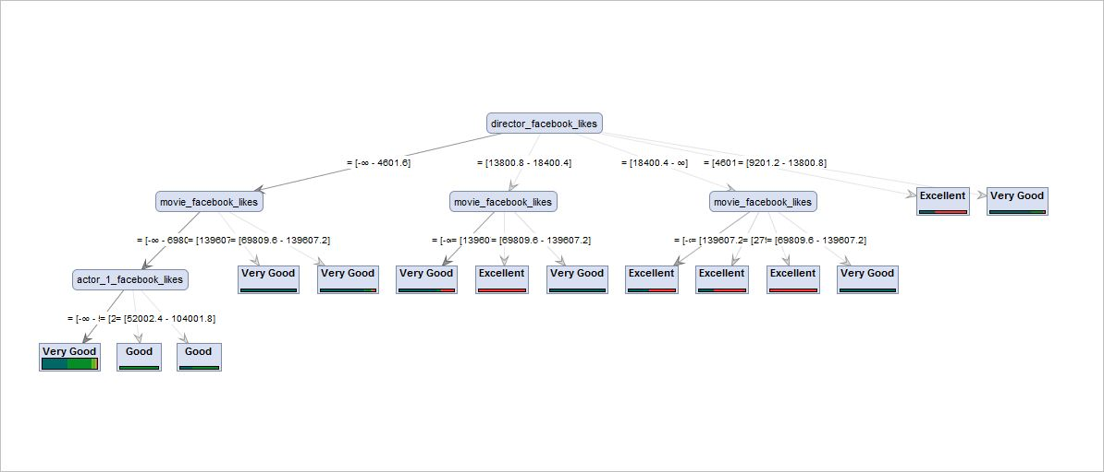

1. Movie Status

**Classification Type** – Decision Tree

**Attributes selected** – Actor Facebook likes, Director Facebook likes, Movie Facebook likes, Movie status as labeled, Director name as Id.

**Initial Analysis –** Movie status that is if movie is Flop, Good, very good, excellent depends upon the Actor’s and Director’s popularity.

**Classification –** The classification model chosen is Decision Tree. Its predicting the Move status based on the popularity of the actor’s and director’s. We have discretized Actor Facebook likes, Director Facebook likes, Movie Facebook likes.

And Movie status is generated from the IMDB score by keeping a range of the score like movies which have IMDB score of 8-10 are Excellent movies.

**Process Design –**

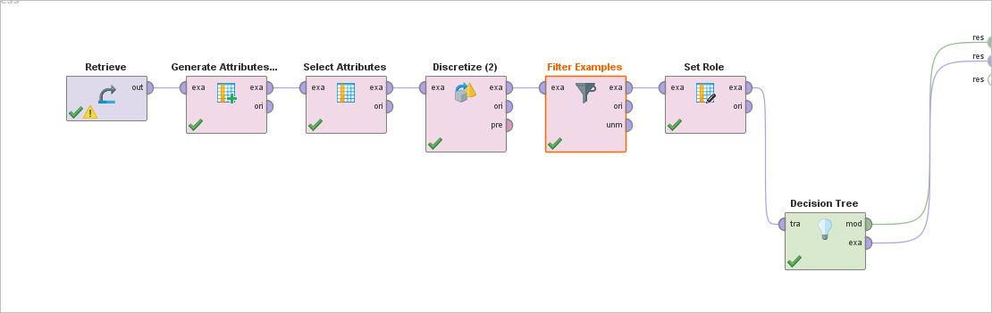

Results –



The decision tree starts with the director Facebook likes and further split into multiple branches. Second level get splits from Movie Facebook likes and then Actor Facebook likes. As we have discretized the values, its taking few ranges and based on that its predicting the movie status.